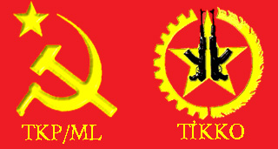
Press Bulletin/ April 2011
To the Press and the Public: 5 martyrs of TKP/ML-TIKKO died in Dersim
The Press statement of the TKP/ML-TIKKO Dersim Region Comittee from April 20th 2011 states that on 2nd February 2011, 5 guerillas of TKP/ML-TIKKO have lost their lives as a result of an avalanche. According to the statement of the Dersim Region; on February 2nd 2011 at 5am an avalanche destroyed the Winter-Camp and killed five female TIKKO guerillas.
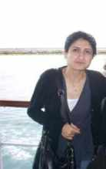
Sefagl Kesgin
1- Sefagul Kesgin: code name, Eylem; was born in Erzurum in 1977. She joined the guerilla struggle in 2007. She was the Political “Polit-Luitenant” of the Dersim Region
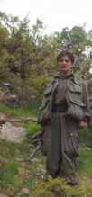
Nursen Aslan
2- Nursen Aslan: code name, Emel; was born in Tokat (Black Sea) in 1981. She joined the guerilla struggle in 1999. She was a forward sympathiser of the TKP/ML. She was a commander in the Dersim Region.
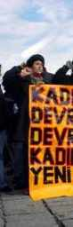
Gulizar Ozkan
3- Gulizar Ozkan: code name, Ozlem; was born in 1967 in Dersim. She joined the guerilla in 2005. She was a forward sympathiser of the party. She was a TIKKO commander.

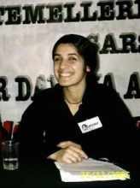
Fatma Acar
4- Fatma Acar, code name, Dilek; was born in 1983 in Mersin. She joined the guerilla struggle in 2006. She was a forward sympathiser of the TKP/ML and a commander of TIKKO.

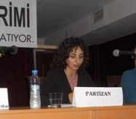
Derya Aras
5- Derya Aras; cod name, Sevda: she was born in 1979 in Erzincan and joined the guerillas in 2009. She was a forward sympathiser of the TKP/ML and a TIKKO fighter.
Even if right after the landslide a immediate interference took place, only the lifeless bodies of the five comrades were buried.
The Dersim Regional Committee further declares that “including comrade Sefagul Kesgin the martyrdom of our five comrades is a big loss for our organization. We know that these losses and death is part our war. In order to bear the price of this heavy loss we will focus on our struggle with all our abilities and strength and we will increase the struggle that has been handed over to us by our martyrs in a way that our comrades deserve.”
“Our five comrades have left a note on the page of history; they have done this with their leading role in our war and in showing the oppressed women the way towards freedom. Their lives, just as their martyrdom, was a rebellion against the oppression of women since thousands of years and this rebellion will illuminate the path of the comrades who will continue the struggle. We can only keep our comrades alive with the weapons we have taken over from them for the struggle of democratic peoples’ revolution, socialism and communism.”
As the international office of the TKP/ML we know that the path of proletarian world revolution is a path full of willpower, sacrifices and determination. The way to final victory can only be reached with the knowledge of proletarian world revolution and the Marxist-Leninist-Maoist ideology. For this we call upon all revolutionary and communist forces to take notice of the martyrdom of our comrades Sefagul Kesgin, Nursen Aslan, Gulizar Ozkan, Fatma Acar, Derya Aras.
Long Live Proletarian Internationalism!
Long Live Peoples War – Long Live Marxism-Leninism-Maoism!

TKP/ML-International Relation Office

