Statement No: 2021/4

Workers of all lands, Unite!

MAY DAY IS STRUGGLE AGAINST IMPERIALIST-CAPITALIST SYSTEM, THE REAL VIRUS!

May 1 is the Day of Unity, Struggle and Solidarity, which is one of the most important milestones in the struggle between the bourgeoisie and the working class and the millions of oppressed working masses. This year, we welcome May 1 in a period in which the ranks of the Revolution and counter-revolution forces become clearer, the contradictions become clearer, and the anger of the oppressed has accumulated, although it has not yet broken its shell.
Of course, one of the most important reasons why this picture has become clear is the corona virus epidemic, which should be seen as a working-class disease. All over the world, more than three million people have died due to the epidemic so far. Workers and toiling masses are the ones who lost their lives. They are the ones getting poorer by the epidemic. This is a fact! In the reports made by some organizations linked to imperialism, this reality is reflected in the estimates that the number of people who earn less than $ 1.90 per day and defined as "extremely poor" will reach 1 billion from 434 million. This is also seen in the fact that, despite the economic crisis that has not recovered since the 2008, the total wealth of the world's billionaires increased by $ 5 trillion to $ 13.1 trillion during the epidemic. The owner of the increasing wealth of these capitalists is the working class and laborers who were forced to work during the epidemic. During the epidemic, the working class and laborers have not only sweat but also blood in every penny spent by bloodsuckers, which reached 2 thousand 755 people, together with 660 people who entered the billionaire list during the epidemic. The fact that the wealth of the 10 richest people in the world is enough to allow all the peoples of the world to be vaccinated is proof that the poor are not killed by the coronavirus, but by the rich. In short, while someone is getting poorer, others are getting rich; impoverishment is at the expense of someone's enrichment.
While the bourgeoisie added wealth to its wealth around the world, vaccination wars as the product of inter-imperialist competition, even the "charity-aid" that the states, their representatives, promised to make to the peoples in the first stages of the pandemic, was forgotten in a noticeably short time. This situation is dire for our country. In fact, Turkey is one of the two countries that allocates the least resources to the public during the, in proportion to its national income among OECD countries. This resource also includes health expenditures, which corresponds to only 1.1 percent of the national income.
The AKP-MHP government on the one hand, in the beginning of the pandemic declared that banned dismissal of workers during the pandemic, but on the other hand allowed bosses to force unpaid holidays on workers and dismiss them using code-29 “situations that do not comply with the rules of morality and goodwill”. This showed that their promise to workers was nothing but a lie! Code-29 has become a special attack policy against resisting workers who organise in trade unions to get their rights. The fact that workers fired with Code-29 cannot use their right to unemployment benefits creates a complete win-win situation for the government. As a matter of fact, while the number of workers dismissed with Code-29 was 176 thousand 662 last year, the number of those on unpaid leave exceeded 2 and a half million. In other words, nearly three million workers were left unemployed and left to die during the "dismissal ban" process.

The Wave from deep hits the Surface!
The Turkish ruling classes and their representative AKP-MHP government are trying to use the pandemic not only to exploit the hard work of the working people more, but also to usurp the democratic-social rights of the people, which are already at the level of crumbling, and build thick walls with a fast-paced fascism. The most obvious example is those who put restrictions against workers demanding their rights through restrictions due to pandemic are the cramming thousands of people in congress halls during the same pandemic. Those who attack the protestors to prevent spreading of the virus but shoving tens of people on to the police vans. It is the attempt to throw away the Istanbul Convention with a presidential decree, which was signed to prevent violence against women and LGBTI +, which women won through their struggle for many years. Taking advantage of the opportunity to appoint trustee to Boğaziçi University. As the unchanging goal of the Turkish state, it is to accelerate the attacks on Kurdish people and to file a closure case against the HDP. Raiding the houses of people breaking their doors with the ram heads at 5 o'clock in the morning on the accusation of "insulting the president".
Even though divided and lacks solidarity, the working class, women and LGBTI+, people of oppressed beliefs and Kurdish people who take to the streets with their legitimate demands and refuse to leave the streets. To overthrow fascism and win our freedom, we need to strengthen solidarity and unity between different layers of the oppressed, especially the working class, and thus create a united struggle line.
Especially, against the aggression carried out in all economic and political fields mentioned above and the rising fascism wave all over the world, by weaving the anti-fascist front in our geography, to unite all the oppressed, especially the working class, within this front, and in the international arena, it is common with anti-fascist and anti-imperialist forces. It is extremely important to get organised by getting a ground. So much so that we can say that one of the two distinct characteristics of the post-pandemic world will be the rise of fascism, and the other will be massive popular movements as the expression of the anger accumulated by the oppressed, exploited, oppressed peoples, which rests on the bones of the knife. This wave of action, which adopts a common language, shouts common slogans, targets the common enemy and triggers each other, will ruin the calculations of the rulers. Based on this reality, anti-fascist forces will be able to take a step towards freedom, justice, and liberation on behalf of those who are oppressed from this process, with organizations based on de facto legitimate resistance and struggle, not being confined to the ground of “order politics”. The subject of such a process and the builder of the future is undoubtedly the working class.

It is Time to Push with all Our Power!
May Day was born out of a great resistance and has been symbolized in the international struggle for liberation through great struggles and resistance of the proletariat and oppressed people and nations all over the world. The working class that wrote the date of May 1 is a class that created the Paris Commune this year, its 150th anniversary, and gave the example of the first proletarian power. Even though the Commune could only survive for 70 days, the peoples of the world have gained important positions against the international imperialist bourgeoisie, especially in the Soviet and Chinese Revolutions, which were fed by the Commune's lessons.
Therefore, the class struggle will decide whether the destruction caused by the current crisis and aggression against the peoples is for the oppressors or the oppressors.
Our party, TKP-ML, calls on the owners of the labour that created the world, the army of wage slaves, the working class and all the oppressed to organise and struggle for a classless, exploitative free, limitless world. There is no other way to overthrow fascism and win our freedom. It is not possible to salvation by saying "We have survived today", waiting for fascism to collapse spontaneously and hoping that they will be buried in the ballot box. We call on all workers, laborers, women, LGBTI +, Alevis, Kurds, Armenians, everyone to turn a word against this power into a field of resistance and struggle on May 1 to show the way to our liberation.

Long live May Day!
Down with Fascism, Long Live Our Struggle for Democratic People's Power!
Long Live Proletarian Internationalism!
Long live Marxism Leninism Maoism!

TKP-ML Central Committee- Polit Bureau
April 2021
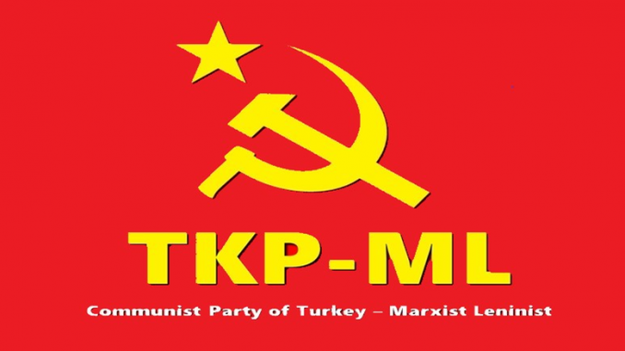

Link: https://www.tkpml.com/tkp-ml-central-committee-polit-bureau-may-day-is-struggle-against-imperialist-capitalist-system-the-real-virus/

