PERSISTENTLY AGAINST HATE, LONG LIVE THE PRIDE WEEK!
LONG LIVE THE LGBTQ+ STRUGGLE!

Of course, “everything” did not start with a bottle thrown by a trans activist during a routine police raid on the Stonewall Inn bar, one of the few places where gay and trans people could socialize, in the district Greenwich in New York in USA. But the bottle that the activist threw on June 28, 1969 and the echo of the sound they made became the announcement of the Pride Week, which continues to be one of the cornerstones of the LGBTQ+ struggle, even after 52 years.
On the 28th of June and the following 4 days, hundreds of people were injured and many were detained during the resistance that continued as if to avenge all hate crimes against LGBTQ+ people such as massacre, harassment, rape, oppression, neglection and so on. But the resistance was not limited to these four days. For example, after the resistance, the "Gay Liberation Front" was established not only against homophobia and transphobia but also against racism, the occupation of Vietnam and capitalism. The next year, on June 28, 1970, on the anniversary of the Stonewall Inn resistance, the first Pride Parades were held in Los Angeles and New York.
The first attempt in our country for the Pride Parade was made in 1993, but it was restrained by the Governorship of Istanbul. The first march was held ten years after this date, in 2003, and during the Pride Week of 2013, one of the most magnificent Taksim marches was held with the participation of over fifty thousand people.
This year, we welcome this honorable week of the struggle for equality and freedom under pandemic conditions and severe fascist practices. This struggle is against the heteronormative patriarchal system, which is dominant within the families, at school, at work, on the streets, in the markets and against the hatred and phobia that this system creates; against discrimination, violence, harassment and rape in all these areas.
While the increasing violence against LGBTQ+s in the nearly two decades of power of AKP, which set out with the motto "We will raise a religious youth", has also found its social response, the hatred they fueled with their rhetoric that connects the cause of the covid-19 pandemic to "homosexuals." continues to permeate the life of LGBTQ+.
Explaining even the decision to cancel the Istanbul Convention, which should be implemented as a shield against violence against homosexuals, LGBTQ+ and non-trans women, as to prevent the "normalization of homosexuality", the government has once again shown that its monist fascist power is based on heterosexuality and masculinity. This is precisely the monist method of male-dominated mentality focused on destroying everyone who is not like him. This is the method of fascism!
The result of this method is that more than 50 people were killed in the attack organized by ISIS on the Pulse Club nightclub in Orlando before Pride Week in 2016. It is the killing of LGBTI+s by throwing them from the buildings in the places occupied by ISIS. The result of this method is that Hande Kader was burned to death, Roşin was shot, Ferhat was strangled, and Petro was lynched. The result of this method is that Eylül, Ocean, Didem, Gökçe and many more were driven to suicide. The result of this method is that hundreds of alleged homosexual and bisexual people in Chechnya are kept in concentration camps and subjected to torture.

They have a hypocritical “honor”, we have an honorable struggle!

In spite of those who try to o standardize our bodies, identities, ways of being and of course our struggle; and who try to strangle us in a hypocritical sense of honor, make fun of us with all their horribleness, and who try to take us as prisoners in their own narrow patterns, we have always existed with our dignity, our identity and our struggle, and we will always exist! We are everywhere in spite of the governments that deny our existence, see us as "perverted, sick" and force us to leave the countries where we live!
As Communist Union of Women, we do not consider the women's liberation struggle and the LGBTQ+ liberation struggle as separate or disconnected from each other, considering the parallel progress of womanhood becoming an oppressed position and the criminalization of homosexuality and transness.
We claim that we can destroy the patriarchal, heterosexist, monist state which should be the target of the struggle of homosexuals, trans people and non-trans women with our common struggle. We claim that we will regain our freedom through our struggle by positioning ourselves outside the patriarchal fascist system as the dynamics of the struggle against fascism, from the streets to the guerrilla areas, from schools to factories. We are fighting for it.
And lastly, on the occasion of Pride Week, we call on all gay and trans people, all people in the LGBTI+ struggle, to be a part of the revolutionary struggle and to organize our collective liberation from the patriarchal fascist exploitation system.

We will smash the homo/transphobic state!
There are LGBTQ+s lar and they are among us! All together or none of us!
Long live the rainbow struggle!
Long live our Pride Parade!

TKP-ML
Communist Union of Women
June 2021
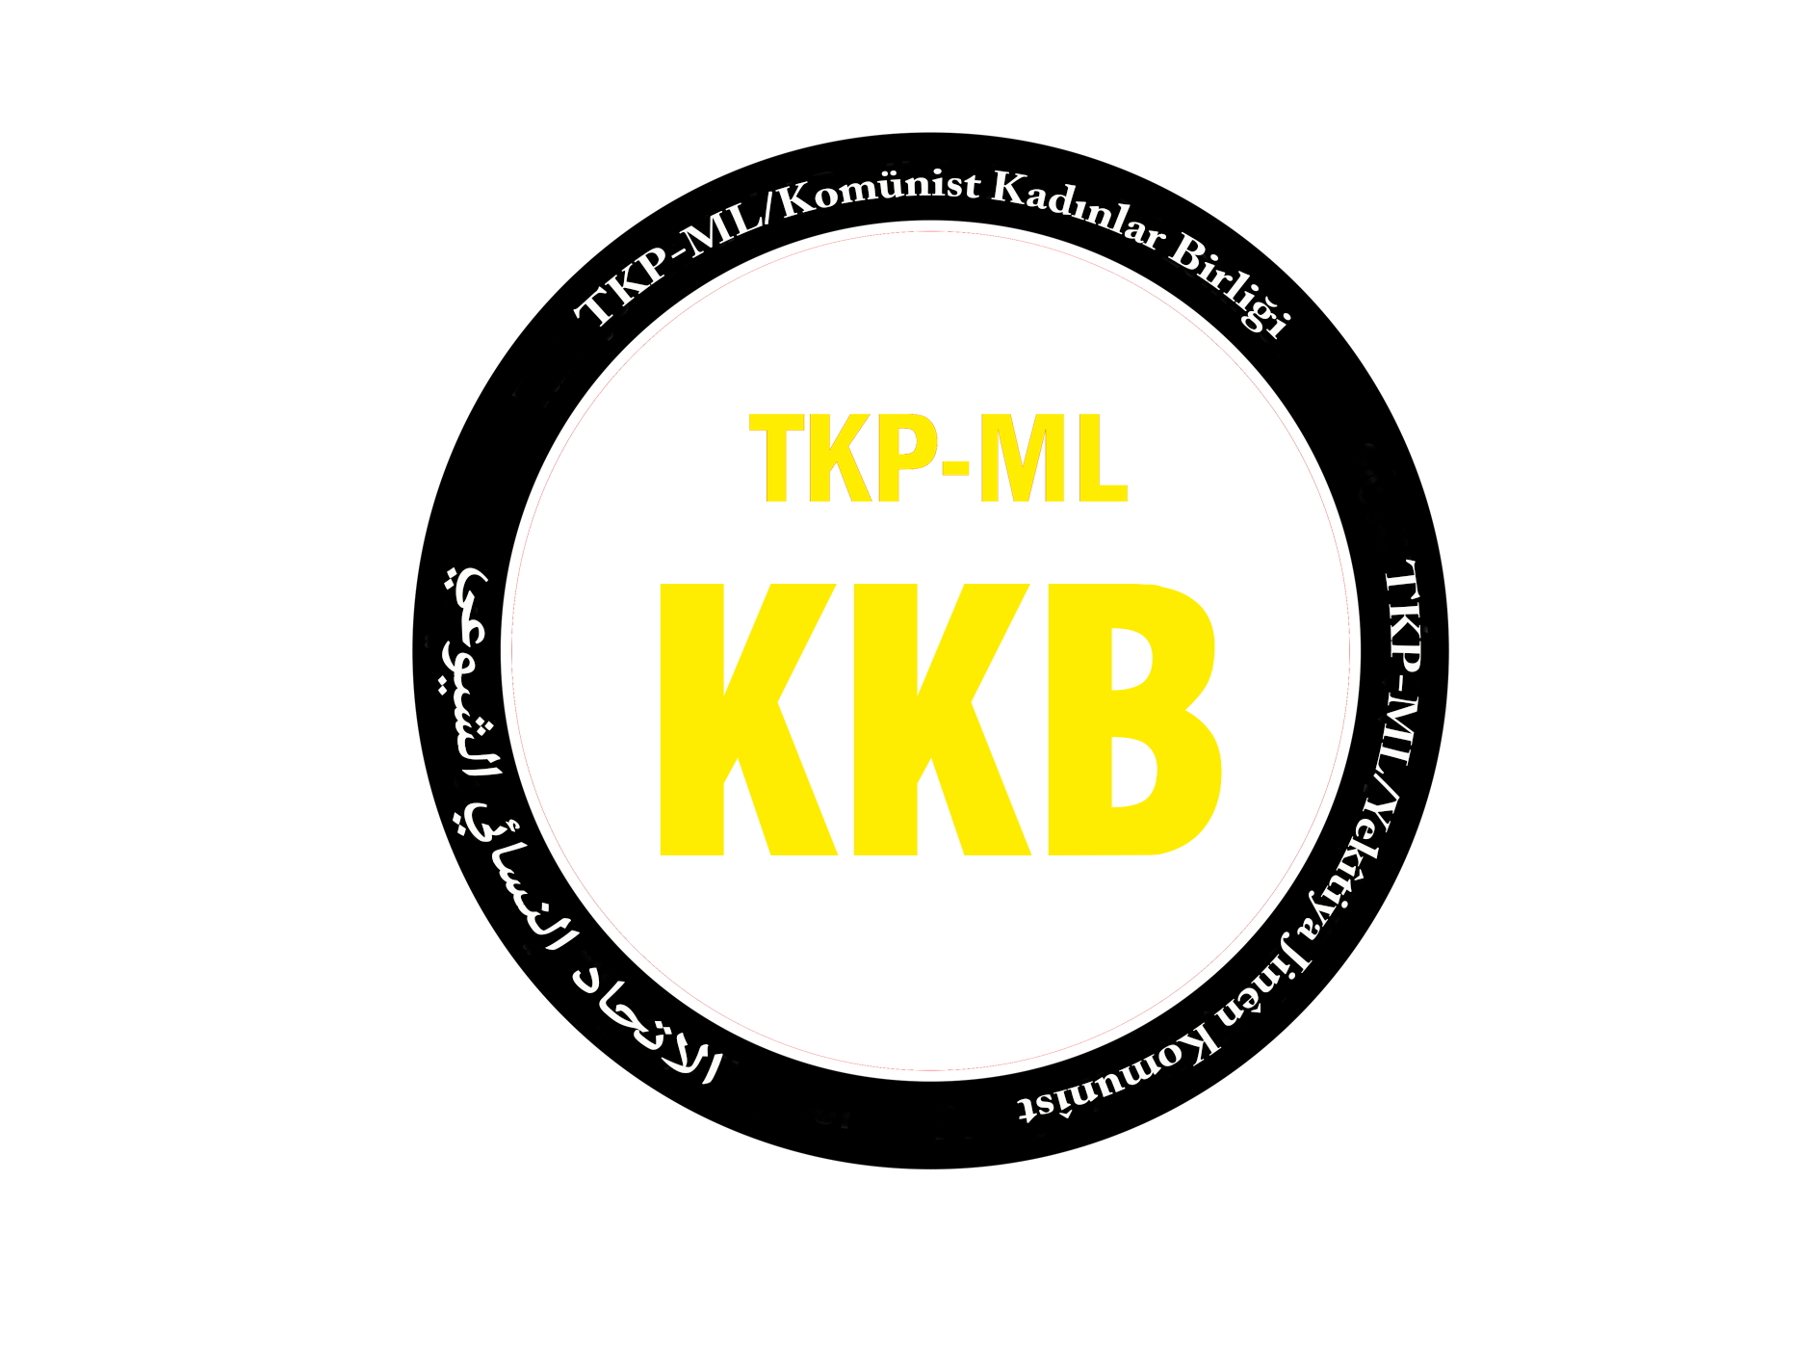
Link: https://www.tkpml.com/tkp-ml-communist-union-of-women-persistently-against-hate-long-live-the-pride-week/

