Mass arrests of journalists aimed at suppressing

pro-Kurdish information and voices

Wave of Condemnation as Turkey Arrests Yet More Journalists

[From Frontlines of Revolutionary Struggle website at:
http://revolutionaryfrontlines.wordpress.com/category/middle-east/turkey/state-repression-turkey-middle-east/ ]

by Alliance for Kurdish Rights, 21 December 2011
Istanbul, Turkey- Dawn on Tuesday brought an unfortunate wake up call to many Kurds and especially to journalists as a wave of arrests across Turkey picked up 40 people, most of whom are journalists.
The arrests came under the premise of alleged links to the Union of Committees
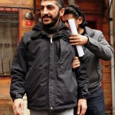
in Kurdistan (KCK). Turkish “anti-terrorism” police specifically targeted pro-Kurdish media, mainly DIHA and ETHA news agencies, the Özgür Gündem daily newspaper, the Demokratik Modernite magazine and the Gün printing press. Turkish state media alleged that the recent wave of arrests was part of a two year long investigation into the KCK and its members. In addition, French Kurdish photographer Mustafa Ozer, who works for the French news agency Agence France Presse, was detained, smiling as he was carried away by security officers.
This wave of arrests is only the latest in Turkey’s sustained assault against the KCK and all those affiliated with it. The new arrests brings the number of journalists alone in Turkish prisoners over 90, making Turkey one of the worst countries in the world for imprisoning members of the media. Along with journalists, Turkey has been undertaking a systemic campaign of arresting children, activists, academics, politicians, and arguably any other powerful voice of dissent in the country.
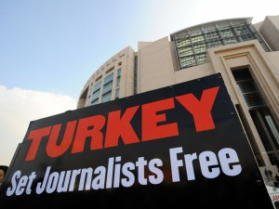
Although for the most part Turkey’s unjust actions against the Kurds go unnoticed, the arrest of 40 Kurds, most of whom are journalists, has received some of the criticism is deserves. Hundreds of journalists gathered in Taksim Square in Istanbul to protest the arrests and demand that freedom of the press in Turkey be preserved and protected. “The imprisonment of journalists means the usurpation of our right for information” read the statement released at the demonstration. “We are here today to defend both our colleagues and the right of information.”
In addition, the international organization Reporters Without Borders released a statement saying they were “very concerned” by the latest arrests, and called on the Turkish government and authorities to “stop trying to criminalize journalism, including politically committed journalism.”
The Peace and Democracy Party (BDP) also released a statement, calling on all those who support the right of information and freedom of the press to protest Turkey’s many human rights abuses.
The detention of 40 journalists, all seeking to reveal the same truth about the situation of Kurds in Turkey, is in fact affecting the entire profession of journalism. With 40 less people reporting on Turkey’s marginalization of the Kurdish community, Turkey is further quashing voices of dissent in the name of anti-terrorism and clearing the path for even more human rights abuses in the future.
This article first appeared on our website KurdishRights.org.

