More than 100 journalists face the threat of imprisonment

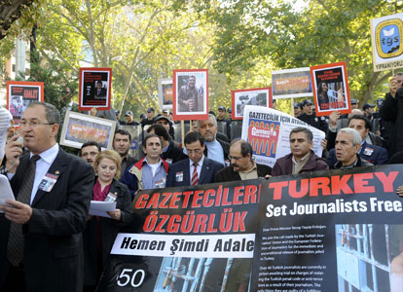

November 5, 2010
The protesters chanted slogans demanding deep-rooted legal amendments to secure the release of jailed journalists and unfurled banners reading 'Freedom to Journalists,' 'Justice now' and '50 journalists are in prison.' DAILY NEWS photo, Selahattin SÖNMEZ
Members of the Freedom for Journalists Platform staged a protest in Ankara’s Güvenpark, calling for the release of imprisoned journalists. “More than 100 journalists are facing the threat of imprisonment in the short term,” Atilla Sertel, chairman of the Turkish Journalists Federation, said in reference to 20 other journalists whose punishments have been stayed five years.
The platform, composed of 23 journalist organizations, brought together protestors as part of Nov. 5 “Stand up for Journalism” activities. The protestors chanted slogans demanding deep-rooted legal amendments to secure the release of jailed journalists and unfurled banners reading “Freedom to Journalists,” “Justice now” and “50 journalists are in prison.”
Speaking on behalf of the group, Sertel said 50 journalists were currently in prison, 44 of whom were under arrest, while the other six have been convicted and are serving a sentence. Sertel said the figure stood at 29 in early 2009, noting that the numbers were increasing each day.
Members of the platform are also expected to visit journalists Mustafa Balbay and Tuncay Özkan, who have been detained as part of the Ergenekon investigation, at Silivri prison. Sertel said Turkey was becoming a country where journalists are targets just because they write what they think about.
The European Federation of Journalists, or EFJ, joined the solidarity campaign. The organization organized their activities around the theme “Set Turkish Journalists Free” for their international campaign this year.
“Each Nov. 5, across Europe, journalists stand up for journalism. They reject commercial pressure, political interference and attacks on working rights. Journalists are taking a stand to defend cardinal principles – authors’ rights, editorial independence, the right to decent working conditions, and the right to trade union organization. All of which are key to winning public trust in journalism as a force for democracy,” EFJ President Arne König said in a written statement released Friday.
It was highlighted in the statement that the day was used in Brussels to launch a solidarity campaign with the Turkish Journalists Union, or TGS, whose members constantly face a climate of fear and intimidation. The EFJ handed over a letter of protest to Ambassador Selim Kuneralp, Turkey’s permanent representative to the European Union, and demanded his government immediately release the 50 journalists currently in Turkish jails.
“If the future is to be as bright as journalists want it to be, we have to force governments to respect our rights such as the protection of sources and we have to force employers to end savage cuts in the newsroom which are turning journalism into a poverty-stricken profession,” said EFJ Secretary-General Aidan White.
“We also have to take our message to the citizens and all levels of civil society. Journalism at its best is a transformative power for social progress. It is a force for good, in the service of all,” White said.

http://www.hurriyetdailynews.com/n.php?n=journalists-protest-for-freedom-2010-11-05

