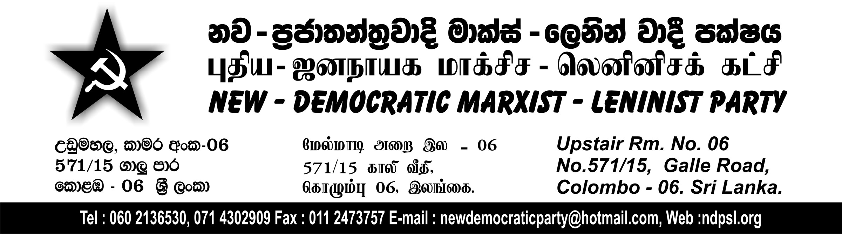
Statement to the Media
23.12.2011
Comrade SK Senthivel, General Secretary of the New-Democratic Marxist-Leninist Party in his statement on behalf of the Politburo of the Party on the Report of the Lessons Learnt and Reconciliation Committee, observed that the Report has been produced, sidelining, ignoring and hushing up important issues like finding a political solution to the national question and investigation of war crimes and human rights violations. This report has no meaningful proposals to offer for providing the necessary relief, reconstruction and rehabilitation for the Tamil people who have been experiencing destruction and misery and whose lives suffer the consequences of war. The LLRC, through its report, displays a tendency to justify and assert the chauvinist stand and wartime activities of the Mahinda Chinthanaya government.
The statement added that, despite boasts by the government that the LLRC would achieve great many things, the LLRC has meddled in matters that did not come within its terms and made comments in a way that does not question chauvinist hegemony. That is, while its mandate was to draw lessons from the peace process, its failure and consequences, and to enable reconciliation, the LLRC went beyond its mandate to make biased statements about war crimes and rule that no war crimes were committed. It has thereby issued the government and its armed forces a certificate of commendation. At the same time, it has made woolly statements about the thousands who have been abducted and gone missing. Besides, the LLRC has failed to properly examine evidence given before it regarding abductions and disappearances.
The Report, which in very general terms states that the Tamil people have problems, has nothing that identifies the problems or their gravity. This Report offers neither the means for finding short or long term solutions for the problems of the Tamil people nor proposals to that effect. Instead, the Report has paid its fullest attention to putting forward suggestions that endorse the actions of the government and the armed forces.
The LLRC is, thus, just another in the series of commissions that are appointed when problems reach crisis proportions to deflect and cover up the underlying issues. Beyond that there is no significance of any kind for the report of the LLRE. Besides, there is little to learn from the report of the LLRC except for the waste of time and huge sums of public funds.
The country and its people suffered destruction and setbacks as a result of denying the rights and demands of the Tamil, Muslim and Hill Country Tamil nationalities and sharpening the ethnic, religious and linguistic contradictions. No due lesson could be learnt nor could reconciliation be achieved without taking this into account. If genuine reconciliation is to be achieved in the country, steps should be taken that would affirm the rights of all nationalities based on equality, the right to self determination and autonomy.
To leave these aside and uphold the hushing up, rationalisation, eye wash and deflection of issues found in the report will only create further complications and crises relating to the national question, and meet with the resistance and struggle of the people. The global and regional powers will seek to transform such a situation into opportunities for them to intervene. The Party forewarns with a sense of caution that such a situation will bring great harm to the country and the people.

SK Senthivel
General Secretary

