The Line of the Comintern
on the Civil War in Spain

[This is an unsigned article that appeared in Revolution magazine, vol. 6, #1, June 1981, pp. 32-70, published by the Revolutionary Communist Party, USA. It has not, so far as we know, been made available on the Internet by the RCP. A few of the photos accompanying the article have been omitted here. —BannedThought.net]

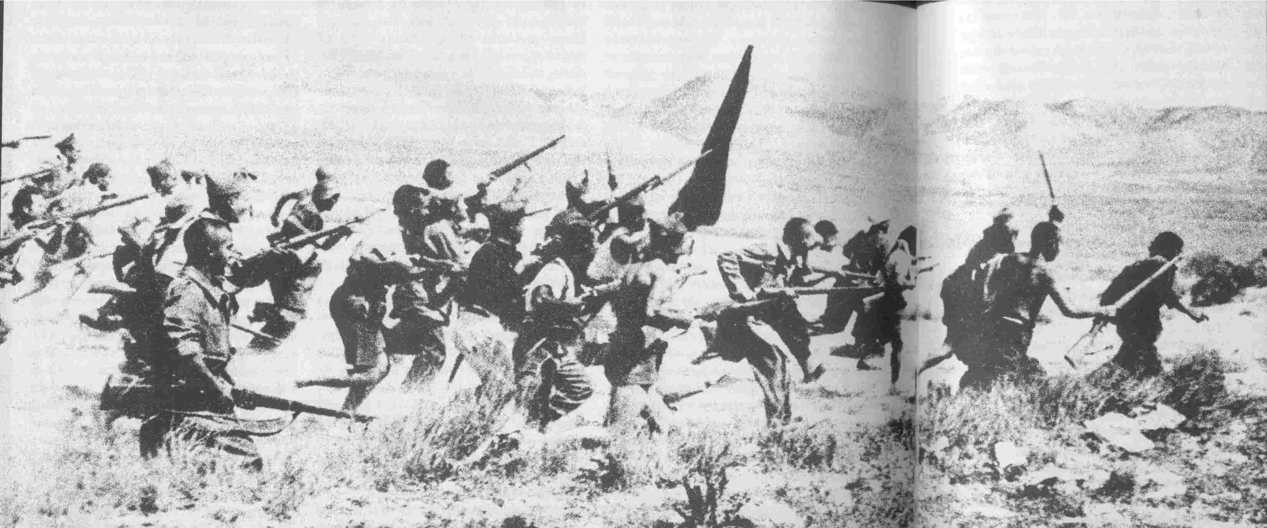
Forces of the Republic rout fascist troops on the Saragossa front in 1936

“In Spain, to be blunt, the possibilities for big revolutionary advances in that country and worldwide were sacrificed…”

I. Introduction

“The people milling around Madrid’s railway station at Antocha could hear the gunfire from the lower barrios in the suburbs of Usera and Carabanchel, see flashes in the sky. Victoria Roman, a university student, saw young children beginning to drag cobblestones to where men and women were raising barricades. She was due to leave the city but now she couldn’t go.

“‘I’m staying,’ I told the evacuation people who wanted me to accompany the children I had been looking after to the Levant. ‘No one can leave Madrid at a time like this,’ I told them.

“Franco’s troops had reached almost to the very outskirts of the city. ‘To the front, five centimos,’ the tram conductors began calling out, for you could take a streetcar right to the front lines by now. José Bardasano, a painter and poster designer, saw a tram leaving—it was full of barbers who hadn’t even had time to take off their white smocks and were still carrying their combs. . .”

*****

During the month of July, 1936, mighty social forces—forces which convulsed the whole world and were at that time beginning to shove the world irreversibly towards its greatest inter-imperialist conflict—erupted in Spanish society.

On July 18 and the days following, the Spanish Army, with General Francisco Franco soon to emerge as undisputed leader, rose up to overthrow the Republic, now run by a Popular Front coalition which had won recent parliamentary elections. With the backing of virtually all of Spain’s ruling class, the active support of Italy and Germany and the consent of Britain, Franco’s forces struck in eight strategic military areas of the country with the aim of quickly converging on the capital, Madrid. It didn’t work out that way. Instead, this attempt to impose fascism gave rise to the broadest and deepest revolutionary upsurge to hit Europe in the entire pre-WW2 period. In all but the most conservative and socially backward area of the country—the Navarre—the masses flooded the streets, seized arms and formed militias, surrounded and won over many of Franco’s troops, and beat back the ruling class’s attempt to save the reactionary order that had been crumbling since the beginning of the decade.

The masses of workers, small peasants and rural laborers arose in such a way as to defy the most basic foundations of bourgeois rule. Symbolic of this was the spontaneous and extremely popular revolt against the Catholic Church, one of the major spokesmen for the ruling class left behind in Republican-held territory, as the big capitalists and the landlords fled for the safety of Franco’s lines. The Spanish Church was far more than a religious symbol. It owned more than 15% of all arable land, with large holdings in bank capital and other financial enterprises. As a legacy of Spain’s colonial empire and sign of the continued parasitism of its ruling class, its 35,000 priests, 20,000 monks and friars and 60,000 nuns—out of a population of 24 million—formed a political machine which was one of the ruling class’s main props, especially in the countryside.

The Church hierarchy supported Franco, not only politically, but in more direct ways as well. In Teruel, where Franco’s army was besieged by Republican forces, the bishop gave his blessing to holding the town’s women and children hostage to guarantee the fascists’ safety. Captured, he replied to demands that he explain his actions by saying “No one resigns himself easily to defeat.” During the opening months of the civil war, churches were burned down by the hundreds and laughing crowds danced in the ashes. Not only the most exploited sections of the people who most hated the Church but also a great many intellectuals (such as teachers sick of the Church’s anti-educational control of education) cheered the church burnings, although some better-off sections were aghast.

The factories and farmlands left by the capitalists who fled to the safety of Franco-held territory were taken over. Trade unions, factory committees, peasant co-ops and the quickly formed militias ran much of daily life, especially in Barcelona. Here, in Spain’s most industrial city, visitors from “civilized” Europe felt they had touched down in another world: the cafes, street corners and trolleys vibrated with the intense political debate going on among the workers. The feeling that it was these workers who were now in command was so strong that people from every class dressed in workclothes. Even the remaining financiers took to describing themselves as “bank workers.”

Only in the colony of Spanish Morocco were the generals able to consolidate a reliable force of Foreign Legion mercenaries and Moroccan troops (whose participation was not inevitable, as we shall see). Italian and German aircraft airlifted these troops from Morocco over the Straits of Gibraltar into the cities of southern Spain from where they swept towards Madrid.

But after three months of advances in which Franco’s Nationalist armies broke through Republican resistance and freed many of the besieged garrisons, they were finally stopped dead in their tracks on November 7, in the outskirts of Madrid, where hastily armed workers and others, organized by their political parties and unions, fought Franco’s well-equipped professionals to a standstill in a ferocious battle that raged from building to building and floor to floor in the University City and in the trenches cutting through the city’s western suburbs. The next day, the Republican militiamen and women were joined by the first of the International Brigades, formed of revolutionary-minded volunteers from all over the world to aid the Republic, and the line held. From this point on, Spain coalesced into two parts, two opposing regimes, fighting a civil war between them that would last for three years. Organizing support for the Republic, and soon, leading the Republican forces in the Civil War, became the main work of the Communist International (Comintern) during that period.

*****

“Now the line was decimated, there was nothing between us and the fascists but disorganized groups of weary war-wrecked men ... I saw another IRA comrade, Jock Cunningham, assembling a small crowd, we hurried up, joined forces . . .The crowd behind us was marching silently ... I remembered a trick of the old days when we were holding banned demonstrations in Ireland. I jerked my head back, ‘Sing up ye sons of guns!’ Quavering at first, then more lustily, the song arose from the ranks— the Internationale boomed out over the ruined countryside.

“On we marched nearer the front; stragglers in retreat stopped in amazement, then turned around and joined us, cheered, the song continued. I looked back; behind the forest of upraised fists, what an unkempt band! ‘Manuel, what’s the Spanish word for forward?’ ‘Adelante!’ he yells back. ‘Adelante!’ we shout in a half-dozen foreign accents . . .”

*****

The victory by Franco’s forces in March, 1939 marked the conclusion not only of three years of civil war, but in fact a decade of intense and intensifying class struggle by the Spanish masses, especially the proletariat. The civil war, however, saw this revolutionary spirit progressively extinguished. By the time Franco’s forces again attacked and finally took Madrid at the end of the war, the professional army that the Republic had come to depend on crumbled under the defeatism and treason of its own generals. The civilian masses whose armed heroism had previously saved the city now watched in silence. The decade of revolutionary struggle had led neither to revolution nor to any advances; instead, the wine turned sour, as the Spanish saying goes. After accumulating this whole rich body of experience, the Spanish proletariat was left without revolutionary understanding or organization. Despite the awesome achievements of the masses in the war, it is simply a fact that even had the Republic somehow defeated Franco’s forces militarily, the war as a whole would have resulted in a setback for the proletariat anyway: the revolutionary leadership, the Comintern and the Communist Party of Spain (PCE), had capitulated politically well in advance of the military defeat.

How did this happen?

At the root of it was the Comintern’s entirely wrong—and disastrous—view of the kind of historic conjuncture into which the world was heading at that time. As Bob Avakian put it in his report to the Central Committee of the RCP in 1979, in a passage which applies strikingly to Spain: “The rub is this: it is precisely the bringing to a head of the contradictions on a world scale—the approach of the resolution of a major spiral, with the imminent prospect of world war—that at one and the same time creates the very great likelihood that the socialist country will face all-out attack by an imperialist power or powers, sharpens, brings into being, or brings closer, the objective conditions necessary for revolution in many countries, perhaps even including the imperialist powers themselves. This raises the contradiction between defending the socialist country and assisting, supporting and accelerating the revolutionary struggle in the other countries to a much intensified level. How have the socialist countries and the international communist movement handled this so far?

“Not too well. In general, as we know, the overwhelming tendency has been to subordinate everything to the defense of the socialist country. ..”

In Spain, to be blunt, the possibilities for big revolutionary advances in that country and worldwide were sacrificed to the defense—on a state-to-state level—of the Soviet Union. The strategy of the Soviet leadership called for an alliance with the Anglo-French bloc against Germany. Nothing, including revolution, could be allowed to jeopardize the possibility of that alliance, as a Soviet-backed revolution in the British junior-partner Spain certainly would. Moreover, this analysis of the Comintern coincided with the capitulationist views the PCE was developing on its own, that the masses in Spain and the party were in over their heads, particularly after the invasion of the fascist powers, and really could only hope for intervention or massive aid from the “democratic” imperialists, England and France.

Many revolutionaries around the world have long sensed that this was not a revolutionary course. But on the other hand, the military move by the Spanish ruling class against the masses, and the intervention by Italy and Germany, unarguably created a difficult situation for the Spanish proletariat; moreover, the world crisis was fraught with danger to the socialist state. Was any other course possible? What is needed is not only a summation of the Spanish Civil War, but a clear and correct understanding of World War 2 in order to help dispel a murky, defeatist aura around the whole question of the possibilities of revolution during times of inter-imperialist war, or impending war.

This article is not in any way a complete and definitive summation of the Spanish Civil War, nor still less an attempt to answer all the basic questions concerning the nature of Spanish society and the course the proletarian revolution must follow there. Rather, it is an examination of the Spanish Civil War done in the context of and to serve a broader summation of the historic conjuncture which confronted the world’s revolutionaries around WW2, and the wrong line taken by the Comintern on the nature of this conjuncture and the relationship between the defense of the USSR and the advance of the world revolution.

The international communist movement needs no more excuses on behalf of the Comintern. It needs the kind of blunt appraisal we can find in the discussion between Mao Tsetung and Kang Sheng concerning the Spanish experience. In it Kang Sheng says (in the context of what is mainly a long talk by Mao, and clearly expressing Mao’s viewpoint also):

“They did not concern themselves with the three points: army, countryside, political power. They wholly subordinated themselves to the exigencies of Soviet foreign policy, and achieved nothing at all.”

*****

“The scene remained engraved on his mind. The jubilant right-wingers sweeping through the working-class quarter; the workers didn’t attack them, didn’t shout back. It was the look of hatred and despair on their faces that José Vergara would never forget. ‘They knew there was nothing they could do. They had lost the war.’
“‘It was easy to say,’ thought Paulino Garcia, communist student and commissar, ‘that the war was being lost because Germany and Italy were helping Franco, and England and France were not helping the Republic. Who could deny the importance of this? But it was not the sole answer. We had to be asking, what lay in our power to do, what possibilities were there which we hadn’t seized, what tasks we hadn’t carried out...’”

*****

II. The Asturias Rebellion; Dress Rehearsal for Civil War

In the late 1920s, as the world crisis was beginning to hit Spain full force, the British and French imperialists, who dominated the Spanish economy, began to export their own beginning economic crisis by dumping cheap coal onto the Spanish market. Spain replied with tariff barriers, the British and French in turn cut off trade in key Spanish agricultural commodities. The bottom quickly dropped away from the Spanish economy and the military dictatorship of Primo de Rivera. Soon after the fall of the governing military junta, Spain’s King, Alfonso XIII, resigned also—to avoid, he said, the “disaster of civil war.”

On April 14, 1931, for the second time in its history, Spain was declared a Republic. The bourgeoisie hoped to draw the petty bourgeoisie—led by Republicans and Socialists—into the running of the bourgeois state, and provide the stability which the ruling class so desperately needed. Suddenly, generals and other lackeys who had served the old monarchy became enthusiastic supporters of the Republic. “The regime was changed in order not to change,” as a Socialist put it.

The honeymoon lasted only two short years. The year 1933 was the hardest year of the depression in Spain, driving the proletariat and poor peasantry into open, often armed rebellion, and ruining the urban and rural petty bourgeoisie. The Republican government showed itself as repressive as any of the hated constitutional monarchies of the past.

The new situation culminated in the October, 1934 uprising by workers in the mining valleys of the northern Asturias region. This revolt, the last of several large and small rebellions which shook Spain in the early 1930s, directly set off a 20-month chain of events which led to the outbreak of civil war.

On October 5, 1934, miners armed with homemade dynamite charges occupied the police station at Sama; at Mieres, a hundred workers surrounded the barracks of the Guardia Civil, firing their ancient rifles from many points to make it seem as if they were heavily armed. Within forty-eight hours, nearly seventy Guardia Civil outposts had been occupied by the workers’ militias. In a few days, over ten thousand workers had been mobilized, town halls occupied, in many cases flying red flags, and “soviets” set up to run local affairs.

An account of a talk with one Socialist youth member shows something about what the workers felt their aims were:

“In the small township of Figueredo, just south of Mieres in Asturias, Alberto Fernandez of the Socialist youth had been waiting two nights for the signal. At 2 AM on 5 October, he heard the sound of an old car advancing and jumped out onto the road. It was the Avance car (the Oveido Socialist newspaper). Antonio Llaneza, son of the great mineworkers’ leader, was in it.

“He took my hand and said with great feeling: ‘This is what we have been waiting for. A la calle (Into the street)’ ‘To the very limit?’ ‘Yes’. That meant it was the revolution. The seizure of power. The inauguration of socialism. Not simply to restore the Republican regime to what it had been in its first two years, as some later said. We set off. . .”

But despite the feelings of this rank and file militant, and in all probability the similar sentiments of the many workers who inscribed hammers and sickles on their red flags (and later visited the Soviet Union by the thousands), the left wing of the Socialist Party (PSOE) that led the rebellion never intended it as a revolution or preparation for revolution. Overall, it was ill-prepared, half-serious at best. Only in Asturias was there much fighting; elsewhere, after the failure of some initial forays, the rebellion collapsed. The Socialist and left Republican leaders who initiated it had no plans to carry it through. Instead, they spent most of the rebellion hiding in an attic, waiting for it to be over. The PCE, although at that point much smaller than the Socialists, did play an active part.

The Socialist and left Republican leaders never intended to seize power. The leading Socialist J. Alvarez del Vayo (later associated with the PCE) makes this painfully clear in describing the original call for insurrection made by the Socialist Executive in January, 1934:

“Confronted with threatened aggression by the reactionaries, and a government incapable of Republican defense, the Left had no choice but to take the defense of the Republic into its own hands, making known to the government and the country that it would not tolerate a Monarchist or Fascist coup d’etat cloaked in a fictitious parliamentary proceeding. . .if power were handed to the right, the Socialist Party would start a revolution. . .”

The “parliamentary proceeding” to which del Vayo refers was the entry of the Church-sponsored fascist-like political organization, the CEDA (Confederación Española de Derechas Autónomas), into the government, which probably was meant to lay the groundwork for a move to fascism. But the response of the Socialists and the PCE, even though it involved armed struggle, was entirely within the confines or bourgeois “pressure group” politics.

The problem was not that they had opposed a move towards fascism, and certainly not that they had acted without a guarantee of victory, but rather that they had no thought at all of ever winning, of seizing power. Instead they limited the uprising’s objective to keeping the CEDA out of the government, to maintaining the Republican form of the ruling class dictatorship, rather than carrying through the insurrection, if not yet as the action of a class ready to seize power, at least as a powerful means of preparation for the eventual seizure of power. The result of course was the Socialists and the PCE worked to strengthen bourgeois democratic illusions among the workers, while the bourgeoisie, far from giving in to this “pressure,” instead lashed out at the revolutionary movement.

In all, the Asturias rebellion raged for two weeks. Workers effectively controlled and administered the region for this time, all the while fighting local police forces, and defeating and winning over troops from the local barracks. Only with the arrival of troops under General Franco, trained in counter-insurgency warfare in Spain’s recently-ended colonial war against the Moroccan people, was the revolt crushed. It was followed by a wave of savage political repression.

The Asturias revolt became the pivot point for all the major forces in Spain, as will be detailed below. The uprising is often referred to as a sort of “dress rehearsal for revolution” like the 1905 revolution in Russia. But, given the line that led it, it was even more a dress rehearsal for betrayal. Amid the burgeoning resistance of all the oppressed classes in Spain, a new force had emerged more fully than ever before—the proletariat. But the sorry leadership of the Socialists and their PCE allies indicated what was in store: the arising, increasingly radicalized proletariat was in the coming years to be tailed, fed with illusions, suppressed, and betrayed by those who claimed to be its revolutionary leadership. But never was it trained in a class-conscious way, in a Marxist understanding of the dangerous but also fertile new situation opening up before it, as a force which could lead all the oppressed to advance towards communism.

III. Spain’s Ruling Class and the World Crisis

For a year and a half following the Asturias events, the “solution” favored by the big bourgeoisie was quite obvious: the most important sections of the ruling class were openly preparing to “restore order” by a repressive move against the masses. The CEDA, whose leader, Gil Robles, had visited Hitler and called himself, Nazi-style, “el Jefe” (the Chief), now had five ministers in the government. Others in high positions, generals and monarchists, contacted the Italian Fascist government, and began to solidify Italian help for the planned move. Moreover, it would seem the opportune time to make such a move, from the point of view of the Spanish ruling class, having brutally put down the 1934 rising and imprisoned tens of thousands of its militants and leaders.

Nonetheless, the move could not be made. It was only in July, 1936 that the bourgeoisie was able to act in the way it had long ago deemed necessary, consolidating forces only a few days before the coup, which even then, of course, ended in initial failure. In fact, while the government of the period 1934-36 measured up formally to the worst fears of the Socialists—that is, the CEDA was a major influence in the government—these months are marked not by the strength of the ruling class but by its weakness, and even some concessions to the mass movement. For example, only two leaders of the Asturias rising were ever executed, many others released.

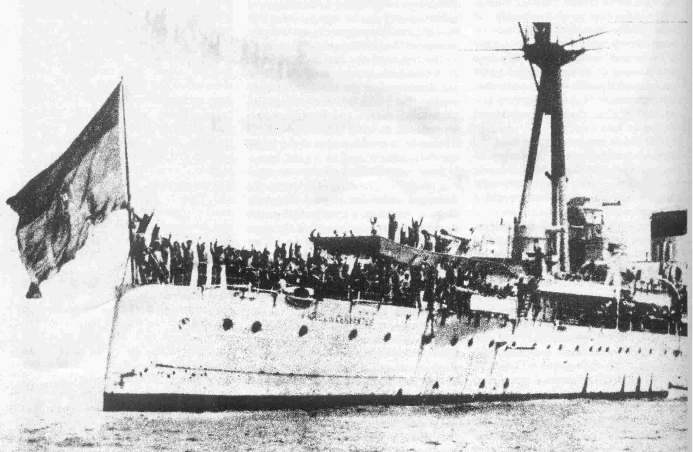
July 1936. The crew of the Spanish cruiser Miguel de Cervantes, having arrested
their pro-Franco officers, assemble on deck and give revolutionary salute.

The ruling class, weak and divided, could not take decisive action on its own. The “reserves” necessary for a fascist move would have to come from outside Spain’s own borders, from more powerful imperialists. The problem was, for the Spanish ruling class, that they could not accept such help from Britain, because the British imperialists’ “help” was already squeezing so hard on their weaker and somewhat unwilling partners.

This weakness went very deep in the history of Spanish capitalism. During the nineteenth century, a nascent bourgeoisie arose and challenged the landed aristocracy in a series of wars. This class consisted of some small manufacturers, landowners who had accumulated capital from colonial oppression, and along with them, a vocal intelligentsia. But these forces were too flabby to seize power, and by the end of the abortive First Republic in 1873, the different warring classes had come to terms. The landowners, urban bourgeoisie and Church all began to merge into one ruling class.

The Spanish bourgeoisie had never been strong enough to carry through a bourgeois-democratic revolution and free the country's industrial development from feudal fetters, as had happened elsewhere in Europe. Far more importantly, in terms of its development, it was too weak to compete successfully with the imperialist great powers, not only within Spain itself, but also in the export of capital and the division of the world. Spain had been stripped of its most important, most profitable colonies by the U.S. in the 1898 Spanish-American War. Even in those colonies it continued to hold on to, the lion’s share of the benefits of imperialism were reaped by Spain's “protectors,” especially Britain, who both really did “protect” Spain (in the sense of keeping other imperialists out of Spain's remaining empire), but in true gangster-style forced Spain to pay dearly for that protection.

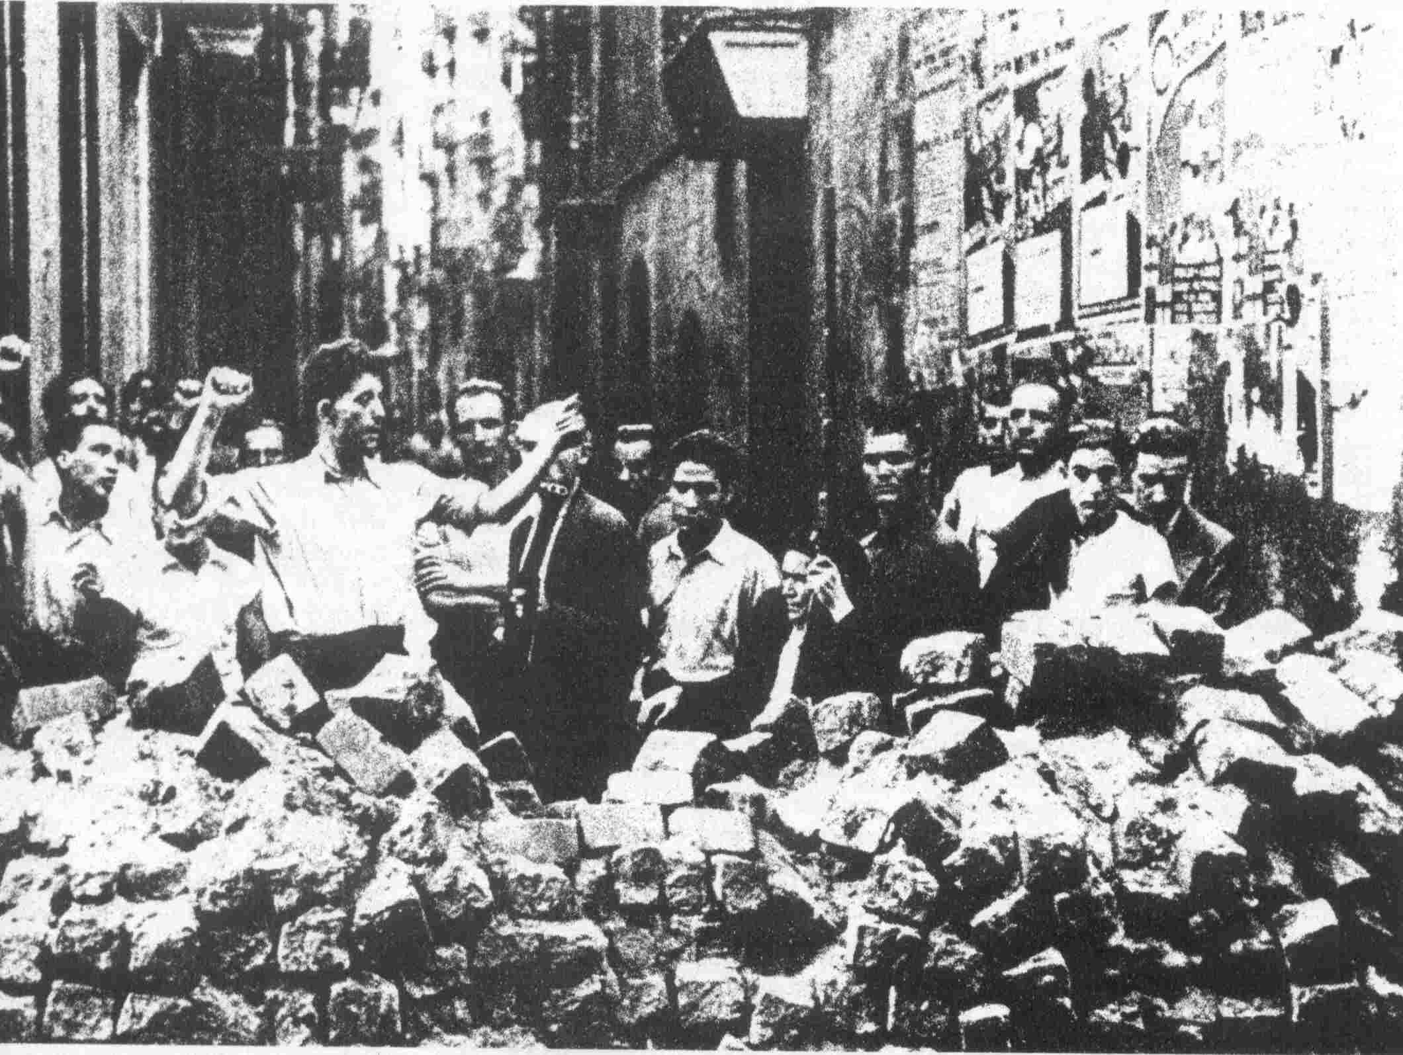
Barricades in the streets of Barcelona, July 1936. "... where the masses were in the streets in great
numbers and took the offensive, the fascist troops soon found themselves cut off and paralyzed."

Spain held three sets of islands—the Balearics in the Mediterranean, the Canaries in the Atlantic, and Fernando Po, off the coast of “Spanish Guinea” (today, Equatorial Guinea). On the African mainland, aside from the latter, it held Rio de Oro (the so-called “Spanish Sahara”), Ifni and a zone of Morocco just across the Straits of Gibraltar. Important banking and other interests were maintained in Latin America and the Philippines. This was often in league with Church interests, particularly in the Philippines. There, too, the feast was shared with the now-dominant U.S. imperialists.

Many of these holdings were enormously profitable; but just as important was the strategic position of certain of them. Morocco in particular became the lynchpin of the Spanish “arrangement” with British imperialism. This strip had been assigned to Spain as part of the “Entente Cordiale,” a gangster-like imperialist division of colonial territory among Britain and France, which was arranged in 1904. Among the terms of this agreement, Britain allowed France to move into Morocco, but insisted that Spain be given the zone of Morocco immediately across from the important British military base and colony at Gibraltar. This flanked the key British routes to the Middle East and India which at all costs had to be kept out of the hands of Britain’s rival, France. Secret protocols were attached to this agreement, certainly including worldwide and Spanish domestic trade and other agreements between England and Spain. But Spain was barred from fortifying the territory, that is, from using it to its own advantage in pressuring Britain. Spain was also expected to pacify the territory—and it was this that was to become a towering problem for the Spanish ruling class.

The Moroccans were enraged at this cynical carving and crushing of their country. By 1923, Spain had over 200,000 troops tied down, and was taking a beating at the hands of the nationalist forces of Abd el-Krim. Over 10,000 Spanish troops were annihilated by the Moroccans in one battle alone, at Anual. (It should be noted that this enormous commitment would be equivalent in its impact on Spanish society to a U.S. force of 2 million troops.) Large numbers of Spanish troops were only withdrawn after Moroccan fighters also attacked into the French zone, bringing the French into the war.

In Morocco can be seen the dead-end alley into which the Spanish bourgeoisie had run. Spain’s military dictator during this period, Primo de Rivera, summed it up quite well in a 1924 interview with a UPI reporter:

“I personally am in favor of withdrawing entirely from Africa and letting Abd el-Krim have it. We have spent untold millions of pesetas in this enterprise, and never made a centimo from it. We have had tens of thousands of men killed for territory which it is not worth having. But we cannot withdraw because England doesn’t want us to.”

Of course, this is more than a little exaggeration. (For instance, Primo de Rivera neglected to mention Spain’s extensive holdings in Moroccan iron mines.) Spain’s ruling class certainly got more than a few centimos from its status as the junior pig at the imperialist feed trough. In fact, it grew rather fat and bloated, with not only finance capitalists and landowners linked to finance capital, but also an enormous Church and army bureaucracy, both part of the legacy of the colonial era, sharing in the spoils.

Within Spain itself, the Spanish bourgeoisie’s holdings were most concentrated in industries, which produced for the world market, such as fishing, leather, copper, coal, iron ore and shipping. Because of the semi-feudal nature of much of Spain’s countryside and its overall underdeveloped state, there was little national market. Industry as a whole was stunted and distorted. Foreign capital often edged out Spanish. (For instance, the telephone/telegraph system was foreign-owned, as was the railway system.) But at the same time, the Spanish ruling class did enjoy a profitable relationship with this foreign capital, which was another aspect of its links to world finance capital. Often this took the form of Spanish financiers literally becoming junior partners of British-owned firms in Spain. As one historian describes it:

“A certain number of Spanish capitalists were shareholders in the [British-owned] Basque-Asturian mining company and in the companies which brought out the mercury from Almaden or worked the iron deposits of Penarroyo or the copper of the Rio Tinto. Spanish ministers and Spanish generals sat on the boards of directors of these companies. The collusion between Spanish oligarchical forces and foreign capital guaranteed to the latter a de facto monopoly over the major activities of the Peninsula.”

What resulted from all this was a ruling class both in contradiction to the dominant imperialist powers, especially Britain, whose grip the Spanish rulers found far too crushing—and at the same time dependent on their financial arrangements with foreign capital and their “share” of imperialism, as well as their ownership of capital in Spain itself and of the vast tracts of land that was controlled by them. This ruling class had little interest in developing Spain’s backward economy—in fact, through their control of finance (and through, in turn, the control of foreign finance), such industrial and all-around economic development was strangled.

The dry Spanish farmlands, for example, would have needed large capital expenditures for irrigation and other improvements in order to increase their productivity, but this kind of expenditure could gain much larger and more immediate profits elsewhere. Consequently vast stretches of farmland lay fallow. The huge unworked stretches of land owned by absentee owners seemed to mock the small peasants and braceros (rural laborers) who starved for want of land and work. This stagnation in agriculture was the main obstacle to the development of an internal market for industry.

Another result, particularly in industry, was the most extreme uneven development. Spain, like Czarist Russia, is a “prisonhouse of nations.” The geographically, economically, culturally and linguistically distinct Basque (Euskadi) and Catalan regions, oppressed nations within the Spanish state, were actually far more economically advanced than the rest of the country. Especially in Euskadi there was massive foreign (mainly British) investment in mining, as well as shipbuilding. There was also considerable foreign (especially French) investment in Catalonia. In fact, Catalonia had almost half of Spain's total industry and over half of its workers, concentrated principally in the textile industry, which consisted of over 400,000 workers laboring in relatively small factories. The upshot was that a kind of a “sphere of influence within a sphere of influence” developed in the industrial areas, with bourgeois forces there either tied to foreign capital and/or more or less independent of the central ruling classes, adding to the national contradictions which had long existed between these oppressed nationality regions and the central government in Madrid. These two areas tended to form a counterweight, favorable to England and France, against Madrid. The industrial bourgeoisie, petty bourgeoisie and intellectuals there were the core of Republicanism, which, significantly, included the autonomy of these regions as one of its central tenets.

During the 1920s, the Spanish ruling class enjoyed the post-war boom that swept through all the powers feasting on the spoils of the world’s redivision. The war years, in fact, had been especially good for the Spanish ruling class, which while openly pro-German (out of desire to be free of British “protection,” and because the Germans enticed them with certain colonial bait), still made profitable sales to all sides. It was during this period that the Spanish ruling class moved to strengthen its position within Spain, buying the railroads from Britain and buying into the foreign-owned power monopoly. But all this, rather than resolving Spain’s contradictions, only exacerbated them. By the 1930s, with the beginning of the intensification of all the contradictions of international imperialism heralded by the stock market crash, the Spanish rulers found themselves squeezed ever tighter out of world and domestic markets. Politically, both the international situation—especially the growing formation of two blocs for a new world war—and the internal class struggle (which was sparked mightily by the Russian revolution as well as by the desperate situation of the proletariat and poor peasants) meant growing crisis.
Chronology of Events
- April 14, 1931—Following resignation of King Alfonso XIII, the Second Republic is proclaimed
- October 5, 1934—Socialist-led rising begins in Asturias, lasting two weeks.
- May, 1935—Soviet-French mutual assistance pact signed
- July-August, 1935—Seventh World Congress of Comintern
- October, 1935—Italian invasion of Abyssinia (Ethiopia)
1936
- February 16—Popular Front wins elections
- March 25—mass Socialist-led land seizures in Estremadura
- April 1—Socialist and Communist youth groups merge
- July 17-20—military coup in Spain and Morocco
- August 4—Franco’s Army of Africa begins march to Madrid
- September 9—British-dominated Non-Intervention Committee meets for first time in London
- November 7-23—Franco’s forces are battled to a standstill at Madrid
1937
- February 5-24—Fascists are checked at Jarama; suffer important losses
- March 8-18—Italian troops backing Franco are routed in Battle of Guadalajara
- March 31—Franco’s offensive on north begins with attack on Vizcaya
- May 3-7—Street fighting in Barcelona—Anarchists, POUM, against government and Communist Party (PCE) forces
- October 19—fall of Gijon completes loss of the north to Franco
1938
- April 14—Franco’s forces reach Mediterranean—cut Republic in two
- July 24—People’s Army launches counterattack on Ebro
- September 30—Munich Pact signed
- October 28—International Brigades’ farewell demonstration in Barcelona
- November 16—Republic’s forces defeated at Ebro, retreat across river with huge losses
1939
- Jan 26—Fascist offensive succeeds in occupying Barcelona
- February 27—Britain and France recognize Franco government. Azaña resigns and leaves for France
- March 6-12—Casado group launches coup against Negrin-PCE government. Fighting in Madrid between Casado and PCE-led forces
- March 27—Fascists occupy Madrid
- April 1—Franco declares end of war. U.S. recognizes Franco.
- August-German-Soviet non-aggression pact.
- September—Germany invades Poland—World War 2 “officially” begins

Most of the proletariat and poor peasantry had been driven to the wall, while the Spanish ruling class
had developed only a flimsy petty-bourgeois “buffer.” In the international arena the bourgeoisie was drained and battered by its “arrangement” with the British, but its moves to gain a better position were countered by the powerful influence of British imperialism right within the Spanish economy—and opposed, too, by the English-leaning class of small industrialists and intelligentsia, and other segments of the people under their influence, including a section of the workers. Yet, these were the very “better off” strata whose support for the Spanish ruling class was so desperately needed as a stabilizing factor among the masses. As a result, this loose grouping, which came to be represented by the left Republicans under Manuel Azaña, came to play a crucial role far out of proportion to its size or economic weight.

Because of Spain’s position in the international imperialist order, the ruling class could not afford to bribe these intermediate strata to the degree that was done, for instance, in Britain, France and the U.S. Add to this the fact that these strata and much of the proletariat itself were concentrated among the oppressed nationalities, and the weakness of the Republic as a form for suppressing the masses, and it is clear why, as far as the Spanish ruling class was concerned, the Republic had to go—at least for now—and why this had to be done principally through an open military move, rather than a more disguised maneuver. At the same time, underlying all this was above all an attempt to change Spain’s international position that could be accomplished only by hooking up with the other imperialist powers arrayed against Britain and its allies.

The ruling class had no choice but to gamble everything on a radical move, to tear apart much of the existing institutions and accepted social relations that had been so long and carefully built up in a political crisis which drew the masses of people into political life and struggle—into civil war—on a scale so vast the whole West shook with the reverberations.

Many historians have searched for something specific about Spain, something in its economic and political structures or in its “national character” to explain why fascism arose the way it did there, and why Spain came closer to revolution than any other country in Europe in the period preceding WW 2. (Although, of course, towards the end of WW 2 and immediately afterwards there were revolutionary upheavals and revolutions in a number of European countries, not to mention the revolutionary warfare raging particularly in China and developments elsewhere in the colonies and neo-colonies.) But even what is most particular about Spain in this period—its very backward agriculture, the volatile character of its petty bourgeoisie, its relatively revolutionary-minded working class—was tied up with what was going on on a world level: the worldwide imperialist financial, political and military web which Spain was caught in, and especially by the crisis sweeping through the entire-imperialist world and pushing it towards world war, which, as Stalin had said of WW 1, “gathered all these contradictions into a single knot and threw them onto the scales, thereby accelerating and-facilitating the revolutionary battles of the proletariat.”

Spain became one weak link of imperialism, one-of-the places where the gigantic forces of the historic conjuncture which was to result in WW 2 were concentrated and burst into open warfare between the bourgeoisie and the proletariat and its allies. Blinded by nationalism and reformism, the PCE and the Comintern failed to see things in this way, failed to see the revolutionary possibilities that this conjuncture opened up for the proletariat internationally. Instead, they saw only the difficulties, only the possibilities of minimizing defeat and subordinated everything to the defense of the Soviet Union. This, in Spain and wherever this line of the Comintern dominated, is what lies behind the fact that a tremendous opportunity for the advance of the world revolution was simply and criminally thrown away.

IV. Forces Line Up

The early years of the thirties saw the contradictions in Spanish society stretch to the breaking point.

Certain events symbolized this, such as the rising and brutal repression of anarchist-led peasants and braceros at the village of Casas Viejas in 1933. The masses here had risen as part of a larger rebellion, seizing rich lands in the immediate vicinity of the village—lands which were used to raise fighting bulls. In the furious retribution directed against the peasants and braceros by the Republican government, units of the Guardia Civil moved from house to house, slaughtering whole families, and burning homes in their wake. All this became the focus of a massive political movement, including among the working-class parties, reflecting the explosion of anger and disgust that had been building against the Second Republican government.

The events at Casas Viejas show that Spain, though dominated by finance capital, was still a mainly rural society, where land remained a crucial question. Even at the outbreak of the civil war, 66% of the people lived in the countryside. These included an immense and smoldering agricultural proletariat—the 1 ½ million braceros—who worked the huge latifundia estates of the south, lands stretching over Andalucia and Estremadura. These workers earned barely enough to survive by their summer earnings, and this had to last the five or six months out of the year that they were unemployed. They were drawn in huge numbers to the anarchists.

Smallholding peasants also existed throughout the countryside, their pitiful lands further divided up at each lapse of their short-term lease arrangements. Only in Navarre and some other scattered portions of the country were a class of middle-peasants managing to hold their own—these formed the base for Church and monarchist social movements.

But it was the proletariat which was really the cutting edge in the social movements that had been shaking and splintering Spanish society in the twentieth century—in the general strikes which swept the country following the February 1917 Russian revolution, in the bitter struggles against the imperialist war in Morocco, in the uprisings and revolts which marked the first three years of the 1920s (called by Spanish historians, “The Bolshevik Triennium”). The class was growing fast in numbers. By 1930 over 26% of the country were industrial workers, double the number in 1910.

The Russian Revolution had been an especially catalytic revolutionary element among the proletariat in Spain, as elsewhere in the world. As one reactionary historian, Cattell, has to admit:

“Symbols, terminology, and methods were copied from the Russian Revolution, without regard for the Communist Party [of Spain]. It was not unusual for a village without one communist member to revolt and establish a Soviet on the Russian model. They would often raise the hammer and sickle and call themselves communists without any reference to the Communist Party of Spain. Likewise, Russian movies and stories of revolutionary heroism appealed to the masses, and as a result Russian novels and showings of movies were widespread.”

As Cattell implies, this enormous respect and enthusiasm for the Russian Revolution was not the same thing as a conscious movement for proletarian revolution. But even this spontaneous movement and revolutionary sentiment pointed a powerful threat at the Spanish bourgeoisie.

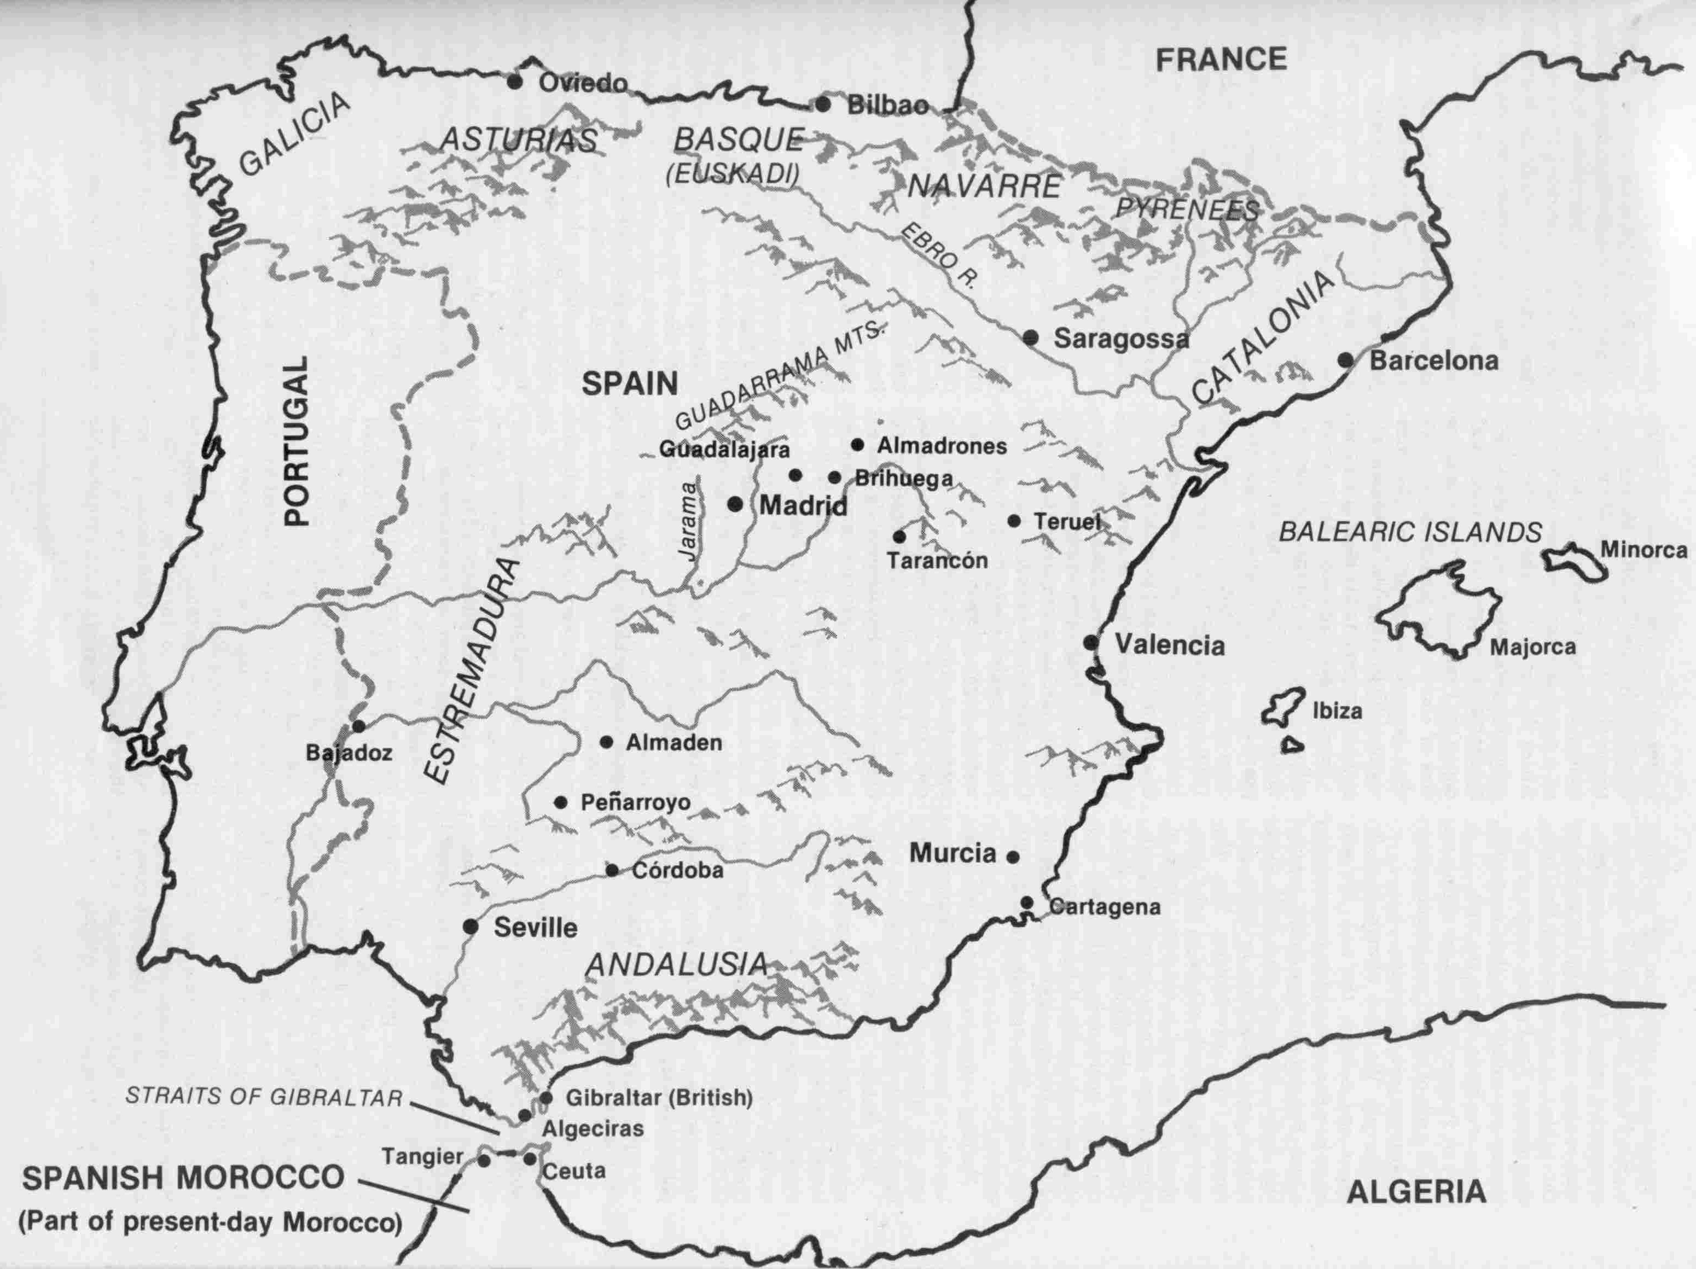

The Republicans

On a cold, sunny fall day in 1935, Manuel Azaña looked out over the crowd flowing unendingly over the gentle hills in the town of Comillas, just outside of Madrid. Over 400,000 people had gathered for this speech, the largest political meeting in Spanish history. Red flags mingled with the tricolor of the Republic, and many of the hundreds of thousands were workers. Azaña’s speech would be an appeal to these masses to oppose the fascism that everyone could see coming—and rally around the flag of bourgeois democracy.

The Republic “must destroy absolutely the privileges of the moneyed classes who now subjugate the people...All Europe today is a battlefield between democracy and its enemies, and Spain is not an exception. You must choose between democracy, with all its shortcomings, with all its faults, with all its mistakes or errors, and tyranny with all its horrors. There is no choice. Ours is made. In Spain one hears frivolous and vain talk of dictatorship. We find it repugnant, not only by doctrine but by experience and through good sense. . .”

The infamously arrogant Azaña had been jailed after the Asturias revolt although he had pointedly kept his distance from the action. (The government was not exactly acting irrationally in jailing him, though—Azaña had also signaled that he would be available for the Presidency should the revolt succeed.) President of the Second Republic for its first two years, leader in the recent merger of three “left Republican” parties, Azaña had become the outstanding symbol of English-leaning bourgeois democracy in Spain.

The Republicans were really an assortment of groupings. Their economic core could be found in the small industrialists of the country, and as part of this they looked to the oppressed nationality bourgeoisies, especially the Catalans, as natural allies. By 1934, Azaña was characterizing the Catalan nationalist party, the Esquerra (“Left”), as “the only true Republicans left in Spain.” (The Basque bourgeoisie had an ambivalent relationship to the Republicans. Tied closely to the British, it had contradictions with Madrid and natural sympathies for the Republicans. But five out of the six leading Spanish banks were located in Bilbao, reflecting that the Basques were also tied in to the Spanish big bourgeoisie certainly more than the Catalans. This made for a politically centrist role for the Basque bourgeoisie.

Aligned with the small industrialists were the urban non-exploiting petty-bourgeoisie—professionals, white-collar workers, civil bureaucrats, teachers, students and others whose numbers had greatly expanded during the relative boom times of the 1920s, but were restricted and crushed down by the big bourgeoisie. The intelligentsia especially came to articulate the interests of all the groupings who labeled themselves Republican. Meeting in literary salons, such as the Ateneo of Madrid, the intellectuals hammered out a programme expressing open admiration for “English-style parliamentarism,” giving voice to the needs of industry, and hitting particularly at the Church whose general backwardness and control of education and other parts of the superstructure stood squarely in the way of the intelligentsia.

The Ateneo became a center for the Republican movement. During the beginnings of the Second Republic in 1931, it was rumored that the Ateneo librarians had stocked guns between the books. Here, Azaña, who was secretary of the Ateneo, grouped around him figures who would play crucial roles in the civil war.

The Republicans tended to oppose the ruling class in its international dealings, also. In the speech at Comillas, for example, Azaña held that “Spain is too weak a power to engage in further adventurist expansion. . .” This was a warning to the big bourgeoisie not to break with its status as junior-partner to the English, a position long held by Azaña. (In fact, Azaña came to prominence in WW 1, when he led mass demonstrations in support of the Anglo/French imperialist bloc, in opposition to the openly pro-German sympathies of the ruling class.)

Yet, despite these sharp contradictions with the Spanish big bourgeoisie, the Republicans also had much in common with it. The first years of the Second Republic had been nothing but a crass collaboration between the Republicans and the Spanish rulers, in spite of the revolutionary fanfare with which the founding of the Republic in 1931 was surrounded. These years deserve the same terse description which Lenin applied to the Kerensky government: “reforms shelved, distribution of official jobs accomplished.” He also says, and this also snugly fits the Second Republic: “In particular, it is the petty-bourgeoisie who are attracted to the side of the big bourgeoisie and are largely subordinated to them through this [state] apparatus, which produces the upper sections of the peasants, small artisans, tradesmen, and the like with comparatively comfortable, quiet and respectable jobs raising their shoulders above the people.”

The first years of the Second Republic were just such an attempt to “subordinate” the Republicans and use them as a buffer against the masses. But by 1935, as the crisis ripped open all actual contradictions in society, this arrangement fell apart. The honeymoon was over; Azaña’s speech at Comillas is fighting words.

As can be seen by their history, the Republicans were opposed to the coming fascist move, but they were also opposed to a revolutionary break with the existing order. This was strikingly symbolized as the speech at Comillas concluded and tens of thousands of clenched fists were raised by the cheering crowd in a revolutionary salute. Azaña watched, refused to return the salute in kind, turned his back, and left the stage.

Socialists and Anarchists

Closely linked to the rise of the Republicans was the Socialist Party, which had originated among the printers and other skilled workers in Madrid at the turn of the century. These social-democrats had a long and opportunist history paralleling that of the Republicans: mass struggle against the regime with the aim of securing a niche in society for those they represented … and open collaboration whenever that niche seemed to be in the offing. Largo Caballero for example, later to be the leading figure in the plans for the October, 1934 Asturias revolt, had been made Councillor of State under the military dictatorship of the 1920s, and Minister of Labor in the early Second Republic.

The Socialists’ political ties to Republicanism were even more clear and direct in the case of Caballero’s traditional rival in the party bureaucracy, Indalecio Prieto, who had risen politically under the sponsorship of the Basque banker Horacio Echeverria. There were big differences in the social base of each of these two politicians, however. In contrast to the business-like Prieto, Caballero represented the trade-union base of the party which was strongest around Madrid and central portions of the country. Caballero had made his career as a demagogue; with fewer direct ties to the Republicans, and engaged in constant competition with the more militant CNT (the anarchist-led union), Largo Caballero was forced to, and did maintain a social base of his own.

The 1934 Asturias revolt signified a major turn in the Socialist Party. The party’s membership had quadrupled in the preceding eighteen months, with nearly half now members of the poor and middle-peasant Landworkers Federation. Despite this, the Socialists still mainly represented relatively upper-stratum workers and, even more than earlier, the petty bourgeoisie, but these groups had been crushed down by the terrible crisis of 1933 and disillusioned by the brutal repressive policies of the Second Republic. In short, the Socialists and their base had been radicalized. They were willing to take the most extreme measures—but still with the aim, as we have seen, of Republicanism, bourgeois democracy.

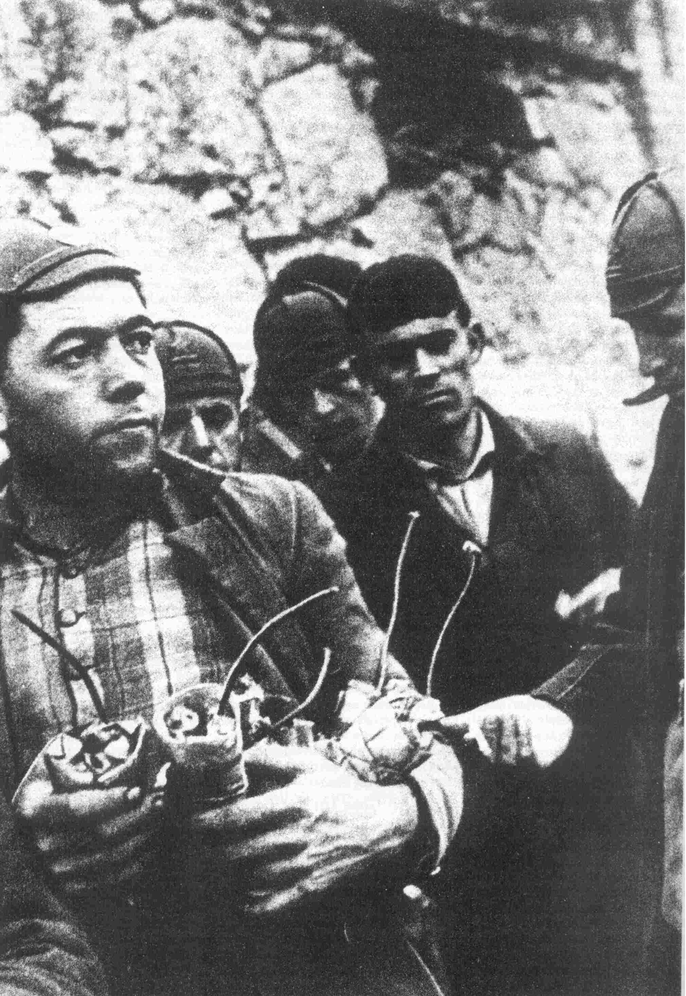
"Dinamiteros"--miners from Asturias, armed with
the tools of their trade, who early in the war came
to defend Madrid against Franco's tanks

The Socialists began to attract large numbers of revolutionary-minded youth who openly admired the Comintern. They advocated the “Bolshevization” of the Socialist Party and actually moved to merge with the PCE. (The Socialists and the PCE merged in Catalonia during this period, and the youth groups of the two parties eventually merged in early 1936.) How the PCE would “train” these forces when they did merge we shall touch on later. The point here is that the changes in the Socialists reflected a radical shift in the mood of the masses. Much more was happening here than (as it is usually put by bourgeois historians), “Largo Caballero read Marx when he was in jail.”

The anarcho-syndicalists, including the more or less purely anarchist FAI (Federación Anarquista Ibérica) and the more syndicalist trade union it led (the CNT—Confederación Nacional de Trabajadores) were mainly absent in the events of October 1934, having exhausted their followers in the insurrections launched earlier in the 1930s (there were three major ones), and additionally, no doubt, had their own opportunist reasons for not joining the 1934 Asturias revolt. Even so, the spread of the anarcho-syndicalist movement was one important barometer of the changing character of the mass movement, along with the radicalization of the Socialists and the enormous prestige of the Soviet Union.

Anarcho-syndicalism had arisen among the rural semi-proletariat of the south, who brought it with them when they were recruited into the textile mills of Catalonia. It flourished in these and other small factories, usually of less than a hundred and very often only 20 or so workers, and among fishermen and woodcutters, as well as rural laborers. These were conditions especially favorable to the idea of factories (and farms) being taken over and run as autonomous economic and political units by those who worked them. As anarchist leader Isaac Puente wrote, “There is no need to invent anything, to create a new organism. The nuclei of the organization around which the economic life of the future society will be organized already exist in the present society; the trade union and the free municipality. . .”

This doctrine is at bottom conservative, closer to the outlook and interests of the petty bourgeoisie than of the proletariat. It sees no need for the proletariat to seize power and establish the dictatorship of the proletariat because it really sees no need to transform society. Instead of doing away with classes and the material and ideological basis for class differences in order to liberate all mankind, the anarcho-syndicalists advocated a “liberation” factory by factory and farm by farm, where workers and peasants would “liberate” themselves by (cooperatively) going into business for themselves.

There is much to criticize in the anarchist line, but it is unarguable that something about the spirit and style of their work much more challenged the masses, was much more rebellious, than the stuffed-shirt trade-unionism of the Socialists and what was soon to be the “respectable antifascism” of the Communist Party. Why wouldn’t revolutionary-minded people be drawn to ideals, such as those expressed by the anarchist Durruti in this interview with the Canadian reporter Van Paasen, a more revolutionary statement than the Communist Party ever made during the war:

“Van Paasen: You will be sitting on top of a pile of ruins if you [the anarchist programme] are victorious.

“Durruti: We have always lived in slums and holes in the wall. We will know how to accommodate ourselves for a time. For you must not forget, we can also build. It is we who built these palaces and cities here in Spain and America and everywhere. We, the workers, can build others to take their place. We are not in the least afraid of ruins. We are going to inherit the earth. There is not the slightest doubt about that. The bourgeoisie might blast and ruin its world before it leaves the stage of history. We carry a new world here, in our hearts. The world is growing, this minute.”

Nothing comes to mind so much as Lenin’s admonition that “anarchism was not infrequently a sort of punishment for our own opportunist sins.”

The problem, however, was that without Marxism-Leninism, and by and large opposed to it, the anarcho-syndicalist movement became a tail on various reformist dogs, including the Socialists, its members criticizing the PCE from the “left” in a way that concentrated on tactics and forgot about political power.

The Falange and the World’s Redivision

In the 1930s, the whole division of the world was thrown into question, with each of the imperialists desperate to redivide it to its own benefit. Spain both sought such a redivision and became a part of the ambitions of more powerful predators.

For the great powers, influence in Spain was a key part of being able to dominate Europe. A position in Spain would enable each of the opposing blocs to turn the flank of the other. Germany would be able to encircle France, while England would retain in Spain a link to the Mediterranean.

Beyond this important strategic role, Spain and the Spanish colonies provided other advantages to the great powers. The Iberian Peninsula and the colonies together fronted the Atlantic trade routes in four places, including, most significantly, the Gibraltar passage between the Atlantic and the Mediterranean. Additionally, Germany eyed Spain as a possible stepping stone back into Africa (in fact, before the war German economic penetration into Spain had concentrated in Spanish Morocco and not on the Peninsula itself). Finally there was of course, the high-grade iron ore that was produced in the Asturias region, with its cheap and convenient access to European industry.

From the point of view of the Spanish ruling class, this sharpening international situation opened up some new possibilities. Already, after an abortive coup attempt by General Sanjurjo in 1932, contacts had been made with the Italian Fascist government by the Spanish military, and from this time on, links were progressively strengthened. Visits to Italy were made by monarchists of both the Alphonsine and Carlist parties; paramilitary troops of these parties were even trained in Italy. To the Spanish bourgeoisie, more and more it began to seem that the Italian connection was “the way out.” Italy could provide the military might and the reliable forces which the Spanish rulers did not possess but desperately needed to suppress the growing mass movement. At the same time, the Italians might become the pry-bar with which to loosen or even break the hold of the British imperialists. Further, there was reason to hope that a new imperialist redivision of the world—and especially the defeat of Britain (and, to a lesser degree, the U.S.)—could mean that Spain could achieve the spheres of influence and opportunities for capital accumulation that were now being denied it.

Of the several groups which made connections to Italy during the Civil War, and which openly put forward the idea of the fascist form of dictatorship, the Falange was destined to become the leading political party under Franco. Formed in 1933, the group was financed by Juan March, Chairman of the Central Office of Spanish Industry and certainly had other important ties to the bourgeoisie as well, as indicated by the fact that its leader was none other than José Antonio Primo de Rivera, son of the military dictator to whom the bourgeoisie had turned in the 1920s. After the February 1936 elections, when the Church-sponsored CEDA failed miserably, most of CEDA’s membership moved en masse into the Falange.

The Falange programme was, then, in advance of most of the groupings within the Spanish ruling class, but nevertheless, well-concentrated its aims: to “restore order,” to “eradicate Marxism,” and fulfill the so-called Spanish “will to empire.” What other, more-entrenched forces were unwilling to do, at least so openly, the Falange did wholeheartedly: it took on the English imperialists, condemning the current division of the world, and the status of Spain within it. Its programme called for the establishment of “Hispanidad,” an imperialist “Spanish unity” stretching from Latin America to the Philippines. This was not exactly a new idea. The Spanish rulers had long retained important interests in former colonies, and carefully kept alive their cultural ties in Latin America. But now the Falange proposed to seize on the world conjuncture, and cash in the chips.

The PCE

The Asturias rebellion also set the stage for the rise of the PCE (Communist Party of Spain) and the influence of the Comintern in Spain. Before this, the PCE had remained small in numbers and influence, and wildly uneven in its line. But starting with the major role played by the party in the rebellion itself and in the turmoil and struggle which followed it, the PCE expanded until, in the course of the war it was to become the single most important influence on the course of the Republic.

The party began in 1921, as a grouping of about 10,000 mainly young revolutionaries split off from the anarchists and Socialists. It passed through a period of effective illegality during the 1920s, during which time its numbers shrank to perhaps 800. In 1931, a letter from the Executive Committee of the Comintern laid out the course the party was to follow until at least the end of 1933: it would “win the majority of the working class” by gaining organizational leadership of the immediate struggles of the proletariat, and these struggles, especially the economic struggle, would lead straight to the overthrow of the “bourgeois-landlord government,” and the establishment of the “revolutionary democratic dictatorship of the workers and peasants.”

In general, there was a certain revolutionary potential in the party at this time, bursting out at such moments as in the 1927 mutiny among sailors in Cartagena, led by PCE cadres in opposition to the war in Morocco. Nevertheless, and without attempting to follow the many shifts and contradictions in the PCE’s early line, it can be said that the PCE was early bogged down in “left” economism, tailing the furious battles of the masses for reforms and against repression, hoping that these would lead to revolution. The PCE, like most Comintern parties at the time, saw a veritable dream road to revolution: automatically as the crisis played out, “millions will be awakening, and are already losing their illusions,” and as the masses increasingly looked to the PCE as the leadership in their immediate struggles, all other forces would soon openly oppose the masses and stand thoroughly exposed. As for the bourgeoisie, the jig was up—the crisis would drive it in a straight line down.

What a shock, then, to this mechanical and narrow way of thinking when by 1935, Azaña was able to mobilize nearly a half-million people at Comillas, when the CEDA won a social base among the peasants and upper petty bourgeoisie, when the Socialists’ numbers exploded, and the anarchists began challenging the very heart of “responsible trade-unionism” in Madrid and elsewhere (although they had lost a lot of support in their traditional base, Catalonia). Nor did the PCE seem to be fully aware of the Spanish bourgeoisie's international “reserves”—its ability, and necessity, to reach abroad to other powers to aid in propping up its rule.

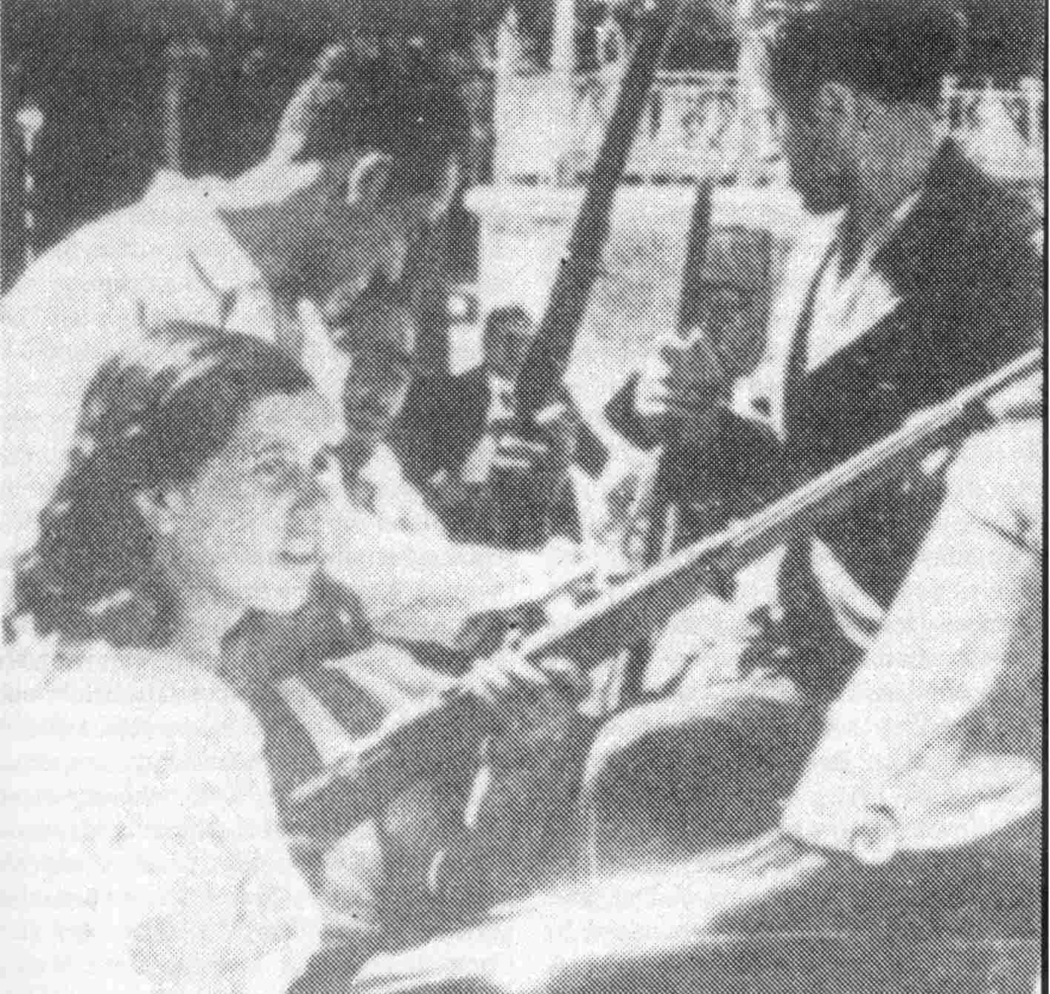
Madrid, July 1936. Caches of arms are broken open and weapons
distributed. A key part of the planned fascist coup was to be an attack
on the city by troops of the great Montaña barracks. But the
barracks were surrounded and the soldiers pinned down.

The point is not that the small size and relative isolation of the party sealed its fate. The rapid development of world events reverberating in Spain were soon to provide extremely favorable conditions for a party guided by a revolutionary line to play a decisive role in the future of Spain and to deeply affect the world. Nor did the fact that they had been so weakened by economism mean that they could not change into a party capable of playing this role, although it did mean that a powerful inertia had been gathered, pushing it along the wrong course. But for the PCE, as for other Comintern parties during this same time, as it became clear that the “left” economist line would not lead to revolution, what got dropped was the goal of revolution, which while not eliminated from the party’s programme was at least dropped into the indefinite and meaningless future.

If the PCE was already set up for a retreat, the trumpet call for the step backward was sounded by the line of the Comintern’s Seventh Congress, which although it took place in July-August 1935, consolidated and announced a line formulated by the Comintern leadership some time earlier.

The effects of this line were broad, deep-going, and utterly bad. As stated in the RCP document appearing elsewhere in this issue:

“Especially after the crushing defeat of the communists in Germany with the rise of the fascist form of dictatorship (1933), heavy defensive and defeatist tendencies grew in the leadership of the Soviet Union and the Comintern. Together with the growing danger of world war, especially of attack on the Soviet Union, openly rightist deviations, of a fundamental nature, became predominant—the promotion of nationalism, reformism and bourgeois democracy, the subordination of everything to the defense of the Soviet Union, etc., in a qualitatively greater way than before ... all this was concentrated in the Dimitroff Report to the Seventh World Congress of the Comintern (1935) and the implementation and further development of this line—which, as we know, involved, among other things, as one of its key ingredients, the basic repudiation of the Leninist position on ‘defense of the fatherland.’ This whole line was in its essence erroneous...”

In June 1935, to implement this Comintern line the PCE called for the formation of a Popular Front Coalition on the basis of a five-point programme of lukewarm reforms (excluding even the PCE’s former, more revolutionary democratic demands, such as independence for Morocco and agrarian revolution), designed to be acceptable to the Republicans and to the British and French imperialists. Just as the class struggle in Spain was approaching the boiling point, the PCE decided to become an electoral party—in the name of fighting off the danger of fascism.

V. It All Goes Up For Grabs

The orientation of the PCE that it was in a bad position for revolutionary advance and in a good position only to “hold back the fascist tide” was not borne out by events. A great wave of struggle was about to break over Spain and spread in ripples throughout the world. At the end of 1935, a falling-out between forces on the Right caused the Cortes, the Spanish parliament, to be dissolved, and new elections called. Especially the CEDA looked forward confidently to the elections, fully expecting to consolidate its base and become an unchallenged reactionary center.

On the part of the mass groups and parties, an electoral Popular Front was formed, including several petty bourgeois Republican parties, the Catalan Esquerra representing the Catalonian industrialists, the Socialists, Communists, Syndicalists, and semi-Trotskyite Partido Obrero de Unificación Marxista (POUM). Other Republican parties representing big bourgeois and rural petty bourgeois interests, the Catalan big bourgeois Lliga, and the Basque separatist and autonomist parties formed a Center. The anarchist-led CNT, though not officially represented in the coalition by political choice, supported the Popular Front also. The programme of this coalition was almost entirely the longstanding set of Republican demands: minor industrial and agrarian reforms (not including redistribution), educational schemes, measures to promote industry. It also included a demand which caught fire among the masses of people, the call for the release of the Asturian political prisoners.

When the voting on February 16, 1936 came to a close, millions had cast their ballots against the bourgeoisie and landlords—and for the Popular Front. A shaken Right coalition went down to a narrow defeat.

But the election results were just the beginning. As it turned out, the Republican programme was considerably more conservative than the mood of the masses of people, who were quick to jump on the opportunity provided by the election victory. On the very day following, huge crowds descended on the prison in Valencia, and forced the release of the political prisoners there. In the town of Oveido in Asturias, and many other parts of Spain, this “demand” was enforced before any law was passed.

The poor peasants and braceros swept over many of the big holdings, occupying them forcibly. These asentamientos—seized land farmed cooperatively—occurred first in Badajoz and Cáceres, but then spread to many other parts of the country.

Strikes also multiplied including many political strikes for the suppression of fascism. On several days alone, the number of strikers reached 450,000.

Along with this, political debate, struggle and mass meetings took place on every street, in every city. One bourgeois observer says, “there were meetings of tens of thousands at which workers applauded with enthusiasm the speakers who announced that the end of capitalism was near, and for them to do as they did in Russia.” Thousands of Socialist Youth marched in Madrid in uniform on May Day, chanting slogans for a “red army” and “a workers’ government.”

Still relatively small but with rapidly growing influence, the PCE found itself carried forward on the crest of this struggle. The masses were occupying lands and overturning city councils, as José Díaz, party general secretary, described it, “not through legal channels, but through revolutionary channels, placing them in the hands of Communists, Socialists, and Left Republicans.” Dolores Ibarruri and other Communist deputies in the Cortes pressured the regime to grant land to the poor peasants (of course, this would in effect have only legalized what had already been taking place).

The PCE was walking a certain line here. It was not yet the major influence in events as it was to be later; nor were the interests of the Soviet Union yet directly involved. It would in some ways support the raging struggles of the masses, while at the same time it was already beginning its long honeymoon with the “antifascist” elements of the bourgeoisie and petty bourgeoisie, especially the group around Azaña.

The military’s plans for a coup became an open secret. Rightist newspapers and politicians consistently hinted and threatened that such plans were in the works as the various class forces maneuvered. The Azaña group, which was now in power, pushed to come to some arrangement with the forces grouped around the fascist generals. This is admitted in effect by the editor of Azaña’s writings, Juan Marichal, who says that the preparations for a military move “did not play in Manuel Azaña’s anguished mind the same role as the attitudes and actions of the extreme left.” Azaña writes that, in a private talk with Gil Robles, he told the CEDA leader, “Your friends should give me a margin of confidence. They should not make difficulties for me. I have enough problems on the other side.”

Certain moves were made by Azaña to supposedly tie the hands of the golpistas (coup plotters). Franco was sent to the Canary Islands (from where, however, a secure and convenient command post was easily set up with his main base of support, the Moroccan-based Army of Africa); Gen. Goded was sent to the Balearic Islands (from where he ultimately directed forces in Catalonia); and Gen. Mola to Pamplona (the base of monarchist support, within striking distance of, and directly across the Guadarrama mountains from Madrid).

As one right-wing historian sneers, the government assumed it possessed “control of the army from above, the most effective method, based on the operation of hierarchical discipline in the armed forces.” It did not possess such control, despite the illusions and deceptions of the petty-bourgeois and bourgeois Republican politicians and their supporters, including the PCE.

The Generals Move

By early July, the various sections of the ruling class had ceased their mutual throat-cutting long enough to agree on a plan of action. Falangist and monarchist cadres were unleashed in a wave of bombings and assassinations, in order to “destabilize” the situation and whip up mass sentiment for “law and order.”

By now the mass movement was straining at the bounds in which the Republican and left organizations had wrapped it. The unions and every major political party had created militias, among which the best-organized and fastest-growing was the Fifth (Quinto) Regiment of the PCE. One issue of the Caballero Socialist newspaper Claridad displayed huge headlines: “Armas! Armas! Armas!” as the masses pressed for arms. But this the Republicans would not do, since as one said, arms in the hands of the masses would be “pregnant with inconceivable dangers politically.”

The masses were tense, but these policies had put them on the defensive, waiting for the bourgeoisie to make its move.

On July 17, Franco made plans to fly out of his exile in Las Palmas in a plane piloted by a British agent. On the 18th, the military launched attacks from the Moroccan garrison at Melilla; at the same time, Franco touched down in French Morocco where a pronunciamiento was issued: “The Army has decided to restore order in Spain...”

From barracks around the country, often in long-planned collaboration with “Republican” mayors and local politicians, the military moved on union and party headquarters, the working-class barrios, town halls and other strategic points. In every city, crowds, sometimes numbering up to hundreds of thousands, came out into the streets demanding arms. Now finally, a certain amount of weaponry was distributed to the people, while others dug up the rifles that had been buried since the defeat of the 1934 uprising. But with or without weapons, where the masses were in the streets in great numbers and took the offensive, the fascist troops soon found themselves cut off and paralyzed. In Barcelona, hundreds of thousands of people fought the troops in unequal battles where lines of people were mowed down, only to be replaced by those behind. In Madrid, the soldiers were caught in the Montaña Barracks and annihilated there.

The generals had counted on swift, violent action, using a minimum of forces. Leaders of the mass organizations sometimes hesitated—they were fooled by reactionary government officials promising “the support of the authorities,” or were intimidated by a show of force, or simply tailed after the Republican officials when they vacillated ... but where the masses had a healthy disrespect for “bourgeois legality” they took action immediately, and smashed the military in their barracks.

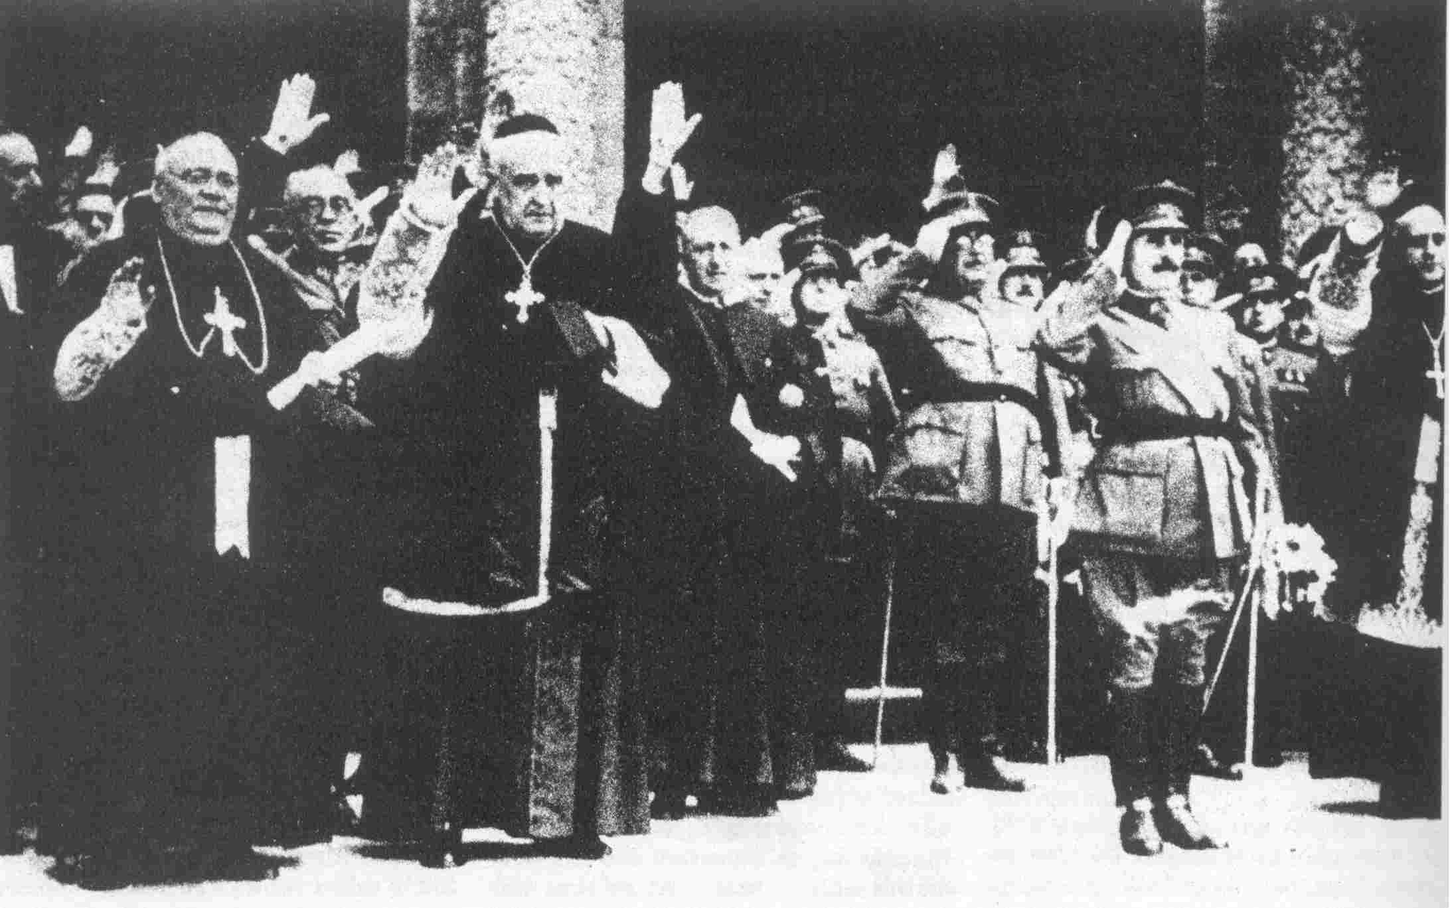
Bishops and Franco's generals indulge in an orgy of mutual saluting and
blessing. The Spanish army and the Church--each with an enormous bloated
bureaucracy--were two of the main pillars of the Spanish ruling class.

Of the eight fascist divisions assigned to the equivalent regions of Spain, three were given the crucial role of marching on and suppressing the capital. With the collapse of these plans at the hands of the aroused masses, all was staked on Spain’s occupation army in Morocco, the so-called Army of Africa, which was to land at southern ports and sweep northward to the capital. However, the Spanish sailors, in their great majority from a working-class background, had been deeply influenced by the upheavals among the civilian working class. When a radioman at the Communications Center of the Admiralty in Madrid discovered the officers’ plans, he telegraphed the radio personnel on all ships, and all hell broke loose. Keepers of the ship arsenals seized arms and distributed them to the sailors. Bloody battles ensued between officers and crews. At 5 p.m., July 20, a telegram was received by the “liberated” Communications Center from the ship Jaime Primero:

“We have had serious resistance from the commanders and officers on board, and have subdued them by force. Killed in the fight were one captain and one lieutenant ... urgently request instructions as to bodies.”

The mutineers seized nearly all the fleet for the Republic, putting a major barrier between the generals’ only reliable and consolidated force in Morocco and their strategic objective, Spain. Several thousand troops had to be flown over the Straits in Italian and German aircraft, the first major intervention of these powers. The mutiny in the fleets had established a critical bottleneck for Franco’s troops.

The coup failed to be decisive. The major population centers, industrial areas, and most of the richest farmlands were left in the hands of the people. Politically, the country was splintered and largely up for grabs—nationalist bourgeois governments were soon to coalesce in Catalonia and the Basque country, while the strengths of the various parties varied from region to region.

People’s War in Madrid

Madrid shaped up as the setting for the first major showdown between the Army of Africa and the Republic. The promised German support to the generals had been predicated on capture of the capital; so too, the Republicans, already set on their “English strategy,” believed that the other European “democracies” and especially Britain would come to their aid if they held control of Madrid. And from a purely technical view, Madrid was an invaluable center of road, rail and communications, as well as a major location of military stocks.

Troops were deployed defensively: the regular troops of the Madrid garrison, many of whom had stayed loyal, were sent to the Guadaramma passes to defend against Mola; other troops were called in from Badajoz and Murcia. As for the militia, by its very nature it fell into a defensive posture. Units were formed within each town, operating according to no overall plan. They fought bravely, but were outflanked, surrounded and annihilated again and again by the Foreign Legion. The militias took to defensively bunching along the roads, ready to retreat, but in this way fell prey to artillery and strafing runs by aircraft.

By November 6, ten thousand of Franco’s troops were fighting through Madrid’s outer suburbs and an equal number of reserves fast coming up in the rear.

The PCE, though it did not begin the battle of Madrid as the largest political force in the city, soon developed into its leadership. In truth, the party had no choice but to take on this task if it was to play any kind of further leading role in the Republic. Moreover, Madrid would have to be defended by people’s warfare, as we shall see, since at the outset the city faced the organized and well-armed fascist troops with little more than the will to resist of a million inhabitants.

The government ministers, now headed by Largo Caballero, had evacuated several days earlier, designating one General Miaja as the “President of the Junta of Defense.” The eminent “People’s Ministers” of the government had left hurriedly, early in the morning so as to “avoid an impression of flight.” However they had got no farther than the suburb of Tarancón when they were intercepted by the infuriated Rosal Column of the anarchists, threatened with execution for desertion, and sent scurrying back to the city. That night they left by air.

Meanwhile, the Junta of Defense which the government had so formidably named, existed only in Caballero’s mind. Miaja’s calls to government offices, including those in charge of military stocks and personnel, mostly went unanswered; others greeted Miaja with a laugh and hung up. Miaja was becoming desperate; he knew he had but ten rounds of ammunition for each of the ten thousand rifles left in the city.

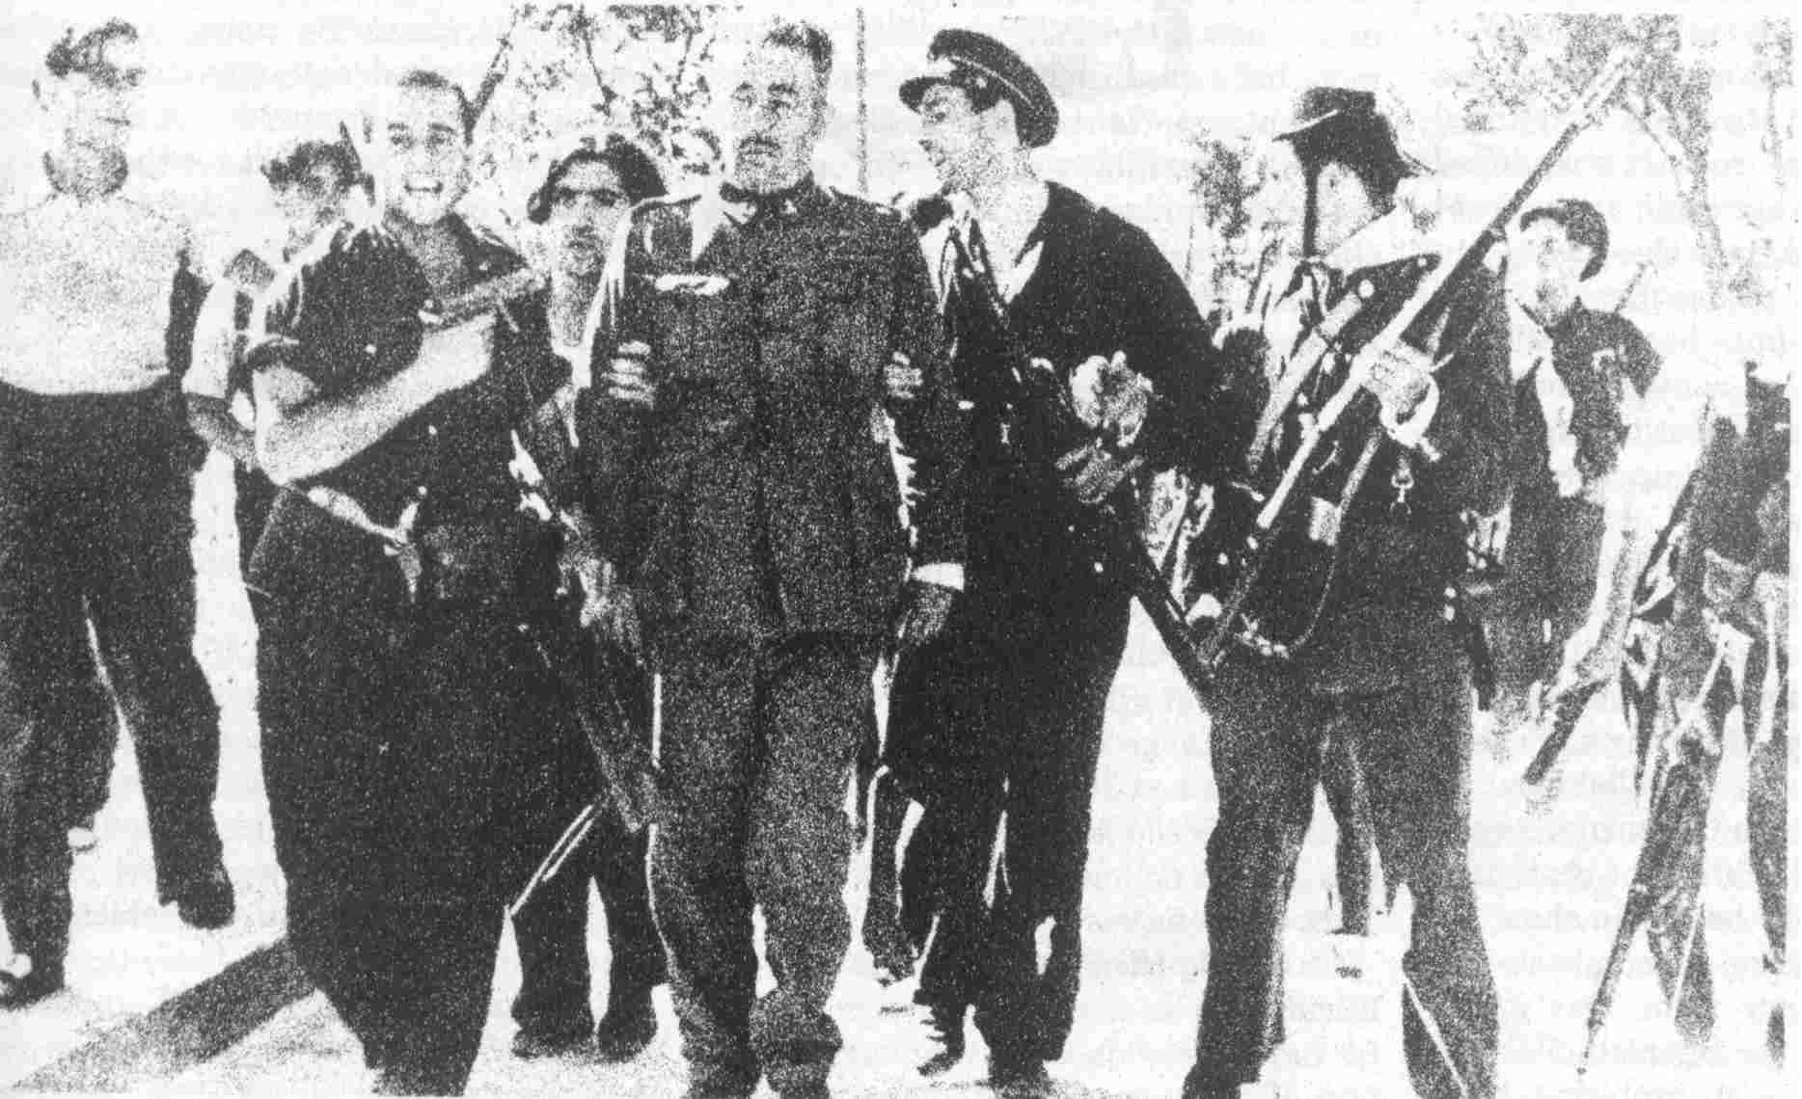
Civilians and militiamen (organized by political parties and
unions) escort a captured fascist officer to immediate trial.

In the War Ministry, the Chief of Operations and six top assistants deserted. Pravda correspondent Mikhail Koltsov, pictured the sorry state of affairs:

“I went to the war ministry ... I climbed the stairs to the lobby. Not a soul! On the landing, two old employees are seated like wax figures, wearing livery and cleanly shaven ... waiting to be called by the minister at the sound of his bell ... Rows of offices! All the doors are wide open ... I enter the war minister’s office ... Not a soul! Further down a row of offices—the central general staff with its sections; the general staff of the central front, with its sections; the quartermaster corps with its sections; the personnel department with its sections. All the doors are wide open. The ceiling lamps shine brightly. On the desks there are abandoned maps, documents, communiques, pencils, pads filled with notes. Not a soul!”

Around the world, Franco’s victory was thought to be imminent. Winston Churchill predicted that “this disagreeable Spanish situation” would be finished in a week. The U.S.-bankrolled managers of the Madrid phone company prepared a banquet to greet “the new government.”

But Miaja’s call to the headquarters of the PCE’s Fifth Regiment found a very different picture. The Quinto had grown to a size of at least 60,000. It included not only military but block organization, and plans for mobilization of the entire population in defense and support work. Committees were organized to root out fifth column agents (the word originated in Madrid: the fascist troops were marching on Madrid in four main columns, the fifth “inside the city”). A few days later, in the midst of the fighting, Miaja was to receive a telegram from Caballero requesting the silverware that had been left at the Prime Minister’s residence. Miaja shot back a message: “We who remain in Madrid are still eating!”

The masses again rose to meet the attackers: at least fifty thousand militia men and women laid down a wall of human bodies. Brigades from the unions—railway men, barbers, construction workers; an artists and graphics workers battalion; a sports battalion; a women’s battalion engaged in bitter fighting at the Segovia Bridge. Miners from the Asturian region formed sapper units, the dinamiteros, and distinguished themselves in anti-tank fighting.

The elite troops of the Foreign Legion, who reveled in their reputation of brutality and the bizarre slogan “Down With Intelligence, Long Live Death!” now found themselves nailed to the very edge of the city. Bitter hand-to-hand fighting erupted even from floor to floor in the university, but the militias wouldn’t back off. (One unit reported sending an inquiry to its headquarters asking what position it should retreat to if necessary. “To the cemetery” came the answer.)

It was the tanks, planes and artillery which most threw the inexperienced militiamen. At first there was not much at hand to fight off the tanks. One U.S. newspaper reported in all seriousness that the Spanish militias had invented a new anti-tank device called “echando conjones al asunto” (literally, “putting your balls on the line”), for that was the answer to the tanks which fighter after fighter had given: “guts.” Militiamen, consciously imitating the Soviet films playing all over Madrid, threw themselves in the path of enemy tanks, let them approach to a few feet, and threw dynamite charges.

With the first arrival of the International Brigades, organized by the Comintern, the fighters learned to dig trenches and also deal more scientifically with tanks and artillery. The impact of the Brigades filled the Madrileños with inspiration. Disciplined cadres of the Commune de Paris (French and Belgian) Edgar André (German and British), and Dabrowski (Polish) Battalions marched through the streets singing the Internationale, fists raised. Other signs of the influence of the international communist movement: huge portraits of Lenin and Stalin dominated the city, especially during the celebration of the Russian Revolution which took place at the height of the fascist attack. As part of this, minute-by-minute accounts of the fighting were broadcast to Moscow, and played on loudspeakers to crowds gathered in Moscow for the celebrations of the anniversary of the Bolshevik Revolution.

The Brigades brought more than help—they brought military training. For one thing, they mostly came from countries which, unlike Spain, had fought in WW1, so that many were veterans. Many, too, were veterans of another sort: of the 1919 Hungarian insurrection, of street battles in Germany and so on. The small British contingent in the Commune de Paris Battalion was from Oxford and Cambridge, upper-crust British colleges whose curriculum included some useful military education. Such people became valuable teachers—but their necessary technical knowledge was accompanied by a bourgeois military line that the PCE later embraced wholeheartedly.
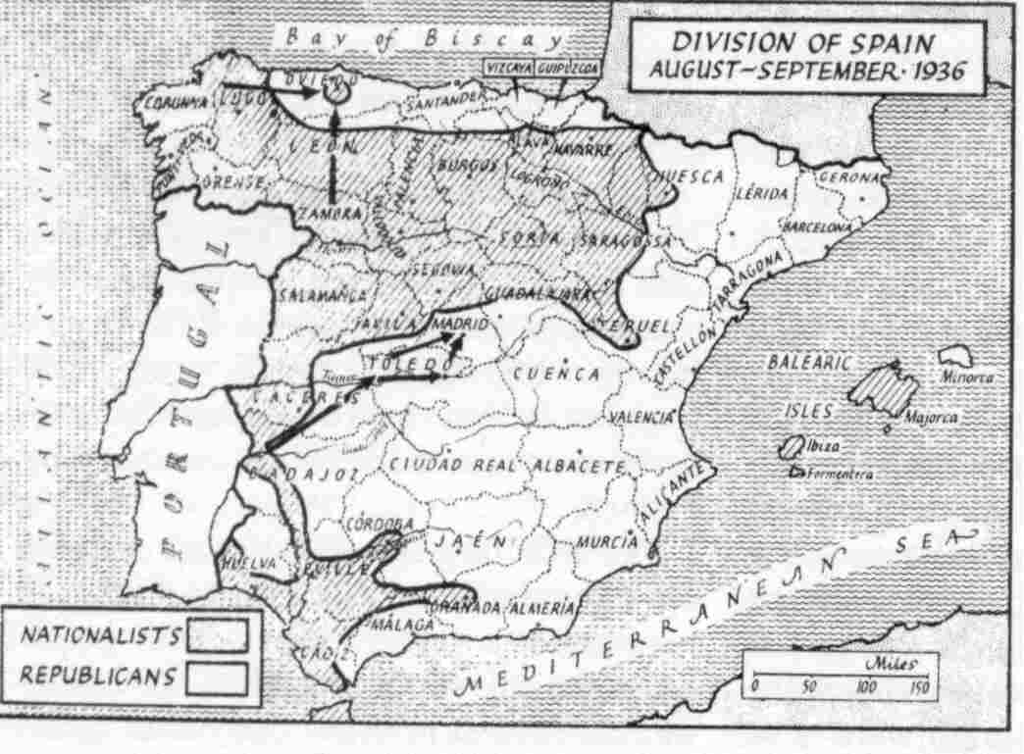

The Division of Spain
1936-1939

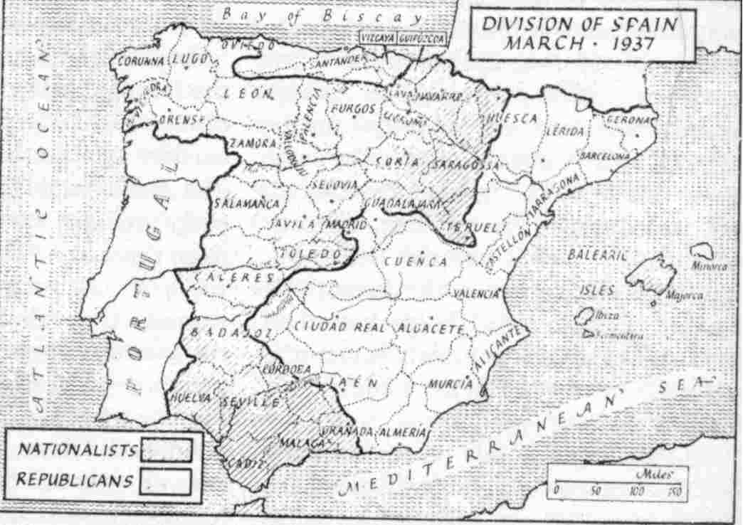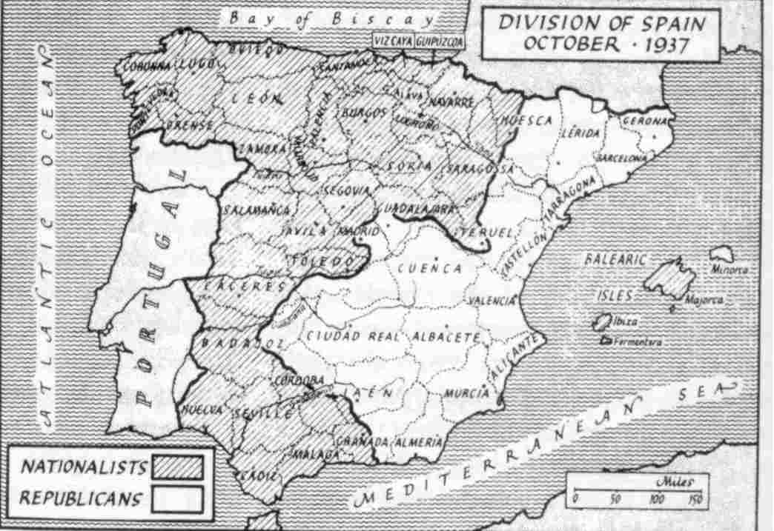

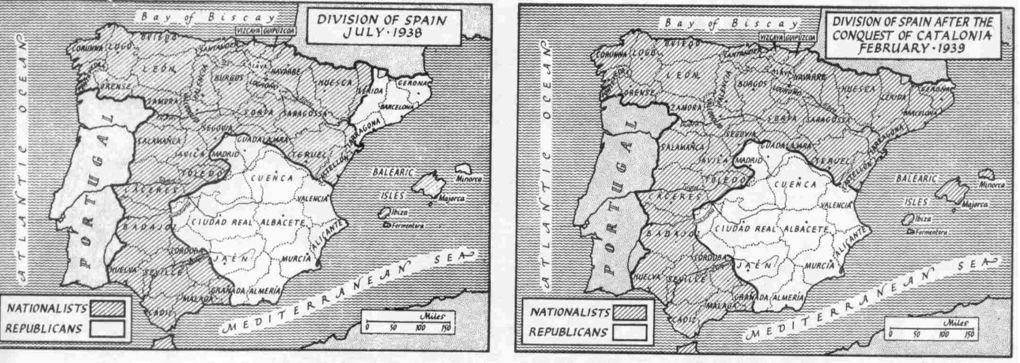

During these November days, and in the major battles following in which the Republic beat back attempts to encircle the capital, the enthusiasm and rich creativity of the masses in war came flooding forward. Typical is this description by a Communist union leader, written after the first Soviet arms shipments were sent to the Republic.

“When they received their first Soviet tanks, crews had to be rapidly trained; a specialized business which in the Soviet Union could take a year. Madrid taxi drivers were pressed into service. ‘This is exactly like driving a taxi, except that instead of a wheel you’ve got two levers.’ People who knew trigonometry were needed to operate the range-finders; the latter were removed. So, too were the radio receivers which were replaced by signal flags. Where the radio had been there was room for three more shells. The Soviet advisors found it difficult to believe the crews were being trained in forty days. They came to see. Julian watched the taxi-drivers maneuver their tanks in perfect formation …”

An armaments industry had to be rigged up—but where could it be located in a city subject to daily carpet bombing? One city engineer drew up a plan to use the incompleted tunnel of the Madrid subway; when the various small plants were moved into this area, the Republic had probably the safest, and most strangely shaped, arms factory in the world.

The front finally stabilized on the outskirts of the city. The following battles to the southeast at Jarama Valley, and north of Guadalajara, also resulted in stalemate. The PCE, with nothing to rely on but the masses of people, had made its most prestigious achievement. But it was the last time the party was to lead in this manner. From now on, just as it relied on bourgeois politics, the PCE was also to stand, above all else, for bourgeois warfare.

VI. “They Did Not Want Political Power”

“They did not want political power.” These words could serve as the epitaph for the PCE during the period of the Popular Front and the Civil War.

This summation, expressed in the conversation with Mao cited earlier, is ironic, since according to countless bourgeois historians, the PCE was “guilty” of a ruthless power grab. The truth is that while the PCE was quite ruthless in combatting the bourgeois forces in the Republic who wanted to capitulate to Franco, and was certainly involved in plenty of jockeying within the government to keep these forces from winning out, overall they subordinated the war against Franco to what was acceptable to the British and French imperialists. While they might have lost anyway, this subordination in fact weakened the war against Franco considerably. To put it another way, they fought to maintain a bourgeois state and society even in the midst of a war against the main forces of the Spanish bourgeoisie and Spanish state. The revisionist “parliamentary road” adopted by the PCE in 1934 under the influence of the Comintern developed into the politically capitulationist line carried out by the PCE when that parliamentary road failed and the masses were thrown into armed struggle against the bourgeoisie by the bourgeoisie itself.

The 1964 comments by Kang Sheng, expressing what seems to have been Mao’s views, are worth quoting more extensively:

“On New Democracy is of great significance for the world communist movement. I asked Spanish comrades, and they said the problem for them was to establish bourgeois democracy, not to establish New Democracy. In their country, they did not concern themselves with the three points: army, countryside, political power. They wholly subordinated themselves to the exigencies of Soviet foreign policy, and achieved nothing at all. (Mao: These are the policies of Chen Tu-hsiu!) They say the Communist Party organized an army, and then turned it over to others. (Mao: This is useless.) They also did not want political power, nor did they mobilize the peasantry. At that time, the Soviet Union said to them that if they imposed proletarian dictatorship, England and France might oppose it, and this would not be in the interests of the Soviet Union … Also, when they fought, they waged regular war, in the manner of the bourgeoisie, they defended Madrid to the last. In all things, they subordinated themselves to Soviet foreign policy.”

The heart of these comments is not that Spain had to go through an anti-imperialist, anti-feudal (new-democratic) stage exactly of the sort suited to the conditions in a colonial or neo-colonial country before going over to the socialist stage of the revolution. Clearly, Spain’s revolution had very crucial democratic tasks to accomplish, especially in relation to the oppressed nations within Spain and the semi-feudal survivals in the countryside; but it is also clear that Spain was not primarily a feudal country nor a semi-colony like China. (Here there are some similarities to Russia which, though not a neo-colonial country, was backward and still went through a democratic stage.) The point here is that it was wrong to make the PCE’s strategy the defense of bourgeois democracy and not the seizure of political power.

Without defining a programme for revolution in Spain (which is far from our purpose), there are some general questions which must be dealt with. The civil war did not represent a “revolt against the legitimate Spanish state” by Franco & Co., as the PCE claimed. What the PCE “forgot” was the same thing it had “forgotten” when it formulated the parliamentary road line: that the state in bourgeois society represents a dictatorship by the bourgeoisie (and other reactionary classes) over the masses of people, a dictatorship which, while sometimes adorned with the trappings of parliamentary democracy, ultimately rests on the bourgeoisie’s armed forces. This Leninist truth was demonstrated by the fascists themselves—when the Popular Front’s parliamentary majority and the Republic itself proved to be in contradiction with the ruling class’ interests, they resorted directly to their army, navy, police, etc. to suppress the opposition and institute a new form of rule.

In other words, regardless of the Popular Front’s election, and even without taking into account that the programme of the Popular Front was simply a series of reforms and in no way revolutionary, even regarding purely democratic questions—still, no matter what the programme of the Popular Front might have been, the bourgeoisie still had the army and essential elements of the police forces, courts, bureaucracy, etc.—in other words, the bourgeoisie still had power.

What was launched by Franco and the other generals in June 1936 was not an “insurrection” as the PCE called it, nor were these men “rebels,” although this was the terminology used to paint the anti-Franco forces with the brush of bourgeois legality. The fascists were not out to overthrow the state—in fact they were part of and utilized the main armed forces of the state. They certainly did not represent a different ruling class from that which had previously ruled through the Republic. This fascist move represented an attempt to change the form of bourgeois rule, as well as Spain’s place within the web of international imperialist relations. But once the bourgeoisie, having overcome a period of near paralysis, had launched this civil war for aims completely in contradiction to the revolutionary interests of the masses, the proletariat had no choice but to fight—and civil war became the main form of class struggle.

Although the bourgeoisie had seized the initiative, the international and national political and economic conditions were very favorable to the revolutionary proletariat. The Spanish bourgeoisie had become unable to govern through the Republican form of rule and unable to impose fascism either. The international crisis of imperialism had a concentration point in Spain, and the jockeying of all the imperialists in preparation for war to redivide the world made it impossible for them to gang up on revolution in the way they might have during other periods. There is no guarantee that the Spanish proletariat could have successfully seized power, but there is every reason to believe they could have waged a battle for power that at least would have changed the political climate in Europe and affected the whole world, a struggle which, even if it had not been successful (and it might have been), would have constituted a powerful dress rehearsal for a revolution.

The central task and the main form of struggle facing the Spanish working class was the defeat of Franco. This constituted a particular phase or substage of the Spanish revolution no matter what other stages it might or might not have had to go through after the defeat of Franco. Certainly there were powerful bourgeois forces that had to be united with or neutralized, that couldn’t simply be driven into the camp of the enemy. These forces were mainly those who had traditionally rallied around the banner of the Republic. But even if it was correct to continue to raise the banner of the Republic in order to facilitate isolating Franco’s forces to the maximum— and insofar as the Republic at least symbolized, for instance, opposition to the oppression of nations within the Spanish state—still, in such a situation the Republic would represent mainly “an order of battle,” to borrow a phrase from Lenin, a temporary and conditional alliance of forces for the duration of the civil war against Franco and not, principally, a form of state to be consolidated.

The essential question was whether the proletariat and its strategic allies would be politically and militarily prepared to establish socialism, even if the proletariat had to share political power with more temporary allies before going over to the dictatorship of the proletariat—or whether the proletariat’s leadership would attempt to restrict the struggle to defending bourgeois democracy in order not to offend those they saw as allies. And in regard to these allies, the question was whether the proletariat would lead them or be led by them, whether it would unite all who could be united to move forward toward ending all exploitation and oppression as part of the international struggle of the proletariat and oppressed peoples, or would fight to continue a form of exploitation and oppression—its “democratic” form which had already proved intolerable to so many millions.

Franco’s “revolt” posed the question of power. This was not grasped by the PCE’s “left” critics, the anarchists and the Trotskyites. The anarchists in particular were determined to carry out a kind of wartime economism, concentrating the struggle on seizing land and factories and establishing co-ops, without regard to the central question of the war. Their programme, which called for seizing the wealth of the landlords and capitalists and opposed seizing political power, actually had much in common with the outlook of the petty proprietor. Since the main form the revolutionary struggle had to take under the circumstances was the civil war against Franco, the insistence by the anarchists and others that the war had to take a back seat to the “Revolution”—that, for instance, the wealth of the “rich” should be seized indiscriminately, without regard to who could be won over to the war against Franco and who could be neutralized, or that any kind of centralized command in the armed forces and the economy was wrong, no matter what was needed to wage the war—all this was not revolutionary at all, despite the widespread revolutionary spirit and heroism among the ranks of the workers and rural poor attracted to the anarchists, and despite the fact that many members of the anarchist organizations actually “betrayed” these anarchist principles and fought for revolution.

The PCE did grasp the centrality of the war, but “they did not want political power.” This latter, and decisive, point they actually had in common with the anarchists, though the PCE’s programme in this regard was more reformist, less revolutionary in spirit. They did not see the war as a method for building up the forces of the proletarian revolution and isolating and annihilating the forces of the enemy. Their whole point of view was that the proletarian revolution had to be in recess during the war, that instead of being the main form of revolutionary struggle, the war was an interlude in the revolutionary struggle which could only proceed again after the defeat of Franco, i.e. after the re-establishment of bourgeois democracy.

Compare the view expressed in the conversation with Mao with the PCE’s views, as expressed by Dolores Ibarurri, also known as “La Pasionaria,” probably the most famous PCE leader:

“It would have been nothing but criminal adventurism had the Communist Party attempted to seize power in a Spain divided by a civil war of such a special nature, and in the midst of a capitalist world pandering to Hitler and preparing for World War II. We would have had to push aside all our allies in the Popular Front, thus clearing the way for the Fascist Powers and international reactionary circles to intervene openly in Spain … neither the Socialist Party nor the Anarchists would have sat back peacefully before a change of this nature …”

Santiago Carrillo, a former Socialist youth leader who rose rapidly into the PCE leadership, put it this way:

“There are some who say that at this stage we should fight for the Socialist Revolution, that we are practicing a deception ... nevertheless, comrades, we are fighting for a democratic republic, and furthermore for a democratic and parliamentary republic ... we know that if we should commit the mistake of fighting at this time for the Socialist Revolution in our country—and even for some considerable time after victory—we should see in our fatherland not only the fascist invaders, but side by side with them the bourgeois democratic governments of the world that have already stated explicitly that in the present European situation, they would not tolerate a dictatorship of the proletariat in our country.”

Another PCE leader, Jesús Hernandez, was also extremely explicit:

“It is absolutely false that the present workers’ movement has as its object the establishment of the proletarian dictatorship after the war is terminated. It cannot be said that we have a social motive for our participation in the war. We, communists, are first to repudiate this supposition. We are motivated exclusively by the desire to defend the democratic republic established on April 14, 1931, and revived last Feb. 18 [with the election of the Popular Front].”

The way the question is posed here is wrong. The PCE leadership used the position of some anarchists and especially the POUM Trotskyites (that the proletariat should make the bourgeois Republican forces the main target of its struggle) as a straw man, as though the only alternative was to completely capitulate and tail these forces. Even if the immediate object of the struggle was not the dictatorship of the proletariat (but rather some form of dictatorship by the proletariat in alliance with other classes over the main reactionary classes), and even given that the class struggle had to be adjusted to unite all who could be united against Franco, still, to promise that “for some considerable time after victory” Spain would continue to be a “democratic and parliamentary republic” was to consign the peoples of Spain and those oppressed by it to the hell this republic had already proven to be. Further, while Spain’s imperialist neighbors could not fully gang up on the revolution there, at the same time the attitude taken by Britain and France—fellow “parliamentary and democratic republics”—towards the Spanish Republic was itself a complete exposure of the class nature of such governments; though torn by contending imperialist interests, they clearly preferred Franco’s fascism. Of course such governments would not tolerate the dictatorship of the proletariat—in fact, they would not tolerate anything less than a fully consolidated bourgeois dictatorship subservient to the interests of one or another of the great powers—but since when had the proletariat ever been bound by what the bourgeoisie will tolerate!

All the imperialist governments were wracked by crisis and on the verge of even greater crisis as world war approached, and their room to maneuver and much of their economic and political reserves were squeezed more and more tightly. Mussolini’s government, which seemed to be the Spanish revolution’s strongest enemy, was to collapse in the midst of World War 2, only a few years later. This approaching world war certainly involved grave dangers—but it also was stretching the whole imperialist system to the limit, creating increasingly favorable conditions for proletarian revolution. Mao recognized this in terms of the Chinese revolution, yet the PCE and the Comintern saw this situation as an excuse not to make revolution in Spain.

On the part of the PCE’s leaders, what was clearly going on was something not exactly unknown in the previous history of workers’ parties: in the face of the grave dangers and tremendous opportunities presented by the conjuncture, they saw only the dangers and politically capitulated to the bourgeoisie—specifically to bourgeois forces in Spain, and to Britain and France—at the same time that they were leading the military struggle against Spain's ruling class. (As we will see, other forces in the Republic, especially those around Azaña, were willing to capitulate directly to Franco.) The PCE’s capitulation fit in with and was encouraged by the line taken by the Comintern on Spain, a line which grew out of the Comintern’s line on the overall conjuncture.

The “English Strategy”

At the end of 1936, after the successful defense of Madrid, Stalin, along with his foreign minister, Molotov, and Voroshilov, head of defense, sent a famous letter to Largo Caballero, then head of the Republican government:

“The Spanish Revolution traces its own course, different in many respects from that followed by Russia. This is determined by the differences in the social, historic, and geographic conditions, and from the necessities of the international situation.... It is very possible that in Spain, the parliamentary way will prove to be a more effective means of revolutionary development than in Russia... The Republican leaders must not be rejected, but on the contrary, they must be attracted and drawn closer to the government. It is above all [emphasis added] necessary to secure for the government the support of Azaña and his group, doing everything possible to help them to overcome their vacillations. This is necessary in order to prevent the enemies of Spain from regarding her as a Communist Republic, and in this way to avoid their open intervention, which constitutes the greatest danger to republican Spain.”

What is being said here, is this: the revolutionaries must not do anything that might offend Britain and France. Stalin is not proceeding from a general theoretical statement that Spain might see the first “peaceful” transition to socialism—nor could he, because the proletariat was already at war with the bourgeoisie. Nor was he necessarily wrong in principle to call for unity, at least some tactical unity—above all, a battlefield alliance—with the Azaña forces linked to British imperialism. Such a course might have resembled the efforts of the Chinese Communists led by Mao to establish a united front with the pro-U.S. Chiang Kai-shek KMT against the Japanese invaders (although it should be kept in mind that what was going on in Spain was not principally an invasion by foreign imperialism, but a civil war). But Stalin is saying much more than this. He is saying that due to “the necessities of the international situation,” the struggle must be confined to bourgeois democracy. What are these necessities? The “open intervention” of “the enemies of Spain.” Leaving aside the formulation “enemies of Spain” (which is more than a little laden with great-nation chauvinism—the Spanish state, after all, itself oppressed other nations), which enemies of Spain was he referring to? Italy and to a lesser extent Germany were already intervening. Did he think that the “greatest danger” was that Britain and France would also intervene? This was not likely, nor did he likely think so. Frankly, the “greatest danger” here is the danger a Soviet-backed revolution or openly revolutionary struggle in Spain might have presented to the USSR’s strategy for defending itself through an alliance with Britain and France.

At bottom, there is Stalin’s line that the defense of the USSR and the world revolution were identical, and that the world revolution, in order to progress, should everywhere be subordinate to the defense of the USSR. The Comintern and the USSR defended the Republic while the bourgeois democracies feared it and worked to see it crushed—but at the same time, Stalin and the Comintern opposed revolution in Spain. This line was the inevitable result of a wrong overall line on the world conjuncture and the defense of the USSR in that context.

The revolutionary goal was to disappear from the party’s agitation, the independent revolutionary preparation of the masses was to be dropped. And why? “The essential thing is to seek the collaboration of the European democracies, particularly that of England,” explained Juan Comorara, secretary-general of the PCE’s sister party in Catalonia. “In the democratic bloc of powers, the decisive power is not France, but England.” Comorara also said, “It is essential for party comrades to realize this so as to moderate their slogans at the present time.” The truth is, though, that what the PCE called for was not a tactical adjustment of the revolutionary struggle but its complete abandonment.

This course followed the diplomatic strategy of the Soviet Union, that of attempting to align Russia and the Anglo-French bloc directly against Germany. In 1935, the Soviets signed a mutual defense treaty with France, but this remained largely a paper alliance; the key, as Comorara stated, was to win Britain to such an agreement. Nothing was to stand in the way of this projected alliance. It became the reactionary policy of the PCE to wean the British away from Franco by proving that the imperialists had nothing to fear in Republican Spain, even one with major PCE influence.

Britain, however, was looking out for its own imperialist interests which, as it turned out, did not involve defending the Spanish Republic against fascism. In fact, for Britain, what was involved was more than its interests in Spain— these were to take a back seat to Britain’s overall interests, particularly their schemes to achieve the most favorable conditions to isolate and defeat Britain’s most important rival, Germany.

Winston Churchill, for example, first looked forward eagerly to a Franco victory, but then towards the end of the war, with German influence somewhat on the upswing, and the “danger” of revolution in Spain ebbing thanks to the PCE and its allies, Churchill changed his position, saying, “Franco has all the right on his side because he loves his country. Also Franco is defending Europe from the communist danger—if you wish to put it in those terms. But I, I am English, and I prefer the triumph of the wrong cause. I prefer that the other side wins, because Franco could be an upset or a threat to British interests, and the others no.” But despite this, Britain continued to pursue a policy of “non-intervention,” including organizing a naval blockade of the Republic to prevent it from receiving arms from abroad, while Franco continued to receive huge arms shipments and troops from Italy and Germany. Why? Because for Britain, its attempts to block the development of the Italian-German alliance and win Italy over to its bloc or at least neutralize it—and even more, its maneuvering to have Germany tied down in a war with the USSR while Britain avoided directly clashing with Germany for as long as possible—were far more important than whether or not Italy increased its influence in Spain at Britain’s expense.

Britain had even gone along with the Italian invasion of Abyssinia (Ethiopia), which more or less fell within Britain’s “sphere of influence.” In early 1936, the English were pushing for detente with Italy in the Mediterranean, an extremely crucial part of Britain’s empire. To this end an Anglo-Italian Naval Agreement was drawn up, and it actually came into effect in the course of the civil war. In the period before the civil war, especially, this idea of winning over or at least neutralizing Italy was not a forlorn hope (although it obviously did not work out, at least not fully), since Italy and Germany already had conflicting interests in the Balkans, over Austria, and over the Mediterranean generally. In line with this, the British were not about to oppose Italian fascist intervention in Spain—and they were not displeased in the slightest by Franco’s efforts to restore “order” and keep the virus of revolution from spreading to where it could infect all Europe.

Britain’s dealings in Spain with Italy were quite different from Britain’s dealings with Germany. It was Italy which, by tacit agreement with Germany, took on the main role in the massive intervention, including sending in very large numbers of ground troops, aircraft, and armor. Germany, by contrast, sent only the Condor Legion air fleet, and a good flow of materiel. Since Germany never did intervene in a really massive way, the British imperialists were able to carry out their policy of avoiding a direct collision with Germany, while keeping a wary eye on it (and on Franco’s dealings with it). Germany, for its part, did keep its distance. But its policy was not a passive one, any more than was Britain’s. Rather, by allowing Italy to take the front lines in the Spanish intervention, it hoped that this unpredictable and volatile war would drive Britain and Italy further apart rather than bring them together.

In sum, Britain did not oppose a Franco victory, nor Italian intervention, although it continued to have grave and growing reservations about German influence. This made for a contradictory (but again, not hostile) stance. The best solution, from the point of view of the British imperialists, was not a straight-out Franco victory, but rather some kind of imperialist compromise. The British and their political representatives in the Republic consistently pushed for a big-power agreement dividing Spain into spheres of influence, and quite possibly would have achieved this if the war had stalemated. (In fact, much to Hitler’s disgust, Spain remained neutral—though pro-Axis—during WW2.)

This was Britain’s motive in becoming the moving force in the so-called International Committee for the Application of Nonintervention in Spain. Twenty-five big and smaller imperialist countries ultimately joined the Committee, and of course worked within it to strengthen their own world positions; the Committee became quite a complex forum for the maneuvering leading to world war. Still, as the French charge in Berlin put it, “The committee and its powers are ... an invention of the English.” As such the Committee was aimed at stemming the flow of arms and volunteers to the Republic, as well as granting a degree of legitimacy and thus freedom of action to Franco and his Italian ally. This it did very effectively, choking off most arms from everywhere except the Soviets and Mexico. The Committee also provided a vehicle for the British collusion (and contention) with Italy, focusing on their gangster-like “détente” in the Mediterranean. Italy was not a member of the League of Nations; for this and other reasons, the Committee was set up outside the League’s structure.

The Non-intervention Committee also became a form of contention between Britain and France. France had originated the idea for a nonintervention committee. But its motives were very different from those of the English—it genuinely wanted to oppose German and Italian intervention. This was not because of the Popular Front (including the French Communist Party) running the French government and its supposed “progressive ideas,” and not simply because a Franco victory would put France’s old rival Italy in a menacing position on her southern flank. The French imperialists also were, it would seem, unhappy about the whole policy of “appeasement.” England’s Spanish policy would, like all its strategic moves of that period, strengthen Germany and Italy, and even if this was intended to pit Germany against the Soviet Union, France would sooner or later absorb the first and greatest blows of war on the continent. France hoped that the Committee’s diplomatic “controls” would make it difficult for Italy and Germany to aid Franco—or at least expose Axis duplicity so sharply that France would gain freedom to carry out its own policies.

Thus France occasionally opened the border to materiel being shipped through France to the Republic, and to a degree funneled arms through Mexico. But the dominant policy in the French bourgeoisie, carried out scrupulously by the Socialist Leon Blum, was founded on the Anglo-French entente. Thus, after Blum shipped some weaponry to the Republic right at the outbreak of hostilities, a French journalist reported from England: “It is not well recorded here.” The British were not about to allow such aid. By December 1936, it was already clear that Britain had “eaten up” the French in this hidden battle. What started as a loose but genuine initiative for nonintervention by the French was taken over and used as a screen and a weapon against the Republic by the British. Said Blum, “A certain number of our hopes and expectations have been disappointed.”

The U.S. was not a formal member of the Non-intervention Committee, in line with its own “neutrality” strategy of hoping to see its rival imperialist powers and the Soviet Union weakened before the U.S. stepped into the coming conflict. Nevertheless, like its soon-to-be allies, the U.S. was “neutral” on the side of Franco. U.S. oil companies supplied Franco with a major portion of the fuel supplies without which there could have been no successful invasion and no large-scale use of mechanized warfare. The trucks transporting Franco’s troops through Spain were more often than not provided by the U.S. as well. At the same time, of course, the U.S. government used its pious claims of strict neutrality to try to prevent American citizens from fighting on the side of the Republic. (Later, starting in the midst of World War 2 itself, the U.S. was to begin to emerge as Franco’s main backer and eventually the dominant foreign power in Spain—a development which sheds some light on the imperialist appetites behind the U.S.’s “neutrality” during the civil war.)

Meanwhile, even in the midst of the most cynical and thoroughly reactionary maneuvering over the issue of Spain by all the major imperialist powers, in order to win over the British and other imperialists and in line with overall Soviet policy, the Comintern did its best to portray the Spanish Civil War as principally a great patriotic war waged against the fascist invaders, Germany and Italy, against whom the whole world should unite. Togliatti, the chief Comintern representative in Spain, declared in October 1936, “The struggle of the Spanish people bears the character of a national revolutionary war. This is a war for the rescue of the people and the country from a foreign enslavement because victory of the rebels would mean an economic, political and cultural degeneration of Spain, her dissolution as an independent state, and the enslavement of her people by German and Italian fascism.”

In this way, the work done by the Comintern to build support for the Spanish Republic, probably one of the most extensive worldwide campaigns in history, rather than building proletarian internationalism—the support of the world’s proletariat and oppressed peoples for the advance, anywhere and everywhere, of the world revolution—instead built up illusions about bourgeois democracy and twisted the support of the world’s peoples for the masses in Spain into support for one imperialist bloc against the other.

As the PCE-leaning Socialist del Vayo put it after the war: “Not a day passed almost until the end when we did not have fresh reasons to hope that the Western democracies would come to their senses, restore us their right to buy arms from them. And always our hopes prove illusory.”

Betrayal of Morocco

The PCE, of course, seldom argued that revolution in Spain had to be held back for “internationalist” reasons, that is, for the sake of the USSR’s alliance with Britain and France. Instead they argued, as we have seen, that flying into the arms of British and French imperialism was the only way out for the “Spanish people.” The example of Morocco is one of the sharpest exposures of how what the PCE was clinging to was imperialism.

By the end of the war, over 135,000 Moroccan troops had fought under Franco. Especially in the first few months they were probably decisive. They constituted at first the only large reliable force, and continued to be the fascists’ most effective shock troops, snipers, and commandos. But from the first, the Moroccan masses had opposed and even in some places had risen in arms against Franco—only the Caliph and Grand Vizir were on friendly terms with the generals, while the main nationalist leaders were antagonistic. Why couldn’t the Moroccans be neutralized or won over? Why didn’t the Republic declare that Morocco should be unconditionally independent?

From even before the generals’ move, a series of appeals to the Popular Front government had been made by Moroccan nationalists in the camp of Abd el-Krim. In the fall of 1936, two leaders, Muhammed Hassan al-Ouezzani and Omar Abdeljalil, visited Republican Spain, promising to organize against Franco in Morocco in return for a promise of regional autonomy such as had been granted to Catalonia. But they were refused and sent packing. Why?

The official history of the PCE complains, “If Spain’s Socialist leadership could have liberated itself from the sick obsession of ‘not irritating England and France’. . .if they could have taken a clear and positive position on the nationalist aspirations in Morocco, then a most difficult situation indeed would have been created for Franco.”

All the evidence shows that this is hypocritical bullshit.

It is true that particularly the Socialist Indalecio Prieto, aligned with the Azaña group, was responsible for turning down the Moroccan delegation and even denying them a hearing in the Cortes (parliament). But one has to ask, not why did the social democrats act like social democrats, but why did not the PCE itself continue to press for independence for Morocco?

There were fertile grounds for a different and revolutionary course for the PCE. The party had a history of struggle against the colonial wars in Morocco, while the small party in Morocco (at one time a branch of the PCE Andalusian District) had itself led rebellions against Spanish domination. And, of course, all this had taken place in the context of a protracted struggle for national liberation on the part of the Moroccan people. (Even after the betrayals of the PCE and Comintern, some Moroccan revolutionaries showed genuine internationalism by still fighting with the Fifth Regiment of the PCE and the International Brigades.)

But during the whole period of the civil war, the party did no consistent work to raise the issue, even later when the PCE was largely determining the course of the Republic. Even in the first Popular Front government platform, the Moroccan question appeared only as the demand for “introduction of a democratic regime” (which was vague to the point of being meaningless), and the PCE built no public opinion even around this. A weak excuse is offered by Alvarez del Vayo: the Moroccan troops were “totally immune from all political propaganda of a democratic nature.”

The problem was not that the Moroccan people were “immune” to revolution. The problem was that the leadership of the Republic was opposed to it. The Socialists feared “irritating Britain and France” because what they were fighting for was the preservation of the existing imperialist world order, including not only the dominant position of these great powers in Europe, but also Spain’s position within that worldwide imperialist system, including its colonies and all the bloodsucking that Spain’s ruling class lived on in Spain and abroad.

With the civil war against Franco, history had thrown the revolutionary proletariat and the masses of people together with many other forces in a common battle; and in the sense that the bourgeois forces were divided and on opposite sides in this civil war, this was a very good situation. But to let the outlook and interests of these forces determine the course of the war and then to complain that it was their pro-imperialist “sick obsession” which prevented the PCE from carrying out the most basic revolutionary duties—this claim by the PCE cannot be allowed to stand. The truth is that in the name of defending the USSR, the PCE was passing over to the camp of imperialism.

Barcelona and the Ebb of the Revolutionary Upsurge

As previously stated, Franco’s attempted coup came in the midst of (and was in part a response to) a massive revolutionary upsurge. This upsurge took a qualitative leap after Franco’s move, as the masses, liberated by the breakdown in the bourgeois order, rose up in their millions to take the initiative and beat down the tottering ruling class. We have described, in the beginning of this article, the exhilarated mood of the masses and their heroic actions which, for a time, stopped Franco’s forces dead.

This revolutionary upsurge did not last. Beginning in the winter of 1936-37, and especially by the following spring, the PCE led the way in restoring the bourgeois order. By the following winter, the militias were disbanded and replaced with a bourgeois-style army. Certainly the militias could not remain the main military force if Franco were to be defeated, but the PCE’s alternative was worse than the militias. In August, many of the peasant co-ops were forcibly disbanded. There had been a serious problem with poor peasants seizing the land and politically alienating many better-off peasants and small landowners who need not have been driven over to Franco, but the PCE’s alternative was to let the rich peasants and landowners who remained loyal to the Republic determine policy in the countryside.

The workers’ “collectives” in the factories whose owners fled to safety with Franco, taken over by the government, were smothered as arenas of political struggle. Certainly “workers’ power” does not mean that the workers in each factory become its owners and in the most immediate sense there had to be more central control, but the PCE’s alternative was just to send in bureaucrats or old bosses and confine the workers’ committees in the factories to, at best, “winning the battle of production.”

Linked to all this was demoralization spreading among the people about the course of the war itself, a mood not unrelated to the way in which the war was being fought—and the course of the war itself was greatly determined by its conduct.

The end of this first revolutionary period was punctuated by the May events in Barcelona, the capital city of Catalonia, following an attempt by the Catalonian Generalitat (Catalonian nationalist government) to clear out the anarchist and POUM-led “collective” which controlled the telephone exchange, an occupation which had allowed these opponents of the government to freely determine communications between Catalonia and the rest of Spain. (The POUM upheld the Trotskyite line of no unity at all with the bourgeois forces in the Republic, although for complex reasons, its leaders, who had been former followers of Trotsky, had come to oppose him.)

This is probably the single most controversial event in the entire Spanish Civil War, infamous at the time and a cause celèbre for “anti-Stalinists” ever since. It is certainly not our intention here to relive it. But a few words must be said to describe the political course of the war within the Republican zone.

The attempt by the Generalitat police and security forces organized by the PSUC (the Partit Socialista Unificat de Catalunya—the PCE’s sister party in Catalonia, formed by the PCE, the Socialists and others) to dislodge the men holding the telephone exchange led to gunfire, and the fighting extended throughout the downtown area. It raged for five days, with several hundred people shot dead by one side or the other.

We cannot here settle the argument as to whether this was a deliberate provocation by the PCE to create an excuse to wipe out the forces opposed to it in Catalonia, as anarchists and Trotskyites claim down to today, or whether it was a provocation by a section of the anarchists who sought the immediate overthrow of the Republic and especially the POUM, with some egging on by Franco agents. Frankly, it does not seem out of the question that both sides have some truth to them. (It should be pointed out that, especially after it became clear that the situation was one that Franco could and was taking military advantage of on the northern front, most of the main anarchist leaders in Spain strongly opposed the Barcelona uprising. It should also be said that regardless of the question of the role played by counter-revolutionaries and actual imperialist agents, a great many of the workers and others who were swept up into the fighting against the security forces still were undoubtedly motivated by righteous revolutionary anger at the way the PCE and the bourgeois forces were trying to halt the general revolutionary upsurge.)

The point is this: the anarchist and POUM line (for similar reasons) was counterrevolutionary. The PCE quite rightly pointed to the deathly stillness on the nearby Aragon front, where militia units led by the anarchists and POUM had failed to mount any kind of offensive against the fascists and thus allowed Franco’s forces free rein to split up the Republican zone. But the PCE did not oppose the anarchists’ and POUM’s thinly disguised reformism and military passivity with something more revolutionary. It simply aligned itself with the forces of the small industrialists and well-to-do grape growers of Catalonia and their counterparts throughout Spain to restore things to the way they had been before all this messy disruption. Looking at how things developed, especially after the Barcelona events, can it really be said that the PCE’s line was any better?

After the Barcelona affair, the Republican government openly moved rapidly rightward. The left-talking Socialist demagogue Caballero, who had been lionized by the PCE and hailed by journalists as “Spain’s Lenin,” was dumped. He was replaced as prime minister by Juan Negrín, a more right-wing Socialist tied to the Republican President, Azaña. Indalecio Prieto, from the most extreme right of the Socialist Party, the man who had threatened to resign if the Moroccan delegation was allowed to present its case to the Cortes, was made Minister of Defense. The PCE maneuvered to get Negrín and Prieto in, with the excuse that this was necessary to step up the war effort—yet Prieto, once in charge of the war effort, was such a notorious capitulationist, so sure of Franco’s eventual victory and so unwilling to mount any real opposition to Franco’s forces, that Jesús Hernández a PCE leader who later became a rabid anti-communist, claims that the PCE kept Prieto in check through blackmail by threatening to reveal all this to the masses.

Whether or not this is true about the PCE, it is clearly an indication of what kind of men and line it promoted. Their appointment seems to have had one sole purpose—to please Britain. All this bourgeois politicking and flagrant sacrifice of the war effort in the name of securing the conditions for winning it could not but further demoralize the masses. Among civilians, especially, political life and activity trickled off. The war became something for the soldiers to take care of—and increasingly, the soldiers were not volunteers, but draftees.

Especially in the countryside, many people apparently concluded that it was all the same no matter what happened. There the failure to carry out revolutionary political work and a revolutionary agrarian policy was one of the Republic’s greatest weaknesses. In the areas which fell to Franco’s forces, Franco was able to draft and use for the bulk of his army hundreds of thousands of peasants as well as others. Why didn’t the PCE carry out work behind Franco’s lines among these strata—and especially why didn’t it rely on them to carry out guerrilla warfare? Because the Republicans (and Britain) recoiled in horror from the idea of mass peasant revolution, which, even if centered on democratic and not directly socialist tasks, still would have unleashed a revolutionary torrent. Rather than relying on the poor peasants and rural laborers and, as part of raising their political consciousness, winning them to a policy of alliance with the middle strata in the countryside so as to isolate the main enemy, instead the PCE became the strongest champion of private property in the countryside, relying on the middle peasants (who joined the PCE in huge numbers) and small landowners and opposing, including by force of arms, the land seizures carried out by the rural poor at the start of the war. Thus a large part of the rural population who should have been activated under the leadership of the revolutionary proletariat was instead kept passive and utilized by Franco.

In fact, it was this overall tailing of the Republicans that was to be the most direct cause of the defeat of the Republic. Azaña, the President whom the PCE and Stalin considered the most essential asset of the Republic, never believed that a victory against Franco was possible—nor did he really want to see the army which had been the pillar of bourgeois rule in Spain destroyed by another one which, although also fairly bourgeois, was of more doubtful stability. In reality, he and Prieto and the forces around them devoted their energies to achieving the conditional capitulation to Franco that corresponded to British imperialism’s interests and instructions.

“From the beginning of the war,” wrote Juan Marichal, who was Azaña’s editor, “he saw that his only possible role was the very limited one of representing a symbolic brake on the revolutionary violence.” And as Azaña himself admitted, writing in a letter after the war, “No one is unaware of the fact that I did everything possible from September, 1936, to influence a compromise settlement, because the idea of defeating the enemy was an illusion.”

Throughout the war, there was constant struggle between the PCE and these Republicans, with Azaña and Prieto doing everything they could to limit the role of the PCE and the Comintern, on the one hand, and to negotiate a settlement with Franco on the other. For its part, the PCE used its influence among the masses, which these Republicans lacked, and the ace in the hole of Soviet arms funneled through the PCE, to keep Azaña and Prieto in line, until these forces finally did surrender to Franco.

Our point is not that it was completely wrong for the PCE to have made some compromises with Republican forces, however vacillating, who could be united for the purpose of defeating Franco. But in relying on them and in failing to build the independent political and military strength of the proletariat, the PCE was only setting up the masses for an inevitable betrayal—inevitable not because it was inevitable that all those who vacillated would go over to Franco, but because only the independent strength of the proletariat could keep them from capitulating, or keep the revolution from necessarily being defeated if they did.

VII. Military Line and Policies

Since the main form of class struggle was the civil war itself, the military line of the PCE and the Comintern concentrated the political questions.

It would be wrong to think that with a correct political line in command, victory in the Spanish civil war would have been inevitable. Our point is just the opposite: the whole war needs to be seen from the point of view of the advance or retreat of the worldwide proletarian revolution, whose interests are higher than taking or losing state power in any one country. But it is also true that the proletariat faced a relatively favorable situation in Spain, which the line of the PCE and the Comintern failed to take advantage of.

The military struggle in Spain unfolded in roughly three stages. The first extends from the July 1936 coup attempt through the revolutionary upheavals in the weeks following, and reaches a culmination in the battles in and around Madrid in November ’36-March ’37. It was a back-and-forth period, with the fascist offensive giving rise to a series of popular insurrections, but overall the Franco forces maintained the initiative and continued to gain ground until the astounding victory at Madrid in November and the Republican triumphs at the battles of Jarama and then Guadalajara, in which Franco was forced to throw increasingly greater forces into thwarted attempts to surround the capital. This period ended in a stalemate, with the fascists occupying the west and part of the north of Spain.

The second stage, the year 1937, comprises a complicated picture. The PCE had, after Madrid, risen to political and military leadership, and concentrated on building a regular and unified armed force. Franco’s forces launched an offensive against the north, which surrendered in October. By the end of the year, the regular Republican People’s Army was ready for action, but at the same time men and materiel had poured into Franco’s Nationalist zone. Meanwhile it had become clear that Western aid was not an immediate prospect, and Soviet aid was limited by various factors. The upshot of all this was that by the time the PCE-led regular army was consolidated, the Franco forces had attained a vast technical and strategic advantage.

In the last stage, stretching from December 1937 to the end of the war, the Republican People’s Army fought a series of engagements with great courage and against increasing odds. By the end of 1938, the Franco forces numbered a million men, mainly conscripts but also including 50,000 Portuguese troops, 50-80,000 Italian volunteers, 135,000 Moroccans, and German technical personnel. At the opening of 1938, the Nationalists outnumbered the Republic in armor and guns by about 2 to 1. By the end of the year the Republican army was fighting virtually without air or artillery support. This series of battles included the Republican offensive which temporarily took Teruel (December 1938), the great crossing of the Ebro (July 1938), the defense of Valencia province (December 1938) and some other smaller-scale battles. These battles were, aimed at holding the line against Franco and demonstrating to the imperialists that the Republican army was still alive and capable of battle. At no time was there a strategic plan to change the balance of forces in preparation for an eventual strategic counter-offensive. The Republican forces spent this stage, as indeed the whole war, strategically buying time, pending aid in weaponry from abroad.

The fragility of Franco’s strategic position in the first months is evident. In the north his forces were overextended, precariously hanging on to Valladolid and Saragossa. In Seville, the old anarchist and PCE base, a vulnerable Nationalist island of control existed. The main body of Franco’s troops moving across the Straits of Gibraltar was exposed to attack at this bottleneck. However, as we have seen, the Republic fell back into defense of the capital, while the militias were eaten up piece by piece, the very same way that the Spanish ruling class had defeated peasant uprisings for hundreds of years.

Kang Sheng’s criticism of the PCE for “defending Madrid to the last” is somewhat wrong, somewhat reflecting the idea that in Spain, the revolution had to first build up strength in the countryside and then surround the cities. This form of protracted warfare, where the revolution must pass through a long period of strategic defensive before it is strong enough to go on the offensive, was necessary in China but not in Spain, where what happened was different in its development. The popular forces held Madrid from the start, and while the PCE and others basically looked at this as necessary to their strategy of winning support from England and France, still there were good political (and military) reasons to strive to keep control of the capital city. In fact, the political impact on the masses (in Spain and internationally) of the victory there was electric. But it was not pursued. Still, Kang Sheng does have an important point here: the Republican forces centered everything on the defense of Madrid (which Franco had besieged), not daring to send forces to attack Franco at his weak points, and thus generally neglecting the main point of warfare, which, as Mao pointed out, is not to preserve yourself but to destroy the enemy.

What was needed above all was the revolutionary policy of attack. Any concentration of force which threatened Franco’s lines of communication to the fascist outlying areas would have had serious consequences. An attack on the enemy bridgehead at Algeciras was certainly called for, as was a declaration of Moroccan independence.

The navy, in the hands of radical sailors who had mutinied, could have snapped shut the bottleneck in the Straits, cutting Franco off from his rearguard, and moved against Franco’s forces in Algeciras. But such a move, revolutionary warfare in the Mediterranean, would have angered Britain, which considered the Mediterranean its “sphere of influence,” and perhaps even led to open conflict with it, since Britain maintained warships in the area to prevent such an occurrence. (In fact, British warships moved into Barcelona harbor during the May 1937 fighting there, presumably poised to intervene if the Republic proved incapable of controlling the situation.)

As the war continued, Franco’s technical strength became formidable indeed. Even in the early going, when the fascist forces were far outnumbered, they still possessed large numbers of tanks and artillery of fairly uniform make and supplied with ammunition. The Republican troops, who fought with widely different makes of weapons assembled from many different sources, often found themselves unable to match up their weapons with the right ammunition—and often their weapons were so old as to be practically useless. Later the Germans provided Franco which new and fine weaponry such as the fastest planes in the civil war, the Messerschmidt, and the feared 88-millimeter artillery. The Republicans were hampered very much by inexperience, and the fascists could use their weaponry in a far more coordinated and effective manner.

But technical inferiority, as Mao points out, is always a condition of revolutionary forces. In coming to grips with this problem in China’s war against Japan, Mao makes a very different kind of assessment: “The enemy forces, though strong (in arms, in certain qualities of their men, and certain other factors), are numerically small, whereas our forces, though weak (likewise, in arms, in certain qualities of our men, and certain other factors) are numerically very large. Added to the fact that the enemy is an alien nation invading our country while we are resisting his invasion on our soil …”

Similarly in Spain, Franco’s forces were numerically very small both in relation to the Republicans’ military (until quite near the end) and among the masses, a largely isolated repressive force. This meant that Franco’s lines would often be spotty, held by patrols moving among fortified points, vulnerable to a sudden thrust (as the People’s Army often proved). Often, although an area might be “occupied,” it could not be secured for lack of personnel (even after the usual round of executions and terror). This made for long, exposed lines of communication back to secure bases. Finally, Franco’s forces were beset by a weakness which the Japanese imperialists did not suffer from—although not a foreign invader, he was dependent on the strength of other powers, and this support was not as firm as the Republicans and PCE made it out to be. By the end of 1937, even after the fall of Santander and the north, unexpected resistance by the Republic had seriously concerned Italian Foreign Minister Ciano, who “feared a Republican offensive to push back the whole nationalist front. ‘Either we strike the first blow,’ he mused on Jan. 14 [1938] ‘or skillfully disengage ourselves, and rest content having inscribed on our banners the victories of Malaga and Santander.’”

The defensive strategy of the Republic, however, could not seize on this contradiction. The Italians thereafter decided not to pull out but to step up their support. As a result, the Republic increasingly became locked into this defensive strategy. After the fall of the north in 1937, the Republic was fighting on interior lines, having lost its chance for the time being of an immediate strategic offensive; men and materiel poured into the Nationalist zone, widening the technical gap; the party failed to maintain a political movement among the masses in the rear, and as a result, guerrilla and militia auxiliary forces became less possible.

The typical pattern of military operations in the war might see a long period of gathering forces on both sides. The People’s Army might stage a breakthrough at some point through surprise and pure boldness. A certain amount of territory would be seized; Franco would then concentrate all available forces on the occupied zone and force the People’s Army back at great cost to both. The Republic would fight to hold this territory so bitterly because, after all, the point was not to defeat the fascist army but to impress the Western imperialists (or sometimes to divert a major enemy offensive elsewhere). Upon seizing the initiative, the Republicans would then concede it back to the enemy.

But as before, the party did not look to change this situation, to find ways to take the initiative. As Mao says, “In any war, the opponents contend for the initiative, whether on a battlefield, in a battle area, in a war zone or in the whole war, for the initiative means freedom of action for an army. Any army which, losing the initiative, is forced into a passive position and ceases to have freedom of action, faces the danger of defeat or extermination.”

Lacking the initiative, the People’s Army found itself on exactly this downhill slide. Why, especially in the early stages of the war when they faced more favorable conditions, did the PCE and the Republic fail to seize on the contradictions underlying Franco’s military position and seek to annihilate Franco’s forces? Many of the military advisers the Comintern sent to aid the Republic were aware of the ineffectiveness of the Republic’s military line and were quite capable of implementing another one, since they had gained tremendous experience and skill in rapid mobile warfare and guerrilla fighting as well during the Russian civil war and elsewhere (including in China). But the military strategy served the overall political line and goals of the PCE and the Comintern.

Discussion of an alternative strategy of people’s war is beyond the scope of this article. But certain elements of such a strategy are apparent: the need for less rigidity in holding territory and strong points, the need for a policy of concentrating troops to attain local superiority in operations, the need to disintegrate the enemy’s troops, the need for a political movement in the rear, the need for guerrilla and militia components.

The Republican People’s Army adhered to a rigorously conventional military strategy. In certain situations, such as the defense of Madrid and the crossing of the Ebro, the People’s Army had no choice but to rely on some of the basic principles of people’s war. But for the most part, in the conventional bourgeois manner of the time, it maintained a rigid front and tended to hold territorial strong points at any cost. It abandoned the use of political agitation at the front and rear to disintegrate the enemy forces. It did not rely on the masses for logistical support but became almost wholly dependent on conventional supply systems. Perhaps most telling, guerrilla warfare was not a component of the Republican strategy.

The Republican army, working in a relatively small and blockaded territory, needed to hold a certain amount of territory. But within this, there was room for much more fluidity, including the use of strategic retreat and establishment of partisan base areas in the enemy’s rear, that is, guerrilla warfare. Not that guerrilla warfare should have somehow become the main form of combat—nor, even as a secondary form, was it the “missing link” of the Spanish civil war —it would not solve all problems. Still, the lack of guerrilla warfare as a part of Republican strategy throws a glaring spotlight on key factors in the PCE’s military line as well as its line on agrarian revolution.

Guerrilla warfare has a long history in Spain. The very word derives from the popular struggles against the French in the early nineteenth century. Partly this is because the Spanish terrain is very favorable. Nearly every part of the country is accessible from mountainous areas. Moreover, conditions in the civil war contained advantages for guerrilla fighting. Franco tended to deploy his numerically inferior troops in a chain of strong points and troop clusters, with lightly patrolled gaps existing between these points. This made them very vulnerable to infiltration. His troops tended to be “road-bound,” existing at the head of long lines of communications, making them sensitive to attack and harassment in the rear.

There was spontaneous large-scale guerrilla fighting in the Estremadura. But the systematic organization of guerrilla fighting was limited to tactical “diversionary” operations, tied closely to action on the front lines. It is hard to find a source which defends this policy. Stalin, Molotov and Voroshilov specifically suggested employing guerrilla warfare as a (not the) strategic component of the war in their letter to Largo Caballero quoted earlier. While it is not clear exactly how much the failure to do so is directly due to the PCE and how much of it due to the PCE’s tailing of even more backward Republican forces, there was an important political obstacle to waging guerrilla warfare successfully. Guerrilla warfare is linked to the revolutionary principle of arming the masses—it must be based on the conscious, active role of great numbers of people. Whether units are composed of “part-time” fighters or professional partisans, this form of combat cannot be widespread or consistent if it is not based on a political movement. But as one lower-level PCE cadre bluntly put it, “There was virtually no politics in the rear guard at all. We were all so absorbed in our tasks at the front that it was left to a few political leaders to express their parties’ views in the rear. There was almost no mass political movement. That made us very vulnerable.”

Obviously the effect of this lack of political work in the rear had significance far beyond the question of guerrilla warfare. What was true of the rear areas in the Popular Front zone was doubly true behind Franco’s lines, especially given the PCE’s line against agrarian revolution. It goes without saying that an underground movement behind the lines, including guerrilla warfare, would have had a powerful effect on demoralizing and disintegrating enemy forces. Neither the PCE nor any other force set out to build clandestine organization that could continue political work in areas that were or might be occupied by Franco. Since they opposed the political arousal and mobilization of the rear in the conditions of the Popular Front zone, it can come as no surprise that they also failed to do so in enemy territory.

The Republican “People's Army”

In the military, the PCE found its greatest source of “legitimacy.” The PCE established itself as the force which most stood for unity of command and discipline. It became known as the “best fighter for Spain,” and thousands of some of the most combative and revolutionary among the masses joined it on this basis. It was overwhelmingly through the military that the PCE’s phenomenal growth was channeled—from 30,000 in February 1936 to over 100,000 at the outbreak of civil war, to nearly 500,000 by the time the war ended.

One professional officer writes, “The Communist Party must be granted the credit in having set the example in accepting discipline. By doing so it enormously increased not only its prestige but its numbers. Innumerable men who wished to enlist and fight for their country joined the Communist Party.

“It often happened that, when I came across a man who was just leaving from the front I asked him,

“‘But why did you join the Communist Party? You were never a Communist were you? You were always a republican.’

“‘I joined the Communists because they are disciplined and do their job better than anyone else.’”

The Socialist Oliveira says, “Army officers and officials who never turned the page of a Marxist leaflet became communists, some through calculation, others through moral weakness, others inspired by the enthusiasm which animated this organization.”

The centerpiece of the PCE military policy became its drive to dissolve or amalgamate the militias and create a “legitimate” armed force. To set an example, the party dissolved its own armed wing, the Quinto, and then set about reconstituting and at the same time securing organizational control of the Republican army. In this it was quite successful—by 1938, over 60% of the officers, most of the commissars, and a good percentage of the rank and file troops (perhaps a third) were party members or supporters (although, in regard to Oliviera’s comment, the initial enthusiasm which led many with little political experience towards the party was not, by and large, transformed into a Marxist line and outlook). But despite some new features modeled on the Soviet Red Army, and despite stubborn persistence in battle, this was a bourgeois army. What makes an army revolutionary is, above all, its goal; from this follows a strategy, tactics and organizational line which rely on the masses of people and their increasingly conscious participation. The People’s Army did have some features in common with the Soviet Red Army that it (especially at first) emulated, but without an overall revolutionary line, they became either mere formalities or else were dropped altogether.

The commissar system of political “delegates” to the command of a military unit was gutted of its content or, in many areas, abandoned midway through the war. The commissars were necessary to watch over the actions of the officers, many of whom were justifiably suspected of double-dealing. But even more important was their political role. As the Comintern representative Carlos Contreras put it (somewhat eclecticly), the commissar was to be the “soul of the combat unit, its educator, its agitator, its propagandist .... He should interest himself in the stomach, the heart, the brain of the soldier of the people... he must see that his political, economic, cultural, and artistic needs are satisfied ….”

The PCE came to rely on the commissars, most of whom were party members or supporters, as one pillar of its influence in the military, and for this reason, the commissariat became the focus of sharp infighting with the Republicans. By mid-war, Prieto was able to engineer the abandonment or severe reduction in responsibility of the commissars and generally restore the absolute authority of the officers.

Another indicator of the increasingly bourgeois character of the People’s Army—and thus its weakness—was the role of women fighters. When the civil war broke out, many women put on the overalls, uniform of the militia, found a weapon and went off to fight. Moreover, women had long been a driving force in the Spanish revolutionary movement, as indelibly burned into the memories of the Spanish ruling class by the “Damas Rojas” in 1909, who led a series of church burnings and mutinies against the sending of troops to Morocco. In part, the impact of the PCE leader Dolores Ibarruri (“La Pasionaria”) derived from the fact that she seemed to symbolize this force.

One woman living in Madrid describes a different atmosphere in the Republic in the relations between men and women: “It was so dark (because of the air raid precautions) that I often bumped into people on the streets. But never was I molested or in any way made aware that I was a woman. Before the war there would have been remarks of one sort or other—now that was entirely gone. Women were no longer objects, they were human beings, persons on the same level as men ….”
The ruling class saw all this as a threat to their most sacred ideals and social order. Franco’s forces killed many of the men they captured, especially those thought to be commisars, political party members or in some other way leaders. But they had a strict policy towards women who were captured: kill all of them immediately.

Even on the Republican side women in the trenches was more than some people could stand. After the March 1937 conclusion of the battle of Guadalajara (the final battle around Madrid in the early going), women were withdrawn from the front. “Dolores Ibarruri, La Pasionaria, came to the front to tell the women that their place was in the rearguard where they would be of more use to the war effort. Lories were drawn up to take the women back. But a childhood friend of mine and a number of others, didn’t leave. I never found out what happened to my friend, but I believe she was killed in the fighting.” In the new People’s Army geared to the expectations of the old-line Republican officers, and in the overall atmosphere of “respectability,” women fighters had no place.

What actually happened to the various militia units, representing the different political forces in Spain? Those in the southern areas, Andalusia and Estremadura, fell to Franco’s forces almost immediately; the forces in the Basque region never submitted to any discipline by central authorities, and were also wiped out quite early (by fall, 1937); CNT (anarchist) and POUMist militias resisted “militarization” by the central government until they were forcefully disbanded by units under the PCE commander Lister. The regular army that was finally consolidated at the end of 1937 under the effective leadership of the PCE was in the main recruited—and drafted—from fresh forces, and in reality only existed in the Central Zone.

In short, as said in the conversation with Mao, the PCE built up a bourgeois army and handed it to the bourgeoisie. Some of its generals were old monarchists, others at least presently members of the Communist Party, but politically it was an army built for bourgeois politics—in one way or another, the preservation of the old order—and not for revolutionary politics, not for fighting to permit the transformation of society and the elimination of classes and class distinctions all over the world.

The British imperialists, who were, in effect, handed over an army in this way to replace the one Franco had tied to rival imperialists, could not help but notice. Winston Churchill made the following remark at the end of 1937, at the time the so-called People’s Army more or less completely displaced the old militias and after the incident in Barcelona: “During the past year, a marked advance toward an ordered system of government and war has simultaneously produced itself in the character of the Spanish Republican government.... The Anarchists have been quelled by fire and steel…. An army which has a coherent entity, a strict organization, and a hierarchy of command has been formed.... When in any country the structure of civilized and social life is destroyed by atavistic hatreds, the state can only be reconstituted upon a military framework.... In its new army, the Spanish Republic has an instrument not only of military but of political significance….”

What an exposure this quote contains! Not only of the PCE but also of the British imperialists, who, even though they recognized and admired the PCE’s work in restoring the bourgeois order, still found it in their overall imperialist interests to see the Republic get crushed by Franco.

The PCE argued that it had to build up a regular army because the militias just couldn’t defeat Franco. They pointed to the following situation: “… there was no central military body that could review the situation on all the battle fronts, formulate a common plan of action, and decide on the allocation of available supplies of men, arms and motor vehicles….”

It was true that the spirit and audacity of the militia, so overwhelming in city fighting and in country with plenty of cover, was simply not sufficient in open country which required coordinated maneuver. One Republican officer reported after visiting the Aragon front, with evident longing for a regular army:

“What could they have achieved with good leaders, with sufficient war materiel, and with military discipline? I saw this later when I visited the different sectors of the front. There were no fortifications at that time. A position was taken by sheer courage, but since nobody bothered to fortify it, it was lost during the next enemy counterattack. The employment of war materiel was equally absurd. I was once in a position where there were several 10.5 guns, but there were no munitions. These were in the possession of a nearby column, which refused to part with them although it had no artillery itself…”

“The system of trenches was also in keeping with the situation. At some points, parapets had been thrown up with an eye to a neighboring column that belonged to a different political organization. There was a certain amount of satisfaction when a rival got a beating from the enemy.”

The militias lacked nothing in heroism, but without a unified command, without coordination of personnel and materiel, an offensive could not be mounted, nor a defensive position sustained. Even the anarchist leader Garcia Oliver, whose organization staunchly defended the militia system, had to admit, “They [the enemy troops] surround a small town and after a couple of days it is taken, but when we surround one we spend our entire life there.”

But instead of the phony “People’s Army,” why couldn’t the PCE have built up a real Red Army, an army which in its military strategy and in its internal organization would both be able to fully mobilize the masses of people (along with other forms of fighting organization) to defeat Franco and serve to build up the political and military strength of the proletariat to eventually enable it to establish socialism? Why could such an army not have been built up alongside local militias in the Republican zone, guerrilla units behind enemy lines and other forms of organization under party leadership which would have served to train people and to propagate a revolutionary political and ideological line, as well as playing their principal, military role?

The argument that the other political forces would not have stood for an army under the leadership of the PCE, which is the answer usually given to this question, is ridiculous. The anarchists and POUM were stripped of their military apparatus by the PCE anyway. While many of the rank and file of these organizations and other “left” tendencies may very well have refused to serve under any army led by the PCE, the fact is that their refusal to serve in the army the PCE did lead was more than a little mixed in with their own desires for something more revolutionary than what the PCE offered.

True, if the PCE hadn’t handed the army over to them then perhaps Azaña, Prieto and other bourgeois forces might have encouraged the formation of separate armies under their own leadership. However, this has to be seen from the viewpoint of the goal. “Without a people’s army the people have nothing,” as Mao wrote.” Faced at the start of the war with the appearance of different armies under different political flags—a phenomenon which would tend to develop in any situation in which the bourgeoisie has lost control and the proletariat has not yet gained it—the PCE argued that the only way to beat Franco was to unite on the most widely acceptable basis: Republicanism. But without an army led by the proletariat and its party, the only possible outcome of the civil war was an outcome determined in one way or another by the imperialists. Without such an army, political power—revolution—was out of the question. So the building of an independent revolutionary army in the hands of the proletariat was a question of principle. At the same time, however, why couldn’t the party fight to attain overall leadership of the fight against Franco—that is, real communist leadership—political and, based on that, military leadership—not leadership by Communists on the basis of bourgeois politics? Although that might have posed tactical problems, it could not have posed any problems more insurmountable than that posed by the separate armies under the leadership of Mao Tsetung and Chiang Kai-shek in China. As we have pointed out, the Azaña Republicans and right-wing Socialists opposed all-out war anyway and generally acted as a brake on the Republic’s war efforts.

The Republic boxed itself in, a box of its own making. The Soviet Union sent some military aid and the Comintern organized material aid and troops, but as long as the Republic simply “waged regular war, in the manner of the bourgeoisie,” it could not defeat Franco’s force, backed as they were by Italy and Germany, without massive aid from Britain and France. It wasn’t the weakness of the “People’s Army” that made British and French support the essential condition, but just the opposite: the weakness of the “People’s Army” principally flowed from the line that considered such aid the most essential factor. Britain, for its own reasons, did not provide such aid and didn’t permit France to do so either. Therefore, the “English strategy” that was at the heart of the PCE’s military strategy was nothing but a recipe for defeat. In this, military line was subordinated to overall political line, as it always is—in this case a wrong and disastrous line with reactionary consequences.

VIII. The International Brigades, the
Comintern and the End of the Republic

“The hold of the little fishing trawler was filthy with a stinking mix of oil, salt water, and fish scales; it rocked the little band of fifteen men pressed tightly to the wood-plank bottom till they were sure they would soon make their own contribution to the concoction. . .but the French coastal patrol was not fooled, its craft tied up next to the fisherboat and pointed flashlights directly downwards. ‘Americains, encore une fois’ … Pinched. It would take even longer now to get across the French border to their destination at the International Brigades training base at Albacete, Spain....

“As the police took them from the dock to the provincial prison at Perpignan, villagers crowded around. Together with the volunteers for Spain, they turned the procession into a demonstration. ‘Vive le republique,’ they shouted at each other, flashing the clenched fist, ‘Vive le front populaire!’”

* * *

From the first, the Spanish civil war stirred the masses around the world. In countless countries, many were drawn to the struggle, some taking it on their own to come and join the revolutionary militias. Long before there were any such things as International Brigades, numbers of people who had come to Barcelona for the Spartacist Olympics (in opposition to the Nazi Olympics being held at that time in Berlin) volunteered to fight in the militias of Catalonia and Aragon. Revolutionary exiles from the fascist countries formed their own centurias, or joined the militias as individuals.

Over the summer of 1936, the Comintern leadership summed this up. Thorez of France and Wintringham of the British party, who seem to have originated the idea, presented the Comintern Executive with a proposal for an international force of volunteers to be organized by the world communist parties. The force was seen as having primarily political, “propaganda value,” and not as a substitute for direct Soviet military aid (which was also proposed). The Brigades would also, of course, have military value in stiffening the inexperienced Spanish troops.

So began a deep-going and worldwide social movement. In the years following, about 45,000 volunteers were to come to Spain to fight on the side of the Republic. Many were to die for this cause—of the 3200 volunteers from the U.S., for example, only 1500 returned alive, and nearly all of these with at least one wound. Despite the line of the Comintern in building the Brigades, which was not revolutionary or internationalist, the Brigades and the movement around them touched a deep reservoir of internationalism which existed among the people of every country. About 300,000 people in the U.S. applied to the Spanish Embassy for permission to come to Spain, although most were stopped by the U.S. government.

A look at some of those who fought in the Brigades gives a sense of the scope of this, movement: Cunningham, one-time commander of the British Saklatvala Battalion (named after an Indian revolutionary), had been condemned to prison for organizing a mutiny in the British army in Jamaica, 1920; Berthel, commissar of the same Battalion, a leader in the Algerian party; Chapiev, leader in the Hungarian Commune of 1919, had been arrested there, later escaped from jail to Czechoslovakia from where he was extradited; Tabakoff, an officer in the Dimitroff Battalion, had taken part in the Bulgarian Revolution of 1924, went underground and only surfaced again as a fighter in the Brigades at Jarama Valley outside Madrid; Kleber, commander of the Brigades, had been an Austrian officer in World War 1, taken prisoner by the Czar’s army and won over to the Bolsheviks while in prison, later assigned as military advisor in China….

In all there were fighters from 53 countries. Some, like the Polish miners of the Dabrowski Battalion, who had been recruited while working as immigrants in France, literally had no country. They had worked in France to replace a whole generation of French miners who had been wiped out in the previous inter-imperialist world war. While the largest number of recruits came from nearby European countries, volunteers also arrived from South America, Central America, China, Japan and Morocco.

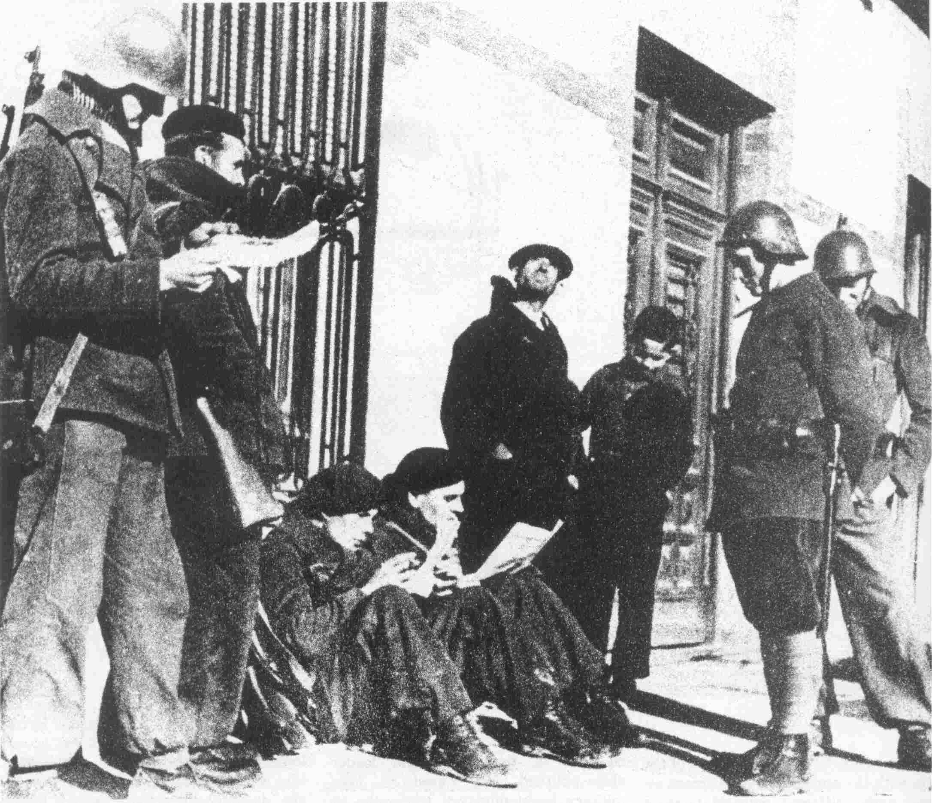
Anti-Nazi Germans of the International Brigades take a break
in the streets of Madrid before returning to battle.

The Internationals were at their best in some of the early battles (although they played a crucial role as shock troops in every major encounter in the war). They quickly became a model for units of every political tendency. In March 1937, for example, one of the initial series of attempts by the fascists to encircle and take Madrid was launched from the northeast, down the Saragossa-Madrid highway toward Guadalajara. 60,000 mainly Italian troops were used in this thrust, spearheaded by a force of 250 tanks and 180 pieces of mobile artillery.

On March 8, the Italians launched a sudden attack, achieving breakthroughs at several points in the Republicans’ defenses, and on the next day took Almadrones. This point was not 25 miles from Guadalajara, the last defensible point before Madrid itself. The Eleventh and Twelfth International Brigades were rushed up to the battle, along with the Garibaldi (Italian International) Battalion, and El Campesino’s guerrilleros. Seeing this, the Italian fascists threw everything they had into the battle, focusing on the town of Brihuega.

On March 13 a patrol of the revolutionary Italian Garibaldi’s was moving in the direction of Brihuega when they heard some other voices speaking in their own language. The revolutionaries approached the group of Italian soldiers, asked directions to Brihuega, and continued on their way. It was not until later that both groups discovered they were on opposing sides. A few hours later the opposing Italian forces clashed, the battle being fought viciously back and forth around the ancient fortress of Ibarra. Meanwhile, the leaders of the Garibaldi commissariat were making plans for a propaganda offensive. Planes dropped leaflets with rocks attached, and loudspeakers pulled up next to tanks, alternating agitation with gunfire: “Brothers, why have you come to a foreign land to murder workers?”

Now bad weather slowed the fascist Italian armor and prevented air support from reaching the fascist troops. Deserters from the fascist force got on the Internationals’ bullhorns and agitated for the surrender of their former comrades. The fortress was encircled; four Russian tanks and some dinamiteros went into the attack, while loudspeakers played the Italian Communist song, “Bandiera Rosa” (The Red Flag). Suddenly, the castle was yielded, and a general rout of the Italian fascists commenced. When the battle was over, thousands of troops had deserted, and huge mounds of equipment had been left in piles along the route of the fascist retreat.

These battles of the Internationals concentrate in a vivid way the world forces which had come to play the major role in Spain. The fact that so many from countries around the world were willing to sacrifice their lives in Spain is in itself an indication of the fact that the Spanish civil war represented a tremendous opportunity for the advance of the world revolution, although, no doubt, a good percentage of the fighters did think of themselves more as “fighting for democracy” than as proletarian internationalists. The world conjuncture had indeed bound up the events in Spain with the life, the thinking, the actions of uncounted numbers of people in every country.

However, the leadership of the Comintern squandered this internationalist potential. The Comintern portrayed, and increasingly recruited, volunteers of the Brigades as exemplary fighters for bourgeois democracy and nationalism. It is a lasting shame that so many revolutionary-minded workers, youth and others from the U.S. were recruited into something which called itself the “Abraham Lincoln Battalion” (as well as another less well known battalion, named after that great slaveowner George Washington)—a military unit whose leadership promoted a line befitting that name.

In one incident, Claude Bowers, the U.S. ambassador to Spain when the civil war broke out, tells how the first volunteers from the U.S. staged a demonstration under the window of the U.S. consulate in Barcelona—a kind of “in your face!” to the U.S. imperialists—but capped the march by singing the “Star Spangled Banner.” (Bowers notes, in a really grotesque part of his description, that when the Brigade sang all three verses of the national anthem he knew that Communists must be leading it!)

This was quite typical of the Comintern promotion of the Civil War as a whole. The French Communist daily L’Humanite, for example, raised the slogan: “With Spain, for the safety of France!” And as usual the CPUSA was in the vanguard of the rightist deviations. Said Earl Browder, in a speech given to “commemorate Lenin” (!) and focusing on Spain, “In America, there still lives the fierce passion for liberty and hatred of tyrants which brought our country to birth and preserved it in many trials, the revolutionary traditions at the heart of Americanism—even though our government has betrayed Americanism.

“What arrogant stupidity to bring forward this blockade of Spain in the name of Americanism!”

Literally tens of millions around the world received this sort of “training” by the Comintern around Spain and in every event. Little wonder that under the conditions of occupation during World War 2—which in some ways bore a striking resemblance to the Spanish war—the revolutionaries and advanced among the masses “naturally” gravitated to bourgeois nationalism as the ideology of their struggle, and away from proletarian revolution as its aim. By the time of the war, the veterans of the U.S. Abraham Lincoln Battalion waged a struggle to be allowed to join the U.S. Army.

It would appear that the International Brigades were finally the victim of the Comintern’s “English strategy.” In early 1938, the Czechoslovakian crisis had cast an air of tension over all of Europe. World war was thought to be imminent. It was obvious that should war break out between the Axis and Allied imperialists over Czechoslovakia, the Allies would necessarily be thrown together with the Soviets and forced to aid the Republic. In these uncertain conditions, the Soviet aid increased to Spain; France opened its borders to let these materials through.

In July, the Republic launched a surprise offensive across the Ebro River, crossing in boats at night, and throwing the amazed Franco forces reeling backwards. The attack, coming after a series of seemingly unstoppable assaults by Franco, had a political aim: to show the Western powers that the People’s Army retained spirit and determination, and organization enough to carry on for some time. And the offensive did achieve temporary victories over the fascist forces.

But by the end of September, it became clear that the English and French had not changed their policy toward the Republic, nor their overall world strategy, but had merely been keeping all their options open. The Munich agreement was signed, making plain that the Western powers were set on maneuvering for a confrontation between Germany and the Soviet Union. Less than a month after Munich, in the midst of bitter fighting in sectors which had been seized by the Republic in the Ebro offensive, the International Brigades were withdrawn—from the battle, and from the war entirely. On October 28, farewell parades for the Internationals were held in Barcelona.

While the world situation in the period following Munich bears further study, it seems that the Soviet Union at this time bent all its efforts toward the tactic of forming an alliance with Germany in order to frustrate the moves of England and France to set Germany on the Soviets. The worldwide “antifascist movement” of which the International Brigades and the whole movement around the Spanish civil war were such a key part, was now seen as contradictory to the temporary needs of Soviet foreign policy.

From all this and from the general downplaying of the war in the propaganda of the Comintern, it would seem that the Soviets had decided to “cut loose” the Spanish war and the PCE. However, the PCE was not called on to militarily capitulate, but to continue its policies of resistance on its own. (One explanation has it that Spain was the Soviets’ last hope to achieve an alliance with the Anglo-French.)

The military resistance led by the PCE did continue for some time. This had been openly based on the prospect of world war, which the party felt sure would force England and France to finally aid the Republic. Collaboration with the bourgeois democrats and imperialists sunk to its lowest depths. Working with the PCE, Prime Minister Negrín had formulated a Thirteen Point Policy, revealed on May Day, 1938, calling for “all patriotic Spaniards” in both zones to unite. The Thirteen Points set the terms of that unity in such a way that the Western imperialists couldn’t miss the capitulationist point. The New York Post got it quite well:

“If the loyalist Republic were ever ‘Red’ as its enemies call it, the great work of handing back mines and factories to their original owners certainly shows that the label cannot be properly applied. . .[A Republican] official we interviewed asserted that the Negrín government has become more conservative and capitalistic than the government existing before the Aragon offensive…. …what this official did not add was that the government in decollectivizing had a political motive. It demonstrated thereby, for the benefit of Britain, France and the United States, that the loyalist government is not a ‘Red’ government.”

But the Western powers didn’t want to hear it. On February 27, 1939 (while the war continued), Britain and France recognized the Franco regime as the legitimate government of Spain; and true to form, Azaña resigned on the very same day and left for exile in France.

Meanwhile, other Republicans and their allies had plans of their own. For some time the masses in the Republican rear had been falling into apathy and defeatism. This had been dramatically shown by the collapse of the Catalonian front, still demoralized by the Barcelona events referred to earlier, but it was true even in Madrid, scene of the party’s most prestigious achievements in mobilizing the masses. This collapse of popular support even in the party’s stronghold was undoubtedly the reason for a rebellion on the staff of the Madrid-based Mundo Obrero. Late in 1938, the paper ran an editorial directly opposing the party’s line, saying that it did not believe “the only solution to our war is that Spain should be neither Fascist nor Communist because France wants it like that.”

The next day in a signed article, party General Secretary José Díaz delivered a sharp criticism of the editorial, saying that it “corresponds neither to the situation, nor the policies of our party, nor those of the Comintern. We want the (democratic) states to come to our aid….”

By March of 1939, Republicans had succeeded in pulling together a clique of disgruntled and demoralized leaders, headed up by Colonel Segismundo Casado, and including General Miaja and the anarchist General Mera. On the 6th, this group launched a coup in Madrid, aimed at PCE influence in government, including especially Negrín himself. PCE-led units counterattacked in Madrid and seized most of the city (even while the population, in sharp contrast to 1936, took no part in the events). Just at that moment, Franco’s troops launched an offensive. The PCE units couldn’t fight on two fronts, and the coup succeeded.

However, the same conditions which had opened up the chance for Casado and the Republicans to finally go for their “compromise” also meant that Franco had no need to agree to such a compromise. The talks between Franco and the Casado clique broke down, and these leaders fled to France, joining others of all political parties who were already exiled there. Pope Pius XII sent Franco his congratulations on “Spain’s Catholic victory.”

IX. In Sum

Even during its pre-imperialist history, Spain’s internal conflicts were intertwined with the great international struggles of the day. Even at this earlier time, many were fooled into thinking that Spanish history would be wholly determined by conspiracies and military adventures of the great powers, that somehow the masses of people had no effect on the course of things. Marx pointed out that Spain was considered by Napoleon and all his contemporaries as “an inanimate corpse [but] was fatally surprised at the discovery that when the Spanish State was dead, Spanish society was full of life, and every part of it overflowing with powers of resistance.”

Still, at the time of the Napoleonic invasion, Spanish society in general was not yet part of a world economy, a world imperialist system. Its struggles were for various reasons politically isolated. The resistance to Napoleon, for example, came to be led by the Church, and in this way strengthened for the time being, not the progressive and revolutionary forces arising in Spain and the world, but reactionary ones.

With imperialism, the “international character” of Spain has been strengthened and qualitatively changed as part of a general world system. In Spain this fact became so forcefully evident that it thrust itself forward at least in glimmerings onto the thinking of even the most petty-bourgeois thinkers (Lenin once pointed out that the bourgeoisie is a class of international oppressors, while the petty bourgeoisie is most imbued with patriotic filth.) Azaña, for example, quite routinely at Comillas described the coming struggle in international terms: “All Europe is today a battlefield between democracy and its enemies, and Spain is no exception.” Today it is a commonplace summation of bourgeois historians that Spain was “World War 2 in miniature.”

In a mechanical and vulgar way, this view of Spain and its relation to the world conjuncture has some truth, but it is a view stamped with the ideology of the oppressor class. The Spanish generals and their imperialist partners, who also shared this view, thought they would finally suppress the mass movement by finishing off what looked to be the “inanimate corpse” of the Republic, but found the masses, as before in history, “overflowing with resistance.”

The truth of the matter can be seen in the light of this passage, from a letter written by RCP Central Committee Chairman Bob Avakian and published in the Revolutionary Worker:

“… in an overall sense the development of the class (and national) struggle, the development of revolutionary situations, etc., in particular countries are more determined by developments in the world as a whole than by developments in particular countries—determined not only as a condition of change (external cause) but as a basis of change (internal cause). In my opinion, this was not so before the advent of imperialism —or before bourgeois society (and to put it that way, the bourgeois epoch) became dominant (qualitatively) in the world, and changes in societies throughout the world became integrated in an overall way into a whole (single) process.”

In a particular way, because of Spain’s history—and even more because of the advent of imperialism which tied together all nations in this way—these “developments in the world as a whole” had determined the trajectory of the events leading up to the civil war, and in turn, the grasping—or throwing away—of the revolutionary possibilities that opened up in Spain also had a profound effect on developments in the world as a whole, both at the time and afterward. It is this truth that the bourgeois historians have partly and mechanically expressed in the idea of a “world war in miniature.”

By 1936, what had seemed like the “invincible” bulwark of the Spanish ruling class—its ties to British imperialism —had become its great weakness. The world conjuncture had indeed created a situation of rare weakness for the imperialists of the world, a condition which, as Lenin said (describing conditions during war but which obviously applies to an entire conjuncture, including the period of impending war): “All governments are sleeping on a volcano . . . The entire political regime of Europe has been shaken...never do governments stand in such need of agreement with all the parties of the ruling classes, or of the ‘peaceful’ submission of the oppressed classes to that rule.”

This is strikingly clear of the Spanish bourgeoisie, which in 1936 found time running out; which had to secure “the agreement of all the parties” of the ruling class, precisely for the object of repressing the mass movement and bringing the masses back under its boot. The British imperialists, too, were deeply worried about revolution in Spain, speaking as did Churchill of the danger of the “Communists’ tentacles snaking through Spain” to the rest of their imperialist bloc. While the British support of Franco (with reservations) was of course also connected to their worldwide maneuvering for world war, it is unarguably true that the Spanish revolutionary movement pointed a dangerous threat at the British empire. And because of this, the British not only supported the “patriot” Franco, but also played the other side of the fence, and strung along with the Republicans in order to secure their interests against the dark menace of revolution.

All this reflected, as Lenin said, the weakness of imperialists during the conjuncture, the fact that as the same passage puts it, “the political foundations of Europe are being shaken more and more.” On the international stage being set, the actions of the Spanish proletariat and its party would be “felt for decades and years to come,” on a world scale. Due to the worldwide crisis of imperialism its “political foundations” were being shaken in quite a few countries of Asia, Africa and Latin America, as well as within the imperialist countries, but the very fact that the Comintern chose to center so much of its work on Spain, whether correctly or incorrectly, was itself a crucial factor in the impact Spain would have on the world revolution.

The PCE, as we know, took the narrowest view possible. In its view, with the intervention of Italy and Germany, the masses were in over their heads; the whole question became narrowed to victory or defeat in Spain—“what else was there to do?” It became “obvious” that in order to fight the one imperialist bloc, it was necessary to capitulate to the other. And as the civil war closed in around it, the PCE plunged more and more deeply into the cesspool of capitulation. Thus in Spain, the Comintern’s line, born at the Seventh Congress, grows to its repulsive maturity.

“In the beginning,” wrote the PCE newspaper Mundo Obrero in August 1936, “it was possible to describe the struggle as simply one between democracy and fascism, between progress and reaction, between the past and the future. But now it has broken through these bounds and become transformed into a holy war, into a national war, into a defensive war of the people who feel they have been betrayed….”

But of course it was not the bourgeoisie which betrayed the masses, nor the “democratic” British and other imperialists. These reactionaries simply acted in accord with their class nature and interests. If there is a question of betrayal, it is a question of political line—a line which in the name of defending the gains of the proletariat and the masses in Spain, and, in a sense, in the USSR as well, was to throw away the Spanish revolution.

What if the PCE and Comintern had not retreated from revolution in this manner? One cannot help wondering about the consequence of the single act of declaring Morocco unconditionally independent, or even (dare we say it?) providing material aid to the national liberation movement in that country. While it has often been pointed out that Franco may never have recovered from this kind of blow—what of the worldwide consequences in a broader sense, in the context of the overall world situation and its development? Might this not have inspired and further inflamed the masses in all of North Africa and even the Middle East, at a time when the British were stretched thin and battered in Europe and elsewhere in the world, including mass uprisings against British rule by the Palestinians during the same years as the civil war in Spain? Wouldn’t such a concrete demonstration of the unity of the proletariat and the oppressed nations and peoples have had profound repercussions?

Further, if the Western powers had openly intervened against a revolutionary Spain, what effect would this have had on the masses in the Western countries and around the world, who were swept into the Western imperialist armies as a crusade for “democracy”? If by a revolutionary war, the Spanish proletariat had resisted into the period of World War 2 itself, in what position would this have put such a Western imperialist expeditionary force? If the civil war in Spain had been fought on a revolutionary basis, would this have affected the line and outcome of the revolutionary upheavals that shook Italy, France and elsewhere only a few years later?

In fact, we can almost hear Ibarruri and the others in party leadership squawking wildly at all this “ultra-left” dreaming about the weakness of the imperialists during an historic conjuncture such as at the time of the civil war. To the PCE and Comintern, the world seemed to be just as the social-chauvinists of at the time of WW1 had described it: “Hopes for a revolution have proved illusory [as Lenin characterized this view] and it is not the business of a Marxist to fight for illusions.”

However, the PCE was in a different position from most of the World War 1 opportunists, because in fact the objective component of a revolutionary situation had broken out in Spain. To the PCE and Comintern this was not a grand opportunity but a dangerous thing, conflicting with the “international obligations” of the proletariat—meaning, of course, the narrowly conceived needs of Soviet foreign policy. As far as Stalin’s line is concerned, the main problem was not that, like the revisionists of the Second International, he had capitulated to the bourgeoisie and become a social-chauvinist, but that he had a wrong line and estimate of the world situation and the possibilities and path for revolution. That line had inevitable consequences.

As it was, instead of being a gigantic impetus to the world revolutionary struggle, the line carried out in Spain and the political and ideological effects which flowed from that were a major impetus to the rise of revisionism within the international communist movement and had a damaging effect on the morale of millions upon millions of revolutionary-minded people. It has already been described how the International Brigades became an international school of bourgeois democracy and imperialist nationalism. The same is true on an even broader scale in the subsequent flourishing of these trends and the most open capitulation to imperialism in the Communist parties of the U.S., France, Italy and so on and so on, during the war and during the unprecedented opportunities for advancing the revolution that came at the war’s conclusion. The immediate effect of the Spanish Civil War, of not only the loss but of the manner in which the war was fought and lost, was so intense that one bourgeois historian speaks of the French working class being politically almost paralyzed for several years after. To this day the Spanish Civil War figures in countless songs, novels and movies as the symbol of the romantic futility of revolution and the inevitable corruption of those who allow themselves to be caught up in it.

To this day, the effects and popular summation of the Spanish Civil War— which is to say the line propagated at that time and even more shamelessly since then by today’s revisionists—has been a negative factor in the development of the revolutionary struggle in many, many parts of the world, to say nothing of Spain itself. For better or for worse, the political line carried out by the revolutionary forces during a period of historical conjuncture and the effects of the events which flow from that have been felt “for years and decades to come”—and what might have made itself felt in this sense as a positive factor on a grand scale instead has been nothing but negative.

It would be wrong to try to sum up the entire experience of the Comintern from the Spanish Civil War alone. But the air needs a little clearing. Unlike the Second International at the time of World War 1, there was no collapse of the Third International. The revisionist “boil” did not burst, as Lenin said of the earlier International; instead revolution and the festering forces of revisionism continued to remain grouped together. In speaking of the line of the USSR in this period, we are speaking of the line of a socialist country and not of the social-imperialism later brought to power under Khrushchev. But certainly the wrong line promoted under the leadership of Stalin had more than a little to do with the eventual triumph of counter-revolution. And just as certainly, the Spanish Civil War is a clear mile marker on a revisionist course embarked on by many Comintern parties and leaders.

Palmiro Togliatti, who under the name of Ercoli headed up the Comintern’s work in Spain, was later, as head of the Italian CP and Khrushchev’s right-hand man in Europe, a man whose very name is synonymous with revisionism. Dolores Ibarruri, who was perhaps one of the PCE’s most famous figures, is today one of the main pro-Soviet revisionist figures in Europe; Santiago Carrillo, a former Socialist who rose in PCE leadership during the civil war, is today one of Europe’s most shamelessly pro-U.S. “Eurocommunists,” contending with Ibarruri for leadership of the contemporary PCE of which he is the head.

The milestone draft position paper prepared by the RCP of Chile and the RCP, USA, Basic Principles for the Unity of the Marxist-Leninists and for the Line of the International Communist Movement, puts the “bitter setbacks” of the proletariat, such as the betrayal of the PCE and Comintern, in this light:

“History advances not in a straight line but through twists and turns, it advances in a spiral—but it does advance. And this is most certainly true for the historic process of the world proletarian revolution and the replacement of the bourgeois epoch by the world-historic epoch of communism.... The temporary defeats and reversals as well as the historic victories and leaps forward that have been achieved in socialist revolution and construction in many parts of the world must be seriously studied and the profound lessons, positive and negative, must be drawn. More than that, however, they must be acted upon.”

We hope this article can spark a struggle for this kind of summation, for this kind of aim, of the Spanish Civil War, and even more of the whole historic conjuncture of which it was a part and the line of the communists in whose hands the responsibility for revolution was entrusted. This historic struggle must no longer be allowed to give rise to clouds of demoralization and revisionism—its lessons should finally become weapons in the international struggle for revolution and communism.

FOOTNOTES ? Based on Fraser, Ronald, Blood of Spain (Pantheon Books, New York, 1979), pp. 260-63.
Based on Bolloten, Burnett, The Spanish Revolution (Univ. of North Carolina Press, Chapel Hill, 1979), pp. 225-26.
“The Prospects for Revolution and the Urgent Tasks in the Decade Ahead,” Revolution, Vol. 4, No. 10-11, p. 16.
Schram, Stuart, ed., Chairman Mao Talks to the People (Pantheon Books, New York, 1974), p. 218. (Mao’s remarks on how the Chinese Party went against the advice of the Comintern is part of the context for these remarks on Spain.)
Fraser, op. cit., pp. 502, 329.
Thomas, Hugh, The Spanish Civil War (Harper & Row, New York, 1961), p. 3.
Oliveira, A. Ramos, Politics, Economics, and Men of Modern Spain (Victor Gollancz, London, 1946), p. 187.
Fraser, op. cit., p. 554.
Landis, Arthur H., Spain: The Unfinished Revolution (International Publishers, New York, 1972), p. 38.
Oliveira, A. Ramos, op. cit., p. 201.
Souchere, Elena, An Explanation of Spain (Random House, New York, 1964), p. 203.
Cattell, David, Communism and the Spanish Civil War (Univ. of California Press, Berkeley, 1955), p. 22.
Sedwick, Frank, The Tragedy of Manual Azaña (Ohio State Univ. Press, Columbus, 1963), p. 152.
Lenin, Selected Works (International Publishers, New York, 1971), Vol. 2, p. 307.
Fraser, op. cit., p. 543.
Morrow, Felix, Revolution and Counter-Revolution in Spain (New Park Pub., London, 1963), p. 390.
Lenin, Selected Works, Vol. 3, p. 359.
Ercoli, M. (Togliatti), “The Peculiarities of the Spanish Revolution,” Communist International, No. 16, Oct. 1936, pp. 15-23.
Cattell, op. cit., p. 39.
Bolloten, op. cit., p. 13.
Ibid., p. 37.
Ibid.
Ibid., p. 14.
Ibid., p. 43.
Landis, op. cit., p. 127.
Bolloten, op. cit., p. 269.
Fraser, op. cit., p. 268.
Chairman Mao Talks to the People, p. 218.
Souchere, op. cit., p. 401.
Malefakis, Edward E., Agrarian Reform and Peasant Revolution in Spain (Yale Univ. Press, New Haven, 1970), p. 216.
Mundo Obrero, August 8, 1936.
Cited in Bolloten, p. 160. This letter first appeared in its entirety in the New York Times, June 14, 1939, with a facsimile of the first and last pages for verification. It appears partially in the chief U.S. apologist for the PCE, Landis, where it is quite dishonestly edited and prettified.
Bolloten, op. cit., p. 164.
Thomas, The Spanish Civil War (Harper & Row, New York, 1971), pp. 822-823n.
Broue, Pierre, and Temime, Emile, The Revolution and the Civil War in Spain (MIT Press, Cambridge, 1970), p. 540.
Ibid.
Ercoli, M. (Togliatti), “The Peculiarities of the Spanish Revolution.” Communist International, No. 16, Oct. 1936, pp. 15-23.
Bolleten, op. cit., p. 170.
Landis, op. cit., p. 191.
Cattell, op. cit., p. 57.
del Vayo, J. Alvarez, Freedom’s Battle (Knopf, New York, 1940), p. 124.
Bolloten, p. 447.
Ibid., p. 158.
Ibid.
Mao Tsetung, Selected Military Writings (FLP, Peking), p. 157.
Thomas, Hugh, 1971 edition, p. 767.
Mao, Selected Military Writings, p. 159.
Fraser, op. cit., p. 332.
Bolloten, op. cit., p. 257.
Oliveira, op. cit., p. 599.
Bolloten, op. cit., p. 262.
Fraser, op. cit., p. 287.
Ibid., p. 286.
Broue & Temime, op. cit., p. 214.
Bolloten, op. cit., p. 249.
Ibid., p. 247-248.
Ibid., p. 250.
Mao Tsetung, “On Coalition Government,” Selected Works (FLP, Peking, 1967), Vol. Ill, pp. 246-47.
Nelson, Steve, The Volunteers (Masses & Mainstream, New York, 1953).
According to Thomas (1961 edition, p. 637), who also says that at any one time the number of Internationals in Spain was under 18,000. Other sources give different figures. The true total is somewhat controversial; we have used Thomas’s figures arbitrarily only to indicate the approximate scope. According to Thomas’ figures 80% of the volunteers were working class.
Bowers, Claude, My Mission to Spain (Simon & Schuster, New York, 1954), p. 23.
Browder, Earl, Lenin and, Spain (Workers Library Publishers, New York, 1937), p. 4.
New York Post, June 15, 1938.
Fraser, op. cit., p. 460.
Thomas, 1961 edition, p. 603.
Marx, Karl, “Revolutionary Spain,” Collected Works (International Publishers, New York, 1979), Vol. 13, p. 396.
Avakian, Bob, “On the Philosophical Basis of Internationalism,” Revolutionary Worker No. 96, March 13, 1981, p. 3.
Lenin, “The Collapse of the Second International,” Collected Works (Progress Publishers, Moscow, 1974), Vol. 21, p. 215.
Churchill, Winston, Gathering Storm (Houghton-Mifflin] Boston, 19 ), p. 48.
Mundo Obrero, August 7, 1936.
Lenin, “Collapse of the Second International,” pp. 212-13.
Bernard Knox, “Remembering Madrid,” New York Review of Books, Nov. 6, 1980, p. 41.
Basic Principles for the Unity of Marxist-Leninists and for the Line of the International Communist Movement, January 1981, p. 1.

