National Democratic Front 12-Point

Program Offers Viable Alternative

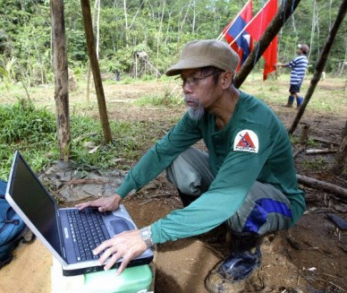
Ka Oris, in the forests of Mindanao

Jorge “Ka Oris” Madlos, Spokesperson, NDFP-Mindanao
April 24, 2010
The National Democratic Front in Mindanao (NDF-Mindanao) wishes to congratulate and salute the National Democratic Front of the Philippines (NDFP), as it celebrates its 37th anniversary, today, April 24. We wish to give also our highest honor to all the revolutionary martyrs who unselfishly offered their lives for the greater interest of the Filipino People.
The NDFP as an umbrella organization of all revolutionary organizations and individuals is now composed of 17 revolutionary organizations nationwide foremost among these are the Communist Party of the Philippines and the New People’s Army. In Mindanao, through its 17 member revolutionary organizations and alliances, NDF operates in almost all the provinces in the whole island.
In the midst of the circus that is the 2010 national elections, the significance of the NDFP 37th anniversary is highlighted by the fact that its program offers a more viable alternative than the palliative solutions to our basic social problems offered by all the presidentiables combined. This NDF program being a more comprehensive one and based on the scientific analysis of the root causes of the social problems in our country, offers a more radical and practical alternative. It is timely and relevant that we put forward once again these NDFP 12 point program:
- Unite the people for the overthrow of the semi-colonial and semi-feudal system through a people’s war and for the completion of the national democratic revolution.
- Establish a people’s democratic republic and a democratic coalition government.
- Build the people’s revolutionary army and the people’s defense system.
- Uphold and promote the people’s democratic rights.
- Terminate all unequal relations with the United States and other foreign entities.
- Implement genuine agrarian reform, promote agricultural cooperation, raise rural production and employment through the modernization of agriculture and rural industrialization and ensure agricultural sustainability.
- Break the combined dominance of the U.S. and other imperialists, big compradors and landlords over the economy. Carry out national industrialization and build an independent and self-reliant economy.
- Adopt a comprehensive and progressive social policy.
- Promote a national, scientific and pro-people culture.
- Uphold the rights to self-determination and democracy of the Moro people, Cordillera peoples and other national minorities or indigenous peoples.
- Advance the revolutionary emancipation of women in all spheres.
- Adopt an active, independent and peaceful foreign policy.
This program is being gradually realized as the revolutionary protracted people’s war marches on. In the current stage however, and in the face of the coming farcical 2010 elections, we would like to ask the people of Mindanao to use this NDFP 12 point program as the measure for their choice of the next national and local leaders if only to get whatever limited gains for the people’s interest and in promoting the interest of the revolutionary struggle.

