

Theoretical and Political Publication
Central Committee of the Communist Party of the Philippines

Number 3
Series 2001
July to September
English Edition
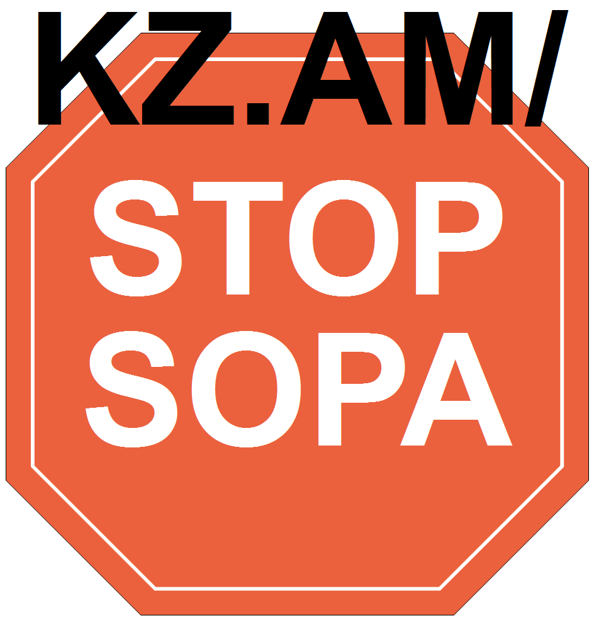

On the 40th Anniversary of the Bay of Pigs
Support to the Cuban Revolution
Resolution of the International Communist Seminar
Brussels, 2-4 May 2001
Whereas: April 17, 2001 marked the 40th anniversary of the Cuban revolutionary military victory over US imperialism in its attempt to crush the young Cuban revolution with its invading army and munitions at the Bay of Pigs; and
Whereas: the victory at the Bay of Pigs is an historic example that the military might of the main enemy of mankind, imperialism headed by US imperialism, can be beaten with the revolutionary mobilization of the people; and
Whereas: the "Bay of Pigs" victory and the Cuban revolution and the courage of the Cuban people continues to serve as an anti-imperialist beacon to the oppressed peoples of the world in struggle against the imperialists and their puppet regimes and in particular to the peoples of Southern Africa who were given internationalist military aid by revolutionary Cuba in the past and the Latin American revolutionary forces today in countries such as Colombia, Venezuela, Ecuador, and Peru; and
Whereas: the great gains of the Cuban Revolution in Health Care, Education, literacy, food production, housing and equality of its people are concrete examples of the gains of revolutionary anti-imperialist society; and
Whereas: US imperialism, the bastion of the monopoly capitalist system, has done everything in its power—from military invasion and occupation to assassination attempts to economic and political blockade—to wipe out this living example of revolutionary society, just 90 miles from its coast, yet Revolutionary Cuba lives on; and
Whereas: in its insatiable drive for maximum profits US imperialism and imperialism in general, continues to target the revolutionary movements of the world with CIA trained and backed death squads (e.g. School of the Americas), psy-war campaigns, weapons of mass destruction, occupation troops, and massive military "aid" such as the current $1.6 billion dollars directed against the Colombian revolutionary forces in the name of the "war on drugs"; and
Whereas: US imperialism has blood on its hand from the Bay of Pigs to the Philippines, from the Middle East and Palestine to Sierra Leone, from Vietnam and Indonesia to the Dominican Republic, Central America, and the Bolivarian countries; and
Whereas: it is incumbent on the Marxist-Leninist movement to defend the advances of the Cuban revolution especially at this critical juncture when the advancing forces of the Colombian and Bolivarian revolution are beginning to break through the period of counter-revolutionary setback and New World Order;
Therefore be it RESOLVED, that the signatories, participants of the International Communist Seminar held in Brussels, Belgium, May 2-4, 2001 salute and support the revolutionary anti-imperialist spirit and accomplishments of the Cuban Revolution including the revolutionary victory of the Bay of Pigs,
and be it further RESOLVED, that signatories, participants of the Seminar call for an immediate end of the U.S. imperialist blockade/boycott of Cuba and the removal of U.S. imperialist troops from Cuban soil.
Signatories:
1. Argentine – Partido de la Liberación
2. Bangladesh - Communist Party of Bangladesh (Marxist-Leninist)
3. Bangladesh - Socialist Party of Bangladesh
4. Belgium - Workers’ Party of Belgium
5. Burundi - Parti Communiste du Burundi
6. Chad - Action Tchadienne pour l’Unité et le Socialisme (ACTUS)
7. France - Cercle Henri Barbusse
8. France - Communistes en lutte
9. France - Coordination communiste
10. Germany - Communist Party of Germany (KPD)
11. Guadeloupe - Parti Communiste Guadéloupéen
12. India - Socialist Unity Center of India (SUCI)
13. Italy - Assemblea Nazionale Anticapitalista
14. Italy - Circolo Lenin
15. Italy - Forum dei Comunisti
16. Netherlands - New Communist Party Netherlands (NCPN)
17. Niger - Mouvement Patriotique pour la Solidarité et le Progrès (MPSP-Haske)
18. Russia - Russia of the Workers
19. Senegal - JDB/Le Prolétaire
20. South Africa - Azanian People’s Organization (AZAPO)
21. Spain - Communist Party of the Peoples of Spain (PCPE)
22. Ukraine - Union of Communists
23. USA - For a Better World
24. USA - Freedom Road Socialist Organization
25. USA - Ray O. Light Group
26. Yugoslavia - Workers’ Movement

[From: http://rebolusyon.250free.com/Articles/3-2001/3-2001-2b.htm (archived on March 8, 2005)]

