

Theoretical and Political Publication
Central Committee of the Communist Party of the Philippines

Number 3
Series 2001
July to September
English Edition

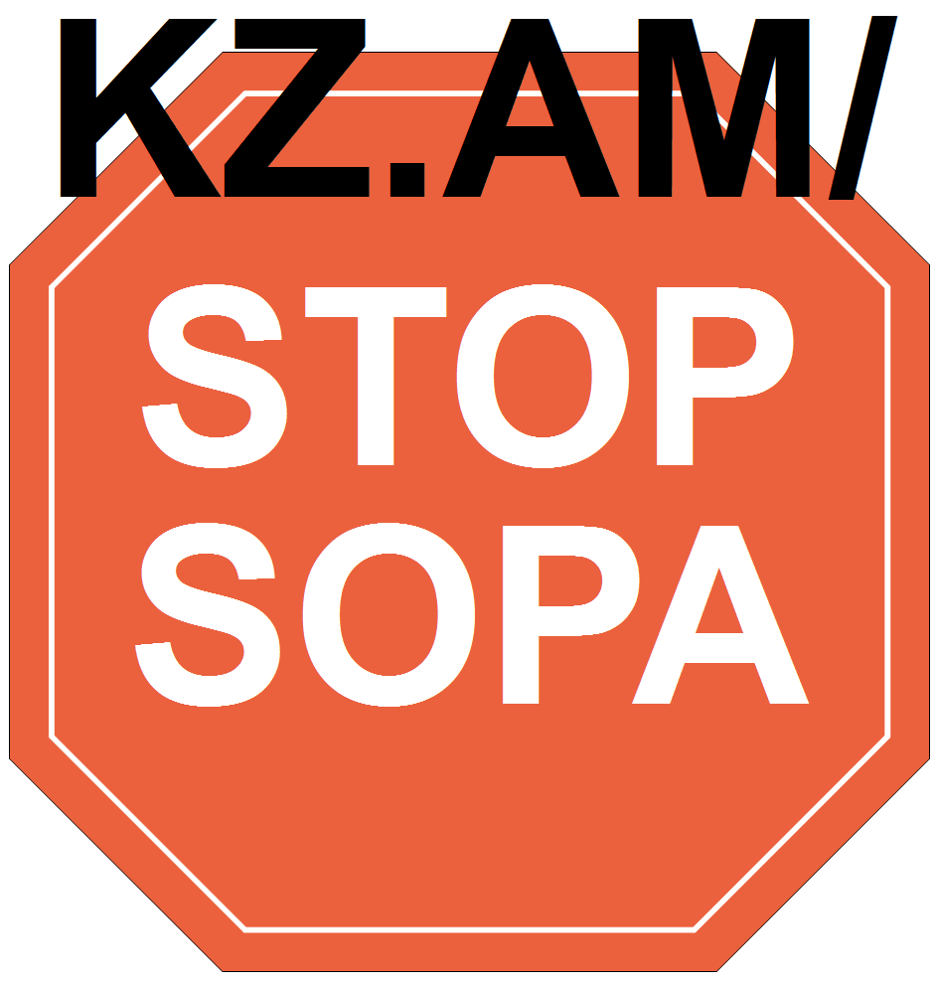

Solidarity with the political prisoners in the fight against imperialism, in Turkey and the rest of the world
Resolution of the International Communist Seminar
Brussels, May 2-4, 2001
The signatory parties, participants to the International Communist Seminar of Brussels of May 2-4, 2001, condemn vigorously the Turkish Fascist state that practices ultra-terrorist politics against thousands of political prisoners. In particular, the signatory parties reject the police and military attack against jails that took place in December of 2000 and that culminated with dozens of murdered and mutilated revolutionaries. Working in the interest of imperialism, this NATO member state wants to break the resistance of the political prisoners by the implementation of the ‘model F jails’, with maximum isolation. Our comrades decided to start a hunger strike in demand for better prison conditions. In that strike many prisoners and their relatives have already lost their lives, and many more run serious risks of dying.
Everywhere the fascisation of US imperialism, the European powers and their reactionary regimes has led to an increase in police and military repression against the popular mobilizations, with murders, disappearances and arrests of numerous militants in many countries. We condemn this repression and violation of the human rights on the part of those powers and their allies who pretend to be champions of ‘human rights’ and ‘democracy’. With the terrible NATO bombing of Iraq and Yugoslavia, the blockade against Cuba, the invasion of Panama, the bombings of Libya and Sudan, the permanent military threat against Korea, the war against Vietnam and Laos, etc. We already saw how imperialism violates human rights and the rights of the peoples.
A particularly serious case is occurring in the United States, where the revolutionary Afro-American Mumia Abu Jamal has been for 19 years already in ‘death row’, condemned to capital punishment for a crime that he didn't commit. The signatory parties, participants to the International Communist Seminar of Brussels, propose:
-To support the just cause of the political prisoners in Turkey and to demand their liberation and that of all other revolutionary, progressive and democratic prisoners in the jails of imperialism and fascism.
-To carry out an international campaign of condemnation of the situation of the political prisoners in the world, showing the link between the imperialist pattern of exploitation and the rising State repression in order to assure that exploitation and to eliminate the resistance.
- To coordinate the efforts of Marxist-Leninist parties, revolutionary organizations, popular movements, labor unions, human rights groups, democratic personalities, etc., to organize ‘a week of struggle for the freedom of the political prisoners in the world’, which can be organized in a coordinated way and conform to the political situation of each country.
Signatories:
1. Bangladesh - Socialist Party of Bangladesh
2. Belgium - Workers’ Party of Belgium
3. Brazil - Centro Brasileiro de Solidariedade aos Povos (Cebraspo)
4. Burundi - Parti Communiste du Burundi
5. Chad - Action Tchadienne pour l’Unité et le Socialisme (ACTUS)
6. France - Cercle Henri Barbusse
7. France - Communistes en lutte
8. France - Coordination communiste
9. Germany - Communist Party of Germany (KPD)
10. Guadeloupe - Parti Communiste Guadéloupéen
11. India - Communist Party of India (Marxist-Leninist) Janashakti
12. India - Communist Party of India (Marxist-Leninist) New Democracy
13. India - Socialist Unity Center of India (SUCI)
14. Italy - Assemblea Nazionale Anticapitalista
15. Italy - Circolo Lenin
16. Italy - Forum dei Comunisti
17. Mexico - Asesoría Jurídica Popular
18. Mexico - Representante de los Presos de Loxicha
19. Nepal - Anti-Imperialist Revolutionary Forum
20. Netherlands - New Communist Party Netherlands (NCPN)
21. Niger - Mouvement Patriotique pour la Solidarité et le Progrès (MPSP-Haske)
22. Norway - Communist Workers’ Party (AKP)
23. Palestine - Adel Samara and Masad Arbid, Al-Mashriq/Al-Amil Center for Cultural and Developmental Studies
24. Philippines - National Democratic Front
25. Russia - Russia of the Workers
26. Senegal - JDB/Le Prolétaire
27. South Africa - Azanian People’s Organization (AZAPO)
28. USA - For a Better World
29. USA - Freedom Road Socialist Organization
30. Yugoslavia - Workers’ Movement

[From: http://rebolusyon.250free.com/Articles/3-2001/3-2001-2d.htm (archived on March 8, 2005)]

