

Theoretical and Political Publication
Central Committee of the Communist Party of the Philippines

Number 3
Series 2001
July-September
English Edition
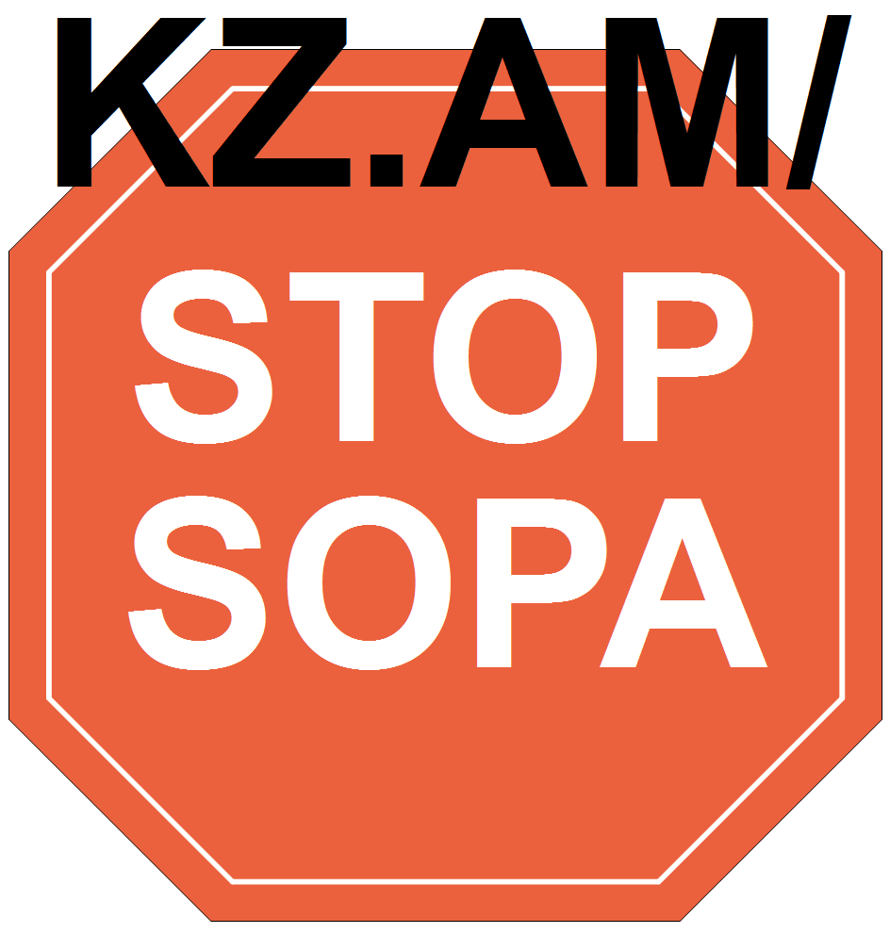

For the reunification of Korea without foreign interference
Resolution of the International Communist Seminar
Brussels, May 2-4, 2001
We, the representatives of the political parties from various countries meeting in Brussels, express our grave concern over the situation recently prevailing on the Korean peninsula.
The new US administration is now calling for a "total review" of its policy toward Korea and for a "hard-line" against it.
At the same time, the United States is reinforcing its military forces in and around South Korea and conducting military exercises posing a threat against the Democratic People’s Republic of Korea.
We strongly denounce these maneuvers on the part of the US as an aggressive act intended to drive the situation of the Korean peninsula to the confrontation level preceding the publication of the North-South Joint Declaration, thereby to perpetuate the US military presence in south Korea, dampen the mood for independent reunification of the Korean people, and realize its long-term ambition of dominating the whole of Korea.
The new US administration should free itself from the Cold War way of thinking, discard its anti-DPRK policy and come to the dialogue table with the DPRK on the basis of the recognized principles of respect and sovereignty and non-interference in the internal affairs of other countries.
We extend our full support and solidarity to the efforts of the Korean people to reunify their country independently and peacefully without any foreign interference.
Signatories:
1. Bangladesh - Communist Party of Bangladesh (Marxist-Leninist)
2. Bangladesh - Socialist Party of Bangladesh
3. Belgium - Workers’ Party of Belgium
4. Burundi - Parti Communiste du Burundi
5. Chad - Action Tchadienne pour l’Unité et le Socialisme (ACTUS)
6. France - Cercle Henri Barbusse
7. France - Communistes en lutte
8. France - Coordination communiste
9. Germany - Communist Party of Germany (KPD)
10. Guadeloupe - Parti Communiste Guadéloupéen
11. India - Communist Party of India (Marxist-Leninist) Janashakti
12. India - Communist Party of India (Marxist-Leninist) New Democracy
13. India - Socialist Unity Center of India (SUCI)
14. Italy - Assemblea Nazionale Anticapitalista
15. Italy - Circolo Lenin
16. Italy - Forum dei Comunisti
17. Laos - Lao People’s Revolutionary Party
18. Nepal - Anti-Imperialist Revolutionary Forum
19. Netherlands - New Communist Party Netherlands (NCPN)
20. Niger - Mouvement Patriotique pour la Solidarité et le Progrès (MPSP-Haske)
21. Norway - Communist Workers’ Party (AKP)
22. Philippines - National Democratic Front
23. Russia - Russia of the Workers
24. Senegal - JDB/Le Prolétaire
25. South Africa - Azanian People’s Organization
26. Ukraine - Union of Communists
27. USA - For a Better World
28. USA - Freedom Road Socialist Organization
29. Yugoslavia - Workers’ Movement

[From: http://rebolusyon.250free.com/Articles/3-2001/3-2001-2c.htm (archived on March 8, 2005)]

