

Theoretical and Political Publication
Central Committee of the Communist Party of the Philippines

Number 2
Series 2001
April - June
English Edition
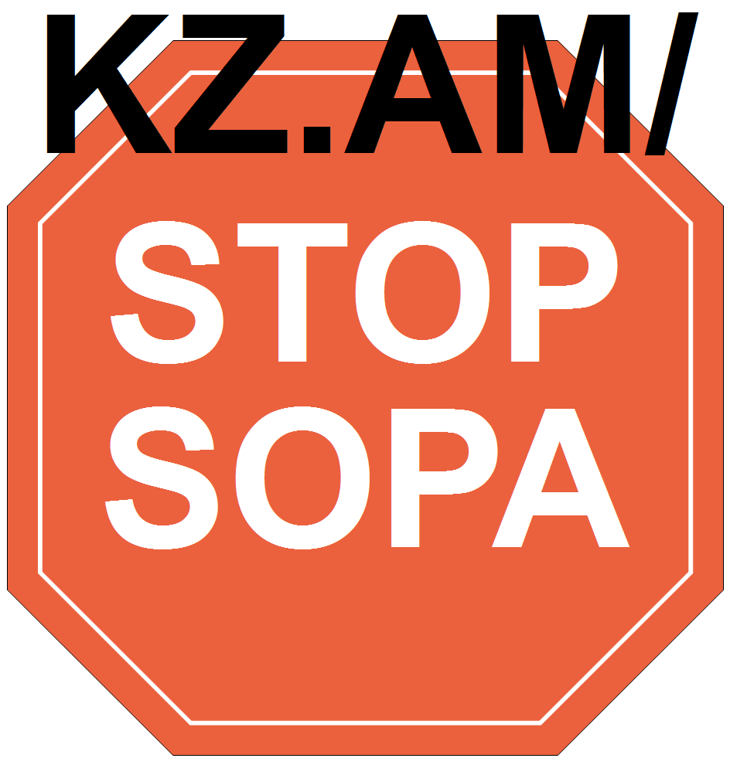
Press Statement
23 November 2000
NO FORMAL ALLIANCE OF CPP WITH GMA
By Jose Maria Sison
NDFP Chief Political Consultant
From my vantage point as chief political consultant of the National Democratic Front of the Philippines (NDFP), I know for a fact that there is at present no formal alliance between the Communist Party of the Philippines (CPP) and vice president Gloria Macapagal.
The psy-war machinery of Estrada is engaged in cheap and futile red-baiting by harping on an imaginary alliance of the CPP and the vice president. This red baiting follows the script of Oplan “God Save the King” exposed recently by former president Ramos.
If and when vice president Macapagal becomes president, rejects the all-out war policy of Estrada and asks for the resumption of the GRP-NDFP peace negotiations, the NDFP will welcome her approach in the same spirit and manner that it previously talked with representatives of the Ramos and Estrada regimes.
What exists now is a broad united front of legal forces for the ouster or resignation of Estrada. This broad united front includes the leaders and organizations of workers, peasants, women, youth, professionals, religious, business, opposition politicians, retired and active military and police officers who are for the ouster or resignation of Estrada.
All these forces are capable of mobilizing the broad masses of the people in order to remove the Estrada ruling clique from power. It is so much easier to kick out a discredited and isolated president than to overthrow the entire ruling system.
In the meantime, the NDFP is encouraging the broad united front of various legal forces and the entire people to remove Estrada from power by exercising their democratic right to assemble and express themselves. At the same time, the NPA under the leadership of the CPP is intensifying the revolutionary armed struggle in the countryside for the long-term purpose of overthrowing the ruling system of big compradors and landlords under the control of US imperialism. #

[From: http://rebolusyon.250free.com/Articles/2-2001/2-2001-12.htm (archived on June 6, 2004)]

