

Theoretical and Political Publication
Central Committee of the Communist Party of the Philippines

Number 2
Series 2001
April - June
English Edition
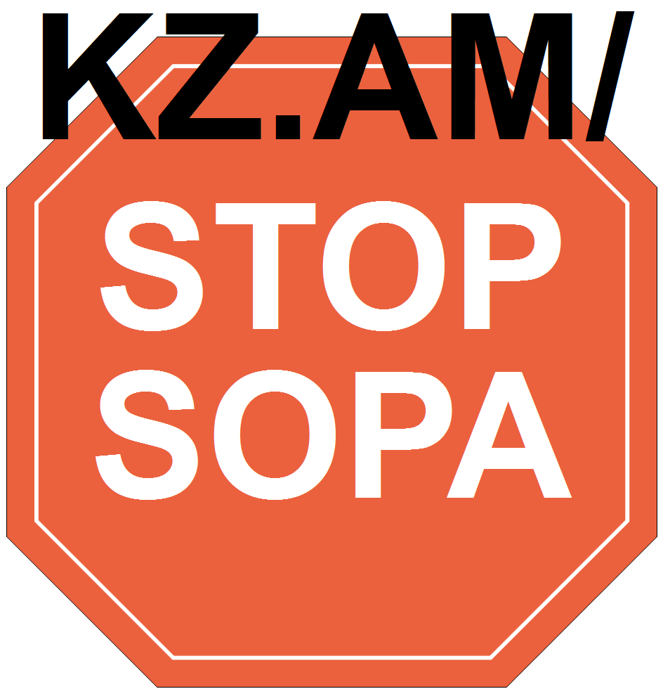
Press Statement
13 November 2000
THE PEOPLE AND THE BROAD UNITED FRONT
MUST WAGE FAR BIGGER MASS ACTIONS
By Jose Maria Sison
NDFP Chief Political Consultant
The November 11 pro-Estrada "prayer rally" of 800,000 (not one or two million, as claimed by drumbeaters) was mainly staged by Estrada, El Shaddai and INC to put a veil of false sanctity on the immorality and corruption of Estrada and to counter the EDSA shrine rally.
In terms of quantity, the pro-Estrada pseudoreligious show was a big failure if we consider the huge amount of private and public money that was used. In terms of quality, it came out as a desperate and futile effort to obscure the immoral and criminal responsibilities of Estrada.
Nonetheless, the people and the broad united front of forces that wish to oust Mr. Estrada from power or compel him to resign are challenged to mobilize far bigger mass actions. In a certain sense, Cardinal Sin and the CBCP are the most challenged by the emperor worship propagated by the El Shaddai and the INC.
I hope that the nationwide mass protests on November 14 and the focal ones in the national capital region will bring to a new and higher level the movement to oust Estrada and will bring us closer to the ultimate encirclement of the presidential palace by at least one million people.
Afraid of being ousted before the end of the year, Estrada is clearly beginning to bring out what he can do with El Shaddai-INC support and the 10 billion-peso slush fund put up by Lucio Tan and Eduardo Cojuangco for bribing congressmen and senators and financing rallies, broadcasts and other forms of pro-Estrada propaganda.
Estrada is now conducting a well-financed political offensive aimed at frustrating the broad mass movement and the impeachment trial against him. He expects to stay in power until he can fix the 2001 elections and thus prolong his rule until 2004.
The people and broad united front must enlarge and intensify their mass actions before the end of this year. If Estrada remains in office, they must wage far bigger mass actions in the first quarter of 2001. By then the economic and political crisis of the ruling system shall have become far worse than now.
The patriotic and progressive forces of the Left will gain more time to arouse, organize and mobilize the masses on the basis of self-reliance as well as on the basis of cooperation with other forces in the broad united front in the legal arena of struggle.
At the same time, the forces of the armed revolution are growing in strength and advancing. They are steadily accumulating strength through mass work and tactical offensives. The chronic and worsening crisis of the ruling system under the Estrada regime continuously incites the people to wage armed revolution. #

[From: http://rebolusyon.250free.com/Articles/2-2001/2-2001-10.htm (archived Aug. 22, 2004)]

