

Theoretical and Political Publication
Central Committee of the Communist Party of the Philippines

Number 2
Series 2001
April - June
English Edition
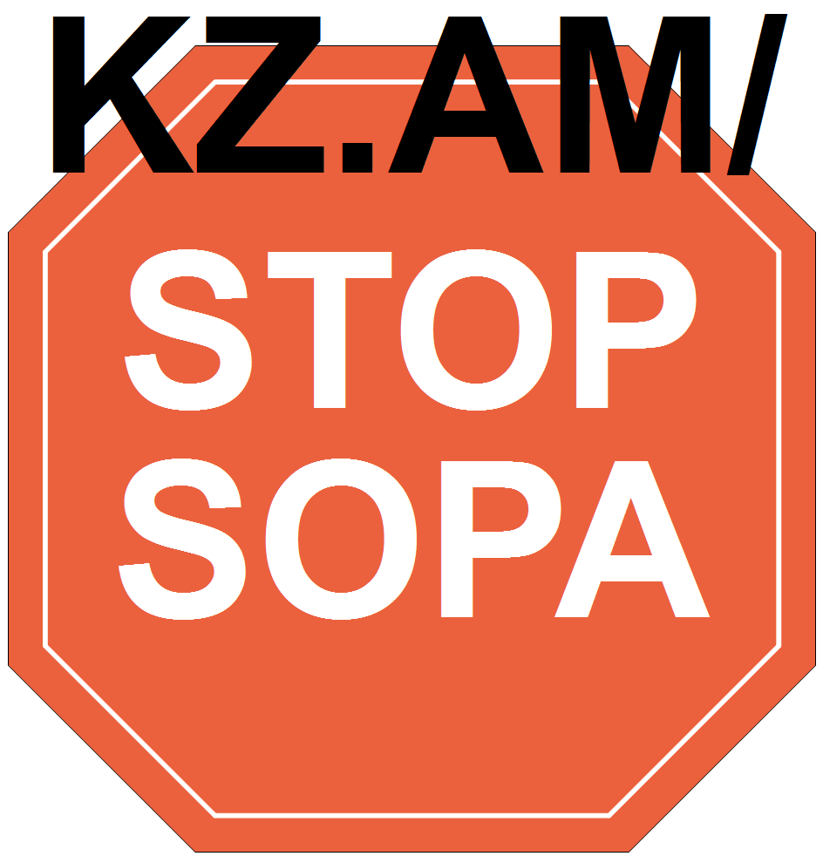
Press Statement
20 September 2000

IN SOLIDARITY WITH MASS PROTESTS
FOR THE OUSTER OF ESTRADA REGIME

By Jose Maria Sison, NDFP Chief Political Consultant

September 21, 1972 is once more remembered as the official date for the martial rule that was imposed on the Filipino people by the US-instigated Marcos fascist dictatorship. It is time for the people to make a new resolve to combat state terrorism and the plunder of the economy by US imperialism and the local reactionaries.
Since the fall of Marcos in 1986, the anti-Marcos reactionaries had celebrated from year to year the so-called restoration of democracy until the direct political and blood heirs of Marcos brazenly returned to power in 1998 with the Estrada ruling clique.
In fact, the toiling masses of workers and peasants and even the middle social strata have continuously suffered rising levels of oppression and exploitation. Defenders of the ruling system have deliberately downplayed human rights violations to conjure the image of democracy and misrepresent the anti-authoritarian uprising of 1986 as a revolution.
Now, as they are confronted by the US-directed Estrada regime, the broad masses of the people are driven to wage all militant forms of struggle by the unbridled puppetry, cruelty, corruption and mendacity reminiscent of the Marcos fascist regime. There is once more a broad united front of patriotic and progressive forces seeking the ouster of the Estrada ruling clique. All actions are being undertaken to isolate, weaken and destroy the regime.
I am in solidarity with the protest mass actions being undertaken by the Catholic and Protestant churches, Islamic groups, Kairos, PCPR, BAYAN, KMU, KMP, Gabriela, Anakbayan and other democratic organizations and personages against corruption, cronyism, economic mismanagement and the all-out war policy of the regime.
The US-directed Estrada regime is trying to deflect attention from these mass protest actions by claiming to go after the Abu Sayyaf but in fact it is bombarding Moro communities and destroying the lives and property of ordinary people. The regime and its military forces are proving to be far worse criminals than the Abu Sayyaf by killing and injuring far more people and forcing their evacuation.
The Abu Sayyaf is despicable for kidnapping civilians for ransom. But far more abominable, far more damaging and far more humiliating to the people is the reign of greed and terror of the multinational firms and banks, Estrada himself and his six families, the Marcoses, Lucio Tan and Eduardo Cojuangco. These are far bigger monsters.
The broad masses of the people must be tenacious in fighting against the Estrada puppet regime. Only by fighting for their national and democratic rights can they have the hope and accumulate the strength not only to oust the Estrada regime from power but also to end the entire ruling system and install a new system of complete independence, democracy, social justice and progress.
Significant advances have been achieved in the new-democratic revolution through protracted people's war. These include the emergence of more than one hundred guerrilla fronts and an organized revolutionary mass base in the millions. The tactical offensives of the people's army have reverberated throughout the country and the world. The revolutionary alliance of the NDFP and MILF is also advancing.
The US-controlled ruling system of big compradors and landlords is rotten to the core. Neocolonialism, especially under the neoliberal terms of imperialist globalization, has aggravated and deepened semicolonial and semifeudal conditions. The socioeconomic and political crisis is unleashing the most intolerable forms of oppression and exploitation and is goading the broad masses of the people to wage armed revolution. #

[From: http://rebolusyon.250free.com/Articles/2-2001/2-2001-3.htm (archived Dec. 7, 2004)]

