

Theoretical and Political Publication
Central Committee of the Communist Party of the Philippines

Number 2
Series 2001
April - June
English Edition
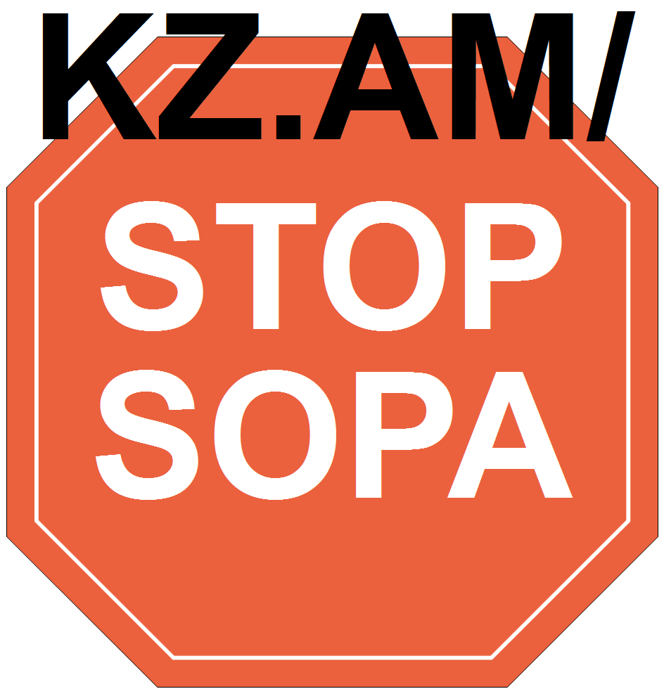
Press Statement
13 October 2000

EXTREME GREED AND FLAGRANT IMMORALITY
HAVE UNDONE ESTRADA

By Jose Maria Sison
NDFP Chief Political Consultant
Extreme greed and flagrant immorality have undone Mr. Estrada. Thanks to the insider expose made by Chavit Singson, Estrada is in the most shameful corner in the country.
Previously, he seemed to be able to get away with murder and with the biggest cases of corruption, in connivance with his cronies. But having so wantonly overextended himself in corrupt practices, he was bound to become completely exposed as a criminal.
Everyday that he clings to power, Estrada goads the people to rise up and those around him begin to consider association with him a grave liability and an intolerable shame.
Who would like to remain associated with a ruler now repudiated and detested by the people for doing nothing but thieving, carousing and grandstanding? Thus, Vice-president Gloria Macapagal has resigned from his cabinet. His allies in both houses of Congress now have to decide to distance themselves from him or else go down with him in ignominy.
The only way for the Mafia Godfather of the Philippines to avert impeachment or the people's uprising is to resign. He should heed the call of Cardinal Sin.
But Mr. Estrada might be unable to read the handwriting on the wall because he is still drunk with power and alcohol. He is also being urged to stay on by daytime president Ronnie Zamora and crooks like Lucio Tan, Danding Cojuangco, the Marcoses, Dante Ang, Atong Ang, Mark Jimenez and Mike Velarde (shaman and real estate racketeer).
The people and the united front of forces that are committed to removing Estrada from power must intensify all their efforts and apply all possible methods of further isolating him, thwarting all his maneuvers and compelling him to step down from office.
We expect the mass actions to mount on a nationwide scale in order to hold him accountable for his puppetry, corruption, the economic disaster and human rights violations. It is feasible to carry out protest actions that expose the gross incapability of the regime to rule.
We expect that Mr. Estrada would further lose support from his allies in Congress, business circles, the bureaucracy, the military and police, mass media and religious organizations.
We expect the revolutionary forces of the Filipino people and Bangsamoro to intensify their armed struggle for national liberation and democracy and prove the futility of Estrada's all-out war policy. As they have decided, they can carry out tactical offensives to prove the gross incapability of Estrada to rule. #

[From: http://rebolusyon.250free.com/Articles/2-2001/2-2001-5.htm (archived Dec. 7, 2004)]

