

Theoretical and Political Publication
Central Committee of the Communist Party of the Philippines

Number 2
Series 2001
April - June
English Edition
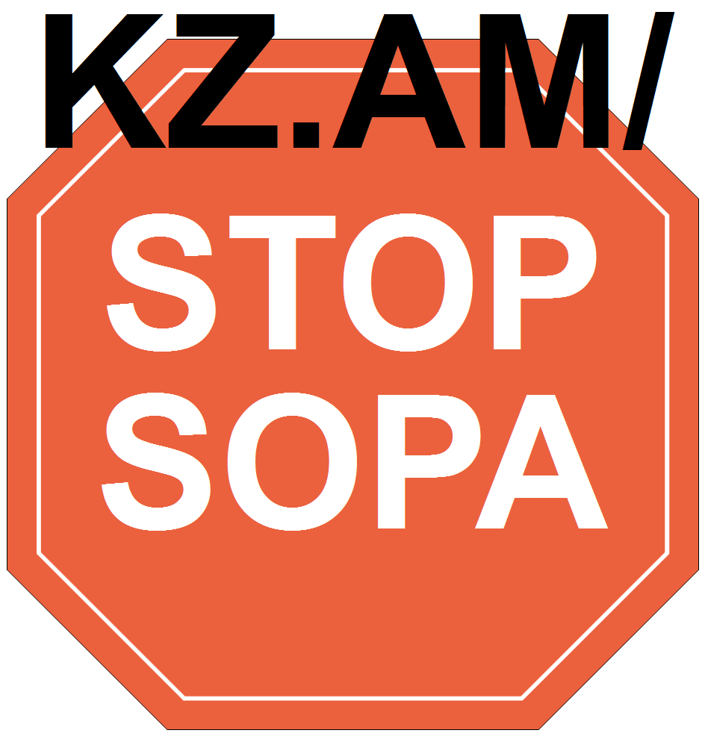

Press Statement
28 October 2000
BROAD UNITED FRONT MUST CONCENTRATE
ON ESTRADA RULING CLIQUE AS TARGET
By Jose Maria Sison
NDFP Chief Political Consultant
The objective of the current broad united front of the Left, Middle and anti-Estrada Right forces is to narrow down the target to the most reactionary and most rotten force in power, which we call the enemy, namely the Estrada ruling clique.
Against this objective, the Estrada regime is using certain pseudo-Left elements to flaunt ultra-Left terms in a futile bid to obfuscate the target of the broad united front and shield Estrada from the wrath of the people.
It is absolutely wrong now to put Gloria Macapagal at par with Estrada or to make her appear as worse than he. At the moment, she plays the special role of countering Estrada’s claim to constitutional and electoral support within the ruling system.
The time is still to come for Gloria Macapagal to succeed Estrada and become the enemy if and when she actually turns out as bad as Estrada or even worse and becomes accountable as the chief political representative of the local ruling classes.
As the probable successor of Estrada, Macapagal will certainly become accountable for the problems of puppetry, corruption, cronyism, the all-out war policy and human rights violations. She would go the ignominious way of Estrada if she would not solve but aggravate these problems.
Under the united front policy, the national-democratic movement can best fight only one enemy at every given time and take advantage of the splits among the reactionaries. The movement ought not to dissipate its strength and blunt its weapons by trying to put a current ally, even if unstable and unreliable, in the category of the current enemy.
In fighting well its current enemy, the national-democratic movement gains strength by being able to arouse, organize and mobilize the people in their millions. The movement proves immediately that it is a significant factor, even in the legal arena, for punishing any incumbent ruler who commits intolerable crimes against the people.
It will take a few weeks or a few months for the broad united front to oust or force the resignation of Estrada. The time scale is not enough for the national-democratic movement to gain such strength as to be able to overthrow the entire ruling system of big compradors and landlords.
Estrada has become such an isolated and weak target that legal and peaceful but militant mass actions can suffice to directly remove him from power.
It is so much easier to overthrow a rotten ruler than the entire ruling system whose coercive apparatuses cannot as yet be completely smashed in a few weeks or a few months by the armed revolutionary movement.
At the same time, the armed revolutionary movement of the Filipino people and Bangsamoro can intensify their tactical offensives in the countryside, while Estrada calls in more troops to the national capital region after having overstretched them on a wide scale as well as overconcentrated them in central Mindanao.
The ringleaders of the pseudo-Left grouplets are agents provocateurs and are paid agents of Estrada. They demand the simultaneous resignation of Estrada, Macapagal, Drilon and Villar in order to shield Estrada from the concentrated fire of the broad united front. They are carrying out the old shallow tactic of concealing one enemy by attacking the many. They are vainly trying to crack the broad united front aimed at removing Estrada from power.
The mix of harebrained calls for a Davide takeover, snap elections and insurrection are desperate and futile attempts to delay the removal of Estrada from power, mislead the broad united front or break the momentum of the mounting mass movement to oust Estrada from power.
The ringleaders of the pseudo-Left grouplets are isolated with Estrada and would become even more isolated if in the name of insurrection they would collaborate with the military psy-war agents of Estrada in disrupting mass actions, breaking shop windows, burning buses and cars and exploding bombs.
Every day that Estrada stays in power aggravates the socioeconomic and political crisis of the ruling system. The people’s war is advancing wave upon wave from more than a hundred guerrilla fronts and helps to strengthen the broad united front for the removal of Estrada from power. #

[From: http://rebolusyon.250free.com/Articles/2-2001/2-2001-7.htm (archived on Dec. 7, 2004)]

