

Theoretical and Political Publication
Central Committee of the Communist Party of the Philippines

Number 1
Series 2001
January - March
English Edition
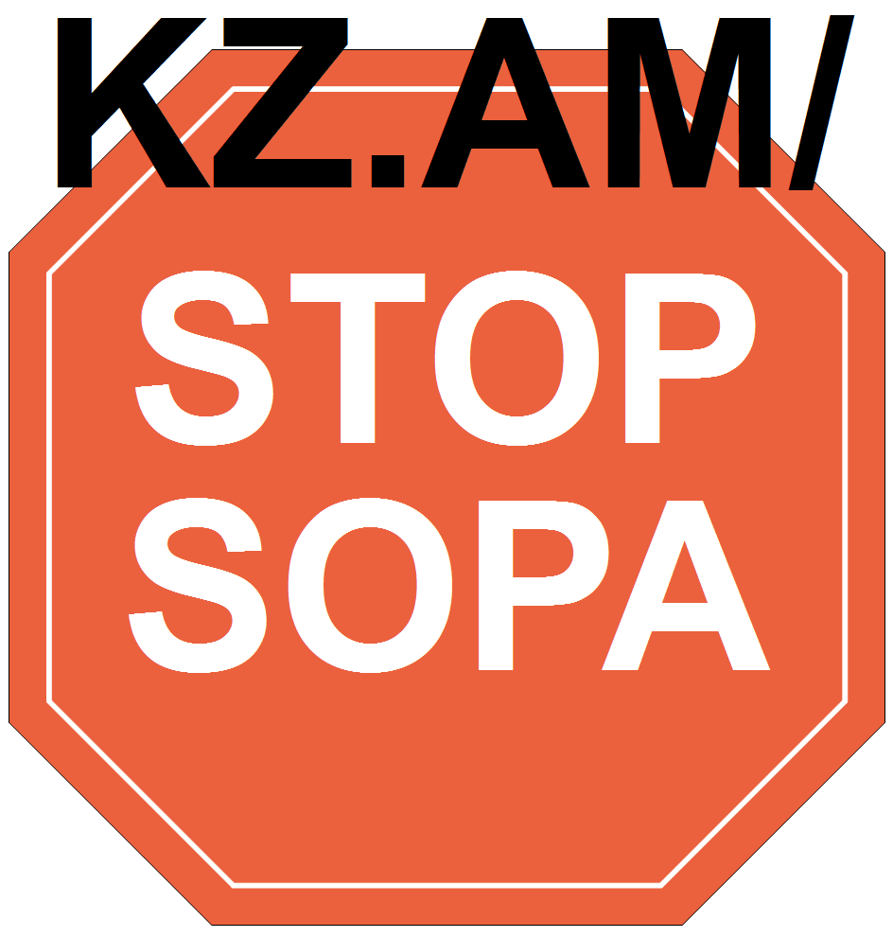

MEMORIAL TRIBUTE
FOR COMRADE ARMANDO TENG:
A GREAT PROLETARIAN LEADER AND HERO

by the Executive Committee of the Central Committee
November 7, 2000, Comrade Aryong, Armando Teng, member of the Central Committee, Political Bureau and Executive Committee of the Party Central Committee and secretary of the Party Regional Committee in Southern Tagalog, passed away. At the age of 49, he was at the peak of his life and service to the revolution. About 30 of his 49 years were devoted to relentless and hard revolutionary struggle-mostly guerrilla warfare in the southern Luzon countryside and the first four years in the movement in Metro Manila.
In 1979, while participating in the restrengthening of guerrilla fronts in Bicol, he was stricken with a serious kidney ailment, with his doctor saying that he had a limited time to live. With exemplary steadfastness and exceptional optimism and with the care of his loving family and comrades, he overcame the crisis. He returned to the countryside and took on the weightiest responsibilities, far surpassing those who were not ill.
But since 1998 and after many years of virtually miraculous remission, his illness began to worsen. The symptoms quickly passed with his use of new medication, and he continued performing his responsibilities without fail. The fact that he felt better, relentless attacks by the reactionary enemy and most of all, his assiduousness that he further manifested with the outbreak of crisis in the moribund US-Estrada regime unfortunately caused him to push his body to the limit, miss scheduled check-ups and belittle the sudden downturn in his health that left him bedridden and eventually led to his untimely death in a few days.
The Party, people’s army and revolutionary movement are in mourning. A great revolutionary proletarian leader and hero, one of the most steadfast and most successful advocates of Marxism-Leninism-Maoism and people’s democratic revolution, is gone. Comrade Aryong played an important role in establishing and expanding guerrilla warfare in Southern Tagalog and Bicol. Nonetheless, his unique contribution lies in his primary role in the Second Great Rectification Movement in Southern Tagalog and his leadership in the latter’s restrengthening.
Although among those that suffered the biggest setbacks due to serious internal errors and the overall offensive of the puppet state in the second half of the 1980s, Southern Tagalog under the leadership of Comrade Aryong took the lead in rising above its setbacks and served as an anchor and inspiration in the revolution’s revitalization nationwide. Not only did the Party recover; it surpassed its past record of expansion and strength. It actively assisted other relatively weak and backward regions while continuing to strengthen itself.
Twelve Philippine Army and Marine battalions and thousands of PNP assault troops and CAFGU paramilitary forces were deployed to the region, with its villages and town centers targeted by relentless military offensives and counterrevolutionary intelligence and psywar operations, both big and small. But this did not stop the advance of guerrilla warfare and the mass movement. It is in this manner that the revolutionary forces in the region were able to uniquely contribute to exposing, isolating and weakening the reactionary ruling US-Estrada regime. Comrade Aryong had anticipated bigger advances in the revolutionary struggle as a result of the all-out crisis of the despicable regime and called for the intensification of mass protests and tactical offensives before he died.
Comrade Aryong was daring in advancing and intensifying the armed struggle not because of any innate impetuosity but because of the depth of his grasp of the crisis of semicolonial and semifeudal Philippine society and its rapid intensification due to the decadence of the capitalist system in the era of imperialism. It is also due to such an understanding that he continued to accord the people’s army and armed struggle the highest priority, as proven by his personal leadership in this matter despite his health problems.
Nonetheless, his stress on armed struggle also meant a constant stress on the integral relationships among armed struggle, agrarian revolution and base-building and advancing the line of protracted people’s war. It will be noticed that Southern Tagalog under his leadership was not only at the forefront of armed struggle but also of various other arenas of struggle, including the mass movement in the countryside and cities, alliance work, Party ideological building, propaganda work and others.
Comrade Aryong was known to be resolute when it came to proletarian revolutionary principles and courageously took on responsibilities and fought for these principles. In 1974, while serving as the leading member of the Manila-Rizal Regional Committee, he was among those captured in a massive wave of arrests that hit the underground movement in Manila-Rizal and the Party’s central organs. The butchers of the US-Marcos fascist dictatorship unleashed an orgy of torture in their desire to extract information leading to the capture of Chairman Amado Guerrero.
Comrade Aryong was among those who led in exposing and resisting the brutality of the fascist dictatorship. He also tenaciously objected to the trend among political prisoners to capitulate and retreat. He condemned those who allowed themselves to be used by the enemy and who gave information that harmed other comrades and demanded appropriate punishment for this. After two years, he successfully escaped from prison in Bicutan and was assigned to the Bicol countryside.
As a member of the Central Committee, he was in the midst of debates, decision-making and struggles to advance the Second Great Rectification Movement. He steadfastly stood for Marxism-Leninism-Maoism, the line of people’s democratic revolution and the Party’s integrity against revisionism, opportunism and factionalism. He was armed with a militant proletarian consciousness honed through many years of studying revolutionary theory and applying this in life-and-death struggle, living close to ordinary peasants and other impoverished folk, and relentless remolding.
It was also significant that at the time that struggles were intensifying on the grave deviations and errors within the Party, he was assigned to the National Instruction Bureau (1986 to 1988). He took advantage of the situation to review and read works of the great Communist teachers and publications of the Party to arrive at a correct analysis and standpoint on leading issues.
In the intense two-line struggle, he did his best to save the biggest number of those who committed errors and deviations and suffered from confusion. But he did not hesitate to turn his back on those who relentlessly waged sabotage and those who earlier on had repudiated the Party, revolution and rectification, like his longtime comrade and friend Sergio Romero. He had only the most intense repugnance for those who sowed intrigue, and were manipulative and two-faced like Arturo Tabara, Romulo Kintanar, Popoy Lagman and Ricardo Reyes.
Throughout his life in the Party, Comrade Aryong loathed bureaucratism and its attendant corruption and anomaly. He ardently advocated a lifestyle of living close to the masses and ensuring that those in the leadership were always aware of the situation and grievances of the masses.
In terms of style of leadership, he was particular about the need to investigate the conditions of those at the lower levels and directly inquire about the work of members. Wherever he was based, he made sure of acquiring first-hand knowledge of, and supervising the work in, surrounding villages. He also always set aside some time to be close to ordinary Red fighters and help them out with their personal and other problems.
Comrade Aryong was strict about Party discipline and the fulfillment of duties and responsibilities. Sometime, in stressing the latter, he would let out stinging rebukes that hurt other comrades. Nonetheless, whenever he was directly criticized, he was quick to take them back, self-criticize, apologize and rectify. In any case, if he was strict with others, he was even more strict with himself. He immersed himself in Party work and worked day and night whenever this was what the revolution demanded. Up to the last, first and most important to him were his revolutionary duties and kept the best of relations with his comrades and immediate family..
Comrade Aryong was born in Tanza, Cavite. He studied at the University of the Philippines at the height of the crisis prior to fascist military rule and became a member of the Kabataang Makabayan during the First Quarter Storm of 1970. He was invited to join the Party in 1971, assigned as a member of the Party branch at the University and eventually, as the branch secretary and member of the District Committee of Quezon City-Marikina.
We will never forget the heroism of Comrade Aryong for the country, the Party and the revolution. Fulfill his most ardent wish: Overthrow the corrupt and reactionary US-Estrada regime, expand and intensify the revolution! #

[From: http://rebolusyon.250free.com/Articles/1-2001/1-2001-4.htm (archived Dec. 7, 2004)]

