

Theoretical and Political Publication
Central Committee of the Communist Party of the Philippines

Number 4
Series 2000
October - December
English Edition
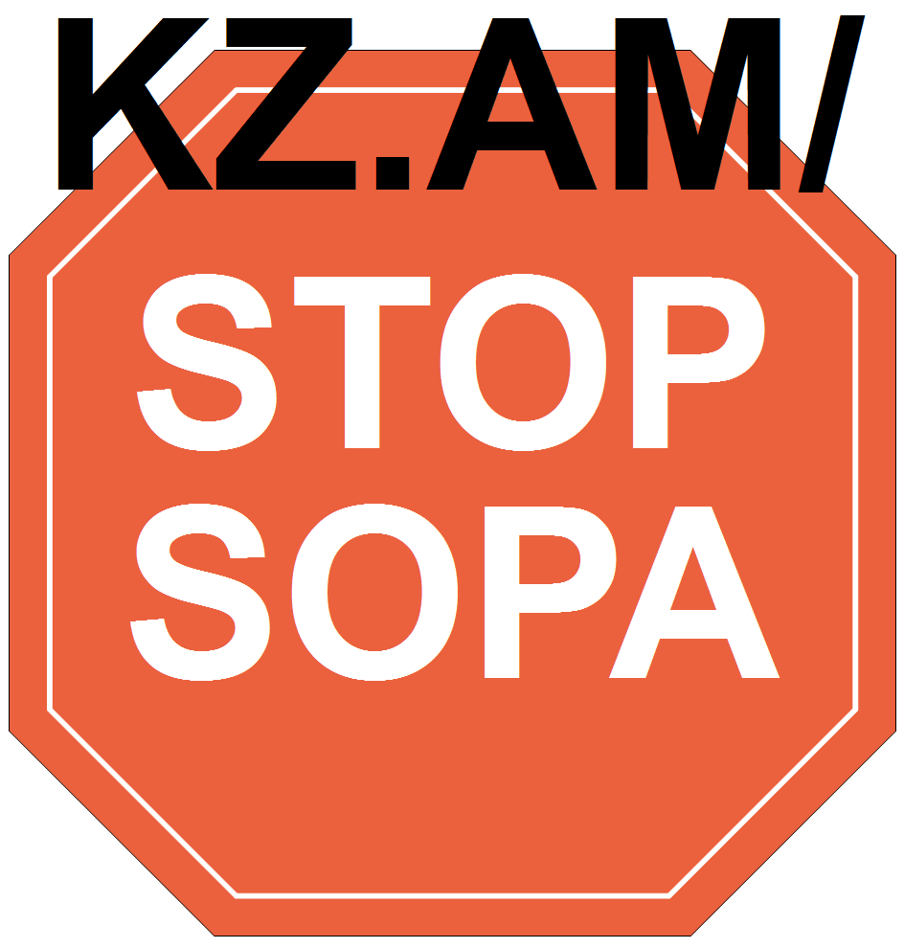

INTENSIFYING FASCIST ATTACKS
SHOWCASE THE FURTHER DECAY
OF THE US-ESTRADA REGIME
Ang Bayan Editorial, July-August 2000
The US-Estrada regime spits bullets and spews poison in the hope of cowing the people and averting the growth of struggles against the fascist regime. As it grows more desperate, the US-Estrada regime raises the level of intensity, brutality and destruction wrought by its fascist attacks against the people.
Peaceful demonstrations and mass actions are now viciously assaulted as in the brutal attack on the anti-Estrada demonstration held in Quezon City in July and the all-out use of force to suppress the LRT workers' strike. Such viciousness is comparable, and in some cases exceeds, the Marcos dictatorship's all-out use of state power during martial law to suppress even the unarmed struggles of the people.
Estrada is further strengthening the machinery for military rule in the countryside. On August 1, he started augmenting by 30,000 men the 33,000-strong fascist CAFGU to intensify further the fascist campaign of suppression and terror in the countryside. There is the distorted official belief that the revolutionary armed struggle can be defeated through absolute superiority in arms and by putting the population under military surveillance and control.
The fascist state's record of violating human rights and international rules of war are worsening. Large-scale military operations destroy the masses' crops, livelihood and property. There are more and more cases of massacre, murder, disappearances, torture, illegal searches, arrests and detention. Captured NPA fighters are denied the status of prisoners of war and are deprived of their corresponding rights; usually denied treatment when wounded and systematically tortured before being executed.
A fascist campaign of disinformation accompanies intensified fascist violence. Led by the very chief and officials of the AFP and PNP, lies against the revolutionary movement are systematically woven and spread.
In a desperate attempt to besmirch the revolutionary movement, they employ the lowest types of propaganda characterized by outright distortion of the truth. The AFP accused the NPA of violating international rules of war when it ambushed on June 27 an AFP "medical mission" in Jones, Isabela, which was, in fact, a brigade-sized operation to sow terror and destruction on the people opposed to the construction of a cement plant in their area. Also, in order to portray the NPA as having reneged on the agreement to release the two prisoners of war in Southern Tagalog, the AFP announced on July 22 a farcical suspension of offensive military operations.
The desperation of the US-Estrada regime grows ever deeper as the economic and political crisis worsens. Contrary to Estrada's boastful claim that the economy is on the rebound, the Philippines continues to suffer from a deep crisis brought about by the government's unrestrained implementation of liberalization, privatization and deregulation. This results in the further ruination of the people's livelihood and standards of living, especially workers and peasants who already suffer from the most wretched conditions.
Estrada and his economists brag about the $16 billion reserves and the $2.28 billion trade surplus. Bragging on the basis of such data is a desperate attempt to make it appear that the economy is sound because these very figures indicate not an economy on the rebound, but one that is slowing down on import-dependent production, and thus, is in the throes of a worsening crisis. In fact, in the first quarter of this year, listed investments fell by 90%, including a 70% drop in direct foreign investments.
The government cannot deny the worsening unemployment. Despite manipulation, official statistics show a 54% increase in the number of unemployed from January to April.
The government wishes to carry out pump-priming programs including large infrastructure projects such as the construction of dams, ports, airports, bridges, roads and others. But the fall in local production, the all-out pouring of funds to advance the military campaign and strengthen the fascist machinery and the widespread embezzlement of public funds by bureaucrat capitalists have depleted the government's resources. This year, the budget deficit is expected to reach P80 billion, more than the original target of P62.5 billion. In 2001, the budget deficit is expected to surpass the P82.5 billion target.
To finance its pump-priming projects, the government is set to borrow close to $2 billion from foreign banks and institutions, primarily from the World Bank, the IMF and the ADB. To date, Philippine external debt has reached $58 billion.
Thus, Estrada is going all-out in the implementation of the policy dictates of these imperialist banks. While other countries are slowing down on liberalization because of the crippling destruction it has caused their own economies, Estrada is going full-speed in auctioning off to foreigners the Philippines' national patrimony. The retail trade, one of the last economic fields under exclusive Filipino control, has also been opened to foreigners.
Estrada gives foreign big capitalists complete liberty to plunder the country's resources and earn superprofits even if it devastates the people. Despite widespread opposition, oil companies freely raise their prices (twice in July), spurring continued increases in the prices of commodities. This and the continued freezing of workers' wages has led to the rapid decline of the toiling people's living conditions.
The extent of the US-Estrada regime's political isolation from the Filipino people is growing. The pro-imperialist and anti-people policies being carried out by Estrada further enflame widespread resistance among different sectors nationwide. There is a growing number of strikes and street demonstrations characterized by militancy, not only for the democratic interests of the oppressed sectors, but also against Estrada's continued stay in power. The all-out anti-Moro war has not only isolated Estrada from the Moro people and leaders, but also from non-Moros who are angered by the devastation wrought by its fascist campaign.
The brazen granting of favors to Estrada's rapacious cronies, including the Marcos family, Lucio Tan, Danding Cojuangco and Estrada's various wives and children, further deepen the factional conflicts among the ruling class. More and more are being disfranchised by such out-and-out cronyism, resulting in Estrada's further isolation even among the ranks of the reactionaries. Anti-Estrada factions continue forming organizations and gathering influence among big business and former government officials. Anti-Estrada groups are also being formed within the military. They take advantage of the low troop morale born out of the failure to crush the MILF and the continued strengthening of the revolutionary armed struggle; and the disgust among officials overstepped in promotions and appointments to desired positions because of Estrada's favoritism.
Estrada continues to enjoy US imperialism's principal support. This was underscored by the military and economic aid extended by Clinton to Estrada during the latter's US visit in July. Still, this does not mean that US imperialism does not extend any form of support to the anti-Estrada reactionaries. Just as in Marcos' case, the US is ready to drop Estrada once he is deemed detrimental to the stability of the ruling system.
The people's anti-Estrada unity should be further broadened. The struggles of workers, peasants and other oppressed sectors should be tirelessly advanced and linked to the struggle to oust the Estrada government. Along with this, we must take advantage of the widening rifts within the ruling class by openly and discreetly, directly and indirectly cooperating with anti-Estrada reactionaries and coordinating in activities against the ruling regime.
While fascist crimes become more brutal, the need to advance the revolutionary armed struggle becomes ever clearer and the situation becomes ever favorable for its intensification nationwide. The NPA should be strengthened for this purpose and for the all-round intensification of people's war nationwide.
The deployment of a large bulk of reactionary troops in Mindanao and other regions like Southern Tagalog must be taken advantage of by launching more tactical offensives against relatively small and isolated enemy units. We must also take advantage of the enemy's inability to absolutely concentrate its troops in all areas. Even in Mindanao or Southern Tagalog, there are always opportunities to intensify tactical offensives because the enemy is unable to concentrate its forces at all times in all areas.
While his government becomes more rotten, there is more solid basis for ousting Estrada from power. Everyday, the situation becomes ever favorable for advancing and strengthening the revolutionary movement. #

[From: http://rebolusyon.250free.com/Articles/4-2000/4-2000-2.htm (archived Nov. 24, 2004)]

