[From Ang Bayan, #16, Aug. 21, 2007]

CPP assails American troops’

presence in combat zone

The Communist Party of the Philippines severely criticized the direct intervention of American troops in ongoing military operations in Sulu this month.
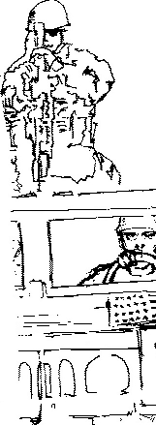
Reports indicate that foreign troops are not simply joining patrols and combat operations. They actually direct military offensives. A reporter has, in fact, taken videos of US Special Forces aboard a Humvee leading a convoy of Filipino soldiers in Indanan, Sulu conducting operations against the Moro National Liberation Front.
Opposition senators and congressmen as well as elements from the broad anti-imperialist movement have also criticized the American troops’ violation of the country’s sovereignty. It is common knowledge that the Arroyo regime has concocted the war in Sulu and Basilan, to the detriment of the Moro people, to create a pretext for the continued presence of American troops and their leadership and direct intervention in local military operations.
American troops have long been deployed in Mindanao. Their intervention and direction of large-scale military operations in the Moro people’s territories have also long been exposed.
Officials of the regime have also been compelled to admit this month the presence and ongoing operations in different areas in the country of agents of the US Central Intelligence Agency as well as other foreign intelligence groups. Their covert and dirty operations are directly linked to the combat operations being conducted by American troops in the Philippines.

[From: http://www.philippinerevolution.net/cgi-bin/ab/text.pl?issue=20070821;lang=eng;article=04
(archived Oct. 6, 2007)]

