Short presentation of Serve the People – Communist League of Norway (Tjen folket – kommunistisk forbund)
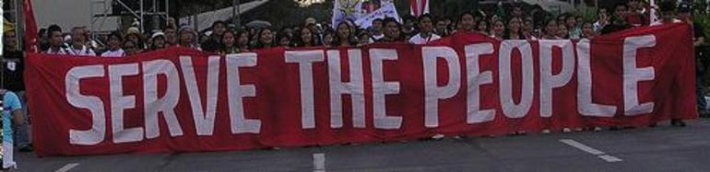
Serve the People – Communist League was founded in 1998. The founding members were expelled from the Workers’ Communist Party (AKP) and Red Youth (RU). The conflict leading to their expulsion was over the line for communist work in the mass organisation SOS Racism (a front against racism), but the root to the conflict was in reality differences in political-ideological lines.
Serve the People was a very small group. Its original name was Serve the People – a Marxist-Leninist Group, but it changed its name in 2009. It has grown slowly during ten years of political practice mostly through mass work against racism. After the merging of AKP and Red Electoral Alliance (RV) in to the party Red (Rødt) the group has been revitalised with new members from the liquidated AKP and among the Red Youth.
Serve the People are Marxist-Leninist and Maoist. It has no formal connections internationally, but has ideological similarities with the ICMLPO (MLPD and CP Philippines) and RIM.
- Serve the People denounces the Dengist counter revolution in China;
- Serve the People use MLM as guiding line for the political work;
- Serve the People defines Red party (Rødt) as a broad left alliance with revisionist and social-democratic tendencies;
- Serve the People develop methods of work and leadership different from those AKP used the last 25 years;
- Serve the People develop criticism of the revisionist development of AKP from 1980 till 2007;
- Serve the People upholds armed revolution and proletarian dictatorship as the only road the communism – also in the western imperialist countries.
Serve the People struggles to strengthen Maoism in Norway and to build a new revolutionary communist party on the foundations of MLM. This must be done trough building red base areas, metaphorically speaking. The communists in the West are weak and we must concentrate our forces in a certain amount of struggles to gain strength and create new communists.
Some of the members of Serve the People are also members of Red party and Red Youth. This is because we support Red in the elections as the only national alternative to the pro-imperialist and neo-liberal hegemony.
However, in 2008 our national spokesperson Henrik Ormåsen was expelled from the [Red] party in April. In their youth organization Red Youth twelve members were expelled in June because of their «connections with Serve the People». And in September two of these were also expelled from the Red party after they went in front to build up a new communist youth organization under the leadership of Serve the People, Revolutionary Communist Youth (Revolusjonær Kommunistisk Ungdom).
Serve the People wish in the future to establish more international contacts, especially in the countries oppressed by imperialism and where there are advanced peoples wars and revolutionary struggles.
You can easily reach us at post@tjen-folket.no.

[From: http://tjen-folket.no/Sentralt/view/10260 (11/01/10)]

