MyRepublica
Hardliners push for revolt, delay in [army] integration

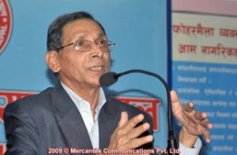
Mohan Baidya

KATHMANDU, January 29, 2010: Sharp differences have surfaced in the UCPN (Maoist) over the party´s next strategic move and direction. The party´s hardliners led by Senior Vice-Chairman Mohan Baidya have pitched for declaring India the main enemy and going for an immediate revolt. Baidya has also called for delay in the integration and rehabilitation of Maoist combatants to help start preparations for a revolt. Another vice-chairman, Dr Baburam Bhattarai, backed by some of the party´s influential leaders, has, however, staunchly pushed for writing the constitution and completion of the peace process.
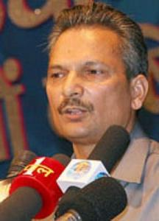
Baburam Bhattarai

The shimmering intra-party differences have come to the fore at the ongoing Standing Committee meeting that began on Tuesday.

Responding to Maoist Chairman Pushpa Kamal Dhala´s analysis of the current political situation and the party´s future strategy, Mohan Baidya argued that the party should identify foreign forces, particularly India, as its main enemy and launch an immediate revolt to achieve the party´s ultimate goal -- dictatorship of the proletariat.
“Our main contradiction is with India, and it should be termed the party´s chief enemy…. We should also immediately go for a revolt to achieve the party´s goals,” a party leader quoted Baidya as saying at the Standing Committee meeting Tuesday. He argued for delay in the integration and rehabilitation of Maoist combatants since the party would need them for the revolt.But Dr Bhattarai argued that the party should focus on constitution writing and concluding the peace process as the party currently lacks popular support for such a revolt, and it would be counter-productive. “If foreign forces and political parties conspire against the peace process and constitution writing, that would give justification for a people´s revolt and we will gain mass support for it,” a standing committee member quoted Dr Bhattarai as saying.
The Maoist vice-chairman also argued that indentifying outsiders as the arch enemy would undermine the party´s struggle to end feudalism at home. “You cannot break the wall with your elbow, it needs a sledgehammer,” the party leader quoted Dr Bhattarai as saying.
According to the party leader, Dahal´s political proposal lacks clarity, though he seems to have favored the hard-line camp. “But it will not be unusual for him to switch to the stronger camp,” he said. It has also been learned that Dr Bhattarai is likely to challenge the party chairman´s strategy and present a separate political paper at the Maoist plenum slated for mid-February, if he fails to push through his strategy.
Bhattarai´s position has become stronger after the release of the party chairman´s indoor speech tagging him as India´s choice for the next prime minister. “He has received wide support and sympathy, especially from the second generation of influential leaders,” said the party leader. Leaders like Top Bahadur Rayamajhi, Dinanath Sharma, Barsaman Pun and Lilamani Pokharel have already backed the line for peace and constitution writing.
“The most worrisome factor for the chairman is that top PLA officials loyal to him are switching sides too,” he said.

http://www.myrepublica.com/portal/index.php?action=news_details&news_id=14582

