The Hindu
(Oct. 5, 2009)

‘We will lead a government soon’

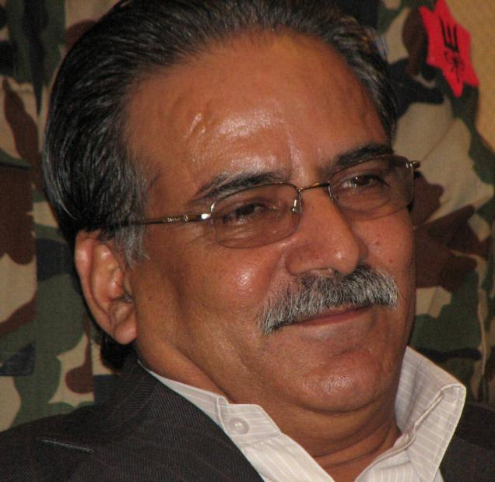

PRACHANDA: We want to show that the relation
between the Maoists and the people is intense.
Photo: Prerana Marasini

By Prerana Marasini
If the Interim Constitution is trampled upon and the country is pushed towards confrontation, people will revolt. Our party will try to take the lead, says Prachanda.
The Unified Communist Party of Nepal (Maoist) has been protesting since May against President Ram Baran Yadav (who had reinstated then Army Chief Rookmangud Katawal) with a demand for the restoration of civilian supremacy in Nepal. The major Opposition party’s continuous obstruction of the legislature parliament has affected the constitution-writing process but the Maoist Chairman, Pushpa Kamal Dahal ‘Prachanda’, says his party will not be responsible if the constitution is not drafted on time. Excerpts from Mr. Prachanda’s interview to The Hindu :
How far have you reached in restoring civilian supremacy in the last couple of months?
In the initial phase, the major political parties of this government were very negative. At this juncture, I feel the parties have realised that moving forward without addressing the Maoists’ demands is not just not right but also impossible. They have started to realise that without the Maoists’ participation, neither can the constitution be prepared nor can the peace process be completed. They are, therefore, trying to forge a consensus.
Lately, there have been intense discussions among the parties to introduce a common proposal to address our demands. Although I don’t think this proposal would be finalised soon, the process is taking a positive direction
So how much do people know about civilian supremacy?
We had a host of nationwide programmes in these months. Thousands of people showed up and listened to us intently. What people have understood is that there is a conspiracy by those who lost in the elections to isolate the Maoists — the party that was voted the largest. This, they know, is not civilian supremacy. This is how they have understood it.
Were your protests, which involved showing black flags to the President, the Prime Minister and the Ministers and throwing stones at their vehicles, reflective of a creative opposition?
It is against our policy and programmes to throw stones, which happened at some places and we are sorry about it. Overall, we carried out peaceful protests. We don’t think the impact of these protests were negative.
You met President Ram Baran Yadav on Wednesday and you said the talks were positive. Can we say your protests were not effective enough and that is why you had to meet the President personally?
Quite the opposite. All our protests of boycotting their programmes and our mass assemblies had an effect on the political parties, organisations, and individuals which led to the belief that it was not right to isolate the Maoists. And in that atmosphere, I met the President. So our understanding is that as a result of our protests, that atmosphere was created.
What did you discuss with the President?
I used to have good interaction with him when I was leading the government. I had not met him after my resignation. [During the meeting] we exchanged our views on why things changed in the later stage. I said: “I hadn’t imagined that you would take a step against the norms of interim constitution and reinstate the Army Chief. Since you were not satisfied with the decision [to sack him], I rather thought you would send me a letter asking me to reconsider the decision. And in case I did not do that, you would probably ask the Court to look into the matter but you completely reversed the government’s decision.” I also told him that the maximum I expected from the political parties was a no-confidence motion and I was prepared to face it. I had not imagined that they would approach the President to fail the Maoists and request him to take an unconstitutional move.
What did the President say?
He said: “I did not take the step under pressure from anyone. The situation was becoming difficult, and as a way to stop it, I dodged your step. But my intention is not to go on like this forever. I am ready to do anything to have a consensus. Maoists are the major strength and that you yourself should come forward.” In conclusion, he said the present stagnation should be broken. I informed him that the parties were trying to forge a consensus and in case no consensus was gathered, I would meet him again.
Does the President want the Maoists to lead the next government then?
He did not exactly say that but as Maoists constitute the largest party, he said it should join the government. He also suggested that he would not have problems if we led the next government.
You have been saying since you resigned from the government that Maoists will form a new government. When will that happen?
If you talk about the present government, it is accepted neither by the people nor by the Maoists, and actually it’s not functioning.
Why is it not functioning?
Because the public does not have faith in it. You see the majority of the leaders of the ruling CPN-UML are against the President’s move. It is an open secret. The government is functioning in a hypocritical manner.
But it is your party that is obstructing Parliament. If tomorrow, the Constitution is not delivered in time, wouldn’t your party be guilty? Will not the people’s faith be lost?
People know that Parliament is obstructed not because of the Maoists but because of the conspiracy of those who lost in the elections, those who maintain the status quo and the regressive elements together quashed the interim constitution. The Maoists have not resorted to vandalism, strikes and closures, and are still responsible. People rather question why the parties in the government don’t try to correct the move. So they won’t blame us. And I don’t think the Constitution will not be prepared on time as the parties are moving ahead with a consensus. However, if this situation persists — civilian supremacy is not restored, Maoists are compelled to launch a movement, and the constitution is not written, the Maoists would not be guilty.
How do you think the issue of civilian supremacy should be addressed as the Nepali Congress and the CPN-UML don’t want to discuss the resolution?
The easiest option is to discuss the resolution and vote in the House. We will accept even if we are in a minority as our position will be clear. If sovereignty resides in Parliament, it will be very shameful and unfortunate on the part of the parties that claim to be democratic not to allow the discussions. We feel we’ll have a majority as a majority of UML leaders — its Chairman, Vice Chairman — are against the Presidential move. In case they issue a whip and we are in a minority, we’ll accept it. The Nepali Congress and the UML can also declare their position. So this would be the best option.
Secondly, we can consider a common resolution motion if it’s in a win-win situation.
Thirdly, there might come a situation where the President will have to clear the issue. If he puts his views across to the people, it could play a role in addressing this issue. And finally, the interim constitution could be amended so that the duties and authorities of the President and the Prime Minister are clearly defined.
You’ve been saying that your party would launch a third revolution that would be supported by the U.N. What kind of revolution is it? Would it be against the peace deal?
We’ve been suggesting a revolution. We haven’t declared the revolution yet.
What we want to do is to show the parties in the government that the relation between the Maoists and the people is intense, which would inspire them to arrive at a consensus. It’s true that if a consensus is not arrived at, we will declare a revolution.
With the U.N.’s support?
The U.N.’s support is wrongly interpreted. What we mean is that the U.N. does not go against people’s right to revolt. It recognises people’s right to rebel. If the Interim Constitution is trampled upon and the country is pushed towards confrontation, people will revolt in the form of a third revolution. Our party will also be involved in it and would try to take the lead. This wouldn’t be opposed by the United Nations.
Would it be an armed revolt?
No, no. We’re not talking about arms now. It will be peaceful.
When will it be launched?
If there is a consensus, it won’t be needed now but if the parties don’t give up their rigidity and try to move ahead isolating the Maoists, we won’t be isolated. We will have to prove that we have a sea of people, and we will declare the revolt.
Why not let the coalition government continue until a new Constitution is written and elections are held?
This coalition is not backed by the people, it is against the spirit of election and the Constitution, so we’ve been saying a new alliance — joint national government — is needed with the Maoists, the largest party, in the lead. If it’s not done, we’ll not accept.
The constitution-drafting process is associated with the peace process. The Maoists have a 50 per cent stake in the peace deal that was signed with the seven parties. Can there be peace, sidelining the 50 per cent stakeholder?
Only when there is consensus to form a government in Maoists’ leadership, can a Constitution be written and the peace process will end.
So, can we see the Maoists’ government next month?
I don’t want to give a date now but that situation is developing.
How is your relation with India after resignation? You met the Indian ambassador on Thursday?
We made it clear while resigning that we won’t bow down to any regressive, feudal elements of the country and foreign powers that try to dictate to us.
It’s true that India played a positive role in bringing a change in Nepal by helping us sign the 12-point agreement. But in the later stage, there were some confusions and gaps. At this point, what I feel is India wants a consensus built in Nepal so that the peace process successfully ends.
Through my meetings with the Indian ambassador and other Indian leaders, intellectuals, and journalists I see a large group of Indians who believe that the Maoists should not be isolated but should be in the government to actively contribute to the constitution drafting and peace process. I feel the government of India is also positive about seeing our peace process end successfully.
Is the Maoists’ relation with India — that had been cold earlier — improving?
Yes, I feel it’s improving slowly.
Does India want the Maoists to take the lead?
Our talks haven’t reached there but probably we will talk about it. At the moment, we are trying to forge a consensus in the country and we hope our foreign friends including India will support us.

http://beta.thehindu.com/opinion/interview/article29571.ece

