That was a good show

OpEd Commentary by Hisila Yami
eKantipur, November 16, 2009

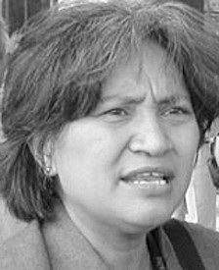

What started as a focus on protests against military supremacy has silently led to a focus on support for civilian supremacy. The retirement of Rookmangud Katawal, the ex-military chief and the main person who triggered the present crisis, has de facto diverted the attention of the United Communist Party of Nepal (Maoist) to support civil supremacy. This means the Maoist party has now shifted its attention to House supremacy whereby the unconstitutional move of the president overruling the then prime minister’s order should be tabled for discussion at the CA. However, this shift has not brought any consensus between the Maoists and the governing old mainstream parties.

At present, both hands of the Maoists are filled with agendas. The right hand represents civil supremacy, making a people’s republic constitution, adhering to the peace agreement, safeguarding nationhood and making a national coalition government. The left hand represents upholding class, ethnic, regional, gender and Dalit issues. In contrast, the governing old mainstream parties have no agenda except to stay in power by hook or crook. They are shamelessly alleging that the Maoists are using civil supremacy as a ploy to capture state power. They forget that the Maoists had resigned from government, not once but thrice, of their own volition on moral grounds.

Among all the above agendas, civil supremacy stands tall as it is on this footing that the rest of the issues can flourish, advance and become institutionalised leading to democracy, peace and stability in the country. To make this point heard, the United National People’s Movement (UNPM), a united front of the UCPN (Maoist), declared a package of protests spanning 13 days. It started with a warm-up consisting of torch rallies (mashal) throughout the country on Nov. 1. This was followed by a gherao of the offices of 58 municipalities and nearly 4,000 village development committees across the country on Nov. 2. Then came a gherao of the district administration offices in all the 75 districts on Nov. 4 and 5. This was followed by a blockade of the capital valley, Kathmandu, at six entry points on Nov. 10. The climax of the series of protests was the encirclement of Singha Durbar, the secretariat of the Government of Nepal, at eight points for two days on Nov. 12 and 13. Thus for 13 days, the protests paralysed the whole functioning of the present government!

The success of this demo lies in the fact that it mobilised all sections of society. Cine artists came forward to show their solidarity by singing, dancing and airing their views, painters came to portray the current mood on canvas and poets came to recite befitting poems to charge the mood of the people. Cultural groups belonging to the Newar, Magar, Tamang, Kumal, Dalit and other communities performed their dances and songs giving a true festive mood to the whole movement. The highlight of the whole street movement was the presence of senior leaders including Prachanda, chairperson of the UCPN (Maoist) and Baburam Bhattarai, vice chairperson of the CPN (Maoist) and UNPM president, who were on the streets from dawn to dusk cheering and controlling the people and cadres.

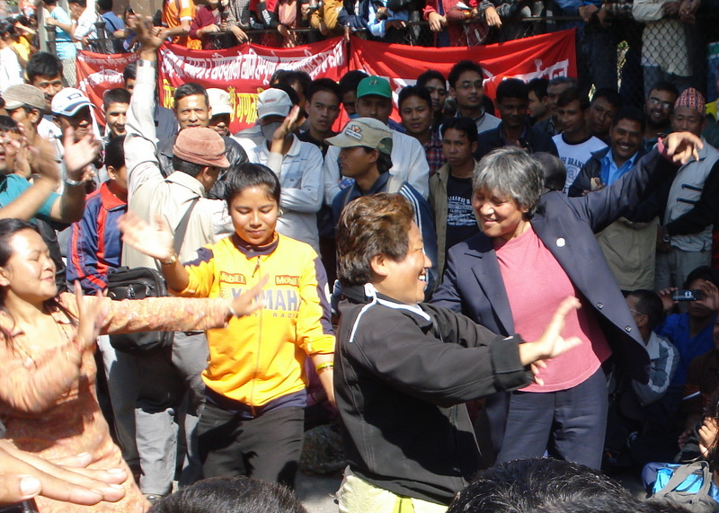

Hisila Yami dances along with supporters outside the Kathmandu Metropolitan City Office
[From Neil’s Nepal website (http://neilsnepal.wordpress.com/), Nov. 2, 2009.]

The speeches focusing on civilian supremacy could not but have influenced the civil police as they are very aware of the effect that democratisation of the military has had on their own relationship with it. The speakers tried to harness their support by reminding them of their class, ethnic, regional and gender fraternity. No wonder there were very few skirmishes with the police except in a few places which were brought under control immediately. The beauty of the movement was that by chanting for enforcement of civilian supremacy, democracy and peace, it embodied the strength of civilians, the strength of street protests, the strength of a legal struggle, the power of the collective people, the power of a disciplined mass, the power of peaceful protest!

Another hallmark of the present movement was that it tried to prevent causing inconvenience to the people as much as possible. On the other hand, the movement tried to harass and embarrass the government as much as possible. The ministers’ last-minute, face-saving attempt to enter Singha Durbar at dawn exposed them further as it seemed that they were underground and illegal while the movement was legal and overground. If the parties who are in government had any sense of dignity, responsibility or maturity, they should have resigned by now.

The international observers, conflict management experts and political analysts studying conflict in South Asia must have noted the big difference between the people’s movement in Nepal and in the rest of South Asia. Nearly 100 people have been killed in Pakistan and Afghanistan during this period while many more have been injured and maimed. More than that, the Maoists are a political force who are not only working for restructuring the state but also struggling for inclusive and proportional representation of all oppressed nationalities, classes, regions and Dalits in the entire state functioning.

In contrast, the movements in Pakistan and Afghanistan are limited to securing their culture and religion against the influence of imperialist forces without giving much heed to reforming the politico-economic structure. And while UN agencies are facing tough resistance to their technical role in Pakistan and Afghanistan, the people in Nepal welcome them for their broader outlook to bring peace and stability.

It is important to note that the Maoists do what they say; and should they make a mistake, they apologise and try to rectify it. During wartime, they were damn serious about the war; and during peacetime, they are damn serious about the peace process. During the war, they upheld ideological supremacy over military supremacy; and now during peacetime, they are upholding civilian supremacy over military supremacy.

The problem of the Nepali Congress is that it is not upholding its own agendas such as civilian supremacy, rule of law, legislative supremacy, constitutional supremacy, commitment to the peace agreement and respect for the voters’ verdict. And the problem with the UML is that it is following the way of the Nepali Congress. What makes the Nepali Congress pathetically defensive is that they are contradicting their own stand. They recently passed collective leadership in place of a strong president in their own party. It is strange that they are advocating presidential supremacy over prime ministerial supremacy in a prime ministerial system which they themselves chose!

So the problem lies not with the Maoists but with the Nepali Congress and its stooge the UML who have not been able to play their historical roles as demanded by the occasion. Therefore, they are to be blamed if a third and more intense movement is launched after Nov. 20, the deadline given to the government to reach a national consensus to solve the present crisis. International stakeholders, particularly India and China, should too do their part of the homework to bring democracy, stability and peace in Nepal.

http://www.kantipuronline.com/2009/11/16/Oped/Thatwasagoodshow/302950/

