The Hindu [India]

March 26, 2012

Nepal's Maoist leader fires a salvo

at his own party government

by Prashant Jha

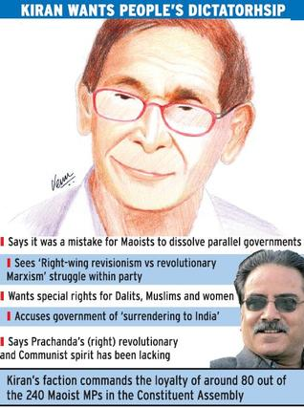

People are being betrayed on the Constitution, says Kiran
Senior vice-chairperson of the Unified Communist Party of Nepal (Maoist) Mohan Vaidya ‘Kiran' has said if the integration of the People's Liberation Army is not “respectable” and a People's Federal Republican Constitution is not drafted, the Nepali people will have a “right to revolt” again. In an exclusive interview to The Hindu, Mr. Kiran reiterated the demand for the resignation of the government, led by his party colleague Dr. Baburam Bhattarai.
Saying there was an ongoing battle in the party between “right-wing revisionism” and “revolutionary Marxism”, Mr. Kiran said: “We are not against peace and Constitution. But the debate is if our party has made anti-people compromises.”
‘Mistakes'
Mr. Kiran said while the goal of a “democratic republic” — set by the Maoist party in 2005, which led to an alliance with other parties against the monarchy — was tactically right, it could not solve people's problems and the party should have aimed to establish a “People's Federal Republic” or a “People's Democracy'. Asked if this meant one-party rule by the Maoists, he said: “Parliamentary democracy is also class hegemony where five per cent rule over 95 per cent. In people's dictatorship, it would be the other way round.”
Pointing to mistakes committed by the party, the Maoist ideologue said that during the war they had created an “army, base areas, people's governments”.
The base areas were opened up and the parallel governments dissolved soon after the Maoists entered open politics in 2006. Mr. Kiran claimed this was wrong and not in favour of the people whose issues Maoists had raised.
“On integration of our army, the party stand was it should be collective and armed integration of combatants with the chain of command of PLA intact. But what is happening now is disarmament. A national security policy should have been framed first, but we did not pay attention to that either,” he said.
To have a people's Constitution, Mr Kiran said, there be provisions for “ethnic autonomy; right to self determination; special rights for Dalits, Muslims and women; right to food, education, health and work; revolutionary land reform; and a proportional representation based electoral system”. “But we fear that Nepali people are being betrayed on the Constitution as well.”
Mr. Kiran also reiterated the demand for the government's resignation. Accusing it of “surrendering to India”, he said: “It signed the Bilateral Investment Promotion and Protection Agreement [BIPPA] with India without consulting anyone. We had opposed unequal treaties in the past. But the Energy Minister of this government, from our own party, went and approved the Pancheshwor agreement in Delhi recently. They are now talking of a DPR [detailed project report] for the Kosi high dam, despite popular opposition.”
Party unity
The political rift within the Maoists has translated into operational disunity, with the establishment faction of chairman Pushpa Kamal Dahal ‘Prachanda' and Prime Minister Dr. Bhattarai calling meetings of their own loyalists while Mr. Kiran's dissident faction holds parallel meetings. Separate committees have been set up at all levels, separate offices are used as a base and independent programmes are held.
Admitting that it was an “unnatural” situation, Mr. Kiran called it a situation of a “party within a party, organisation within an organisation”. Asked if the party would split, he said: “That depends on the principles, political roadmap, tactics and strategy which the party will undertake. There is a complex two-line struggle at present. Can we take that forward and resolve it positively? Revolutionaries don't split; they revolt. If the leadership turns opportunist; a federal, anti-imperial, pro people's Constitution is not made; and if PLA is not respectfully integrated, Nepali people have the right to revolt.”
Talking about his relations with Mr. Prachanda, whom he had helped promote to general secretary of the party over two decades ago, Mr. Kiran said: “He was a new young revolutionary talent. I had recognised it, and he played an important role in the revolution. But in recent years, his revolutionary and Communist spirit has been lacking.” He added that they continue to engage, with Mr Prachanda trying to convince him that revolutions are not linear and need compromises. “I respond by expressing my fears that the party is becoming reformist.”
Reliable sources indicated to The Hindu that Mr. Kiran's faction commands loyalty of around 80 out of the 240 Maoist MPs in the Constituent Assembly, and has approximately 50 out of 147 central committee members. Mr. Kiran's group is unlikely to walk away from the party till May 27 — when the term of the CA expires — and then decide its course of action dependidng on the political situation.

[From: http://www.thehindu.com/news/international/article3248385.ece ]

