[Two news articles about abolishing slavery in Nepal]

Slavery criminalised in Nepal
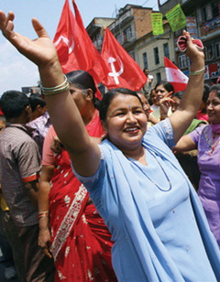
September 8, 2008
Nepal's Maoist-led government has abolished the slavery-like Haliya system by freeing 20,000 people from the hands of moneylenders and landlords.
Under the system, prevalent for decades in nine districts in western Nepal, moneylenders force poor villagers who borrow money to farm their land until they repay their debt.
Peace and Reconstruction Minister and former Maoist commander, Janardan Sharma, says from now on anyone who practises the system will be punished.
He says the government has set up a panel to consider rehabilitation of the former slaves and their families.
The Maoists have vowed to initiate revolutionary land reforms in a country where more than 80 per cent of its 26.4 million people eke out their living from farms.

http://www.radioaustralia.net.au/news/stories/200809/s2357872.htm?tab=latest

----------------------------------------------------------------------------------------

Nepal abolishes slave labour system

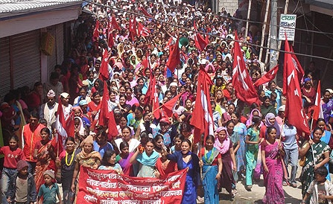

Sun Sep 7, 2008 10:51pm

KATHMANDU (Reuters) - Nepal's Maoist-led coalition government has abolished the Haliya system, a slavery-like condition, by freeing about 20,000 poor people from the hands of moneylenders and landlords, a cabinet minister said on Sunday.
Under the system, prevalent for decades in nine districts in western Nepal, moneylenders force poor villagers who borrow money from them to plough their land until they repay their debt.
They are offered low wages which are never enough to feed their families, let alone repay the loan, as labourers get trapped in the vicious cycle of debt.
"The government abolished the system on Saturday," said Peace and Reconstruction Minister Janardan Sharma, a former Maoist rebel commander.
"Anyone who practises the system will be punished," Sharma said, without spelling out the penalty.
He said the government had set up a panel to consider rehabilitation of these people and their families.
The Maoists waged a decade-long civil war against the monarchy until they signed a peace deal in 2006.
Early this year, they won a surprise victory in a constituent assembly election and are now heading a coalition government.
During the insurgency, which killed more than 13,000 people, the Maoists said they were fighting for the rights of the under-privileged and marginalised people in one of the world's poorest countries.
They have vowed to initiate revolutionary land reforms in a country where more than 80 percent of its 26.4 million people eke out their living from farms.

