

Two Maoist Parties Start Merger Talks

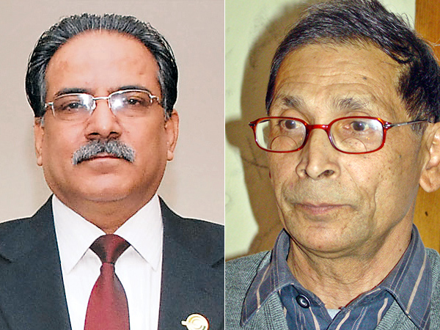

KATHMANDU, MAR 16 [2015]- The UCPN (Maoist) and the CPN-Maoist have made formal announcement to take forward negotiation process for their unification.
During the first round of formal talks held on Sunday, top leaders from the two parties agreed on a need of holding an organised negotiation to bridge ideological, political and cultural differences. They also decided to form a high-level committee--comprising UCPN (Maoist) Chairman Pushpa Kamal Dahal, senior leaders Baburam Bhattarai and Narayan Kaji Shrestha, Krishna Bahadur Mahara and Top Bahadur Rayamajhi and CPN-Maoist’s Chairman Mohan Baidya, Vice-chairman CP Gajurel, General Secretary Ram Bahadur Thapa and Dev Gurung--for further negotiations.
Leaders from both sides said the Sunday’s talks have brought them one step closer to unification though the chance of merger looks slim before the promulgation of the new constitution.
During the meeting held at Dahal’s residence, the two parties also agreed to launch a joint protest to press the government and ruling parties for promulgation of constitution through consensus.
Issuing a joint statement, Dahal and Baidya said the protest was aimed at counter-challenging regression, anti-people as well as anti-national movement and upholding struggle for people’s daily necessities. The parties also warned of launching protests against “counter-revolutionary steps” of the ruling parties regarding the peace process, including the formation of the Truth and Reconciliation Commission and the Commission of Inquiry on Enforced Disappearances.
The two parties have been discussing possibilities of unification ever since the UCPN (M) suffered a stunning defeat in the second Constituent Assembly election. The efforts were stalled after Netra Bikram Chand spilt from the CPN-Maoist to form the CPN Maoist. Gurung said the two parties are just beginning serious talks and the unification will still take time. “The two parties cannot be together at present situation as we are poles apart in ideological and political terms. All we have agreed is to begin discussions to unite the parties politically and ideologically before real unification,” he said.
Leaders say the strategy pertaining to “revolution” remains the most difficult issue to be resolved before unification. The CPN-Maoist has insisted on retaining the ideology of “New People’s Revolution” which does not recognise the Constituent Assembly, parliamentary politics and the overall peace process whereas the UCPN (Maoist) has adopted the “Socialist revolution” recognising peaceful politics after its Hetauda Convention.
In 2012, Baidya had split the UCPN (Maoist) and formed the CPN-Maoist citing reasons, including the “disgraceful” integration of PLA into the Nepal Army.
Posted on: 2015-03-16 08:00

http://www.ekantipur.com/2015/03/16/capital/two-maoist-parties-start-merger-talks/402877.html

