myrepublica.com

CPN-Maoist Secretary Boycotts Politburo Meet

Dissidents forming parallel committees in districts
KATHMANDU, Nov 11, [2014]: A serious rift has surfaced in the Mohan Baidya´s CPN-Maoist after disgruntled faction led by party secretary Netrabikram Chand boycotted the party´s politburo meeting in Kathmandu on Monday.
The agitating faction has been forming parallel committees in several districts and is also preparing to hold a separate national convention within a few weeks, said a leader of the faction. Secretary Chand had also boycotted the party office bearers meeting held on Friday and Saturday.
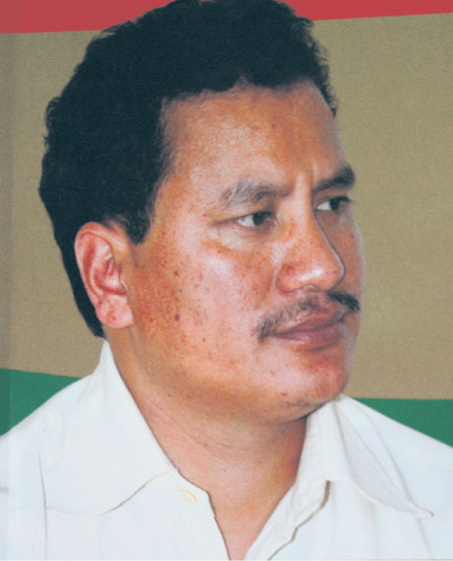
Netra Bikram Chand
"Comrade Biplav (Chand) was also among those demanding the politburo meeting, so his absence does not bode well," party spokesperson Pampha Bhusal, told Republica.
But a leader close to Chand said that Chand is currently in Chitwan to make preparations for an unilateral national conference of the party, said a leader close to him.
In the 13-member politburo of the CPN-Maoist, Chand and another leader Khadga Bahadur Bishwakarma represent the dissident faction.
CPN-Maoist was formed in 2012 as a splinter faction of the UCPN (Maoist). But division started in the splinter faction itself when Chand during the party´s central committee meeting in July submitted a separate political paper, expressing his differences with the political line of party chairman Mohan Baidya. Though the party in July had decided to hold a special general convention within a year to finalize its political line, it has not yet fixed the date for such convention.
Chand in his separate political paper has proposed to make preparations for yet another "people´s revolt" saying that producing "people´s constitution" is not possible from the existing political course and power structure while Baidya-led faction is for creating public pressure to produce "people´s constitution" on the ground laid by the 10-year long Maoist insurgency.
The Chand faction leaders said that, their boycott is just a reaction to the party´s refusal to hold special convention. Irked by a party´s decision to suspend a leader of his faction in Chitwan on the charge of forging alliance with a faction of UCPN (Maoist), Chand faction has of late expedited its parallel activities in various districts.
"There is no point in attending the party politburo meeting because we have been demanding special convention for resolving the issue of political line of the party," Party central committee member Santosh Budha, who is close to Chand told Republica.
Despite the boycott from the disgruntled faction, politburo meeting of the party started Monday. "We discussed party´s organizational issues and possible protest programs targeting the constitution promulgation deadline of January 22," said spokesperson Bhusal. "The meeting will continue on Tuesday as well."
The party establishment faction has claimed that, the party would take action against the leaders boycotting the party meetings.

This news item is printed from myrepublica.com - a sister publication of Republica national daily.
© Nepal Republic Media Pvt. Ltd. Kathmandu Nepal.

From: http://www.myrepublica.com/portal/index.php?action=news_details&news_id=86377 [Nov. 11, 2014]

