“If rights are not given to people, it is sure

that arms will be taken up” –Kiran

[Posting from: Frontlines of Revolutionary Struggle at:

http://revolutionaryfrontlines.wordpress.com/2013/01/18/nepal-if-bourgeois-state-does-not-deliver-democracy-we-will-take-up-arms/#more-25281 ]

[While the split in the revisionist-bourgeois UCPN(M) and the formation (re-formation) of the Communist Party of Nepal - Maoist has been the focus of high hopes among revolutionary Maoists internationally, the consolidation of the CPN-M has also been a subject of conflicting views and an emerging debate about how complete the split with revisionism has really been.

Aspects of the emerging line have not yet been spelled out completely, but some signs of an ongoing and developing struggle over political line have been on the surface of public events. These struggles are further expressed in former liberated (by the People's War) base areas, among former PLA fighters, and among others who have shown dismay at the urban-centric work plans and diplomatic ties with Chinese, Korean, and Indian post-Mao revisionists. While these issues will be watched, and debated, by Nepalis and by internationalists who continue to raise the revolutionary road, the danger of a consolidated "centrism" and of uneasy and unprincipled "reconciliation" of revisionist and revolutionary lines is present. The following article may, or may not, be indicative of this centrism. The response of others who are undoubtedly advocating a Leninist and Maoist understanding of the class nature of the state, is not yet being reported. We anxiously await further developments, and hope this new party will be a far more receptive (and productive) place for this struggle than the UCPN(M) in the revisionist hands of Prachanda and Bhattarai has been. -- Frontlines ed.]
——————————————————————————

“Maoists will take up arms” if…. : Baidya
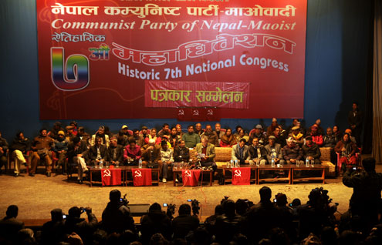

KATHMANDU, Jan 17, [2013]: The CPN-Maoist on Wednesday warned that the party will take up arms if the state power cannot assure the rights of the people. Speaking at a press meet organized here by the party following the conclusion Tuesday of its seventh general convention, the CPN-Maoist also informed that the time for the revolt will be determined by the political situation.
“Give rights to the people. It the people get their rights, who will take up arms? Nobody. Why is the state conspiring instead of assuring people their rights in accordance with previous agreements and assurances. If rights are not given to people, it is sure that arms will be taken up,” answered Mohan Baidya, newly elected chairman of the CPN-Maoist, when asked about the reason for people´s revolt.
“As far as the date for launching a revolt is concerned, it is not a matter to be announced at present. It will rather be determined by the circumstances. Asked when they would launch their revolt, Baidya said, “We will launch the people´s revolt or people´s war as and when circumstances compel us because no one takes up arms just on the basis of the whim or interests of certain leaders”. “Arms will be taken up by any other force also when the situation so demands, even if we ourselves drop the idea.”
The general convention endorsed the launching of a people´s revolt on the foundation of the decade-long people´s war as the party´s political line. The foundation of the people´s war is people´s government, people´s court and people´s liberation army, according to the party line. The experience of war and the experience of running people´s government and people´s courts during the insurgency will be the Maoists´ foundation for people´s revolt, Baidya said when asked if the party was going to revive them.
Armed struggle was nothing new, he argued, pointing out that the USA, which claims to be the proponent of human rights, also took up arms. The NC and UML had also taken up arms in the past. According to him, they forgot that once they attained power. Then they started to criticize the issue of arms. Similarly, the general convention has endorsed an immediate program for bringing in a people´s federal republic, a people´s constitution and a national joint government.
Talking to media persons, he termed the current government a puppet government, arguing that it signed the BIPPA agreement with India and allowed India to undertake security responsibilities at 15 airports, claiming that these are anti-nationalist activities. In the past, the UCPN(Maoist) had termed the Madhav Nepal government a puppet government. Baidya accused the political parties including the UCPN (Maoist) of abandoning the entire agenda of the people and not following up on previous agreements. He said a new agreement should be worked out in accordance with the changing situation, as the earlier agreements had failed.
“The 12-point deal and the comprehensive peace accord have all failed. We should work out a new agreement in accordance with the changed situation,” said Baidya. He also made it clear that his party would not join the Nepali Congress and CPN-UML protests. According to him, they can go together only in demanding that the Bhattarai government step down. “But we can keep up debates with them,” he said. Baidya urged media to strike a balance over coverage of the killing of journalist Dekendra Thapa, informing that journalist Krishna Sen was also killed during the insurgency, by state forces. “You [media] are projecting cases unilaterally. Raise the issue of journalist Krishna Sen also,” added Baidya.
http://www.myrepublica.com/portal/index.php?action=news_details&news_id=48401

