Republica

CPN-M General Convention Kicks Off

By KIRAN PUN
KATHMANDU, Jan 10, [2013]: The general convention of the newly formed CPN-Maoist party kicked off in the capital on Wednesday. This is the party´s first general convention following its split from the UCPN (Maoist) last June, the 7th in the history of the party and its mother party, and the first in 21 years.
Addressing the opening session of the 7th General Convention at Khula Manch, Chairman Mohan Baidya lauded China for respecting Nepal´s sovereignty and accused India of casting ´covetous eyes´ on it.
Chairman Baidya demanded that India scrap the ´unequal´ bilateral treaties that were a threat to Nepal´s sovereignty, stating that his party wanted good relations with India and the Indian people.
“We want to have good relations with India with fresh treaties which are acceptable to both, and Indian rulers should stop casting ´covetous eyes´ on our national sovereignty,” added Baidya. According to him, the main challenge is to save national sovereignty.
Addressing the mass gathering, he also claimed that his party is ready to lead the country, informing further that the general convention would come up with plans to completion a new democratic revolution.
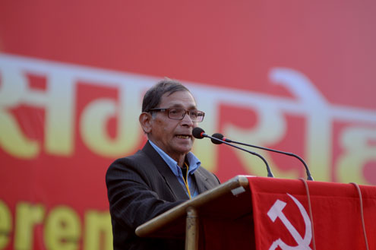
Baidya addressing convention. (Photo: Bijay Rai)
"We want to move ahead as a new force taking on that responsibility," said Baidya adding that his party would also review its failings and weaknesses.
He expressed the commitment that the general convention would enter a new Singhadurbar, claiming that a new democratic revolution was necessary and possible. Turning to the families of martyrs, the disappeared and the injured and to party cadres, he expressed commitment to a plan to complete the revolution.
Categorizing the challenges before Nepal, he said that the domestic enemies are bureaucratic feudalist and reactionary forces and the external ones are American imperialism and Indian expansionism. Chairman Baidya made it clear that his party would never compromise with American imperialism and Indian expansionism.
He also added that the next challenge before the parties styled communist are increasing ´rightist revisionism´ in the world, and his party would plan to fight against them through a joint front of nationalists and revolutionary leftists. He accused the major political parties of neglecting the future of Nepal and the Nepali people.
According to him, the alliance with the parliamentary parties has failed as it could not yield a solution. He urged an alliance with the nationalists and leftists parties to complete the new democratic revolution. "The revolution has not stopped," he added.
Baidya declared that fresh constituent assembly (CA) elections were not possible in the present context and blamed the major parties for the existing political scenario. “There are no differences among the four parties except for choice of government leadership,” he said.
Reviewing the past, Baidya said the party has been victimized by a neo-revisionist leadership. "The main leadership engaged in serious betrayal of the party and the revolution," added Baidya.
General Secretary Ram Bahadur Thapa said foreign agents held sway in Nepal and republicanism had been converted into dalaltantra[stooge-cracy]. "Here are only stooges and the corrupt. We cannot even elect our prime minister," said Thapa, urging nationalist forces to unite.
Earlier, cadres of the CPN-Maoist took out rallies from different parts of Kathmandu Valley before converging at Khula Mancha. Altogether 1,200 representatives, 400 observers, 300 volunteers and 100 cultural artists are participating in the convention. The closed session of the convention is scheduled to begin at the Nepal Academy. The five-day convention will conclude on Sunday.
---------
The major political parties -UCPN (Maoist), Nepali Congress, CPN-UML - and the ruling Madhesi parties were not invited to the inauguration of the general convention. Only fringe leftist parties and some nationalist parities - which the CPN-Maoist has termed friendly forces - and civil society leaders Padma Ratna Tuladhar and Sundar Mani Dixit were invited.
The Chinese and North Korean ambassadors also participated in the programs, representing their respective parties.
Representatives of fraternal communist parties from 11 countries including USA, India, Turkey and Canada, who were also present, expressed their good wishes and solidarity.
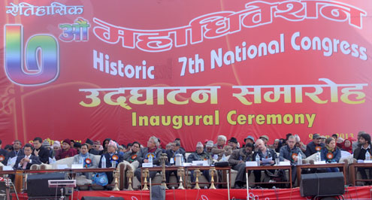
Maoist leaders in the convention. (Photo: Bijay Rai)
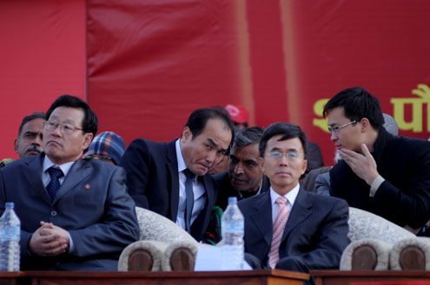
Diplomats attend opening ceremony of the convention. (Photo: Bijay Rai)
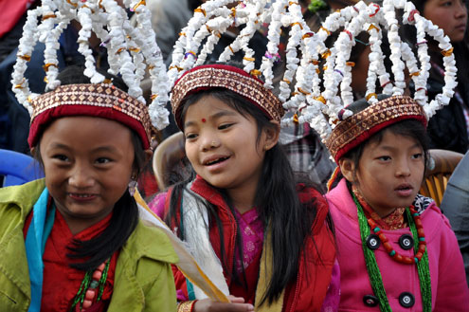
Girls in the convention. (Photo: Bijay Rai)
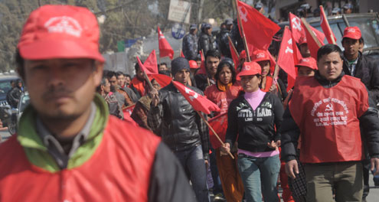
Maoists in the rally. (Keshab Thoker)
Published on 2013-01-10 04:00:54

[From: http://www.myrepublica.com/portal/index.php?action=news_details&news_id=48012 ]

