The Hindu (India)

Nepal Maoist faction serves ultimatum

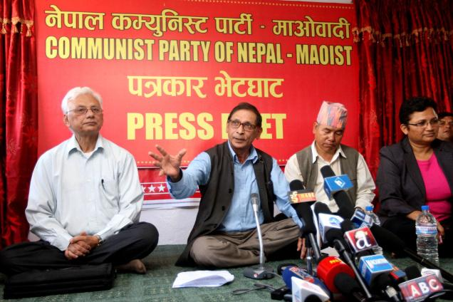
Communist Party of Nepal-Maoist Chairman Mohan Vaidya 'Kiran' talking to media-persons
at CPN-Maoist office, Buddhanagar on wednesday. Photo: Special Arrangement
Demands, inter alia, scrapping of peace treaty with India
By Prashant Jha
Kathmandu, Sept. 5, 2012
Sixteen years after Nepal’s Maoists presented a memorandum with 40 points to the then government before launching their ‘People’s War’, a splinter radical Maoist party has decided to present a list of 70 demands to the Maoist-led government.
The Mohan Vaidya ‘Kiran’-led Communist Party of Nepal-Maoist, which split from the parent party in June, has threatened to launch a struggle — and armed revolt ‘if necessary’ — if their demands are not met.
At a press conference here on Wednesday, Mr. Kiran accused the Prachanda-led Unified Communist Party of Nepal (Maoist) of “neo-revisionism”. “Instead of addressing demands they themselves had raised during the war, our own friends are now behaving like the ruling class.” He said while there had been some “achievements”, the country remained in a “semi-colonial, semi-feudal, and neo-colonial” situation, and a new “struggle” was necessary. Many of the issues listed in the new document are taken from the original 40-points agenda.
The new party has demanded the scrapping of the 1950 Nepal-India Treaty of Peace and Friendship; the 1965 bilateral security pact; the Mahakali treaty; the Small Development Projects supported by government of India in Nepal; and the Upper Karnali and Arun-3 hydropower contracts given to Indian companies.
It has called for “controlling and managing” the open border between the two countries; ending “border encroachment” in Nepali territory and “unauthorised” entry of Indian security personnel into Nepal; stopping entry of cars with Indian number plates; stopping Hindi and English cinema, video and publications; ending foreign investment in media; closing down Gorkha recruitment centres and “strictly controlling” all “anti-China” activities conducted using Nepal as a base.
In the third week of August, Mr. Kiran had met the chairperson of the royalist Rashtriya Prajatantra Party-Nepal, Kamal Thapa, and discussed co-operating on the issue of “nationalism and sovereignty”.
‘People’s Democracy’
Other demands revolve around “people’s democracy and livelihood”. These include: institutionalising a ‘People’s Federal Republican’ constitution by elected people’s representatives, federalism with “national identity”, full proportionate inclusion in state organs, drafting a new national security policy, relief and compensation to those who suffered in the ‘People’s War’, end of discrimination and untouchability against Dalits, employment guarantee, free and compulsory education till Class 12, land reform, and action against corrupt.
Mr. Kiran said while their struggle would initially be peaceful, they may adopt the armed method if their demands were not met. Analysts, however, believe that it is unlikely that the entire party will revert to an insurgency. But unconfirmed reports suggest that a section, led by a radical young leader Netra Bikram Chand ‘Biplab’, is organising former soldiers of the People’s Liberation Army (PLA) and collecting arms to prepare for a violent revolt.
Ironically, in 1996, it was the then ideologue Baburam Bhattarai who prepared and submitted the demands on behalf of the Maoists.
This time, in his capacity as the Prime Minister, he will receive a similar set of demands from his erstwhile colleagues.

From: http://www.thehindu.com/news/international/article3863011.ece?homepage=true

