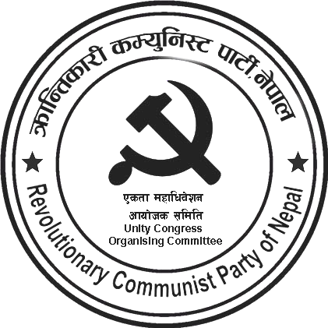
kq ;+Vof÷Serial No. :-
rnfgL g+=÷Regd. No. :-

Party Unity Statement
The party unity between two revolutionary communist parties, the Revolutionary Communist Party of Nepal, and the Communist Party of Nepal (Mashal), the vanguards of the Nepalese proletariat, and its declaration that followed on May Day 2024 have become a meaningful and glorious event for the proletariat in Nepal and the world. No revolution can be accomplished in the absence of a unified communist party equipped with the utmost consciousness of Marxism-Leninism-Maoism/Mao thought and formed of the proletarian vanguards who believe that liberation of the labouring masses is impossible without a unified communist party enlightened by this advanced consciousness. By grasping this fact, this unity, based on a series of talks, discussions, and debates among the then CPN (Revolutionary Maoist), CPN (Majority), and CPN (Mashal) for more than a year, was confirmed only after the Party Unity Coordination Committee meeting decided on April 25, 2024. Through this unity, we pledge to transform the Nepalese Communist Movement, suffering from unity-struggle and recurring splits, into unity-struggle and transformation, and a higher level of unity in the days ahead.
This unity is based on the principles of Marxism-Leninism-Maoism/Mao thought. We are committed not to allowing bargaining and waning the principle of new democracy as a general program and scientific socialism as the fundamental one, the role of violence in revolution, proletarian internationalism, democratic centralism, an end to the present parliamentary system, the establishment of the people's republic of Nepal, scientific socialism and communism, continuing revolutions under the dictatorship of the proletariat, etc. The unity of understanding on these fundamental questions has made this unity between the two parties possible.
We must firmly adhere to the defense and application of the originality of Marxism-Leninism-Maoism/Mao thought and develop it in accordance with space, time, and situation. Today, the development of science and technology has brought about unforeseen changes in social life. Only by correctly addressing those changes can the creative application and development of MLM/thought happen. In this context, we should remain prepared to put into practice Mao's synthesis that one must have the courage to advocate something new and establish something different.
By advocating for and establishing different things, Mao accomplished the new democratic revolution in China, despite her situation being different from Russia. The Revolutionary Communist Party of Nepal is committed to applying Marxism-Leninism-Maoism/Mao thought to the concrete condition of Nepal, and to leading and advancing the Nepalese revolution ahead. In a situation where a neo-colonial socio-economic condition along with semi-colonial and semi-feudal characteristics exist, remnants of feudalism, comprador, and bureaucratic capitalism, mainly comprador capitalism stand as the obstacle to revolution, and workers, landless peasants, soldiers, squatters, and the national bourgeoisie are the friendly forces, the contradiction between state power led by comprador and bureaucratic bourgeoisie and the broad oppressed people of Nepal is the principal contradiction. Our party is committed to the fact that the solution to this contradiction is scientific socialism, which will be reached by passing through a step of the new democratic revolution.
The problems of national independence, democracy, and people's livelihoods have become grave in Nepal. It has become even more severe after the latest agreements like MCC and SPP. Limited democratic rights are being gradually snatched away. The problem of democracy has deteriorated further, the imprisonment of political activists in false cases exposes it. The problem of people's livelihoods has skyrocketed owing to the

extreme usury of microfinance, local money lenders, and cooperative organizations under the patronage of banks' economic policies. Instead of solving these problems, the state, government, and related agencies are suppressing the voices of the agitators. Our party is committed to leading struggles to solve the problem of national independence, democracy, and people's livelihood.
On this joyous and cheerful occasion of party unity, we call on the confused revolutionaries scattered in various parliamentarian revisionist parties and groups, and individual revolutionary personalities to polarize with and participate in this historic unity process. With this unity, we will become a strong headquarters of the Nepalese revolution, and the revolution will be accomplished. No matter how arduous the road may be, the future is bright.
May 1, 2024,
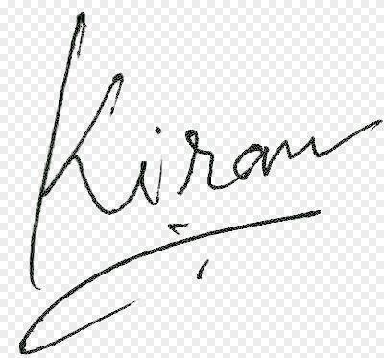
Kiran
Coordinator

