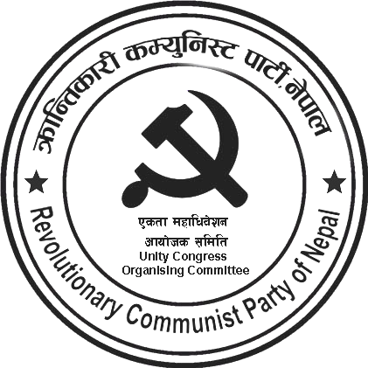
kq ;+Vof÷Serial No. :-
rnfgL g+=÷Regd. No. :-

Press Statement on the Twenty-Ninth People's War Day
Under the leadership of the erstwhile CPN (Maoist), the Great People's War, which was initiated on February 13, 1996, has entered its twenty-ninth year today. On this occasion, we are going to celebrate People's War Day across the country. On this historic occasion, our party pays heartfelt tributes to all the immortal martyrs who attained martyrdom in the process of the Nepalese revolution, expresses our sincere respect to the disappeared, wounded, and disabled warriors, and commemorates the records of sacrifice, heroism, and devotion presented by the Nepalese people. Also, our party salutes the families of martyrs and disappeared warriors, entire party members, supporters and well-wishers, respectable people and fraternal parties, and the world proletariat.
In Nepal, which was in a semi-feudal and semi-colonial condition, the Great People's War that was declared exactly twenty-eight years ago with a resolve of accomplishing a new democratic revolution internally against feudalism, comprador and bureaucratic capitalism and externally against imperialism and expansionism had been able to build seven divisions of the People's Liberation Army, establish and defend base areas and people's governments in the countryside in a short period. It disseminated a new message of revolution and social change across the world and posed an immense challenge to world imperialism. However, due to the neo-revisionist deviation and immense treason of the principal leader from within the Maoist movement, the Nepalese revolution has now suffered a severe setback. The principal leader who led the People's War yesterday has today become a reliable puppet of imperialism/expansionism, whereas another leader has reached a subjective conclusion that Marxism has been irrelevant.
The limited democratic rights that the Nepalese people had gained because of the People's War and the Mass Movement are being seized gradually. The economic crisis in the country has become grave, and the trade deficit is skyrocketing. Thanks to widespread unemployment and high price rises, working-class people are worried about the problem of making ends meet. The Nepalese ruling class does not think of developing a self-reliant national economy and opening the door to employment by effectively administering the agricultural and industrial sectors in the country. On the contrary, the Nepalese ruling class feels "proud" for the remittance the country accumulates by selling youths in the name of foreign employment has sustained the country's economy.
The Nepalese ruling class has opened the way to make Nepal a military base of the United States by signing with US imperialism the anti-national agreements like MCC and SPP, which are integral parts of the Indo-Pacific strategy. The Nepalese rulers have lost the courage even to diplomatically oppose the border encroachment and political, economic, and cultural interference by the Indian ruling class in Nepal. All this is the result of the senior leaders of Nepal's parliamentarian parties becoming dependable agents of imperialism/expansionism in the process of colonizing the country. In this way, the question of the country's national independence, democracy, and people's livelihood is becoming grave with the passing days. It is the bitter reality of Nepal today.
People's dissatisfaction with state power, the system, and the parliamentarian political parties is boiling over, and the regressive elements are trying to take advantage of it. Regressive elements cannot be an option for

this. Thus, scientific socialism through the new democratic revolution in Nepal has become an urgent necessity.
The process of social revolution is not straightforward; it advances via scores of cycles of revolution and counter-revolution. The Nepalese revolution has suffered a setback, but the process of revolution has not stopped. It is advancing in a new way in the new situation. We have formed the Revolutionary Communist Party of Nepal by uniting the erstwhile CPN (Revolutionary Maoist) and CPN (Bahumat). We are preparing for revolution by learning from the positive and negative experiences of Nepalese and world proletarian revolutions by creatively applying Marxism-Leninism-Maoism to the Nepalese specificity. On the occasion of the 29th Great People's War Day, we sincerely call upon the entire revolutionary groups and scattered revolutionaries to proceed along the path of revolution.
February 13, 2024

Kanchan
Spokesperson

