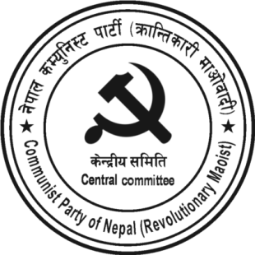
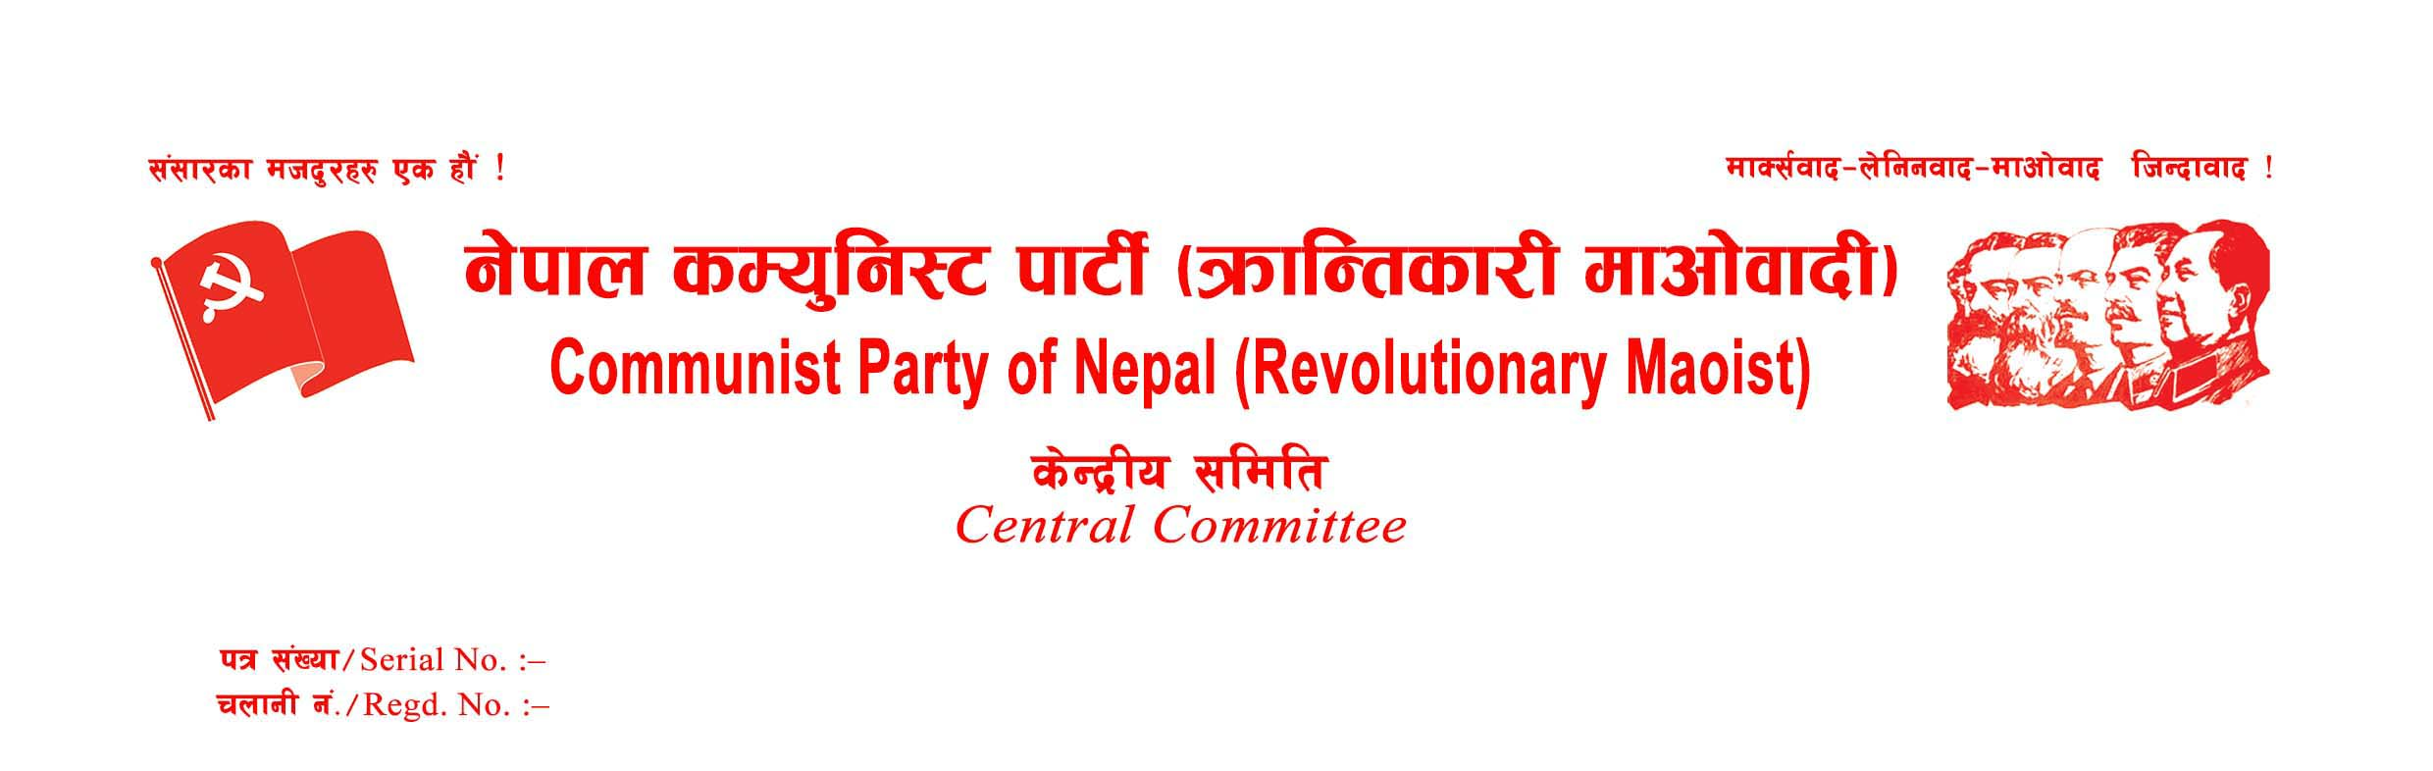
Today, Baisakh 9, 2080, accordingly 22 April 2023, is a historically significant day. Right 73 years before, the Communist Party of Nepal was founded under the leadership of Comrade Pushpalal. Today is also the birthday of Lenin, the great leader of the world proletariat. So, this day has a special significance not only from the point of view of the establishment of the Communist Party in Nepal but also from that of the world communist movement. On this important event, the Central Committee pays emotional homage to the entire martyrs and congratulates and expresses its best wishes to all party ranks, injured and disappeared warriors, martyrs' families, revolutionary people, international fraternal parties and organizations, and the world proletariat.
The Nepalese communist movement has completed 73 years and entered 74 years today. In this period, this movement has reached this point through sharp two-line struggles erupted at times, revolutionary transformation, new unity on a new basis, rebellion against revisionism, and in some cases, immature splits. In the meantime, the people's movements, Jhapa rebellion, people's war, and different types of people's struggles have been waged under the leadership of the Communist Party. Nepalese people have also exercised people's power under the protection of the People's Liberation Army, Nepal, led by the erstwhile CPN (Maoist). Nepal has not been free yet from semi-feudal and semi/neo-colonial socio-economic conditions. The dream of the Nepalese people to complete the new democratic revolution and pave the way towards scientific socialism and communism remains unfulfilled. Also, the exploitation, repression, and oppression of comprador and bureaucratic capitalism, feudalism, imperialism, and Indian expansionism are becoming more terrible. Right-wing revisionism is the main danger for the Nepalese Communist movement.
After the restoration of the so-called democracy in Nepal, the number of revisionist communists in the Nepalese Parliament has remained significant. At times, the parliamentarian communists have even formed the government with a two-thirds majority. But the irony is that large-scale anti-national and anti-people activities have taken place under the leadership or with the help of 'communists'. With the ridiculous interpretive declaration of the Maoist centre, the initiative of the Nepali Congress, and the active participation of other parties, including the UML, the Nepali Parliament has approved the anti-national agreement like the MCC by an overwhelming vote. Not the Nepali Congress alone, none of the governments formed under the leadership of the 'communist' party have yet spoken a single word against the Indian encroachment in the areas of Limpiyadhura, Lipulek, and Kalapani. The country is subject to and dependent on imperialism and expansionism. The limited democratic rights that the people have obtained due to people's war, people's movement, and various people's struggles are also being taken away. Unemployment is rampant in the country; prices have skyrocketed, and the economic crisis is becoming severe. The Nepalese economy, which depends on remittance and import and consumer taxes, has reached a point where it needs loan to meet even the regular expenses. The neoliberal economic policy is the main reason for this situation to happen, and so-called communists have been buttressing it. Corruption has crossed the border. The ministers and high-ranking employees of the government formed under the leadership of the so-called Communist Party are at the forefront of this. All this shows how dire the situation of the country is.
In Nepal, the party's values and norms have declined in the so-called communist parties even more sharply than in the bourgeois parties. No party and leader cares for ideology, politics, country, and people, merely a chair lies before their eyes. Three power centres of the parliamentary system, the executive, the judiciary, and the legislature, are all in disarray. A Metropolis mayor challenges the federal government directive, but the government cannot do anything. Is this just a result of the incompetence or anarchy of a particular person? No, it is not the problem of a specific leader of a specific party only; it is also not the problem of the parliamentary system only, it is also a problem caused by the failure of the imperialist world system based on neoliberalism.
The parliamentary system cannot solve the problems the country is confronting. The solution to this problem is a new democratic revolution, under the leadership of the genuine Communist Party guided by Marxism-Leninism-Maoism. Not only is the objective condition favourable for revolution in Nepal, but it has become an objective necessity. Given this, we have decided to unite our party and the CPN (Bahumat) recently, and the unity talk is underway with CPN (Mashal) through party unity coordination committee. On the historic occasion of the party establishment and Lenin Day, we sincerely request all revolutionary leaders, activists, and masses of the people to uncompromisingly fight against right-wing revisionism, which is the main danger for the Nepalese communist movement, and unite genuine revolutionary communists scattered in different groups in favour of the revolution and propel the new democratic revolution ahead.
April 22, 2023
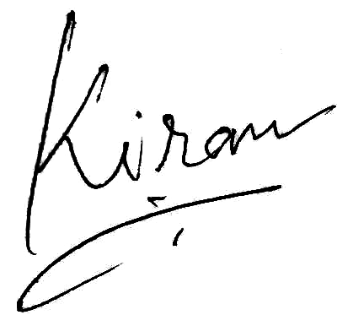
Kiran
General Secretary
CPN (Revolutionary Maoist)



