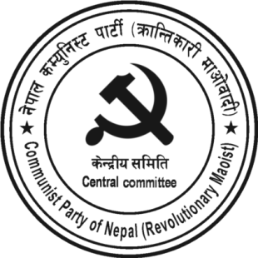
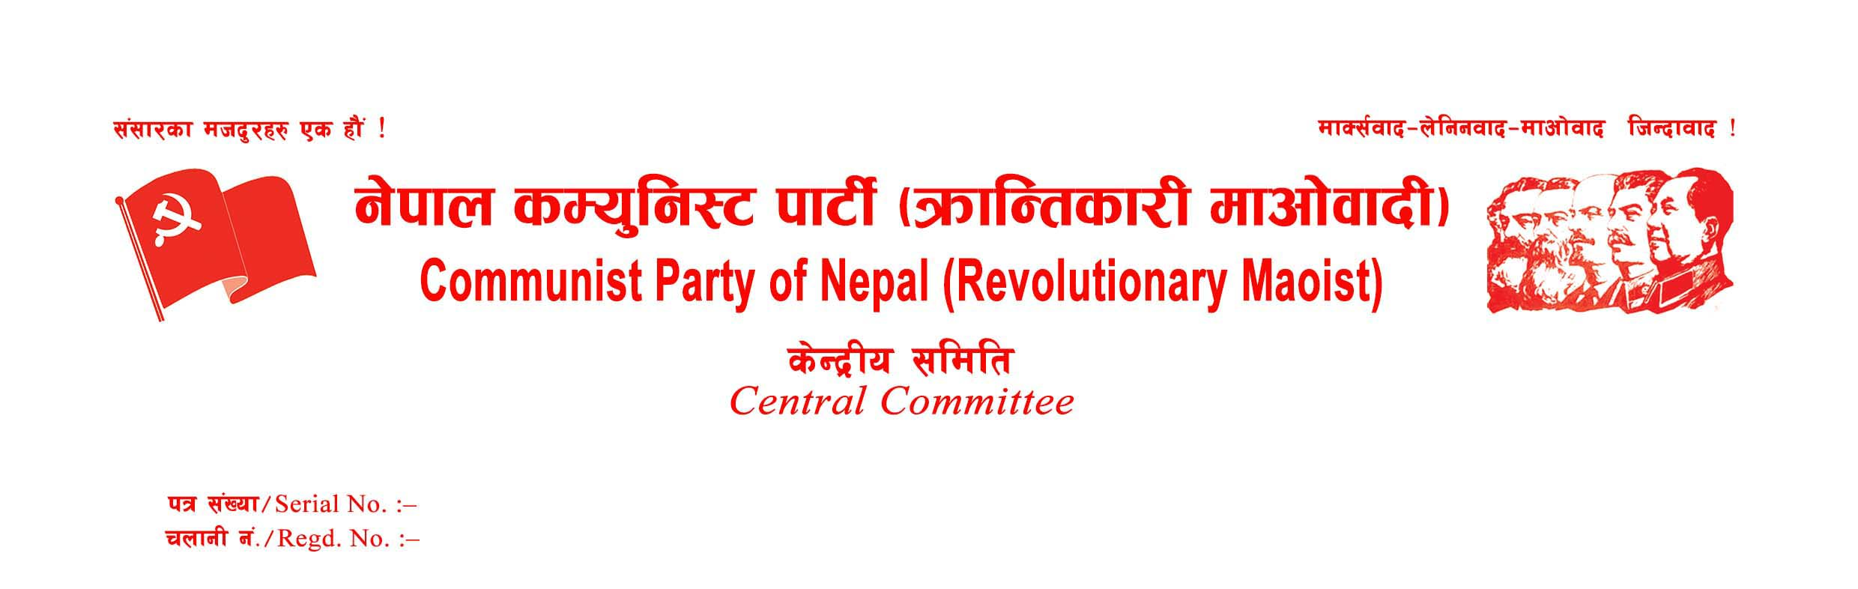
Press Statement on the Occasion of People's War Day
February 13, 2022, is the 27th People's War Day. Today, our party is going to celebrate the Great People's War Day by organizing various programs all across the country. First of all, on this historic day, we pay our heartfelt homage to all the immortal martyrs, who sacrificed their lives in the process of the Nepalese Revolution, and bestow our heartfelt respect to the disappeared, wounded, and disabled fighters. Also, on this occasion, commemorating the high records of sacrifice, bravery, courage, and devotion shown by the Nepalese sons and daughters for the liberation of the country and the people, bestow our red salute to the families of the martyrs and disappeared warriors, all party members, supporters and well-wishers, and international fraternal parties along with the world proletariat.
Twenty-six years ago, the Great People's War was initiated under the leadership of the then Communist Party of Nepal (Maoist), to pave the way for scientific socialism and communism by establishing a new democratic state in Nepal against the internal exploitation and oppression perpetrated by the comprador and bureaucratic capitalism and feudalism, and the external interference of imperialism and Indian expansionism. In a short period, the People's War succeeded in spreading the new message of proletarian revolution the world over by building the People's Liberation Army, establishing people's powers in the vast rural areas of the country, and forming people's government. However, due to the rightist neo-revisionist deviation born in the main leadership of the party, today the revolution has been betrayed, the revolution has turned into counter-revolution and the great Nepalese people's war has become a history. Today, the protagonists of yesterday's revolution have become the protectors of the same old reactionary state power, the same parliamentary system, and the anti-people constitution. This is a sad reality.
Even after the establishment of the democratic republic in Nepal, the oppressed Nepali people, including workers, peasants, women, indigenous nationalities, Madhesis and Muslims have not been able to entertain their democratic rights, on the contrary, even the existing rights are being gradually curtailed. Rising unemployment and skyrocketing prices have made it difficult for people to make ends meet. The national independence of the country is being seriously threatened one after another. The US imperialist rulers have started threatening the senior leaders of the parliamentary parties by phone and various media to get the MCC project, a part of the Indo-Pacific strategy, ratified by the Nepalese Parliament. The Nepalese leaders have remained tight-lipped even when the Indian expansionist regime has openly declared the construction and expansion of roads on the Nepalese territory – Limpiyadhura, Kalapani, and Lipulek region. The senior leaders of Nepal's parliamentarian parties have become the accomplices of imperialist and expansionist ruling classes in colonizing the country. Thus, the nation is becoming more dependent, day after day.
In Nepal, the parliamentary system and its three main organs, the legislature, the executive, and the judiciary, are all in disarray. The economic situation of the country is getting worse and crisis-ridden. The so-called democratic and revisionist communist parties have all failed. It clarifies that a new democratic revolution has become an objective necessity in Nepal.
At this time, the Nepalese revolution has certainly experienced a blow, but the process of revolution has not stopped. Learning from the positive and negative experiences gained by the world proletariat in the process of revolution in the past, creatively applying Marxism-Leninism-Maoism in the particularity of Nepal, our party is preparing for revolution for the establishment of new democratic state power in Nepal. On the occasion of the 27th anniversary of the Great People's War, our party makes a special appeal to the independently active revolutionary groups, the revolutionaries still mistakenly remaining in the opportunist and revisionist parties, and the independent personalities to get polarized and unified along the path of revolution.
With revolutionary greetings!
Date: February 13, 2022
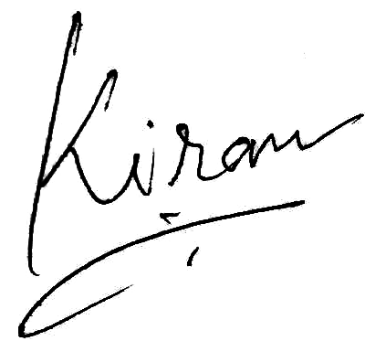 Kiran
General Secretary
CPN (Revolutionary Maoist)



