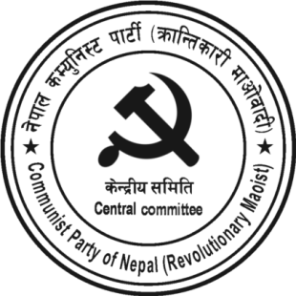
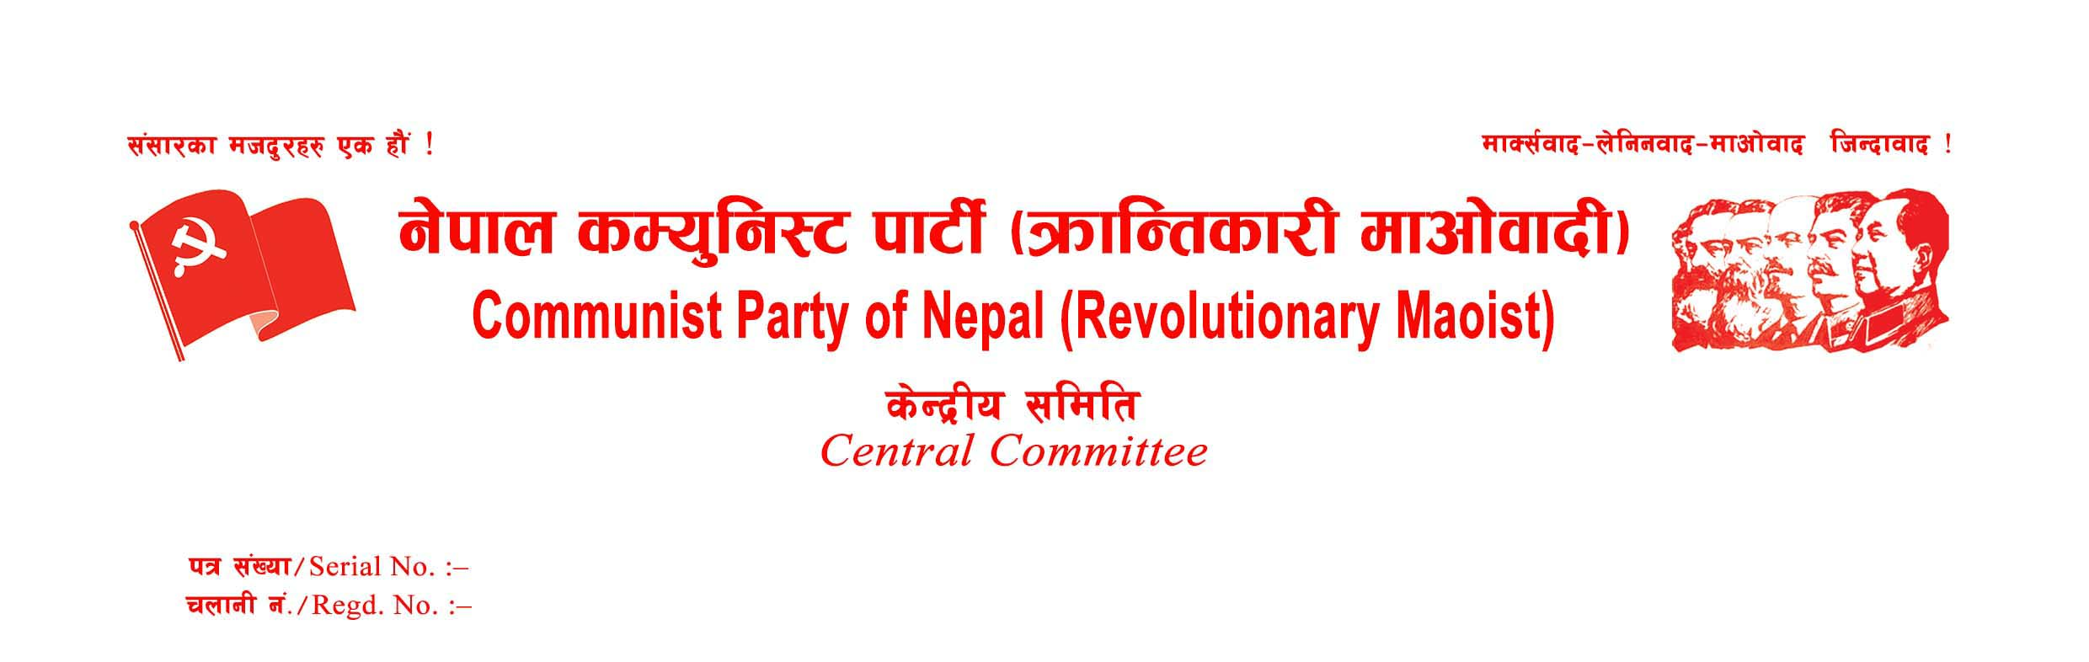
Press Statement
In spite of the nationwide protests of the patriotic Nepalese people and the utter disagreement of some parliament members, who are in favor of national independence, the MCC project, which is a part of the US military strategy, has been approved by the majority of the House of Representatives on the night of February 27, 2022, amid different kinds of temptations, deceptions, intrigues, conspiracies, repressions, and arrests. It has paved the way for US imperialism to put Nepal under its security umbrella, to make Nepal a military base to encircle China and to exploit its precious national heritage. By ratifying this kind of treasonous compact from Parliament, the leaders of Nepal's parliamentarian political parties have been proved to be faithful accomplices of the US imperialist stratagem to trap the country in the neo-colonial web.
The so-called communists, who claim to be patriots and had vowed not to ratify the compact without any amendment till the recent past, have sided with the Nepali Congress that has a long history of treason, in brokering US imperialism. Given that the United States has repeatedly refused to amend the compact, the so-called interpretive declaration prepared by the Nepalese government cannot be a part of the MCC agreement. It is nothing but a torn net to cover the shame of opportunists and traitorous puppets. It is simply a piece of paper prepared by betting with the national independence of the country by those parties that bargain for the job of a few dozens of parliament members and a few ministers.
The country's national independence is becoming extremely weak day by day. The leaders of the communist-named revisionist parties and those of the Nepali Congress, who call themselves democrats, have been working to hand over the country's national independence, sovereignty, and self-respect of the Nepali people to foreign powers. We have been constantly opposing such parties and their anti-national activities. In the present context of Nepal falling into the clutches of imperialism and expansionism, our party heartily calls upon all patriots, true democrats, leftists and revolutionary parties, groups, and personalities to move forward in a united struggle for the defense of national independence, sovereignty and territorial integrity of the country.
Date: February 28, 2022
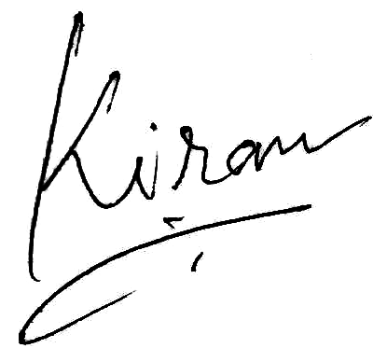 Kiran
General Secretary
CPN (Revolutionary Maoist)



