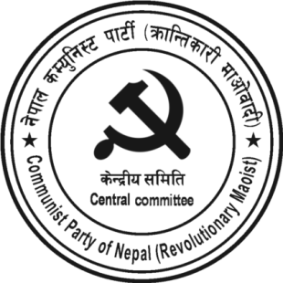
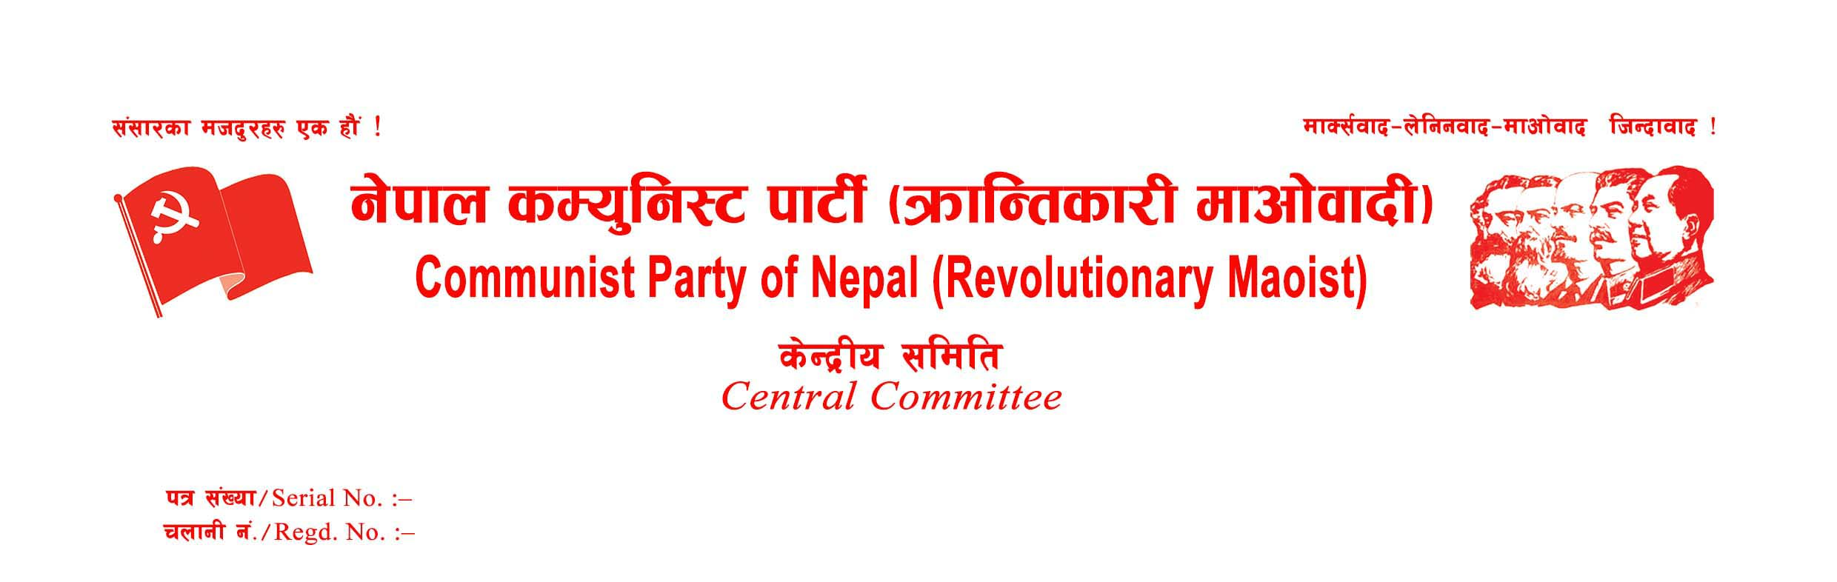
Press Statement
The local body election, organized by the Government of Nepal in one phase, ended on May 12, 2022, at 5 PM. In this election, the candidates used all means to allure the voters. The government declared the election a success amid dozens of firings of bullets, hundreds of rounds of tear gas cells, and indiscriminate baton charges in many poll stations. In this course, one person has been shot dead, another has been killed in infighting between rival groups, and another has been killed by a leader's car and thousands of voters injured. Voting has been postponed in 77 poll centres due to the conscious protests of the people, clashes between different groups, and negligence of the polling staff. This statement has been issued to make public the preliminary opinion of our party about this election.
First, the politics of parliamentarian competition based on ideology, outlook, and ideal is almost over in this local election. The act of the Maoist Centre and Nepali Congress, which are supposed to be diametrically opposite ideologically, have forced their ideologically committed cadres to cast their vote reciprocally proves it. Political parties have become groups of power interests.
Second, it is clear that the current electoral alliance is not aimed at benefitting the entire party and people supporting them but for the benefit of a tiny group of leading oligarchs. An unequivocal statement from all the coalition leaders in a mass meeting that the country will fail if a particular coalition candidate does not win the election shows that the parties' role has ended and the oligarchs have become decisive. It is the end of internal democracy and the failure of the parliamentary system in Nepal.
Third, the election campaign was not based on the party's economic and political programs and the people's agenda. In this election, fear, terror, intimidation, temptation, feasting, and bribing were used as tools to allure voters to the concerned candidates. Looking at the amount of money spent by a candidate in this election, ordinary working-class people cannot even think of contesting the election. It is a part of the stratagem to alienate the economically weakened oppressed masses from political activities and establish the monopoly in politics of the comprador, bureaucratic bourgeois, feudal lords, and well-off contractors.
Fourth, the misdeeds seen in the local elections this time are not the creations of any particular party or candidate only. Rather, they are the obvious results of monopoly consumerist capitalism that throws the masses into chaos and exploits them.
Fifth, this time, the masses did not show enthusiasm as they did in the previous elections. Public participation in the election has declined, especially in the capital and urban areas. On the other hand, stone-pelting at the vehicles of pro-MCC leaders, shouting slogans against them, and snatching and blazing ballot boxes show the people's disgust with the government, system, and leaders leading it is escalating.
Sixth, the Deuba-led coalition government shamelessly repressed the party's peaceful propaganda campaigns against the reactionary regime and the system that the party had launched under the boycott policy. In the process of reaching out to the people with the boycott program, from the leaders of the standing committee to the ordinary supporters were detained and tortured by the police at different times and places. It is clear that even the limited democratic rights gained by the Nepalese people through a long and arduous struggle are being taken away, and the government is resorting to fascism to defend its power.
Seventh, based on the above facts, the decision taken by the Central Committee Plenum of our party to boycott the local elections as a preparation for a new democratic revolution has been proved to be objective, correct, and timely.
Finally, the Party Central Headquarters expresses its heartfelt thanks to all the leaders and cadres of the party, who worked round the clock to make the party's election boycott campaign reach the people, and the masses participating in the boycott movement by accepting our call.
14 May 2022
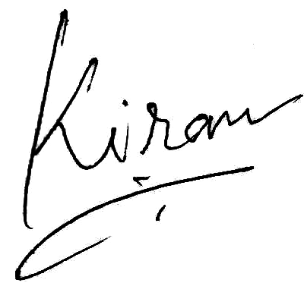
Kiran
General Secretary
CPN (Revolutionary Maoist)

