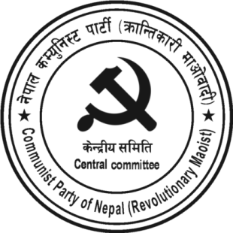
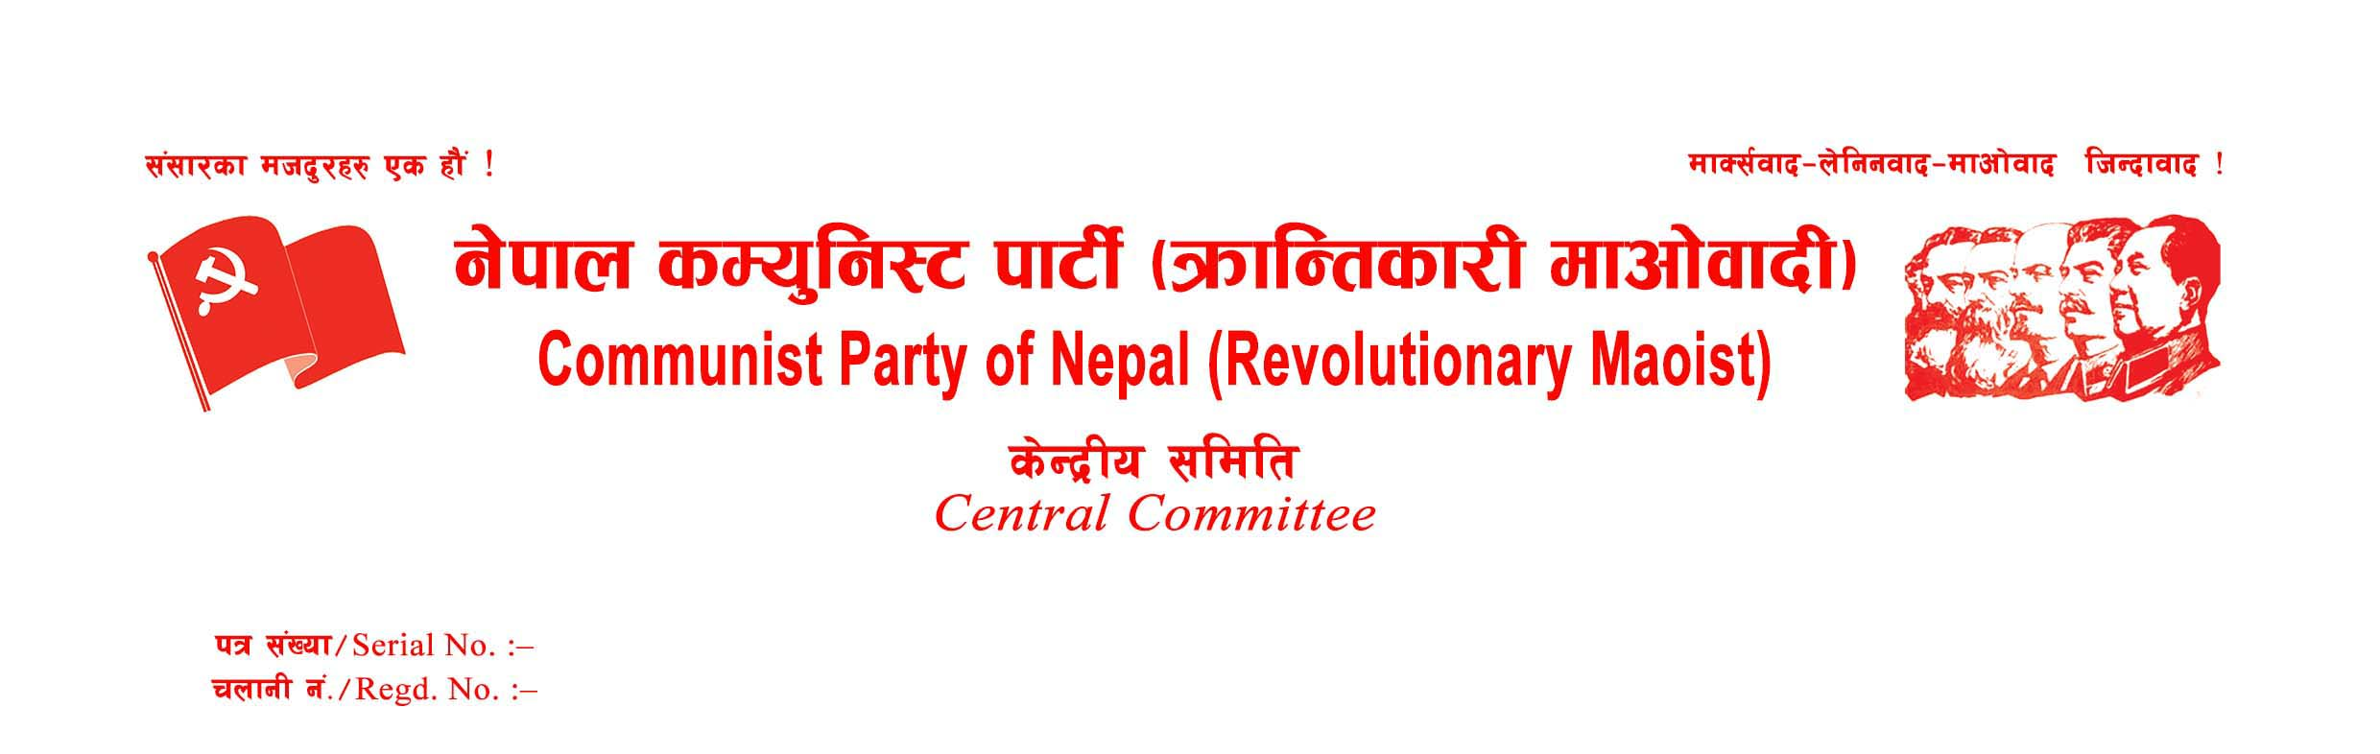
Press Statement
May 1, 2021, marks the historic festival of the entire working-class people, especially the international proletariat. This year's May Day has fallen on the eve of the 150 years of the Paris Commune that one of the contingents of the world proletariat had established its power in France, the first-ever proletarian state in history. On the special occasion of the 132nd May Day, our party conveys heartfelt well-wishes and revolutionary greetings to the entire working-class people fighting the imperialist oppression and pays homage to those fighters, who laid their lives for the liberation of the broad oppressed masses the world over.
Imperialism is now undergoing a severe economic crisis all over the world. The capitalist robbers are utilizing different forms of exploitation and oppression to shift the burden of this crisis onto the shoulder of the toiling masses. The world economy, which was approaching a crash, has now undergone a severe crisis after the outbreak of Covid-19. Tens of millions of laborers working in organized and unorganized sectors have been forced to struggle with hand-to-mouth problems whereas a handful of multi-national companies have grabbed maximum profits from the monopoly business, including the Covid-19 vaccines. As a result, the economic gap between the highest and lowest strata of the society is ever more widening. It has sharpened the contradiction between labor and capital in the world and even more sharply in the advanced imperialist countries.
Imperialism has followed a method of neo-colonial exploitation upon the underdeveloped and developing countries to compensate for the economic loss caused by the cyclic crisis of capitalism. As a result of neoliberal globalization and privatization, the oppressed countries have been trapped in the web placed by multi-national companies. The domestic ruling class, the pawns of imperialism, who invite multi-national companies for the unrestrained looting of the cheap resources and labor from their country, are pushing the broad masses into untold misery and extreme poverty. It has led to further intensification of the contradiction between imperialism and oppressed nations and people, which is principal contradiction of the world today.
On the other, the imperialist superpowers are competing to extract more super profit by extending their arena of exploitation in an unprecedented way. The contradiction between the US and China in the regions, including South China Sea, Taiwan, and the Middle East, is intensifying. And the world is getting polarized between the Sino-Russia pole and the US pole. Even the imperialist think tanks have started talking about the possibility of the trade war between China and the US converting to a full-fledged war. If the war breaks out anywhere in the world, the danger of it making up WW III has increased.
Thus, all of the fundamental contradictions of the world have become explosive after the outbreak of Covid-19. Imperialism will not be able to solve the ongoing economic and political crisis even after the pandemic has been under control. Contrarily, it will intensify further. It is true not only for the oppressed countries but also for the advanced imperialist countries as well. The days ahead will be the days of resistance struggles and rebellions all across the world. It is a very favorable situation to advance the proletarian revolution.
The political and economic crisis in Nepal has been deepening. Not only the parliamentary system, the reactionary state power defending it, and the so-called democratic parties have failed, but also the communist-tagged revisionist parties have failed in Nepal. The so-called communist government that was formed of a nearly two-thirds majority and the party leading it have crumbled due to the internal scuffle for lion-share of power and privileges. The anti-people content of the slogan "Happy Nepali and Prosperous Nepal" based on the neoliberal policy of imperialism has been exposed. People have started talking about an alternative to this political system. The new democratic revolution has become an objective need in Nepal.
Now the world is globalized and the ruling classes are united more strongly than before to protect their class interest. They have succeeded safeguarding their heaven of loot and plunder by nipping in the bud the revolutionary class struggle, wherever it sprouts. The internationalist proletariat is now in a weak and unorganized condition, the world over. The revolutionary communists are left with no option other than going ahead in a conscious and planned way to deal with the aforesaid world situation and advance revolutionary class struggles guided by Marxism-Leninism-Maoism. The only way to change this situation is to get organized and fight in one's country against the exploitation and oppression perpetrated by the imperialist plunderers and their pawns. There is no other way to liberate oneself from imperialist oppression.
The only way to defeat imperialism is the global victory of socialism. In the present epoch of globalized imperialism, the importance of the international task has increased manifold not only for the worldwide victory of socialism but also for the victory of the proletarian revolution in one country. For this, there are two vital tasks the genuine communists must fulfill soon, internationally. They are; one, the constitution of an international organization of the communist parties under the ideological guidance of MLM; and two, the organization of an anti-imperialist united front.
In the historical context of 132nd May Day and on the eve of the 150 years of the Paris Commune, our party heartily makes a call to the entire Marxist-Leninist-Maoist parties of the world to come unitedly forward to realize the aforesaid tasks, sooner than later.
Long Live May Day!
Long Live Paris Commune!
Long live Proletarian Internationalism!
Long Live World Socialist Revolution!
Down With all Shades of Revisionism!
Down With Imperialism and Expansionism!
Workers of all countries, unite!
April 30, 2021
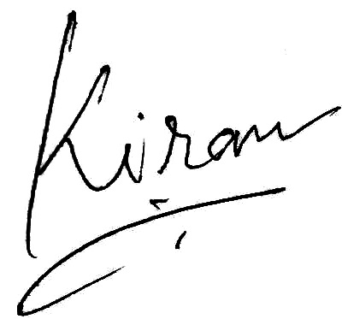
Kiran
General Secretary
CPN (Revolutionary Maoist)

