Morocco’s war on free speech is costing its universities dearly
December 7, 2015 11.17pm EST

By Shana Cohen

Author
- 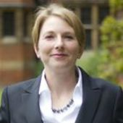Shana Cohen
Senior Research Associate, University of Cambridge

Disclosure statement
Shana Cohen received funding from the Leverhulme Trust for research on Morocco.

Partners
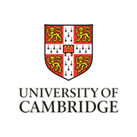
University of Cambridge provides funding as a member of The Conversation UK.

The Conversation’s partners
View partners of The Conversation

Republish this article
We believe in the free flow of information. We use a Creative Commons Attribution NoDerivatives licence, so you can republish our articles for free, online or in print.

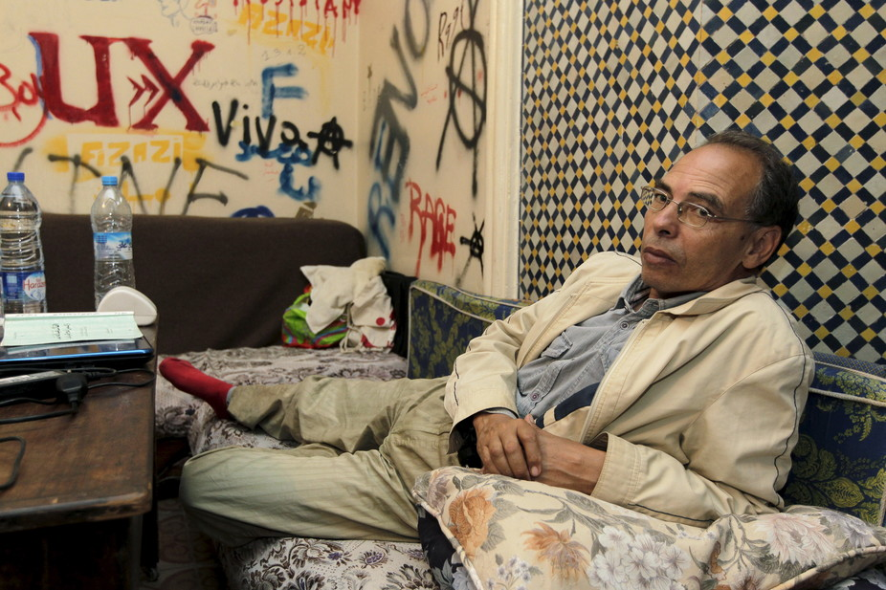Professor Maati Monjib has become the face of Morocco’s war on freedom of expression. Reuters
Morocco frequently turns to the courts when it doesn’t like what its critics have to say. The charges levelled against journalist and historian Professor Maati Monjib reinforce just how common this tendency, which emerged during the 1970s, is in Morocco. The State tries to quash critique among journalists and other public intellectuals by using the judicial system and imposing extraordinary fines.
Professor Monjib and six others have been accused of “threatening the internal security of the State” and “receiving foreign funding without notifying the government”. He has staged two very public hunger strikes to protest the allegations. Monjib has been a fervent supporter of investigative journalism in the country and an outspoken critic of the very restrictive state.
Several journalists have left the country in the face of state censorship. Others have quit the profession.
In an age of digital media and the rapid flow of information, the state’s campaign against freedom of expression serves mostly to generate international attention to Morocco’s human rights record. When one journalist or intellectual is arrested, articles published abroad inevitably list the charges against other intellectuals and journalists. These charges are sometimes completely unrelated to their profession.
One blogger wrote of the case against Monjib:
The campaign against Maati Monjib is incomprehensible … His views may be unorthodox, but hardly a menace that would explain the level of persecution he has endured. The level of negative international press coverage his case is generating has done a great harm to Morocco’s image.
Morocco was a French Protectorate until 1956, when it became independent again. The country has one of the oldest monarchies in the world, and the King still retains substantial power in the constitution and in governing. Morocco has an elected parliament led since 2011 by the Islamist party Parti de Justice et Developpement.
Morocco has an important geopolitical role as a conduit between sub- Saharan Africa and Europe. While there is a long history of protest and leftist and Islamist opposition in Morocco, the Arab Spring did not have the same depth as in other countries in the region, aside from the 20 Fevrier movement.

Universities under pressure
The case against Monjib and his co-accused also damages academia and university research in Morocco.
There is very little funding available for research at the public universities that dominate the North African country. Most private higher education colleges and universities focus overwhelmingly on teaching, particularly vocational or professional degree programmes like business management. For now, this takes the place of research or training in research skills.
Morocco has also, particularly over the past five or seven years, followed the lead of the US and Europe when drafting education policies. Recent policy strategies to reform higher education and research have adopted a neoliberal approach. This means treating students like consumers who need to be satisfied with a product, as well as strengthening oversight of “product” sales – that is, teaching – and trying to align skills with job market demand.
Some American and British academics have criticised this trend in their own countries. They argue that students' ability to think critically declines and they acquire less general knowledge when they are treated like consumers.
In Morocco, the language of higher education has become very much about categorising students as customers in an expanding marketplace.

Freedom to think differently
What connects restrictions on freedom of expression for journalists and the motivation and ability of researchers to practice their trade with independence and free thought? Quite simply, without the freedom to think differently, research cannot address real issues: poverty, unemployment and public health. Those who want to do such research or use their education to find practical solutions may try to leave. Those who want to stay in Morocco often leave academia.
Instead, what research and critical thinking does exist in Morocco often comes from foreign academics. Moroccan academic Youssef Chiheb has criticised
the lock that foreign experts and consultants have on the process of finalising public policy or strategies while graduates are not eligible or trained to take on the challenge because of a lack of mastery of a section of knowledge and a firm grip on foreign languages, French and English in this case.

Opening up new spaces
The threat of legal action may effectively narrow public debate within Morocco, but the growth of online news and blogs, often based abroad, has more than compensated. Access to Internet reporting and diverse, often critical, viewpoints means that an alternative public sphere exists. This is especially true for younger generations.
In my research in Morocco, and in Europe, individuals and groups find satisfaction in initiating social change in their local areas. This suits local governments that lack the resources to address social problems. Individuals and community-based organisations abandon the notion that they can affect change at a national level. They may try to have an influence beyond their country’s borders through the Internet and participation in international movements, whether mainstream or radical.
Professor Monjib and other journalists and public intellectuals work at a national level. They contribute to building a public sphere in Morocco that welcomes debate and new ideas organic to the country rather than imposed from elsewhere. Importantly, they provide an example for expressing different points of view, encouraging especially young people to believe they can make a difference, rather than seeking other outlets to prove themselves – such as becoming radicalised.
If Monjib and his colleagues cannot do this work, their other options are to go elsewhere – or quit. Neither is good for Morocco.

[From: https://theconversation.com/moroccos-war-on-free-speech-is-costing-its-universities-dearly-50547 ]

