Inside Indonesia [Oct-Dec. 2008]

Freedom of expression
Written by Jennifer Robinson

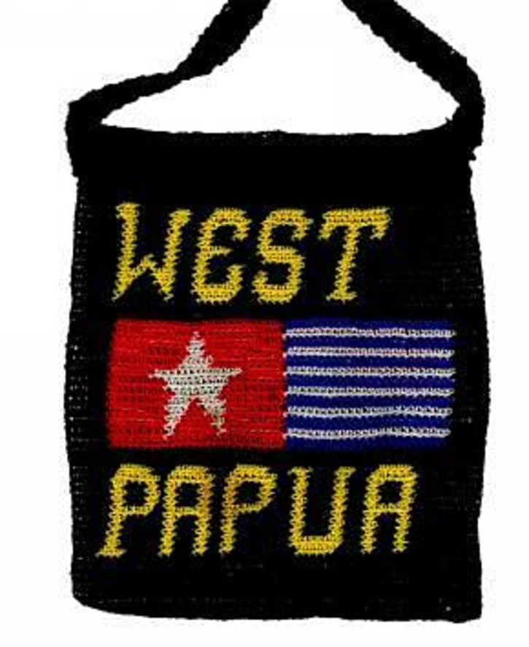

Fashion statements:


such bags are now banned in Papua
Yohana Pekei and Nelly Pigome sell handicrafts by the road in Jayapura. In January 2008 they were interrogated by Indonesian police and intelligence agents because of the bags they make and sell. What could possibly be so dangerous about a bag sold by the roadside by two West Papuan women? Woven into the design of their bags was the Morning Star flag; a regional and cultural symbol of huge significance for indigenous Papuans, and the symbol of Papuan nationalism.
Yohana and Nelly were reportedly targeted in police crackdowns throughout Papua on the use of the Morning Star flag, under Article 6 of Government Regulation No.77 of 2007, which prohibited the use of ‘any flag or logo used by separatist movements’. This law seemed to backtrack on the provisions of Special Autonomy under Law No.21 of 2001, which allows the use of Papuan regional symbols as an expression of Papuan cultural identity. While the Morning Star flag was not specifically listed as a protected regional symbol in the Special Autonomy Law itself, during Wahid’s presidency, display of the flag was permitted as a matter of government policy. In July 2007 the Papuan Tribal Council and Papuan People’s Council (MRP) recommended that the flag be made an official regional symbol in draft by-laws designed to implement special autonomy. Yet the policy of subsequent Indonesian governments has been to respond to flag raisings with violence and arrests. The prohibition of the flag, and the harassment of people like Yohana Pekei and Nelly Pigome, takes existing restrictions even further.
Legally speaking, Yohana and Nelly can no longer make their bags. Nevertheless, women like them continue to sell their handicrafts in Jayapura today. Governor Suebu has pledged that he will not authorise police to arrest or imprison women and children for these activities. But informal assurances provide little comfort as long as the law stands.

Continuing restrictions
In the past, the Indonesian state restricted free speech and communication of information, including peaceful criticism of the government, through criminal prosecution of ‘hate sowing’ offences. Articles 154 and 155 of the Indonesian Criminal Code criminalised ‘public expression of feelings of hostility, hatred or contempt toward the government’ and prohibited ‘the expression of such feelings or views through the public media’. The crime attracted prison terms of up to seven years. Political dissidents, critics, students and human rights defenders in Papua – as elsewhere in Indonesia – were targeted under these laws during the Suharto regime.

Indonesia is – and should be – praised for the steps it has taken towards democracy since the fall of Suharto
In July 2007 Indonesia’s Constitutional Court declared the ‘hate sowing’ offences in Articles 154 and 155 to be unconstitutional because they violated the right to free speech protected in the 1945 Constitution. Described by Amnesty International as a ‘landmark ruling for freedom of expression’, the decision has been welcomed as a sign of Indonesia’s transition to democracy and to greater protection of the right to freedom of expression in Indonesia.
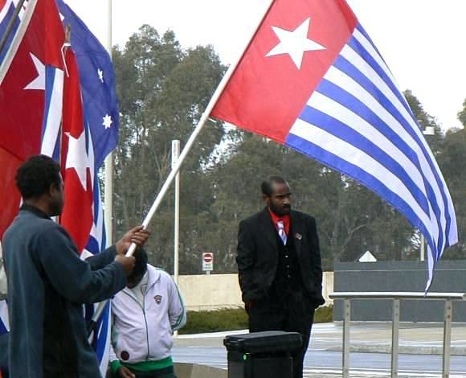

West Papuan refugee Herman Wanggai leads a demonstration at Parliament House, Canberra, 15 August 2007. In Papua, use of the flag in peaceful protest can attract prison sentences

Kipley Nink
Despite this Constitutional reform, most of the criminal offences used to suppress political opposition in Indonesia remain in effect. For example, Article 106 of the Criminal Code makes criminal any acts which are conducted with intent ‘to separate part’ of the territory of the state. The maximum penalty is life in prison. This catch-all offence uses extremely broad language, allowing prosecution for a broad range of acts associated with ‘separatism’. For example, in 2005 Filep Karma and Yusak Pakage were sentenced to 15 and 10 years in prison respectively for organising peaceful pro-independence celebrations and for flying the Morning Star flag. This provision – which has historically been used to target non-violent political activists across Indonesia – continues to be used in this way in Papua against those advocating self-determination. In March 2008, nine people were arrested for raising the flag in a peaceful demonstration against the new regulation prohibiting the Morning Star flag. In July 2008 forty-six more people were arrested after another flag-raising in Fak Fak, Papua, in protest against the 1969 Act of Free Choice. Most have now been released, but six remain in prison and face prosecution.

Papuans continue to be intimidated and arrested for expressing their political views and for taking part in peaceful protests
In Papua at least, then, the decision of the Constitutional Court has not had any real practical impact. According to Human Rights Watch’s February 2007 report, laws continue to be used in Papua to suppress free speech. Then in November 2007, Iwanggin Sabar Olif, a Papuan human rights lawyer, was arrested for forwarding a text message that stated that the Indonesian government had ordered the ‘elimination’ of the Papuan people. He was charged with ‘agitation’ under Article 160 of the Criminal Code, a crime attracting a six year prison term, and faces trial in Jayapura. Many see his arrest and prosecution as evidence of authorities’ surveillance and intimidation of human rights defenders. Public intellectuals and academics are also targeted through the censorship of books and intimidation by authorities. In December 2007 the Indonesian government outlawed a book by Sensius Wonda about Indonesia’s role in West Papua. According to Sri Agung Putra, Chief Prosecutor in Jayapura, Wonda’s book contains elements that ‘discredit the government’, ‘disturb public order’ and ‘endanger national unity’. This is the second Papuan book to be banned in recent times. Another book about the assassination of Papuan leader Theys Eluay was banned in 2002. The author, Benny Giay, a prominent Papuan academic, has been routinely threatened by Indonesian authorities ever since.

A long way to go
Indonesia is – and should be – praised for the steps it has taken towards democracy since the fall of Suharto. But progress is not equal across the archipelago. Restrictions in Papua remain, as Papuans continue to be intimidated and arrested for expressing their views. In fact, in many ways, state action and policy in Papua continue to resemble the repression experienced under Suharto. Many assert the need for peaceful dialogue in Papua. But there cannot be genuine and meaningful dialogue without freedom of expression. Whether Papuans support autonomy or independence, assert contested versions of the Act of Free Choice, or simply criticise the current implementation of Special Autonomy, their right to express such views must be protected. The fate of Indonesia’s democracy depends on it. ii
Jennifer Robinson (jennifer.robinson@balliol.ox.ac.uk) is an Australian lawyer and Rhodes Scholar at Balliol College, University of Oxford.

Inside Indonesia 94: Oct-Dec 2008

From: http://www.insideindonesia.org/freedom-of-expression (accessed May 15, 2016)

