Voice of America

India says Progress Made in Tackling Maoist Rebels
Anjana Pasricha | New Delhi 09 February 2010
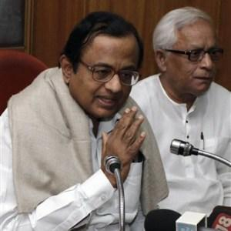

Photo: AP
Indian Home Minister Palaniappan Chidambaram speaks as West Bengal Chief Minister Buddhadeb Bhattacharjee, right, looks on after a meeting with chief ministers of some of the eastern Indian states which are among the worst hit by Maoist violence in Calcutta, India, 09 Feb 2010
India says it is making progress in a massive offensive launched to stem a Maoist rebellion. The Maoists, who have entrenched themselves in several parts of the country, are the biggest internal security threat confronting India.
Home Minister P. Chidambaram says several key Maoist leaders have been detained since thousands of security troops launched a coordinated operation against the rebels in five states worst affected by violence.
In these five states - West Bengal, Jharkhand, Orissa, Chattisgarh and Maharashtra - the rebels have established a strong presence in remote, rural areas.
Chidambaram said progress in the anti-Maoist offensive has been "steady but slow."
But the minister is optimistic that, in the next few months, the government will be able to re-establish its authority in areas under the influence of the rebels, who are known as Naxals.
"I am confident that further progress will be made in the next six months," Chidambaram said. "We will reclaim areas which are now dominated by the Naxals. Civil administration will be firmly established in these areas and this will be followed by development."
The government launched the massive operation as the insurgency intensified and become more violent in the past two years. Officials say the rebels have spread their presence across nearly one third of the country since it started as a peasant uprising in 1967. These are some of the poorest areas, mostly in central and eastern India.
Chidambaram has reiterated an offer of talks to the rebels.
"If you halt violence, we are prepared to talk to you on any matter that is of concern. Unfortunately past appeals have been spurned, therefore we are obliged to continue the operations."
Officials say more than 600 people have died annually, in the past decade, in Maoist-linked violence. The rebels have been targeting security forces and infrastructure, and say they want to build a communist state.
The government admits that lack of development in some of India's poorest areas has made it easy for the rebels to spread their influence. New Delhi has vowed to bring schools, roads and jobs opportunities to impoverished areas, once the security forces root out the rebels.

http://www1.voanews.com/english/news/asia/India-says-Progress-Made-in-Tackling-Maoist-Rebels-83878567.html

