Delhi Protesters March Against Operation Green Hunt
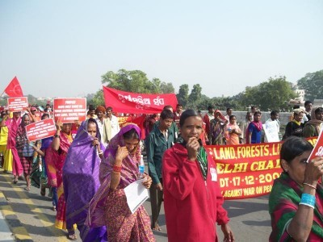
On the streets of Delhi
PRESS STATEMENT, December 17, 2009
The Forum Against War on People organised the “Rally Against War on People” to protest against the brutal military offensive of the Indian state on the tribal people of central and eastern India through Operation Green Hunt, wherein lakhs [1 lakh = 100,000] of the paramilitary-military as well as various vigilante gangs such as the Salwa Judum, Nagrik Suraksha Samiti, Sendra, Tritiya Prastuti Samiti, Harmad Vahini etc. has let loose on the people. …
The rally commenced from ram Lila Maidan at 11 am and reached Parliament Street where in various social activists, intellectuals, representatives of people’s organisations and civil rights activists addressed the gathering. People from Punjab, Haryana, Uttar Pradesh, Bihar, Jharkhand, Orissa, Andhra Pradesh, Maharashtra, Tamilnadu and Kerala attended the rally.
Later a delegation comprising of BD Sharma (Former Commissioner SC/ST), GN Saibaba (Assistant Professor, DU), Prashant Bhushan (Advocate, Supreme Court), Karen Gabriel (Associate Professor, DU), Gautam Navalakha (Consultant Editor, EPW), Mrigank (Navjawan Bharat Sabha) gave a memorandum to the Prime Minister. In the absence of the Prime Minister, Mr. Prithviraj Chauhan, MoS, PMO accepted the memorandum.
In Solidarity,
Campaign Against War on People, Committee Against Violence On Women (CAVOW), Naga Students Union Delhi (NSUD), Navjawan Bharat Sabha (NBS), Correspondence, KRALOS, KLAS, Krantikari Yuva Sanghathan (KYS), PFD, People’s Union for Civil Liberties (PUCL), MKP, Campaign for Peace & Democracy Manipur (CPDM), Democratic Students Union (DSU), Committee for Release of Political Prisoners (CRPP), DGMF, People’s Front (PF), Mazdoor Ekta Manch (MEM), Left Democratic Teacher’s Front (LDTF), Revolutionary Democratic Front (RDF), People’s Democratic Front of India (PDFI), CPI (ML) (New Democracy), CPI (ML) (Liberation), CPI (ML) (New Proletarian), JNU Forum Against War on People, BD Sharma, Arundhati Roy, Tripta Wahi, Vijay Singh, Neshat Quaiser, and others.

