Condemn the murder of Wadeka Singala, President
of Chasi Mulia Adivasi Sangh, Orissa!

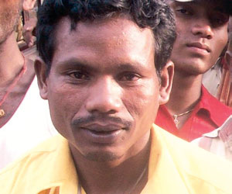

November 22, 2009

The Orissa government led by Naveen Patnaik has unleashed a fresh wave of fascist attack on the people’s movements. Two members of Chasi Mulia Adivasi Sangh (CMAS), including its president Wadeka Singana were killed in police firing on 20th November 09 during a protest by its members in Narayanpatna Tribal Panchayat region. The other deceased member is yet to be identified. At least six were injured in the incident. CMAS is an organisation of adivasi peasants which have been fighting for the rights of tribal communities over land and forests. It has come in conflict with the government and its armed forces which is facilitating the plunder and loot of natural resources by the Indian and multinational corporations. The CMAS has also been fighting against alienation of tribal lands, and to stop their encroachment by non-tribals.
The villagers and CMAS members were protesting this Friday in front of the Naraypatna police station against atrocities by the security forces during patrolling. The CMAS was demanding withdrawal of CRPF and frequent patrolling by the police in the area. More than 300 CMAS activists, including women and children armed with the traditional tribal weapons, gheraoed the police station in protest against the massive deployment of security forces in the area. “It’s harvest time and the locals were being harassed by security forces combing the area,’’ a tribal leader stated. The agitators first went to the CRPF camp only to be turned away. They then reached the police station to lodge their protest. While the CMAS and others were protesting peacefully, the police gripped by panic opened fire indiscriminately and without provocation. The police and the administration have justified the firing by claiming that it had to open fire “in self-defence”. Moreover, while the movement is demanding withdrawal of armed forces, the state has responded through repression and adding to the number of troops in the area after the incident. One company of CRPF and another company of Indian Reserve Battalion have been now deployed in the area to “maintain law and order”!
DSU condemns the killing of the two activists of CMAS by the police, and demands punishment of the guilty. We also demand that the grievances of the people must be addressed, and the armed forces removed from the Narayanpatna region.
Democratic Students Union
JNU, Delhi

From the Indian Vanguard website at:
http://indianvanguard.wordpress.com/2009/11/23/condemn-the-murder-of-wadeka-singala-president-of-chasi-mulia-adivasi-sangh-orissa/

