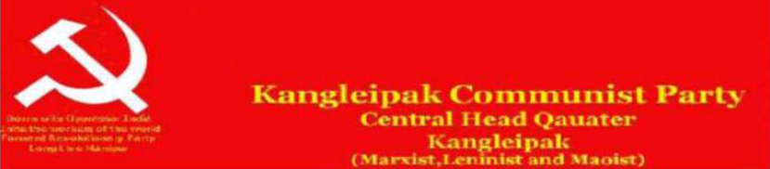
Ref.No. 283/kcp-chq/2011 Press Release Date 12/04/2011
KCP and Communist Movement in Manipur : Maoist
Comrade Irabot is the main engineer of Communist construction in Manipur. He learned Marxism and Leninism from the comrade inmates at Sylhet jail. Manipur State Council made him exiled at Silchar charging him for provocation of people's movement in Manipur. Manipur State Council has lifted banning on Comrade Irabot to enter Manipur in March 1946. Then after he organized a new party called Manipur Praja Mandal in April 1946. Comrade Irabot contested Manipur State Assembly election held on 1948 and won from Utlou Assembly constituency as a Krishak Sabha candidate. It will be very important to mention that He did not contested election as a CPI candidate. At the same time India again start a conspiracy to form a new state called Purbachal Pradesh comprising of Manipur, Tripura, Cachar and Lushai hills. Comrade Irabot called on a meeting all the progressive people on 21st September 1948 in protest against the formation of Purbachal Pradesh. The bloodshed incident took place at Pungdongbam village when the Manipur Police force to disperse the people who came to attend the meeting which claim a police officer was killed on the spot. The Manipur state Council declared the Manipur Praja Mandal and Manipur Krishak Sabha as unlawful. Actually the incident was intentionally framed by the fascist ruling class to suppress the peasant revolutionary democratic movement. The logic behind the conspiracy was to take over the Manipur state constitution without the representation of revolutionary mass. It is true that there is no provision of the civil rights of the Manipuri peoples in the Manipur state constitution 1947. This constitution was designed by Mr. Peerson in his own interest by appointing constitution making committee members of Valley and Hills representatives in an unofficial manner with a well planning to serve the imperialism. Manipur grew up as an integral part of the world proletarian revolution. The historical facts and the then present socio-political economic condition demands the formation of Manipur Communist Party instead of the formation of CPI Manipur State Committee. So Comrade Irabot took the correct political line and formed Manipur Communist Party on 29th October 1948 as an armed political party. He organized its arm group called Manipur Red Guard. He was death on 26th September 1951 at some part of the Burma due to his chronic disease. We find mainly two trends in international communist movement in this respect. The first trend that does not consider the arm struggle as an inevitable part of political struggle for power but one sidedly emphasizes on the political offensive or relegates preparation of peoples war in various pretexts is outright reformism and right revisionism. While the second one that emphasizes more on military offensive but ignores the political one or equates war with political represent Militarism. Right revisionism is the principle danger but militarism too has not harmed less in the political struggle for power in revolution. So after the death of Comrade Irabot, Comrade Ngangom Mahendra, Comrade Moirangthem Ibohal and their opportunist group took the line of right revisionism by surrendering the wills of revolutionary mass and Comrade N.Binoy and his group took the line of militarism and following by comrade Ibohanbi with the formation of Kangleipak Communist Party. That was the mistake in history communist movement in Manipur. But it will be wrong to define Manipuri Communist movement from the nationalist point of view but as a part of world proletarian movement with the enthusiasm of Manipuri nationalism. The communist movement established in Manipur before its annexation into Indian imperialist union. The Present status of Kangleipak Communist Party (KCP) is nothing but Looter. They have no ideological basis. The fact derives from an objective study of the development of the organizational, political system and their working modalities. It is very true that the KCP only depend on the task of Money Collection. But The Kangleipak Communist Party (Maoist) is a new group which not related with the former KCP. KCP (Maoist) is a new group of new generation Manipuri Communist. So we KCP (Maoist) urged the people to unite against such looter to bring an end. We also greet the people of Manipur in relation with the KCP 31st Foundation Day.

(Comrade Nonglen Meitei)
Assistant Secretary Publicity and Propaganda
Kangleipak Communist Party (Maoist), Manipur

