The Hindu

Mamata used people’s movement

in Singur, Nandigram: Kishenji

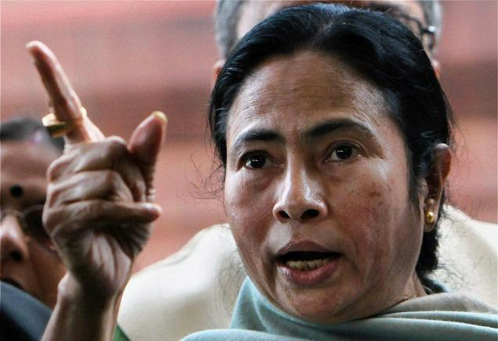
A file picture of Union Railway Minister Mamata Banerjee

January 10, 2010
Trinamool Congress chief Mamata Banerjee, who has vowed to throw the ultras out of Bengal, has been accused by a top Maoist leader of having taken their help in Singur and Nandigram and now turning her back on them.

“Ms. Mamata used the people’s movement at Singur and Nandigram to reach the corridors of power at the Centre and now she is dreaming of the chief minister’s chair at the cost of people’s interest,” Maoist leader Kishenji said in a fax message.
“It sounds like the threats of Buddhadeb Bhattacharjee and P. Chidambaram. Let Ms. Mamata try to tarnish Maoists and despatch forces to suppress a people’s movement. The red flag will continue to fly in ‘Jungle mahal’ which she cannot resist and which will bring change in Bengal.”
‘Jungle mahal’ is Maoist-hit areas in the districts of West Midnapore, Bankura and Purulia where joint operations by securitymen have been underway since the middle of last year.
On Ms. Banerjee’s resolve to drive Maoists out of Bengal ‘if voted to power’, Mr. Kishenji said “it is a matter of surprise that Ms. Mamata herself speaks against the people’s movement to strengthen the hands of CPI(M) raiders when the people’s rights are being established.”
Alleging that Ms. Banerjee was in the habit of ‘political somersaults’, he said “she should be answerable to the people.”
“Why has she joined hands with a fascist party like the Congress or a communal outfit like the BJP?” Mr. Kishenji asked, claiming she only wants to get the chief minister’s chair.
Mr. Kisenji invited her to visit ‘Jungle mahal’ and see for herself the ‘oppression’ of the people by the ‘CPI(M) and the police’.
He also criticised her for admonishing her own party MP Kabir Suman for singing ‘songs of protest of suppressed tribals’.
“This attitude does not show a human face for the poor tribals of Jungle mahal,” he said.
Ms. Banerjee during a press conference yesterday had asked “Who is Kisenji? Who is Chhatradhar (Mahato)? Who is Bikash? All of them are creations of CPI(M).”

http://beta.thehindu.com/news/states/other-states/article78504.ece

