

Bollywood Movie Shows the
Solution to Naxal Problem
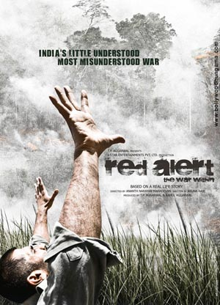

There are many problems that government faces every time like naxal and maoist problem. But the Govt. has not been able to find a satisfactory solution to resolve these problems. But it seems that Bollywood has an answer to these problems.

From long time Bollywood has produced movies on many serious issues like corruption, bad politics and Naxal problems. Through these movies directors have tried to bring out a solution to end the war between government and Naxalites. Usually in the Bollywood movies, an angry hero destroys complete mass of terrorists.

To uplift such courage in our security forces and people against Naxal terror Ananth Mahadevan has made a new film ‘Red Alert – The War Within’. The premier of the movie will be held at the 40th International Film Festival of India.

The movie ‘Red Alert – The War Within’ is story of a poor cook Narsimha(Suniel Shetty), who delivers food to the Naxal people. Narsimha lives in a Naxalite territory, Khammam district of Andhra Pradesh. Eventually he joins the Naxal people. One day Narsimha saves the lives of two school kids in Naxal attack on the school. Unhappy with Naxal philosophy Narsimha decides to stop the bloody war once and for all. Narsimha kills Naxal ‘dalam’ leader and captures police mission.

Mahadevan told reports that, “The idea for the film came from a newspaper report. Its headlines said: “We both fired, he missed, I didn’t.” The report was about a poor farmer who goes on to kill a Naxal leader after being trapped in the movement.”

Suniel Shetty who played the main character of Narsimha said he did a “lot of homework” for the movie.he also said, “The Maoists are not revolting against the country. It is the system they are not happy with.”

According to the director Ananth Mahadevan he has “made an honest film, which does not cater to the Hindi formula”. Talented actors like Naseeruddin Shah, Seema Biswas and Vinod Khanna have played major roles in the movie. The movie will release in January 2010.
http://www.hiphopgossips.com/bollywood-movie-shows-the-solution-to-naxal-problem#

Bollywood spotlight on India's Maoist insurgency

Tue Dec 1, 2009 12:03pm IST

PANAJI (Reuters) - A new Bollywood film takes a hard-hitting look at the Maoist insurgency in India and its effect on the common man.
"Red Alert - The War Within", directed by Ananth Mahadevan, is about a cook who falls into the hands of Maoist rebels in the southern state of Andhra Pradesh and is forced to take up arms against the police and the government.
"It is the story of the common man who is trapped between the outlaw and the law," Mahadevan told reporters on the sidelines of the 40th International Film Festival of India in the tourist haven of Goa.
The director said he wrote the script after reading a newspaper article about a farmer who finds himself trapped amidst Maoist rebels.
The Maoists started their armed struggle in West Bengal's Naxalbari town in 1967 and have expanded their support among villagers by tapping into resentment at the government's recent pro-industry push.
Prime Minister Manmohan Singh has described the Maoist insurgency as one of the gravest threats to the country's security.
"I am merely reporting their cause, there is no bias," Mahadevan said.
The rebels, estimated to have 22,000 fighters, operate in large parts of the eastern, central and southern countryside, and officials say they are now spreading to cities and bigger towns.
"No one paid any attention to this problem when it started 40 years ago. Now we are terming it as a big threat," Mahadevan said.

