China’s ‘State Capitalism’

Sparks a Global Backlash

Wall Street Journal, Nov. 16, 2010

By JASON DEAN, ANDREW BROWNE And SHAI OSTER,
(Please see Corrections & Amplifications item below.)
BEIJING—Since the end of the Cold War, the world's powers have generally agreed on the wisdom of letting market competition—more than government planning—shape economic outcomes. China's national economic strategy is disrupting that consensus, and a look at the ascent of solar-energy magnate Zhu Gongshan explains why.
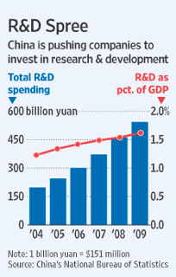
A shortage of polycrystalline silicon—the main raw material for solar panels—was threatening China's burgeoning solar-energy industry in 2007. Polysilicon prices soared, hitting $450 a kilogram in 2008, up tenfold in a year. Foreign companies dominated production and were passing those high costs onto China.
Beijing's response was swift: development of domestic polysilicon supplies was declared a national priority. Money poured in to manufacturers from state-owned companies and banks; local governments expedited approvals for new plants.
In the West, polysilicon plants take years to build, requiring lengthy approvals. Mr. Zhu, an entrepreneur who raised $1 billion for a plant, started production within 15 months. In just a few years, he created one of the world's biggest polysilicon makers, GCL-Poly Energy Holding Ltd. China's sovereign-wealth fund bought 20% of GCL-Poly for $710 million. Today, China makes about a quarter of the world's polysilicon and controls roughly half the global market for finished solar-power equipment.
Western anger with China has focused on Beijing's cheap-currency policy; President Obama blasted the practice at the G-20 summit in Seoul last weekend. Mr. Zhu's sprint to the top points to a deeper issue: China's national economic strategy is detailed and multifaceted, and it is challenging the U.S. and other powers on a number of fronts.

China: A Growing Challenge
China's economic approach today is still far more focused on government guidance than the world's other top economies.
Central to China's approach are policies that champion state-owned firms and other so-called national champions, seek aggressively to obtain advanced technology, and manage its exchange rate to benefit exporters. It leverages state control of the financial system to channel low-cost capital to domestic industries—and to resource-rich foreign nations whose oil and minerals China needs to maintain rapid growth.
China's policies are partly a product of its unique status: a developing country that is also a rising superpower. Its leaders don't assume the market is preeminent. Rather, they see state power as essential to maintaining stability and growth, and thereby ensuring continued Communist Party rule.
It's a model with a track record of getting things done, especially at a time when public faith in the efficacy of markets and the competence of politicians is shaken in much of the West. Already the world's biggest exporter, China is on track to pass Japan this year as the second-biggest economy.
Charlene Barshefsky, who as U.S. trade representative under President Bill Clinton helped negotiate China's 2001 entry into the World Trade Organization, says the rise of powerful state-led economies like China and Russia is undermining the established post-World War II trading system. When these economies decide that "entire new industries should be created by the government," says Ms. Barshefsky, it tilts the playing field against the private sector.

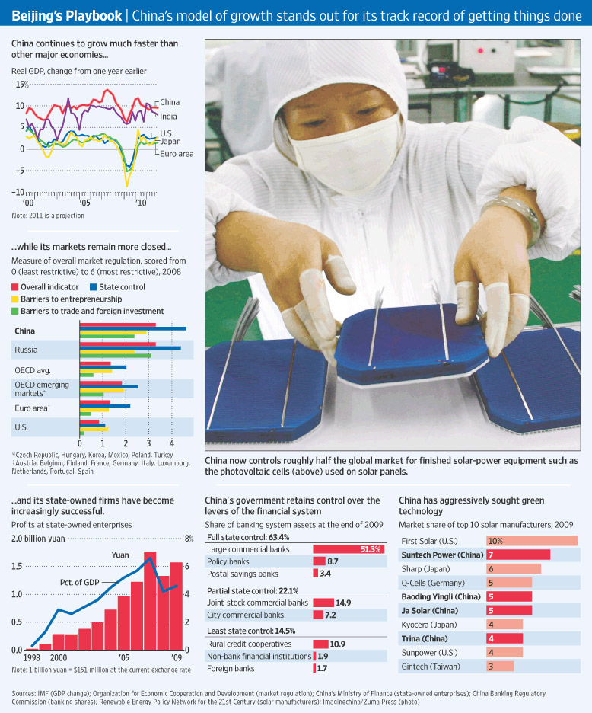

Western critics say China's practices are a form of mercantilism aimed at piling up wealth by manipulating trade. They point to China's $2.6 trillion in foreign-exchange reserves. The U.S. and the European Union have lodged a series of WTO cases and other trade actions targeting Beijing's policies, and hammer China's refusal to let its currency appreciate more quickly, which they argue fuels global economic imbalances.
Top executives at foreign companies have started griping publicly. In July, Peter Löscher, Siemens AG chief executive, and Jürgen Hambrecht, chairman of chemical company BASF SE, in a public meeting between German industrialists and China's premier, raised concerns about efforts to compel foreign companies to transfer valuable intellectual property in order to gain market access.
Some observers think Beijing's vision is rooted in a desire to avenge China's "century of humiliation" that started with the 19th-century opium wars. Such critics believe that China's focus on "indigenous innovation"—nurturing home-grown technologies—entails appropriating others' technology. China's high-speed trains, for instance, are based on technology introduced to China by German, French and Japanese makers.
"The Chinese have shown that if they have the ability to kill your model and take your profits, they will," says Ian Bremmer, president of New York-based consultancy Eurasia Group. His book, "The End of the Free Market," argues that a rising tide of "state capitalism" led by China threatens to erode the competitive edge of the U.S.
So far, though, multinationals aren't staying away, because China remains a vital source of growth for companies whose domestic markets are saturated.
China's strategy echoes the policies Japan employed in its economic rise—policies that also rankled the U.S. But China's sheer scale—its population is 10 times Japan's—makes it a more formidable threat. Also, its willingness in recent decades to open some industries to foreign firms makes its market far more important for global business than Japan's ever was, giving Beijing much greater leverage.
Chinese leaders have begun to acknowledge the backlash. At the World Economic Forum in Tianjin in September, Premier Wen Jiabao said that the recent debate about China among foreign investors "is not all due to misunderstanding by foreign companies. It's also because our policies were not clear enough."
"China is committed to creating an open and fair environment for foreign-invested enterprises," Mr. Wen said.
The state has always played a big role in China's economy, but for most of the reform era that started in the late 1970s, it retreated as state-owned collective farms were dismantled and inefficient state industrial enterprises closed. Accession to the WTO in 2001 represented a big bet by the leadership on liberalizing markets further. The gamble paid off, with growth rocketing much of the past decade.
But the state is again ascendant. Many analysts say the pace of liberalization has slowed, and point to vast swaths of industry still controlled by state companies and tightly restricted for foreigners. The government owns almost all major banks in China, its three major oil companies, its three telecom carriers and its major media firms.
According to China's Ministry of Finance, assets of all state enterprises in 2008 totaled about $6 trillion, equal to 133% of annual economic output that year. By comparison, total assets of the agency that controls government enterprises in France, whosedirigiste policies give it one of the biggest state sectors among major Western economies, were €539 billion ($686 billion) in 2008, about 28% of the size of France's economy.
The government's increased involvement in sectors from coal mining to the Internet has spawned the phrase guojin mintui, or "the state advances, the private sector retreats," among market proponents in China. A January report by the Organization for Economic Cooperation and Development said China's economy had the least competition of 29 surveyed, including Russia's. Prominent Chinese economist Qian Yingyi has said he worries over what appears to be "a reversal of market-oriented reforms in the last couple of years."
The state's huge role in the economy gives it enormous sway to pursue its policy goals, which are often laid out in voluminous five-year (sometimes 15-year) plans. These relics of the Mao-era command economy are central to the corporate fortunes of Western giants like Caterpillar Inc. and Boeing Co. that rely on the country's market. China is now one of the biggest sources of revenue growth for Caterpillar, and is the biggest buyer of commercial jets outside the U.S., according to Boeing.
One of Beijing's most important goals: wean China off expensive foreign technology. It is a process that began with the "open door" economic policies launched by Deng Xiaoping in 1978 that brought in waves of foreign technology firms. Companies such as Microsoft Corp. and Motorola Inc. set up R&D facilities and helped train a generation of Chinese scientists, engineers and managers.
That process is now in overdrive. In 2006, China's leadership unveiled the "National Medium- and Long-Term Plan for the Development of Science and Technology," a blueprint for turning China into a tech powerhouse by 2020. The plan calls for nearly doubling the share of gross domestic product devoted to research and development, to 2.5% from 1.3% in 2005.
One area of hot pursuit: green technology. China's "Torch" program fast-tracks industries, attracting entrepreneurs with offers of cheap land for factories, export tax breaks and even a free apartment for three years.
Take the case of Deng Xunming, a China-born U.S. citizen who is a pioneer of America's solar industry and whose innovations light up the first solar-powered billboard on New York's Times Square.
His company, Xunlight Corp., has been nurtured by U.S. financial aid and embraced by politicians eager for the U.S. to win the race to develop new energy technologies. Xunlight has pulled in more than $50 million in state and federal grants, loans and tax credits, partly aimed at bringing needed jobs to Toledo, Ohio, where the company is based.
But two years ago, Mr. Deng, who left China in 1985 to study at the University of Chicago, set up a Xunlight unit on a giant industrial estate near Shanghai. The company now also makes its thin-film solar panels there and employs 100 workers. The panels are exported back to the U.S.
Mr. Deng says he is trying to keep the Chinese operation "low key." It isn't mentioned on Xunlight's website, and Mr. Deng declined to comment on the China factory in an interview. "China will be a good market for the future," he said. "But right now, the bigger market is in Europe. We're putting our attention on the Europe and U.S. market. But meanwhile we're developing efforts for the China market," which could eventually be bigger, he said.
While the state seeks new technology, it also uses control of banking to feed cheap credit to industries it wants to foster. The government sets interest rates for China's bank depositors low relative to rates of growth and inflation. That means Chinese households, through the banks, effectively subsidize the state's industrial darlings.
Privately held telecommunications equipment maker Huawei Techologies Co. has long had its overseas expansion supported by China Development Bank, which in 2004 extended a five-year, $10 billion credit line and routinely lends money to foreign buyers to finance their purchases of Huawei products. Revenue has risen more than 200% in the past five years, and it has become one of the top three telecommunications companies, along with Nokia Siemens Networks and Telefon AB LM Ericsson.
Sprint Nextel Corp. recently excluded Huawei and fellow Chinese telecom company ZTE Corp. from a contract worth billions of dollars, prompted by U.S. fears that the companies have ties to China's military. The Sprint decision was a setback for Huawei in the one major market it has had difficulty penetrating, the U.S., and shows how mounting concerns over China's policies are starting to exact a cost.
Huawei has also faced complaints in Europe that Chinese government backing gives it an unfair advantage. Both Huawei and ZTE have said their equipment poses no threat to U.S. security, and deny benefiting unfairly from government support.
For China, the biggest risks may be internal. Some attempts to generate high-tech breakthroughs by fiat have fizzled. A drive to produce a home-grown microprocessor took years to replicate features of those from Intel Corp. and Advanced Micro Devices Inc., whose products had continued to evolve. A Chinese-developed mobile phone technology has yet to gather significant momentum abroad, despite the government forcing China's largest phone company to adopt it.
Longer term, China faces a host of challenges that threaten growth. They include a population that is aging quickly because the one-child policy limited births in recent decades, and environmental damage resulting from the country's breakneck pace of industrialization.
For now, that pace has the West on guard. "Our competition has gotten tougher during a period for the U.S. of profound economic weakness that magnifies any perceived threat," says Ms. Barshefsky, the former U.S. trade representative. There is a "significant and profound—almost theological—question about the rules as they exist."
Corrections & Amplifications: An earlier version of this article mistakenly said that Chinese economist Qian Yingyi is from Peking University.
—Andrew Batson contributed to this article.
Write to Jason Dean at jason.dean@wsj.com, Andrew Browne at andrew.browne@wsj.com and Shai Oster at shai.oster@wsj.com

http://online.wsj.com/article/SB10001424052748703514904575602731006315198.html?KEYWORDS=Company+profits+rise+to+record+annual+rate#

