New York Times
April 23, 2010

Chinese Military Seeks to

Extend Its Naval Power

By Edward Wong
YALONG BAY, China — The Chinese military is seeking to project naval power well beyond the Chinese coast, from the oil ports of the Middle East to the shipping lanes of the Pacific, where the United States Navy has long reigned as the dominant force, military officials and analysts say.
China calls the new strategy “far sea defense,” and the speed with which it is building long-range capabilities has surprised foreign military officials.
The strategy is a sharp break from the traditional, narrower doctrine of preparing for war over the self-governing island of Taiwan or defending the Chinese coast. Now, Chinese admirals say they want warships to escort commercial vessels that are crucial to the country’s economy, from as far as the Persian Gulf to the Strait of Malacca, in Southeast Asia, and to help secure Chinese interests in the resource-rich South and East China Seas.
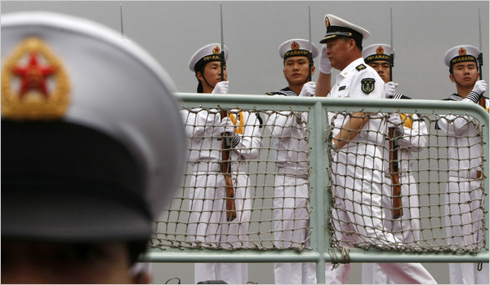

In late March, two Chinese warships docked in Abu Dhabi, the first time the modern Chinese Navy made a port visit in the Middle East.
The overall plan reflects China’s growing sense of self-confidence and increasing willingness to assert its interests abroad. China’s naval ambitions are being felt, too, in recent muscle flexing with the United States: in March, Chinese officials told senior American officials privately that China would brook no foreign interference in its territorial issues in the South China Sea, said a senior American official involved in China policy.
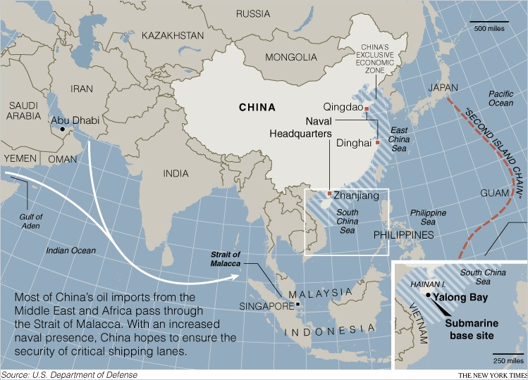

The naval expansion will not make China a serious rival to American naval hegemony in the near future, and there are few indications that China has aggressive intentions toward the United States or other countries.
But China, now the world’s leading exporter and a giant buyer of oil and other natural resources, is also no longer content to trust the security of sea lanes to the Americans, and its definition of its own core interests has expanded along with its economic clout.
In late March, Adm. Robert F. Willard, the leader of the United States Pacific Command, said in Congressional testimony that recent Chinese military developments were “pretty dramatic.” China has tested long-range ballistic missiles that could be used against aircraft carriers, he said. After years of denials, Chinese officials have confirmed that they intend to deploy an aircraft carrier group within a few years.
China is also developing a sophisticated submarine fleet that could try to prevent foreign naval vessels from entering its strategic waters if a conflict erupted in the region, said Admiral Willard and military analysts.
“Of particular concern is that elements of China’s military modernization appear designed to challenge our freedom of action in the region,” the admiral said.
Yalong Bay, on the southern coast of Hainan island in the South China Sea, is the site of five-star beach resorts just west of a new underground submarine base. The base allows submarines to reach deep water within 20 minutes and roam the South China Sea, which has some of the world’s busiest shipping lanes and areas rich in oil and natural gas that are the focus of territorial disputes between China and other Asian nations.
That has caused concern not only among American commanders, but also among officials in Southeast Asian nations, which have been quietly acquiring more submarines, missiles and other weapons. “Regional officials have been surprised,” said Huang Jing, a scholar of the Chinese military at the National University of Singapore. “We were in a blinded situation. We thought the Chinese military was 20 years behind us, but we suddenly realized China is catching up.”
China is also pressing the United States to heed its claims in the region. In March, Chinese officials told two visiting senior Obama administration officials, Jeffrey A. Bader and James B. Steinberg, that China would not tolerate any interference in the South China Sea, now part of China’s “core interest” of sovereignty, said an American official involved in China policy. It was the first time the Chinese labeled the South China Sea a core interest, on par with Taiwan and Tibet, the official said.
Another element of the Chinese Navy’s new strategy is to extend its operational reach beyond the South China Sea and the Philippines to what is known as the “second island chain” — rocks and atolls out in the Pacific, the official said. That zone significantly overlaps the United States Navy’s area of supremacy.
Japan is anxious, too. Its defense minister, Toshimi Kitazawa, said in mid-April that two Chinese submarines and eight destroyers were spotted on April 10 heading between two Japanese islands en route to the Pacific, the first time such a large Chinese flotilla had been seen so close to Japan. When two Japanese destroyers began following the Chinese ships, a Chinese helicopter flew within 300 feet of one of the destroyers, the Japanese Defense Ministry said.
Since December 2008, China has maintained three ships in the Gulf of Aden to contribute to international antipiracy patrols, the first deployment of the Chinese Navy beyond the Pacific. The mission allows China to improve its navy’s long-range capabilities, analysts say.
A 2009 Pentagon report estimated Chinese naval forces at 260 vessels, including 75 “principal combatants” — major warships — and more than 60 submarines. The report noted the building of an aircraft carrier, and said China “continues to show interest” in acquiring carrier-borne jet fighters from Russia. The United States Navy has 286 battle-force ships and 3,700 naval aircraft, though ship for ship the American Navy is considered qualitatively superior to the Chinese Navy.
The Pentagon does not classify China as an enemy force. But partly in reaction to China’s growth, the United States has recently transferred submarines from the Atlantic to the Pacific so that most of its nuclear-powered attack submarines are now in the Pacific, said Bernard D. Cole, a former American naval officer and a professor at the National War College in Washington.
The United States has also begun rotating three to four submarines on deployments out of Guam, reviving a practice that had ended with the cold war, Mr. Cole said.
American vessels now frequently survey the submarine base at Hainan island, and that activity leads to occasional friction with Chinese ships. A survey mission last year by an American naval ship, the Impeccable, resulted in what Pentagon officials said was harassment by Chinese fishing vessels; the Chinese government said it had the right to block surveillance in those waters because they are an “exclusive economic zone” of China.
The United States and China have clashing definitions of such zones, defined by a United Nations convention as waters within 200 nautical miles of a coast. The United States says international law allows a coastal country to retain only special commercial rights in the zones, while China contends the country can control virtually any activity within them.
Military leaders here maintain that the Chinese Navy is purely a self-defense force. But the definition of self-defense has expanded to encompass broad maritime and economic interests, two Chinese admirals contended in March.
“With our naval strategy changing now, we are going from coastal defense to far sea defense,” Rear Adm. Zhang Huachen, deputy commander of the East Sea Fleet, said in an interview with Xinhua, the state news agency.
“With the expansion of the country’s economic interests, the navy wants to better protect the country’s transportation routes and the safety of our major sea lanes,” he added. “In order to achieve this, the Chinese Navy needs to develop along the lines of bigger vessels and with more comprehensive capabilities.”
The navy gets more than one-third of the overall Chinese military budget, “reflecting the priority Beijing currently places on the navy as an instrument of national security,” Mr. Cole said. China’s official military budget for 2010 is $78 billion, but the Pentagon says China spends much more than that amount. Last year, the Pentagon estimated total Chinese military spending at $105 billion to $150 billion, still much less than what the United States spends on defense. For comparison, the Obama administration proposed $548.9 billion as the Pentagon’s base operating budget for next year.
The Chinese Navy’s most impressive growth has been in its submarine fleet, said Mr. Huang, the scholar in Singapore. It recently built at least two Jin-class submarines, the first regularly active ones in the fleet with ballistic missile capabilities, and two more are under construction. Two Shang-class nuclear-powered attack submarines recently entered service.
Countries in the region have responded with their own acquisitions, said Carlyle A. Thayer, a professor at the Australian Defense Force Academy. In December, Vietnam signed an arms deal with Russia that included six Kilo-class submarines, which would give Vietnam the most formidable submarine fleet in Southeast Asia. Last year, Malaysia took delivery of its first submarine, one of two ordered from France, and Singapore began operating one of two Archer-class submarines bought from Sweden.
Last fall, during a speech in Washington, Lee Kuan Yew, the former Singaporean leader, reflected widespread anxieties when he noted China’s naval rise and urged the United States to maintain its regional presence. “U.S. core interest requires that it remains the superior power on the Pacific,” he said. “To give up this position would diminish America’s role throughout the world.”
Thom Shanker contributed reporting from Washington.

http://www.nytimes.com/2010/04/24/world/asia/24navy.html?th&emc=th

