Open Letter of CPMLM BD, CPMLM F and WOA to the International Communist Movement

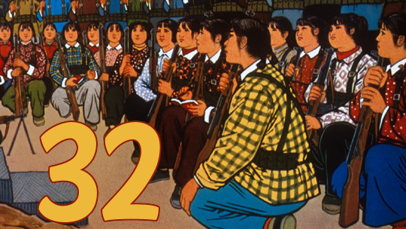

Open Letter to the International Communist Movement

Today, the International Communist Movement faces many challenges, like the deepening of the general crisis of capitalism, the tendency to imperialist war and the sharpness of imperialist powers concurrence, climate change.
And because of the uneven development existing in the International Communist Movement, there are many differences about how to understand reality; there are indeed no sufficient unity, no sufficient exchanges among the International Communist Movement.
According to us, this situation must change, in fact it is already changing, the requirements rise, the world masses want answer, they want a way to shine in front of them. They are hungry for a way to break their chains, to build a new society, far from exploitation, oppression and decadence.
We must answer this: the level of ideological, theoretical and cultural exchanges among communists must be developed. This means building an international platform, a democratic platform for the communists, which would be a step for the ideological unity in the future.
Nevertheless, such a platform can exist if it really corresponds to the requirements of the masses, which is the World Proletarian Revolution, to build the world socialist Republic, bringing us to Communism.
That is why, according to us, to understand what is happening and to transform reality, we need science, dialectical materialism, which means at our epoch: Marxism-Leninism-Maoism, applied to each national reality, because each nation is the framework of social transformation.
At our epoch, Maoism, as Marxism-Leninism-Maoism, synthesis of the ideology of working class, can only exist as a guiding thought in each country, forging the avant-garde in correspondence with the inner contradiction of the country, unleashing People’s War. In this process, all the People’s War unite and combine themselves, forging the path to the World Proletarian Revolution.
Because of the uneven development, thoughts have been developed in some countries, like Gonzalo in Peru, Akram Yari in Afghanistan, Siraj Sikder in Bangladesh, Ibrahim Kaypakkaya in Turkey.
These thoughts must be studied, compared also with others thoughts that may be appeared, like Charu Mazumdar and Kanai Chatterjee in India, Ulrike Meinhof in Germany, Alfred Klahr in Austria. In each country, communists must study and understand if and how a thought may have been developed.
We know that there are Marxist-Leninist-Maoist organisations that did not understand this question of the thought, or that may even reject it. It was and is historical understandable, it comes from the law of uneven development.
We are so fully aware of it but we think the question is unavoidable, and that history will make these organisations either jump to the thought, or fail. In our eyes, genuine communists can only recognize the contributions of Chairman Gonzalo, who synthesized the lessons of the Great Cultural Proletarian Revolution, summing it up in the slogan: “People’s War until Communism!”
For this reason, we are for an open, democratic discussion among Marxist-Leninist-Maoist organisations wanting the International Communist Movement to move forward.
We are for unity, we are not afraid, neither of discussions nor of a common struggle against counter-revolution, capitulation and revisionist ideologies like Prachandism and Avakianism.
Comrades, let’s dare unity. Let’s build an international platform, to show our spirit of unity, to be able to exchange about our experiences and our lessons, to show to the world masses that, despite the uneven development, despite our differences, we are guided by the same red star, we are fully aware of our duty.
Workers Organization of Afghanistan (Marxist-Leninist-Maoist, principally Maoist)
Communist Party Marxist-Leninist-Maoist Bangladesh
Communist Party Marxist-Leninist-Maoist France

[Distributed on Feb. 2, 2013]

