Call of CPMLM Bangladesh
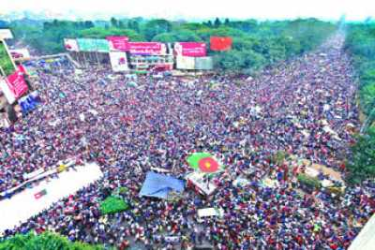

Awami League has been exposed. It has been exposed to the young generation. They came from the whole country demanding the trial of war criminals. Many of them perhaps don’t know that Awami League is as war criminal as the Jamat-e-Islamli is. Yahia and Sheikh Mujive are the same blood thirsty butcher. Zia, Ershad, Hasina and Khaleda are also the same.
They must know why Bangladesh was not liberated in real sense.
Siraj Sikder and his party fought for what?
Why did Sheikh Mujiv and Awami fascist government kill Siraj Sikder and innumerable Maoist communists?
Why did Zia and his fascist government kill innumerable solders?
Why have Hasina and Khaleda gangs continuously been killing innumerable Maoist communists in the name of crossfire?
Are not those war crimes?
Their hands are red with blood.
They have no difference with Qader Molla.
All of them use religion to protect this exploiting society.
People need liberation; Liberation from those exploiters.
That needs the ideology of Marxism-Leninism-Maoism!
Leadership like Siraj Sikder is needed, young and vigorous!
And a Communist Party, that will lead in people’s war with the ideology of MLM to the shining path of communism!
Communist Party Marxist-Leninist-Maoist Bangladesh
10 February 2013

[From: http://sarbaharapath.com/?p=385 (accessed Feb. 10, 2013)]

