We are deeply shocked at the death of hundreds of workers in Garment prison in Dhaka and at the death of many people being crushed by the over way in Chittagong. This is a war of exploiting classes against the masses. Transform tears into strength. Confront war by means of war.
Posted on 28 November 2012 by admin in CPMLM - BD.
Here, life and death goes hand in hand. This is nothing new to die by being burnt in garment factory or crushed under hill sliding or bridge. Human lives are worthless. Who are human? Are those Capitalists, bourgeoisie politicians or revisionist collaborators? The opposite is proven. Human are the workers, peasants and oppressed people who were burnt or crushed under bridge.
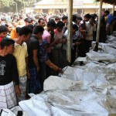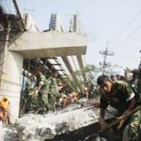
They have no place in the bourgeoisie world of profit and greed. In our world, also the exploiters have no place. This is why WAR. A Punjabi poet said: without war, we are helpless. Remember Siraj Sikder. He said to confront war by means of war.

[From: http://sarbaharapath.com/?p=226 ]

